**22.04.2020**

**Due 23.04.2020 at 23:59**

**ACM 114 – Introduction to Computer Science and Programming**

**Homework 2**

**Question 1 (50 pts):**

Write a turtle graphics program that uses the square or rectangular functions (also you should have a main function to design these squares) along with a loop (or loops) to draw the checkerboard pattern shown in Figure Q1.1 below.

Hint: The example we did in the lesson can guide you. You can think of a checkerboard as a 2-dimensional array (list).

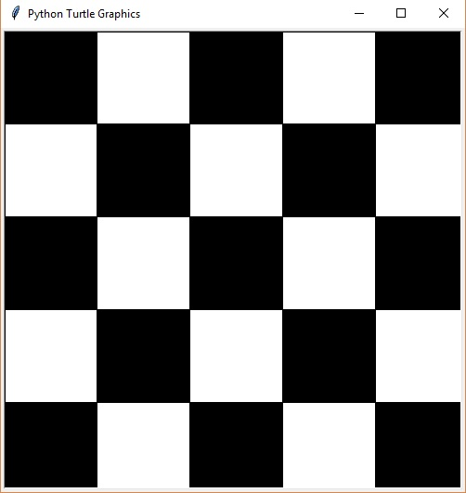

Figure Q1.1. Checkerboard pattern

**Question 2 (30 pts):**

Write a program that predicts the approximate size of a population of organisms. The application should use text boxes to allow the user to enter the starting number of organisms, the average daily population increase (as a percentage), and the number of days the organisms will be left to multiply. For example, assume the user enters the following values:

Starting number of organisms: 2

Average daily increase: 30

Number of days to multiply: 10

The program should display the following table of data:

Day Approximate Population

----------------------------------------

1 2

2 2.6

3 3.38

4 4.394

5 5.7122

6 7.42586

7 9.653619

8 12.5497

9 16.31462

10 21.209

**Question 3 (20 pts):**

Write a program that accepts a sentence and calculate the number of upper case letters and lower case letters.

**\*\*\*For your information!\*\*\***

Please do the assignment yourself. Assignments with similar content will not be taken into consideration, as they were been copied. The assignments are for your own development and aim to observe your progress in the Python programming language.

Best regards!

Take care, wish you all the best...

#StayHomeStaySafe