**10.05.2020**

**Due 12.05.2020 at 23:59**

**ACM 114 – Introduction to Computer Science and Programming**

**Homework 3**

**Question 1 (40 pts):**

Write a program that reads the contents of two text files and compares them in the following ways (also you should have a function definition (including loops) to analyze these files – it is sufficient to define only one function; however, this function must include all of these following operations.):

1. (8 pts) It should display a list of all the unique words contained in both files.
2. (8 pts) It should display a list of the words that appear in both files.
3. (8 pts) It should display a list of the words that appear in the first file but not the second.
4. (8 pts) It should display a list of the words that appear in the second file but not the first.
5. (8 pts) It should display a list of the words that appear in either the first or second file, but not both.

Hint: Use set operations to perform these analyses. For instance, you can display a list of words that appear in both files using the set.intersection( ) operation to obtain the intersection of sets.

* When the contents of the first and second file are such as:
* Let's start coding in Python, it is so exciting. 🡪 for the first file
* How about we begin coding in Python! It is so cool. 🡪 for the second file
* The output of the program will be as like this:

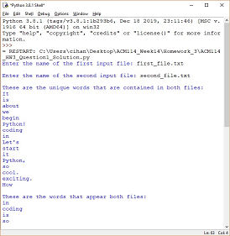 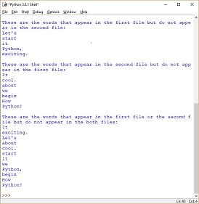

Figure Q.1. The parts of the program's entire output

**Question 2 (40 pts):**

1. (8 pts) Write a program that asks the user how many words they would like to write to a file, and then asks the user to enter that many words, one at a time. The words should be written to a file (you should define a function (using loops) for writing process).
2. (32 pts) Write another program (you can combine this program with the program of the first sub-question above – part a) that reads the words from the file and inserts the following data to the same file (you can define only one function (using loops) for reading and inserting processes):

* (8 pts) The number of words in the file.
* (8 pts) The shortest word in the file.
* (8 pts) The longest word in the file.
* (8 pts) The average length of all of the words in the file.
* When you enter the contents as follows to create the file, the program should give this output on the screen:

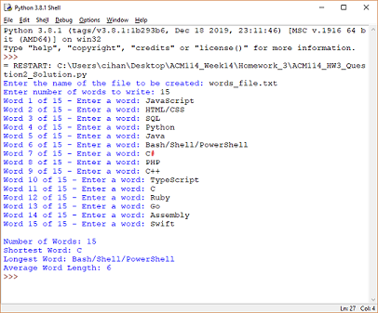

Figure Q.2.1. The output of the program on the shell.

* When you finished all of the processes of the your program, you will have an output file as like this:

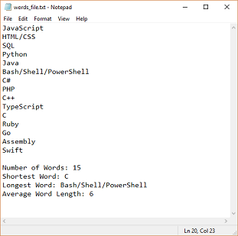

Figure Q.2.2. The output file of the program.

**Question 3 (20 pts):**

Write a program to compute the frequency of the words from the input. The output should output after sorting the key alphanumerically. Suppose the following input is supplied to the program:

* All the world’s a stage, And all the men and women merely players; They have their exits and their entrances. From the part of the speech: “All the world’s a stage” BY WILLIAM SHAKESPEARE
* Then, the output should be:

All: 1

And: 1

BY: 1

From: 1

SHAKESPEARE: 1

They: 1

WILLIAM: 1

a: 2

all: 1

and: 2

entrances.: 1

exits: 1

have: 1

men: 1

merely: 1

of: 1

part: 1

players;: 1

speech:: 1

stage,: 1

stage”: 1

the: 5

their: 2

women: 1

world’s: 2

“All: 1

**\*\*\*For your information!\*\*\***

Please do the assignment yourself. Assignments with similar content will not be taken into consideration, as they were been copied. The assignments are for your own development and aim to observe your progress in the Python programming language.

Best regards!

Take care, wish you all the best...

#StayHomeStaySafe