**Object Oriented Programming Hmw1**

**150160542-Cihat Bostancı**

At the beginning, we should design appointment system for new identity card. We have two different list which are these in the following:

-Citizen with Appointment

-Citizen with no Appointment

So we need divide the list depend on HasApp -> True or False

I am parsing and divide the file with the respect to “/t” tab. I obtain Citizen of idNo’s , Name’s, Surname’s etc. I am containing with stl vector ( Citizen of idNo’s, Name’s, Surname’s etc. )

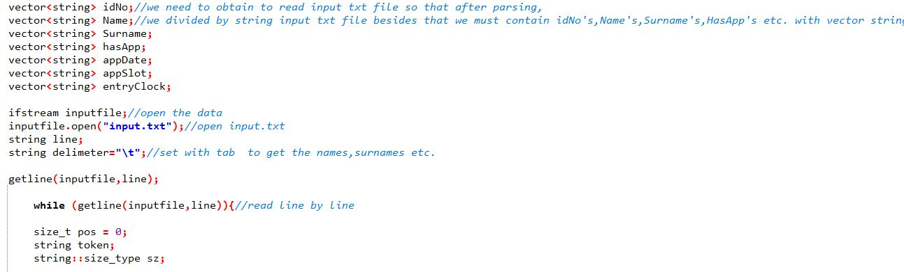

At this point I could design my Time.h and Citizen.h . I built these class to assignment’s attributes and class methods. I create a Time constructor which is included to convert from string to integer because of my attributes. I create a Citizen constructor which is included to convert from string to whatever ı want to attributes types. In Time class, I have to compare entry clock and dates to understand who citizen comes from early and arrange to appointment fairly at this way. Hereby, I should build operator overloading functions to arrange dealing with these problems fairly as I could use these functions in Civil Registry Class.

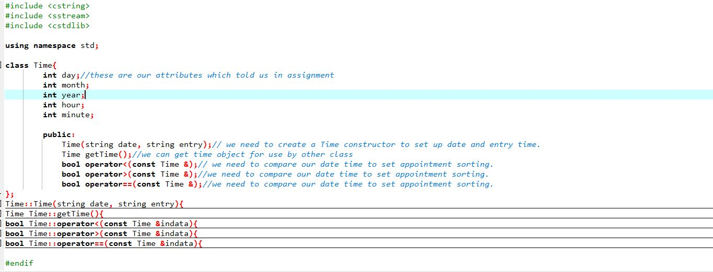

In Citizen class, I have already converted the respect to attributes types. I build char *(idNoName,Surname),bool HasApp and Time objects (obtain entry and date) to be able to create a citizen class. I must use destructor function to destroy char * arrays to prevent memory leak problems. And I create getAppTime and getName class getter functions (because of private attributes for the data hiding) to access easier in Civil Registry Class.

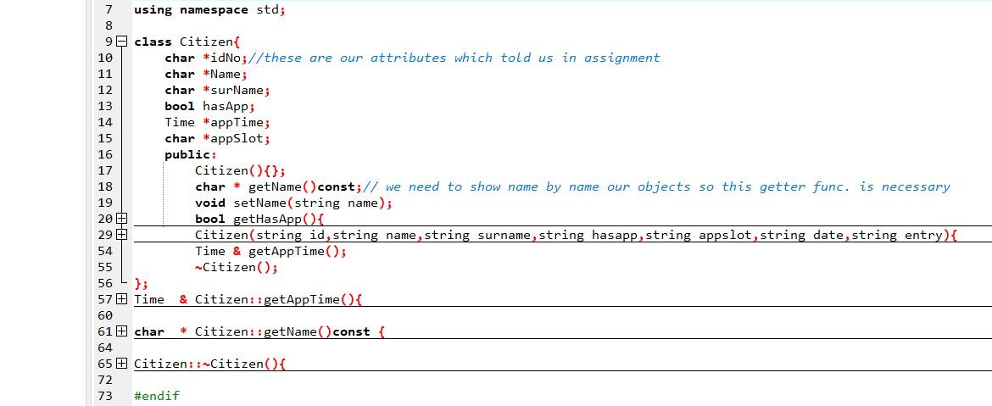

Civil Registry Class has two attributes which are wApp and wOutApp stl list and three methods which are insert,remover and print functions. At this class, I compare the dates and entry clock (accessing to operator overloading functions) with respect to HasApp and decide which list is selected and to adding push_back or push_front Citizen Objects (accoring to operator overloading function) in insert function. In remover function, I give integer argument to decide which list remover pop_front objects. In print function , I could show the list elements.

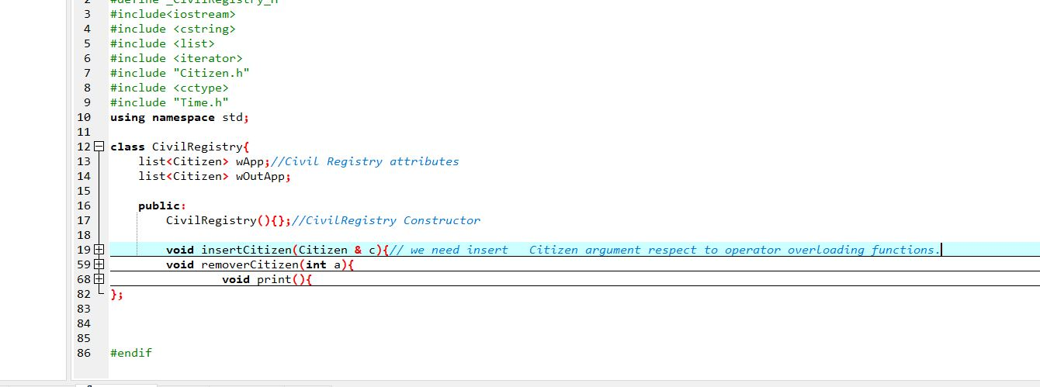

At the end of the main.cpp, we should create Citizen objects arrays and we need to insert these citizens in Civil Registry class. As we could remove(pop_front) and print them all.

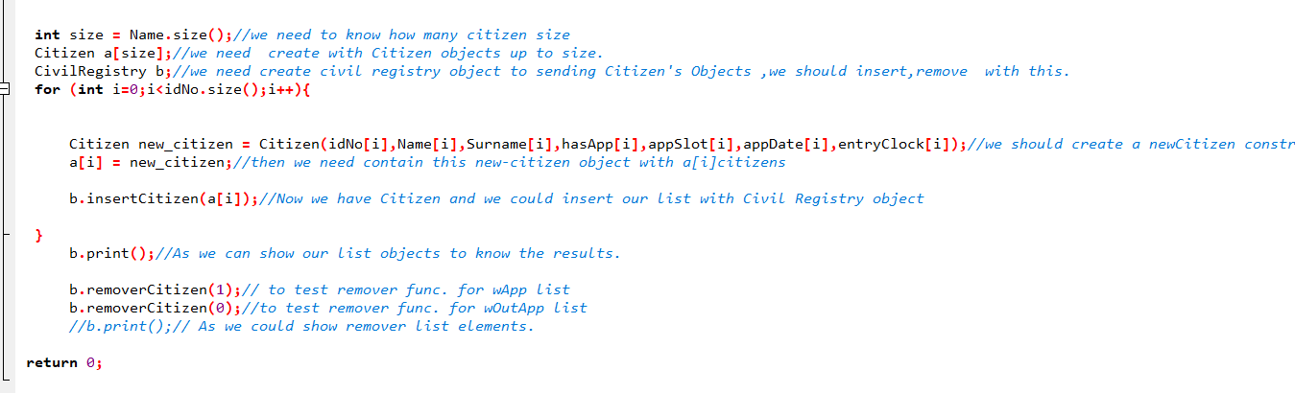

Note: My all attributes are private and my all methods are public because of data hiding. I did not need to use any static ,const etc in attributes.