Model Improvement and Validation Report
HealthConnect Clinic, Appointment No-Show Prediction
Prepared by: Priscilla Arhin | AnalystLab Africa Experience Lab, Data Science Track | Week 6

1. Week 5 to Week 6 Transition
The main Week 5 output was a baseline Logistic Regression model predicting appointment No-Show versus Attended, achieving 64.6 percent accuracy and a ROC-AUC of 0.700 on a patient level test split. The most important result was confirmation that booking_lead_days and previous_no_shows are the strongest predictors, consistent with the Week 4 hypothesis. The main limitation identified was that waiting_time_minutes had an ambiguous origin and an unconfirmed data leakage risk, and that classification threshold and alternative model types remained unexplored. This work depends on the Data Science track's own Week 5 output and is intended to inform the Machine Learning Engineering track's pipeline integration work.

2. Baseline Performance Summary

3. Error Analysis
The Week 5 baseline was re-evaluated on its test set to identify where and why it makes mistakes.
Booking Lead Days by Prediction Outcome
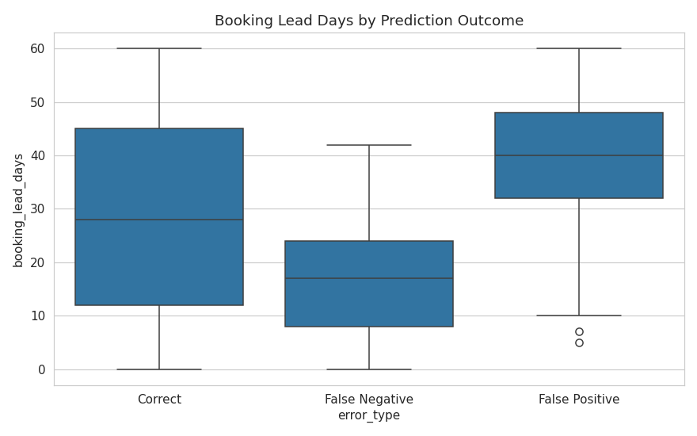
False Negatives (missed no-shows) have a much shorter average booking_lead_days (17.1 days) than correctly identified no-shows (43.0 days), and lower prior no-show history. This indicates the model's main blind spot is 'surprise' no-shows: patients who book close to the appointment date with no prior history, but do not attend anyway.
Model Confidence by Outcome Type
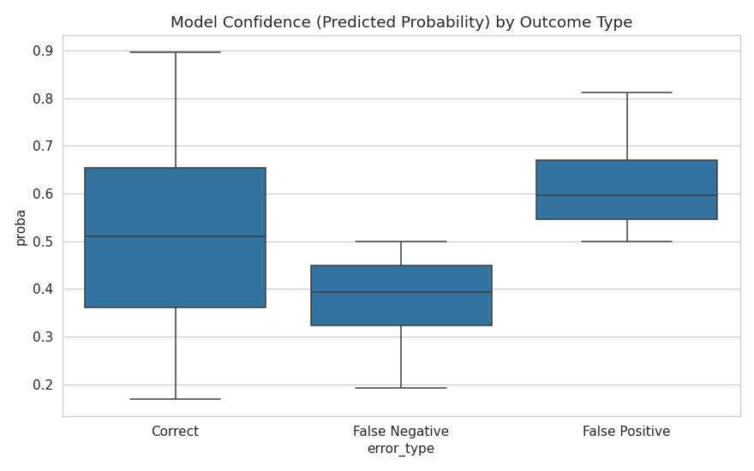
Both False Negatives and False Positives cluster close to the 0.5 decision boundary (median probability 0.39 and 0.60 respectively), indicating the model is genuinely uncertain on these cases rather than confidently wrong. This points toward both better features and threshold adjustment as valid improvement directions.

4. Feature Refinement
waiting_time_minutes, flagged in Week 4 and Week 5 as having an ambiguous origin and an unconfirmed data leakage risk, was formally resolved with evidence: its correlation with the target is effectively zero (-0.004), meaning it carries no predictive signal regardless of its leakage status. It was removed from the Week 6 modelling dataset on this evidence based justification, rather than left as an open assumption.
appointment_day and reminder_channel were re-checked and continue to show narrow, largely flat no-show rates across categories, confirming their status as weak individual predictors from Week 4/5. They were retained rather than removed, since a tree based model may still find value in them through interactions with stronger features, and removal on correlation grounds alone was not judged sufficiently justified.

5. Model Comparison
Two improved modelling approaches were developed and compared against the refined Logistic Regression baseline: Random Forest and Gradient Boosting, both capable of capturing non-linear feature interactions the linear baseline cannot.

ROC Curve Comparison
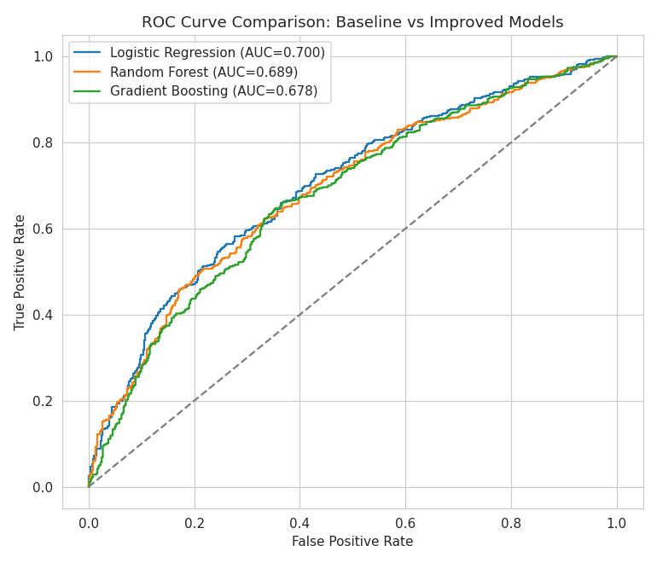
Neither tree based alternative outperformed the refined Logistic Regression baseline on ROC-AUC. This is a genuine and useful result: it indicates the relationship between the strongest predictors, particularly booking_lead_days, and the target is close to monotonic rather than driven by complex non-linear interactions, favouring a simpler, more interpretable linear model over additional model complexity at this stage.
Random Forest Feature Importance
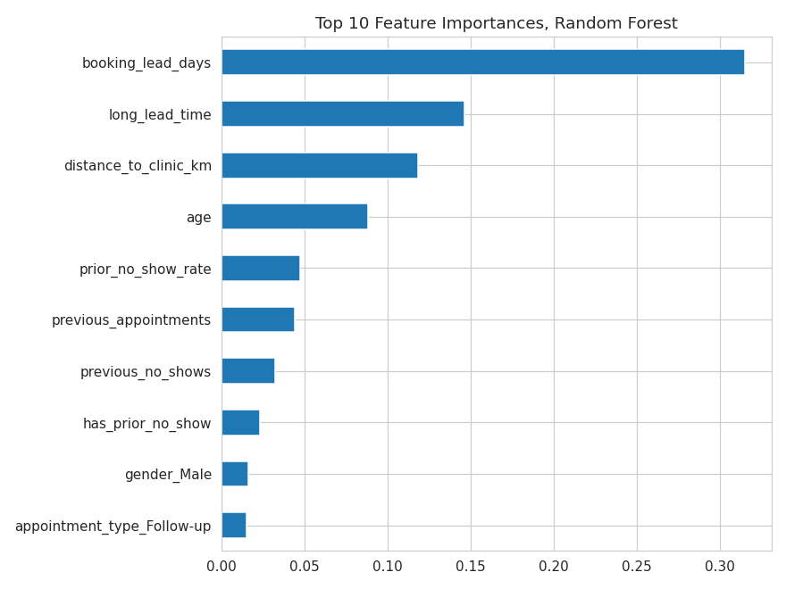
Random Forest's own feature importances independently confirm the same top predictors identified by the Logistic Regression coefficients in Week 5, namely booking_lead_days, long_lead_time, and distance_to_clinic_km, providing model agnostic confirmation of which features matter most.

6. Threshold Tuning
Since Logistic Regression remained the best performing model, its default 0.5 classification threshold was tested against alternatives, motivated by the likely business reality that a missed no-show costs HealthConnect Clinic more than an unnecessary reminder call.
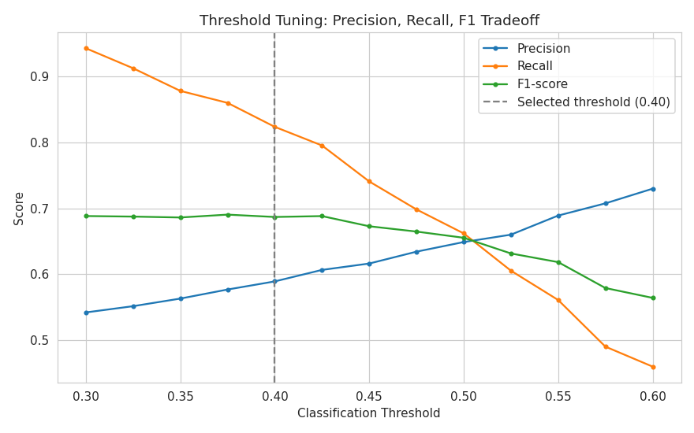
Lowering the threshold from 0.50 to 0.40 increases recall on the No-Show class from 66.2 percent to 82.4 percent, missed no-shows drop from 167 to 87, while F1-score improves slightly from 0.655 to 0.687, at the cost of accuracy dropping from 64.8 percent to 62.0 percent. A threshold of 0.35 pushes recall higher still but at a steeper false positive cost judged excessive at this stage. The 0.40 threshold is selected as the better balance.
Final Candidate Confusion Matrix
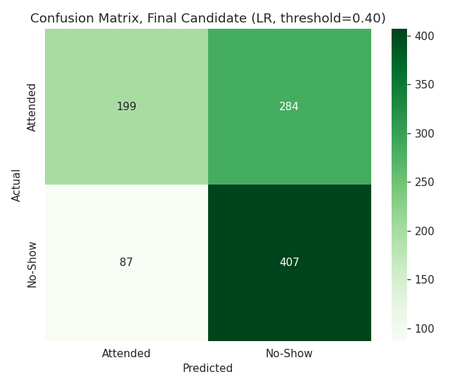
At threshold 0.40, the model correctly identifies 407 of 494 true no-shows in the test set, compared to 327 at the Week 5 default threshold.

7. Final Candidate Model
Recommended candidate: Logistic Regression, refined feature set with waiting_time_minutes removed, classification threshold set to 0.40. This is recommended over both tree based alternatives, since neither improved on the linear model's ROC-AUC, and over the default 0.50 threshold, since the lower threshold substantially improves the model's ability to catch true no-shows with only a modest cost in overall accuracy, better matching the clinic's stated priority of reducing missed appointments.

8. Business Relevance
In practical terms, the final candidate model allows HealthConnect Clinic to flag substantially more at-risk appointments for proactive intervention, such as a follow up call or rebooking outreach, at the cost of also flagging more appointments that would have been attended anyway. Since the assumed cost of an unnecessary reminder call is low relative to the cost of a wasted appointment slot, this tradeoff is judged appropriate for the intended use case.

9. Modelling Limitations
• The dataset remains fictional and anonymised; absolute model performance should not be assumed to transfer directly to a real clinic population.
• Tree based models were tested with a single, reasonable hyperparameter configuration each; a more exhaustive hyperparameter search was not conducted and might change the comparison outcome.
• The 0.40 threshold was selected based on a qualitative judgement about relative error costs, not a quantified cost-benefit analysis; a formal cost matrix from HealthConnect Clinic stakeholders would allow a more precise threshold choice.
• Date and time based features beyond booking_lead_days and appointment_day remain unexplored.
• The current features do not fully resolve the surprise no-show blind spot identified in the error analysis; patients with short lead times and no prior history remain difficult to classify confidently.

10. Cross-Track Contribution
This work provides the Machine Learning Engineering track with a finalised candidate model specification: Logistic Regression, the exact refined feature set with waiting_time_minutes excluded, the fitted StandardScaler parameters, and the recommended classification threshold of 0.40. This gives that track a stable, validated target to integrate into its pipeline, rather than an unfinished or still changing baseline. A separate Cross-Track Integration Evidence document records this handoff formally.

11. Assumptions, Limitations, Risks and Dependencies Update
• Resolved: the ambiguity around waiting_time_minutes has been resolved with correlation evidence and the feature has been removed.
• Remains relevant: the fictional nature of the dataset and the limitation on generalisation to a real clinic population, unchanged from Week 4/5.
• New issue discovered: the model's specific blind spot on short-lead-time, no-history no-shows, which current features do not adequately address.
• New dependency: the Machine Learning Engineering track now depends on this week's finalised model specification (algorithm, feature set, threshold) to proceed with pipeline integration.

12. Week 7 Testing Requirements
• Validate the final candidate model's performance on a further held-out sample if additional data becomes available.
• Test the integrated pipeline, once built by the Machine Learning Engineering track, end to end using the exact feature set and threshold specified here.
• Conduct a more formal cost-sensitivity analysis with HealthConnect Clinic stakeholders to validate or refine the 0.40 threshold choice.
• Test model stability across different random seeds for the train and test split to confirm reported metrics are not an artefact of one particular split.

