Initial Data Exploration — Visualisations
Employee Attrition Analysis — ABC Manufacturing Ltd
Prepared by: Priscilla Arhin | AnalystLab Africa — Data Science Internship Programme | Week 1
This section presents the required exploratory visualisations (3 bar charts, 2 histograms, 2 boxplots, and 1 pie chart), each interpreted against the underlying data and business questions from the assignment brief.

Chart 1 — Bar Chart: Attrition Count by Department
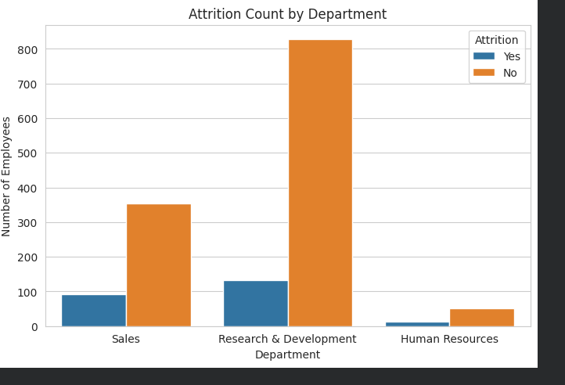
Interpretation:
While R&D has the highest number of employees who left in absolute terms, this is because R&D is by far the largest department. When measured as a percentage of departmental headcount, Sales has the highest attrition rate (20.6%), followed closely by HR (19.0%), while R&D has the lowest rate (13.8%). This suggests Sales and HR may have department-specific factors driving attrition that don't affect R&D as strongly.

Chart 2 — Bar Chart: Attrition Count by OverTime Status
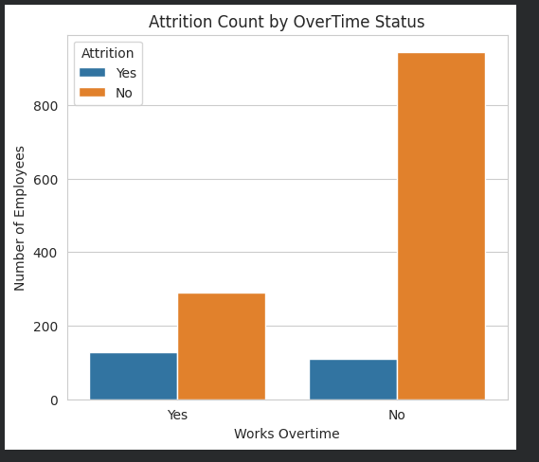
Interpretation:
Overtime shows a strong relationship with attrition. Employees working overtime have an attrition rate of 30.5%, compared to just 10.4% for those who don't — nearly three times higher. This suggests overtime and workload are among the most significant factors driving attrition at this company, and is a strong candidate variable for a future predictive model.

Chart 3 — Bar Chart: Attrition Count by Job Role
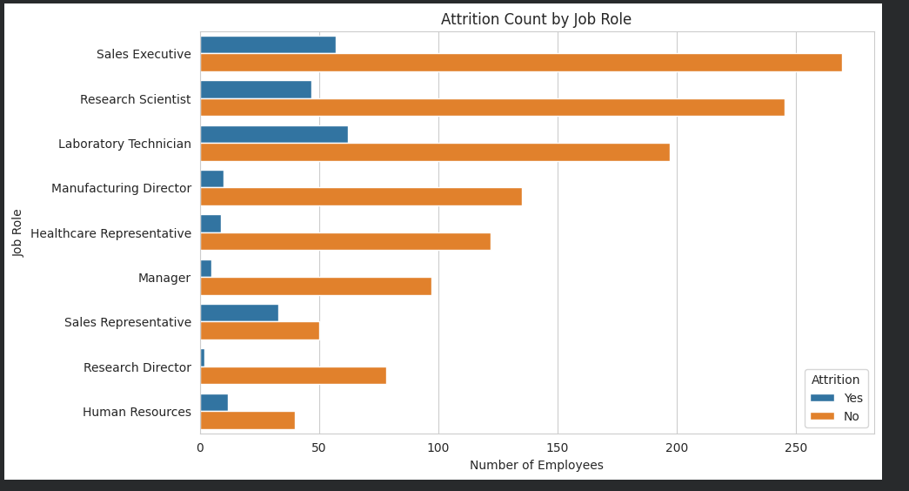
Interpretation:
While Sales Executive had the highest raw count of departures, attrition rate reveals Sales Representative as the highest-risk role at 39.8% — nearly 4 in 10 employees in this role leave. Laboratory Technician (23.9%) and Human Resources (23.1%) also show elevated attrition, while senior roles like Research Director (2.5%) and Manager (4.9%) are the most stable. This pattern suggests attrition risk is concentrated in junior/entry-level and customer-facing roles rather than senior positions.

Chart 4 — Histogram: Age Distribution by Attrition
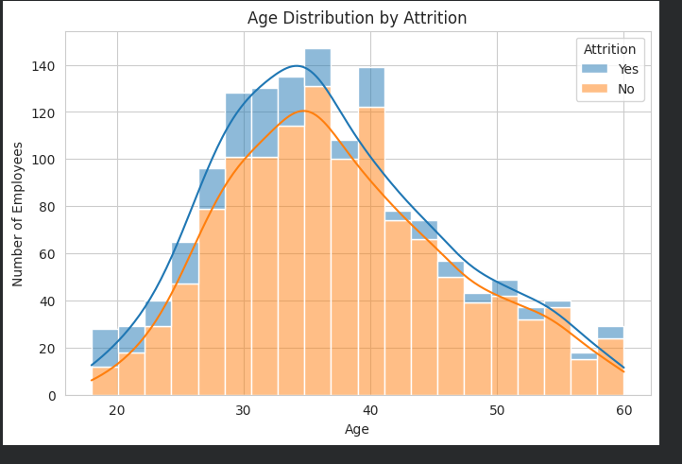
Interpretation:
Age shows a clear relationship with attrition. Younger employees (18-25) have the highest attrition rate at 34.8%, more than double the next bracket, likely reflecting early career exploration, lower company tenure, and fewer ties to the organisation. Attrition falls to its lowest point in the 36-45 bracket (9.2%), representing the most career-established, stable segment of the workforce, before rising slightly again near retirement age (56-60, 17.0%).

Chart 5 — Histogram: Monthly Income Distribution by Attrition
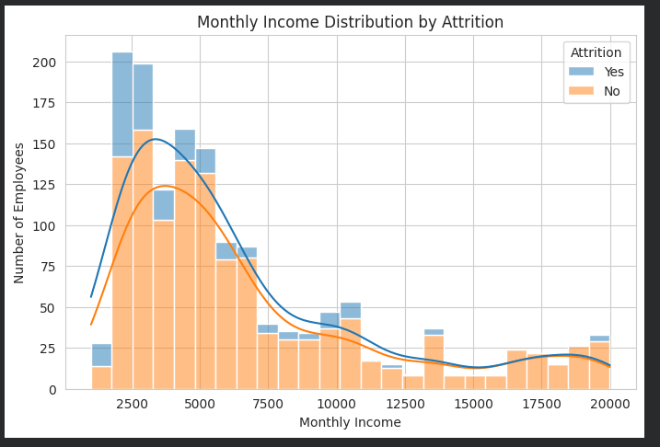
Interpretation:
Monthly income shows a strong inverse relationship with attrition. Employees in the lowest income quartile leave at nearly 3 times the rate (29.3%) of those in the highest quartile (10.3%). Attrition drops sharply between Q1 and Q2 and then levels off, suggesting that being in the lowest-paid segment specifically, rather than income in general, is the key risk factor. This supports compensation review for lower-paid roles as a potential retention lever.

Chart 6 — Boxplot: Monthly Income by Attrition
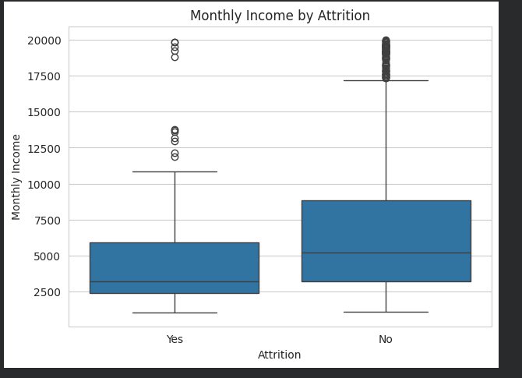
Interpretation:
The boxplot confirms the income-attrition relationship seen in the histogram from a different angle. Employees who left have a median monthly income of roughly 3,300, compared to roughly 5,200 for employees who stayed. The 'Yes' group's box is also positioned lower and more compact overall, showing that departing employees are concentrated in the lower income range, while retained employees span a wider and generally higher income distribution.

Chart 7 — Boxplot: Age by Attrition
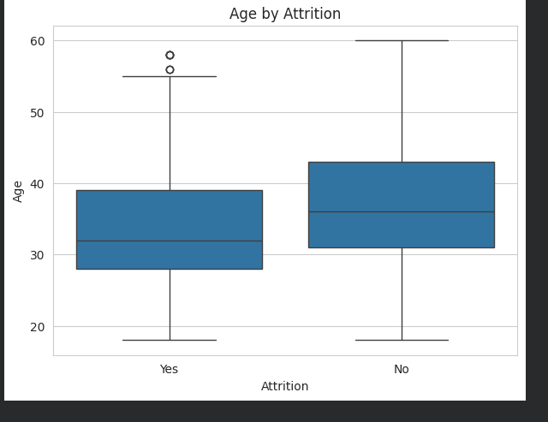
Interpretation:
The boxplot confirms the age pattern seen earlier. Employees who left have a median age of approximately 32, compared to 36 for those who stayed, and the interquartile range for departing employees (roughly 28-39) skews younger overall than for retained employees (roughly 31-43). This aligns with the earlier finding that attrition risk is highest among the youngest age bracket (18-25).

Chart 8 — Pie Chart: Overall Attrition Proportion
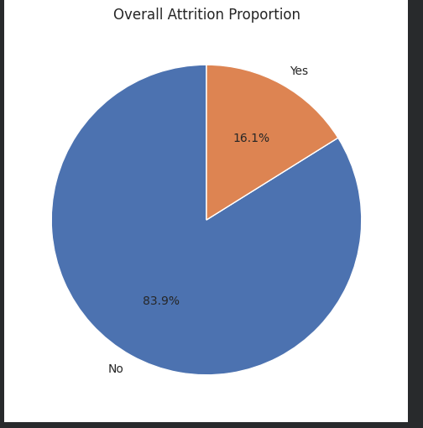
Interpretation:
The pie chart visualises the overall class distribution of the target variable: 83.9% of employees remained with the company, while 16.1% left. This confirms the class imbalance noted in the Dataset Inspection Report and provides a clear visual baseline against which all other attrition patterns in this analysis should be interpreted.

