Cillian Cooke
23 Moyne Road, Ranelagh, Dublin 6 · +353 83 354 6599
cicooke@tcd.ie · https://github.com/Cillian-Cooke

Motivated First Year Computer Science student at Trinity College Dublin with a strong record of academic excellence, leadership, and initiative. Experienced in building real-world software projects, leading teams, and running independent ventures.

Education
TRINITY COLLEGE DUBLIN Dublin, Ireland
MAI Integrated Computer Science (current average 72%) 09/2025 – present
- Developing proficiency in multiple programming languages and the ability to quickly learn new technologies Expected graduation: 05/2030
CTYI ENGINEERING PROGRAMME 09/2022 – 05/2023
Children of Talented Youth Ireland (average grade 90%)
- Selected for competitive engineering programme focused on problem-solving, design and analytical thinking

ST CONLETH’S COLLEGE 09/2019 - 05/2025
Secondary School Eductation

Employment Experience

Lockup 01/2026

COO of a 2 month long start-up that helps reduces phone usage of students in secondary schools.

Accepted into a selective startup incubator called Alpine Valley (only 25 people across the world).

GARDENING 06/2022 – present
- Managed an independent business serving 10+ recurring clients, handelling scheduling, customer relations, pricing and service delivery.

DUNGEONS AND DRAGONS SUMMER CAMP Summer 2024 & Summer 2025

Founder and Organiser
- Designed, marketed and ran a multi-year summer camp
- Managed client communication, planning and group facilitation.

HAPPY DAYS PRESCHOOL AND AFTERSCHOOL 07/2025 - 01/2026

Customer Afterschool programme assistant and web designer
- Developed responsibility, communication and teamwork skills
- Designed and built the Happy Days Preschool & Afterschool website, delivering a clear, user-friendly online presence

Leinster Rugby Ball Boy 09/2019 - 04/2025
- Selected to support professional-level matches, requiring discipline, teamwork and performance under pressure

Projects

ATLAS 10/2025 – present

Social Media Startup · Solo Project · Flutter|Firebase
- Ongoing independent project (4+ months) designing and building a social media application
- Responsible for full stack development, UI/UX and system architecture

CLAUDE BUILDER HACKATHON 11/2025

Winning Team Project · Dungeons and Dragons game

Winning Most Creative Use of AI & Best Teamwork

Built a collaborative Dungeons & Dragons campaign app powered by generative AI
Skills and Interests
Coding Languages: Dart (Flutter) [advanced], Java [intermediate], Python [intermediate], RStudio [basic]
Technical skills: Firebase (Authentication, Firestore, Hosting) [advanced], VS Code [advanced], GitHub [intermediate],
Interests: Football, Circus and Juggling, Dungeons and Dragons, App Development, reading non- fiction books.

Awards & Leadership
Student of The Year – Awarded in St Conleth’s College five times for academic excellence, commitment and leadership.
Rugby Team Captain – Demonstrated leadership, discipline and team coordination.

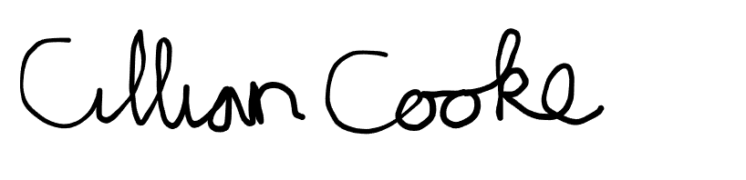

Dublin, 11/2/2026

