**Gamification in teaching about eating habits and health: Health Tycoon**

**Matheus Cirillo**

**Gustavo Moura, Michel Hecker, Alexandre Ponce de Oliveira, Carla Roberta de Oliveira Carvalho**

**Paulo Sérgio Lopes de Souza**

University of São Paulo

matheuscirillo@usp.br

**Objectives**

With the idea to use digital games in the winter course of the Institute of Biomedical Sciences of the University of São Paulo (ICB/USP), this project aimed to build an educational digital game to contribute to the teaching of diets, physical exercises and obesity. In a playful way based on the *tycoon genre,* the playerinfluences a character's actions and this directly impacts his health. So the user learns about metabolic regulation, fasting, exercise, and obesity. Therefore, this work explores the concepts and benefits of the process called Gamification[1].

**Methods and Procedures**

The project was divided into the following stages:

**Analysis of requirements:** periodic meetings took place with the ICB team, where the needs and important contents to be taught in the digital game were discussed.

**Digital**: development of the game Unity development engine2], a free game creation platform that employs the C# programming language[3]. The project was organized from a *Game Design Document* (GDD)[4] in which the game was conceived and planned. There were also alignment meetings weekly with the advisors in order to follow the proposed schedule faithfully. Besides that, meetings with the ICB were held, where the evolution of development was presented and improvements were suggested, seeking to align the final product with the preferences and needs of the course.

**Verification, Validation and Testing (VV&T)**: the game has two validation stages, an initial one carried out by the ICB team responsible for the winter course, and a second stage that will take place during the course and will be carried out by the participants/students themselves.

**Results**

The game showed enormous potential as an educational tool in the hands of the teachers, receiving positive reviews and showing itself as a high-level tool turning mainly to an audience a little bit older.

Figure 1 shows the main game screen, from where the user can access the various menus responsible for controlling the character's actions. Figure 2 is the kitchen menu, where the player feeds the character, focused on putting a plate with a balanced diet.

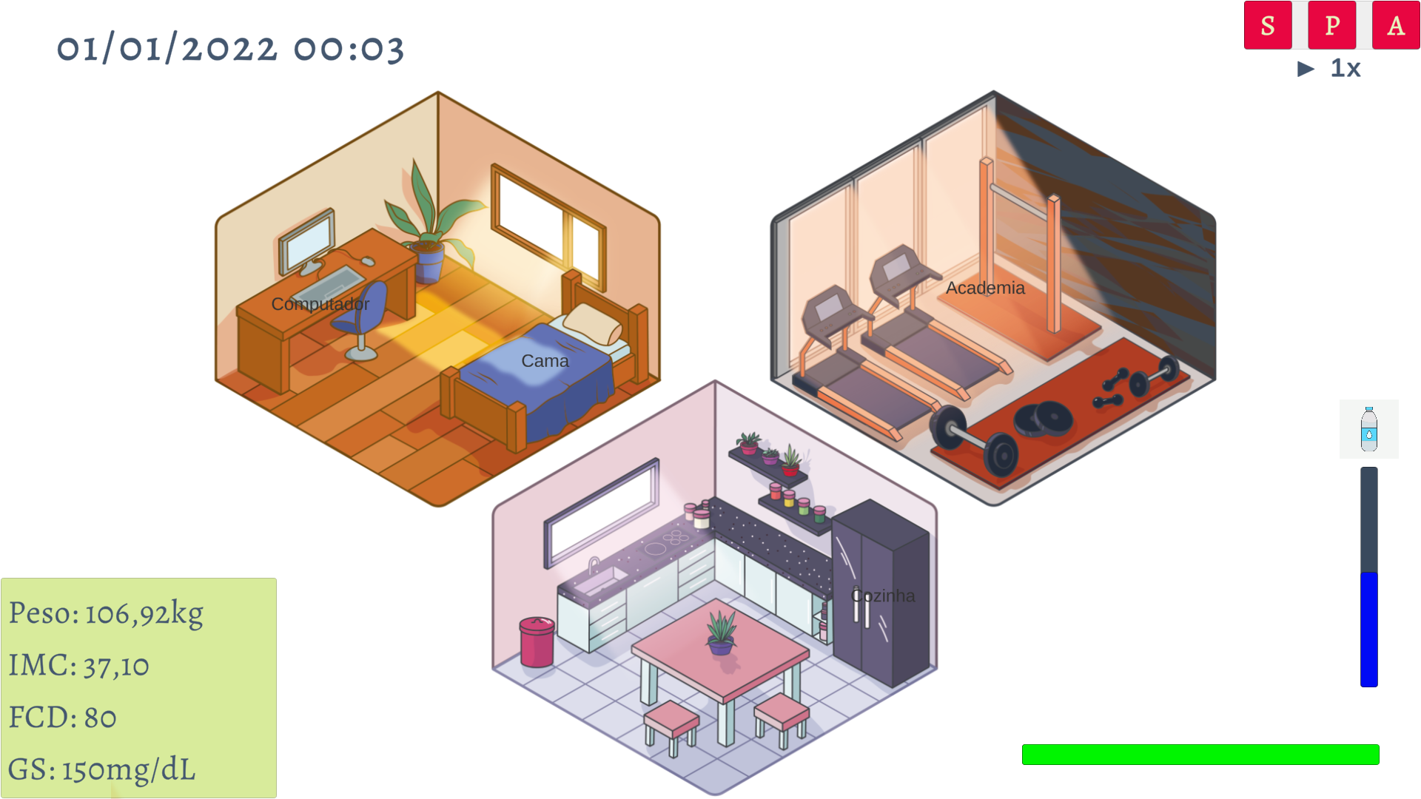

Figure 1: Scenarios of the Health Tycoon game.

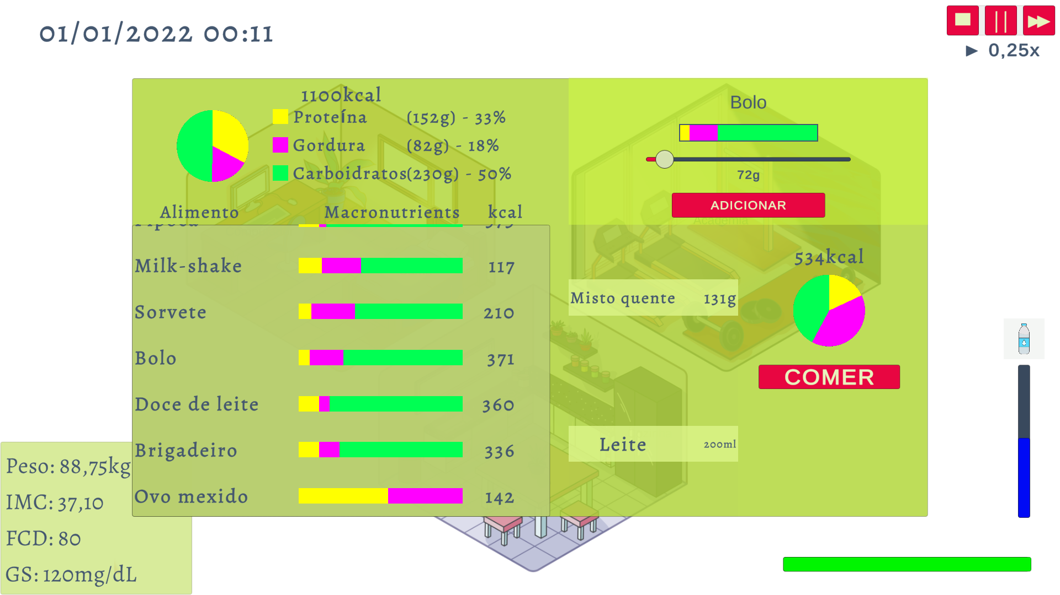

Figure 2: Game kitchen

**Conclusions**

Initial results were promising, with the tool showing potential as a simulator to test and present the impacts of habits on a person's health. The next step will be a collection of users’ data for analysis and understanding of the effectiveness of the project as a teaching tool.

**References**

[1] 5 Benefits of Gamification. Available at: https://ssec.si.edu/stemvisions-blog/5-benefits-gamification. Accessed: Sept. 2022.

[2] What is Unity? - A guide for One of the Top Game Engines. Available at: https://gamedevacademy.org/what-is-unity/. Accessed: Sept. 2022.

[3] C# documentation. Available at: https://docs.microsoft.com/en-us/dotnet/csharp. Accessed: Sept. 2022.

[4] What is a Game Design Document and How to Write it?. Available at: https://www.dreamstormstudios.com/blog/what-is-a-game-design-document-and-how-to-write-it. Accessed: Sept. of 2022.