# BaseConcept

First download of BaseConcept and compile BaseVistaSample makes problem:

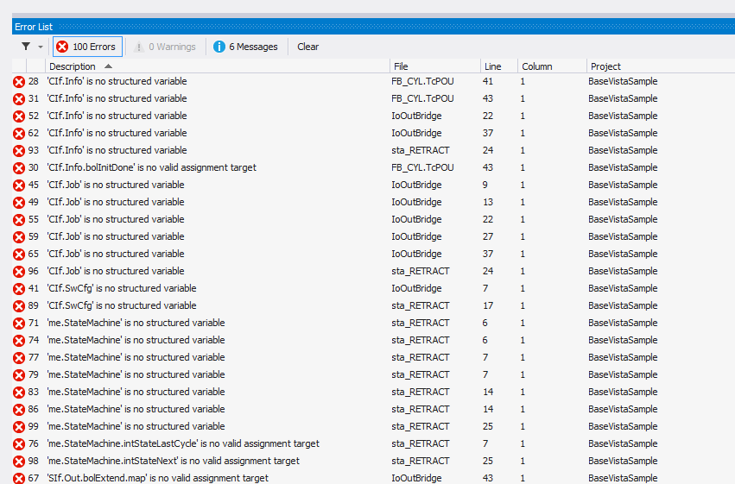

¨The problem ist hat the referenced library from Vistaprint (BasePLC) is not install on the development system. So you have to install the library remove the existing reference and add the library. The last successfull generated library, from project BaseVista, is saved in the folder … \CommonPlc\BaseConcept\BaseConcept\BaseLibrary.

First install library -> go to „Library repository…“: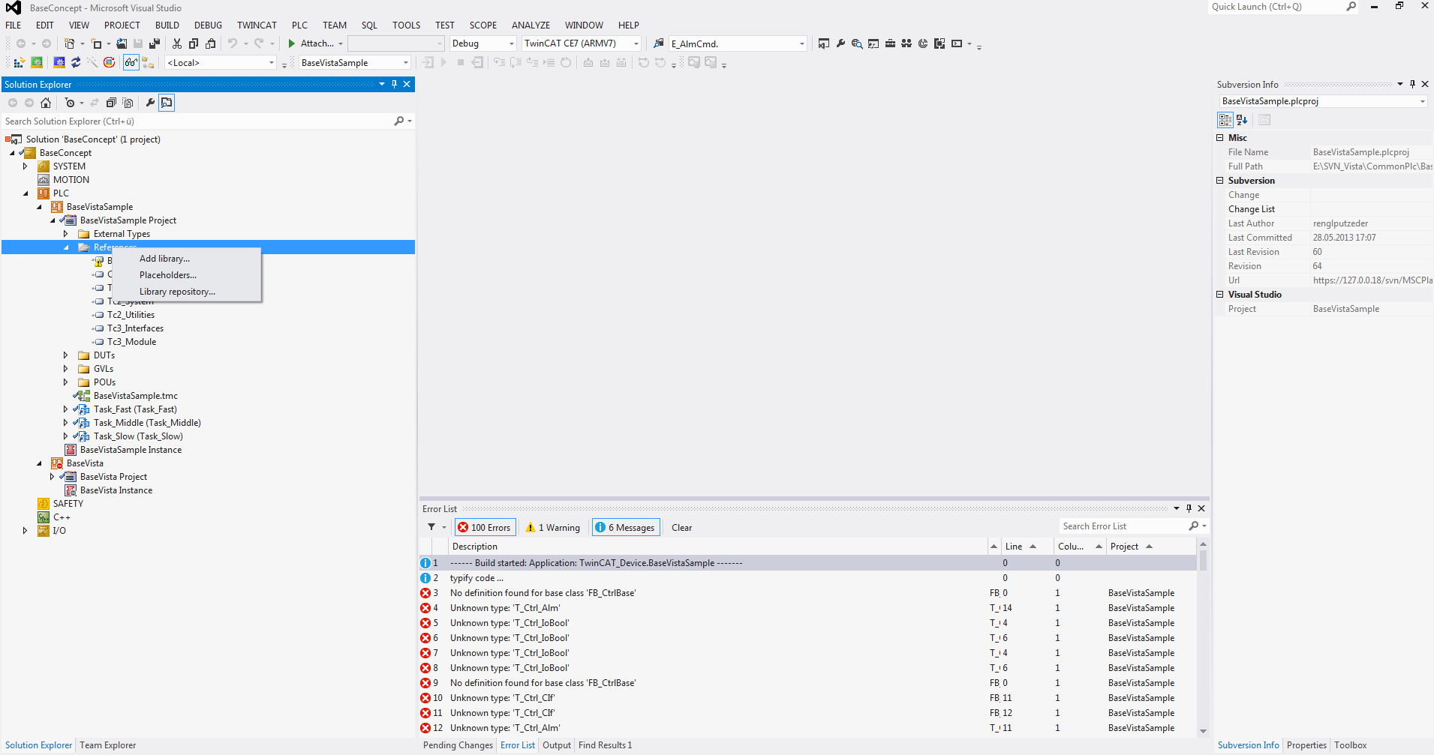

Install library BasePLC: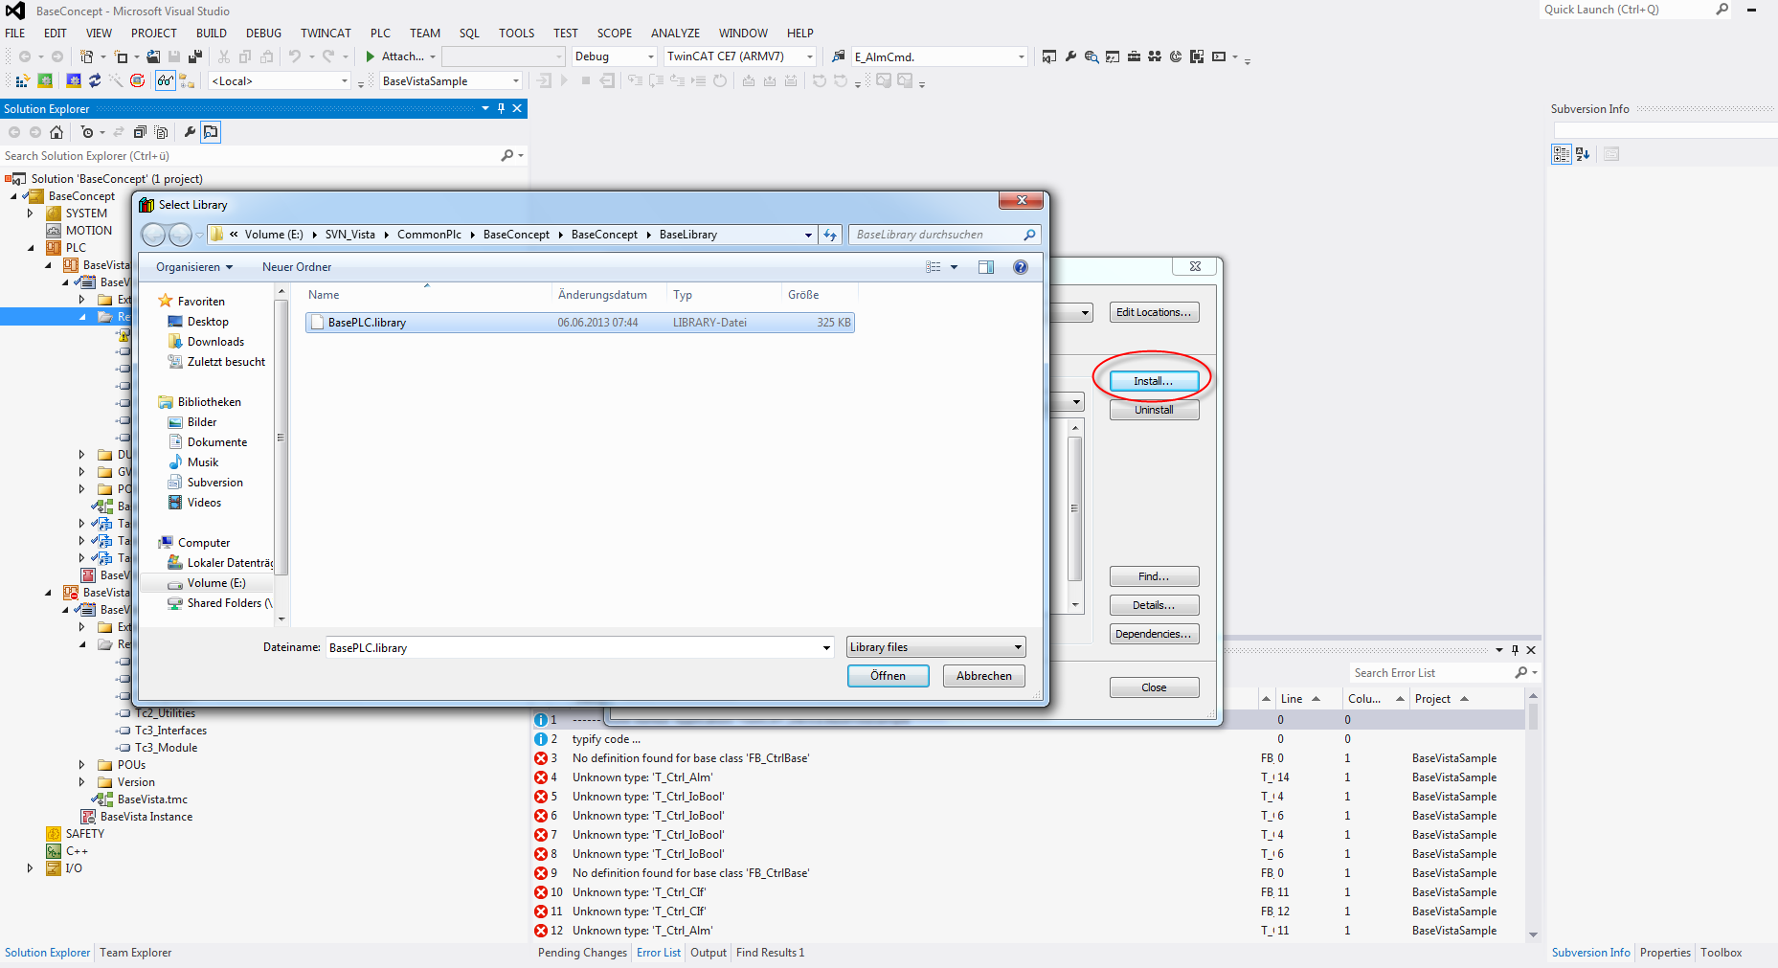

Delete the old reference and add the new reference to the installed library: