Setup for running experiments

The package contains source codes, examples of outcomes and documents that support the experiments reprodution. The main folder encompasses (Figure 1):

- Database: network topologies used for simulations.
- Documents: research papers and scientific reports.
- Matlab: model implementation sources develop in Matlab.
- Results: example of outcomes generated by simulation for 10 networks.
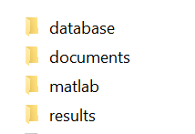Figure 1: Main folder

The testbed for simulation comprises:

- Matlab libraries: several functions and procedures for implementing the proposed integrated control laws, the performance assessment protocol and the output for supporting analytical results analysis.
- Parametrization setup: models and testbed parametrization are set in a specific matlab file (setModel.m).
- Network database : random network topologies used for simulation.

MATLAB libraries

The Matlab libraries structure (\Project_ITA_Unimore\matlab\) is presented in Figure 2.

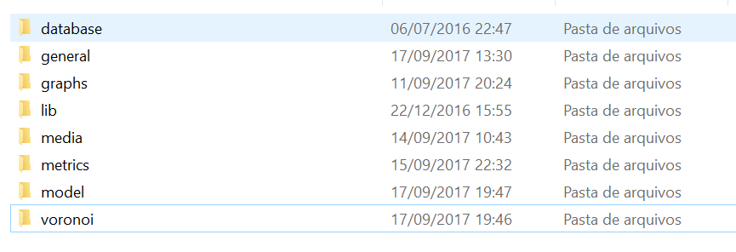Figure 2: Matlab folders

- Database: codes for generating networks.
- General: general purpose functions and procedures.
- Graphs: libraries used for processing graphs - networks are considered graphs for several processes.
- Lib: library with functions for area coverage rate estimation.
- Media: procedures for generating videos and figures.
- Model: the testbed protocol and the control law implementations.
- Voronoi: functions and procedures for creating bounded Voronoi diagrams.

For running simualtion consider as the main folder “model” that contains the following files:

- setModel.m: the model parameterization setup.
- main.m: the main program for performing simulation (see Figure 3).
- adapt_network.m: responsible for performing network adaptation, including, when set, perturbation (removal of the most central node(s) or attack) (see Figure 4).
- CombinedControLaw.m: the Ordinary Differential Equation (ODE) implementation (see Figure 5).

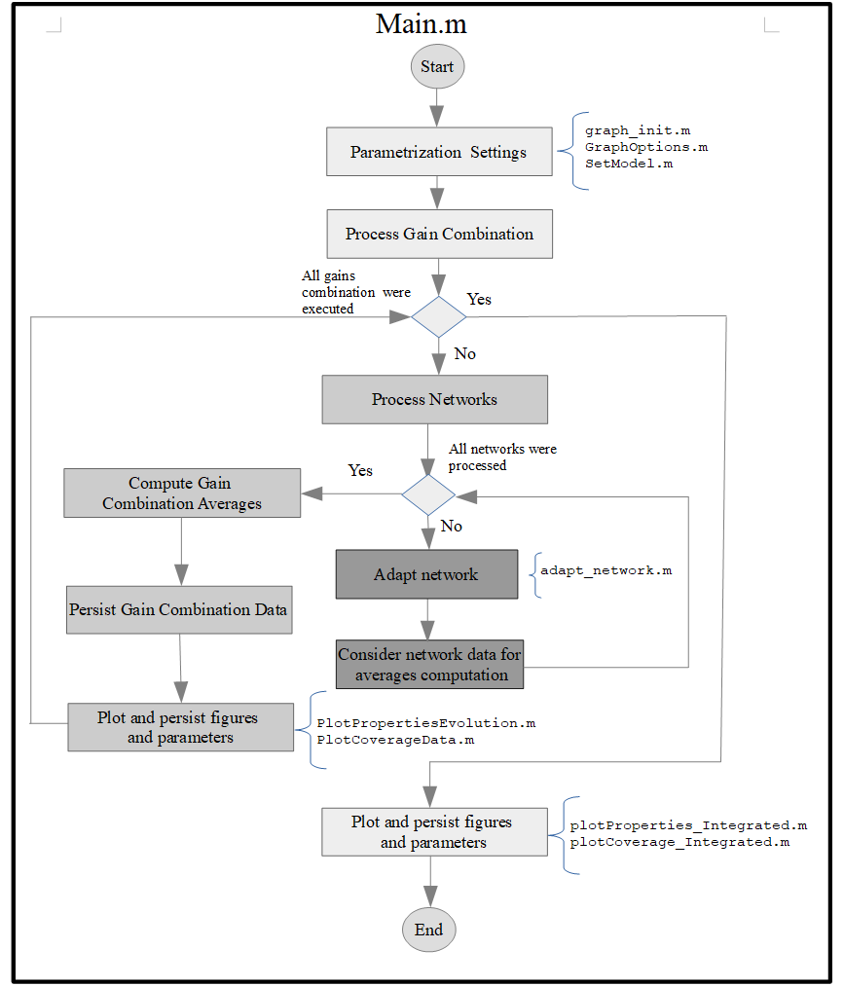Figure 3: Main.m Flowchart.
No
While simulation time <
total simulaltion time
Start
Compute network Properties
Compute coverage Estimation
compute_properties.m

coverageProperties.m

Perform network Perturbation
attack_network.m

Define Goal Position
robutsness
Persist data iteration
Define Goal Position
coverage
define_goalPosition.m

Run ODE
combinedControlLaw.m

define_centroid_local.m

There is nodes into the network and the total simulation time is not fulfilled
End
Yes
No

Figure 4: adapt_network.m flowchart
adapt_network.m

Figure5: combinedControlLaw.m flowchart
combinedControlLaw.m
compute_properties.m

connectivity_controller.m

collisionAvoidance_controller.m

robustness_controller.m

coverage_controller.m

Start
Compute network Properties
Connectivity control
Collision avoidance control
Robustness control
Coverage control
Weights sum
End

DATABASE

Random connected networks topologies compose the database used as benchmark for simulations. The database considered for papers and examples contains 200 network topologies and is available in folder “..\Project_ITA_Unimore\database\20\50_16\. The name convention is only informative and means:
- 20 means that each network contains 20 nodes
- 50_16 means that nodes are positioned at a square area of 50m2 and the communication range of each node is 16m, i.e., there is a link between nodes if the distance between them is less than 16m.

Each network is defined by a matlab file (position.mat (x and y coordinates)) in a directory named sequentially. The directory also contains the network topological properties (properties.mat), such as local and global efficiencies, average degree, etc. For simulation, the position.mat of each network is loaded by the main.m execution.

The procedure for generating network with the desirable properties are avaliable in folder “\Project_ITA_Unimore\matlab\database” - mainDatabase.m for running the main procedure and setModelDatabase.m for model parametrization.

SIMULATION RESULTS

For exemplification purposes, the simulation results generated according to the parametrization setup, defined in setModel.m, are in folder \Project_ITA_Unimore\results.

Two simulation scenarios were performed separately: fault-prone and fault-free. Notice that each one consider its own setModel.m, since it is necessary to set if attacks will be performed and the main directory where results will be persisted.

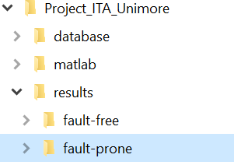Figure 6: Main folder structure of the simulation outcomes
The folder structure , i.e. “\results\fault-free” or “\results\fault-prone” (Figure 6) , is given by the main.m implementation. According to this, the resulting folder tree generated by simulation is presented in Figure 7 and means:
- 20 : the number of nodes into the networks
- 0_0_0, 2_0_1, 2_1_0 and 2_1_1, contains the results for each gain setting: \lambda, \psi and \zeta , representing connectivity, robustness and coverage control laws, respectively. For each gain setting combination, figures with analytical data and files containing data from the simulation execution are persisted in the root of each directory. In addition, several folders, one for each network evaluated, are created with a sequencial number. Files (Figure 8) into each directory are mostly used for media generation: Iteration_data.mat contains each node position during the simulation time and properties.mat the network properties at that specific time. The number associated with each file name corresponds to the simulation time in which the network properties, the coverage and the robustness are evaluated. For these simulations there are 80 files since the total simulation time set was 80s and the network evaluation occurs at 1s.

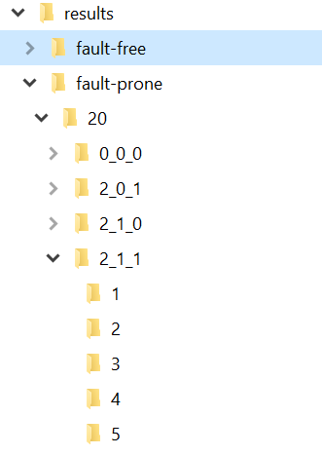Figure 7: Folder tree generated by simulation.

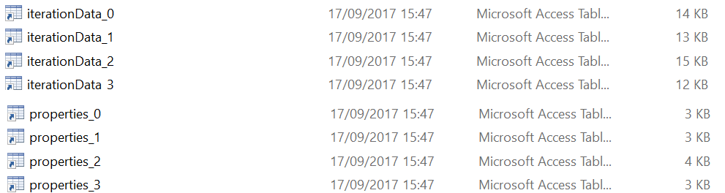Figure 8: Files generated by simulation regarding each network

MEDIA GENERATION

The procedures for generating videos of the simulation perfomed are available in folder “\Project_ITA_Unimore\matlab\media”. MainMedia.m is the main file and setModelMedia.m is the setup.

The procedure takes data generated during the experiment execution to reproduce videos for the desired networks and gain parametrizations. It is also possible to generate figures from a network snapshot (network state during at specific simulation time), see Figure 9.
The options for type of media (video, image), networks, gains, timestamps, etc. are set in setModelMedia.m.

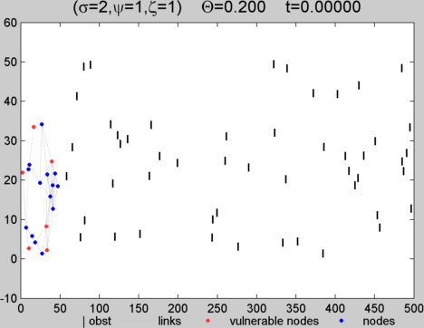
Figure 9: Figure of a network snapshot.
Examples of videos generated by mainMedia.m can be found in the “\Project_ITA_Unimore\results\..” folders for networks of numbers 1 and 5, in folder videos, for each of the parametrization performed during the simulation (see Figure 10).
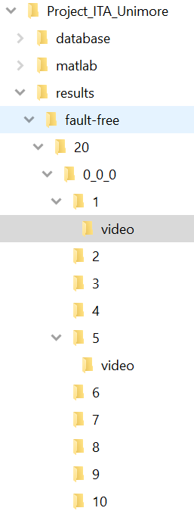
Figure 10: Folder structure for visualizing examples of simulation videos
ADDITONAL DIAGRAMS

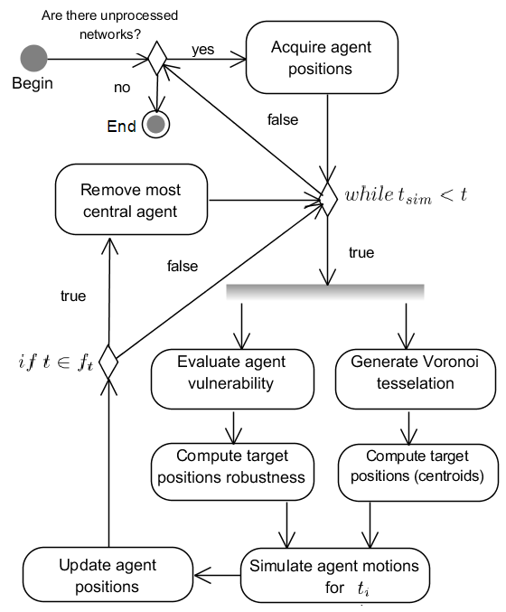
Main procedure:
Control law:

