**Share your Love for Charlie Banana® with your friends and start making money!**

**[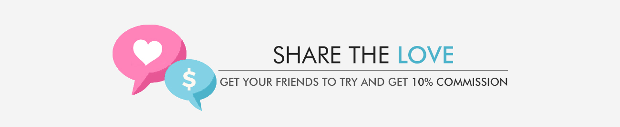](https://charliebanana.refersion.com/)**

Hello and welcome to Charlie Banana® affiliate program! This is your chance to start a regular stream of income by earning a commission for every new order placed through your referred link.

All you have to do is to create an account and share your Charlie Banana® love with your friends on an email/social media/your blog or a website. Every new order, which is registered via your affiliate link, will generate you 10% commission on the total amount spent.

Below are the 4 steps which will give you a better understanding of how Charlie Banana® Referral Program works and what it has to offer.

**Step 1: Register for Charlie Banana® Referral Program**

Sign up with us or log in if you are already an existing user.

[](https://charliebanana.refersion.com/)

**Register**

**Step 2: Copy the Referral Link and Share your Charlie Banana® love with your friends**

Copy the referral link to your website or blog and ask your friends to join our affiliate program. There is absolutely no limit on the number of friends you refer.



**Copy Referral Link**

**Step 3: Promote waste reduction**

Promote waste reduction via your social media and website and save money by choosing reusable products.



**Promote Waste Reduction**

**Step 4: Receive 10% Commission**

You will receive 10% commission from every order placed by your referred friends.

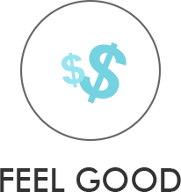

**Earn Credits**

**Who are we?**

Charlie Banana® was created out of a love for Eco-Friendliness, Quality, and Design. Our motive is to design products that are simple, comfortable that are reusable, heathier and promote waste reduction.