Dynamic Channel Assignment for Wi-Fi Mesh Networks Using Multi-Agent Reinforcement Learning
Wissarut Taiyawong and Chakchai So-In
College of Computing, Khon Kaen University, Thailand
Wissarut.t@kkumail.com, chakso@kku.ac.th
Abstract
We propose EGAT-MAPPO for joint channel assignment and routing in multi-hop Wi-Fi mesh networks. Every node is an agent that chooses its downlink channel and its parent. The model combines an edge-aware GATv2 encoder, two decision timescales and a residual prior from Ko's local-cost rule; it is warm-started by behaviour cloning, trained with MAPPO and executed in a decentralised way with switch hysteresis. In a 20-node, six-channel simulator whose airtime model is calibrated against ns-3, over 11 scenarios, we compare it with M0, Ko, Q-neutral, Yuan (GAT+DQN) and Li (GAT-A2C) on a five-metric composite fixed before the main experiments. On pre-registered confirmation topologies its composite exceeds every adapted baseline by more than 10% (Ko +24.6%, Li +17.9%, Yuan +24.8%), and with the same hysteresis it still beats Li (+10.7%) and Yuan (+6.7%) significantly. Its throughput is 12.4% above Ko's with 93% fewer switches. In ns-3 it significantly beats every method, including Ko (+23.1%) and Yuan with hysteresis (+16.4%). The model has no GRU memory: the ablation dropped it, and a pre-registered protocol confirmed the change.
Keywords: channel assignment, routing, graph attention, MAPPO, Wi-Fi mesh
1 Introduction
In a multi-hop Wi-Fi mesh network, channel selection and route selection affect each other. When a parent changes its channel, every child is affected, and each switch pauses the link and may drop queued packets. Distributed methods such as Ko's local-cost rule [1] are fast and explainable, but they decide from the immediate cost and re-adapt often. Reinforcement-learning methods built on graph attention, such as Yuan [2] and Li [3], use no link features and do not choose routes.
We propose EGAT-MAPPO and make three contributions. (1) It decides channels and routes jointly with an edge-aware GATv2 encoder, two decision timescales and a residual prior from Ko. (2) It is warm-started by behaviour cloning from Ko, trained with MAPPO, and uses switch hysteresis at execution to suppress unnecessary switches. (3) It is evaluated with a protocol fixed in advance: confidence intervals that count the training variance of both methods, baselines given the same hysteresis, an ablation, and a pre-registered confirmation of the model change on new topologies.
2 Related Work
Ko et al. [1] proposed distributed channel assignment for multi-radio mesh networks, in which every node minimises the interference cost in its neighbourhood. Yuan et al. [2] combined DQN with graph attention for resource allocation in cognitive radio networks, and Li et al. [3] combined GAT with A2C for C-V2X resource allocation. Both use GAT-style attention [4] but no edge features and no routing. Classic multi-radio mesh work such as [11]–[14] assigns channels and routes jointly with optimisation or global heuristics. We use GATv2 [5], add edge features to the attention score, and train with PPO [6] and GAE [7] in the MAPPO form [8], whose centralised critic is used only during training.
Our earlier work developed GAT+RAES on native ns-3 [10] for 15 single-hop AP–STA pairs. It reached 61.773% satisfaction against 35.283% for the starting configuration and beat a BFS-CA-based method [9], but its gain over Q-neutral was only 0.833 points and it was not a multi-hop mesh. This work extends it to multi-hop mesh and changes the evaluation so that results carry statistical significance.
Table 1 summarises how the baselines, our earlier work and this work differ.
Table 1. Comparison of related work with this work
Work | Method | Routing | Link features | Tested network | Reported result
Ko [1] (2007) | distributed local cost | no | no (interference cost) | 14-node mesh testbed | capacity +50% vs. single channel, +20% vs. random
Yuan [2] (2022) | DQN + graph attention | no | no | cognitive radio + slicing | reported in its own setting
Li [3] (2025) | GAT + A2C | no | no | C-V2X | reported in its own setting
GAT+RAES (earlier work) | GAT + DDQN + RAES | no | no | ns-3, 15 single-hop AP–STA pairs | SAT 61.8% vs. 35.3% (start)
EGAT-MAPPO (this work) | GATv2 + MAPPO + Ko prior + hysteresis | yes | yes (7) | 20–80-node mesh, 11+5 scenarios, ns-3 | composite Ko +24.6%, Li +17.9%, Yuan +24.8%, Yuan+H +6.7%; 93% fewer switches than Ko

3 System Model and Problem
3.1 Network and channels
The network has n = 20 nodes placed at random in a square of side 30√n m, with two gateways. A link exists when the received power is at least −76 dBm, and two links interfere at −82 dBm or more. Path loss follows the ns-3 default log-distance model [10], and rates follow 802.11ax MCS (8.6–143.4 Mb/s). Every node has two radios: the downlink radio picks one of six channels, and the uplink radio uses its parent's channel. Interfering links on the same channel form one domain, and the airtime actually used in a domain is capped at η = 0.65, a value calibrated against ns-3 (Section 6.6). Uplink traffic is on/off, a step is 100 ms and an episode is 200 steps. A node that switches channel or parent cannot use that link for one step, and in setting (a) the interrupted flows lose their queues.
3.2 Problem formulation
Every node is an agent in a partially observable Markov game. An action is a pair (downlink channel, parent slot), 24 in total. The system reward is R = Σ log(x̄_f + 0.01) − 0.1N_sw − 0.05N_rc − 0.1N_drop, where x̄_f is the 1-second average throughput of flow f. The per-agent reward is r_i = λu_i + (1 − λ)R/n − 0.1s_i − 0.05c_i. Baselines use λ = 0.5; the proposed method anneals λ from 0.5 to 0.1 during training.
4 EGAT-MAPPO
Fig. 1 gives an overview of the model; the dashed parts are used only during training. The pipeline has six stages: (1) node and edge features, (2) a shared GNN encoder, (3) route and channel heads, (4) the Ko residual prior, (5) decentralised execution and (6) the action of every node.
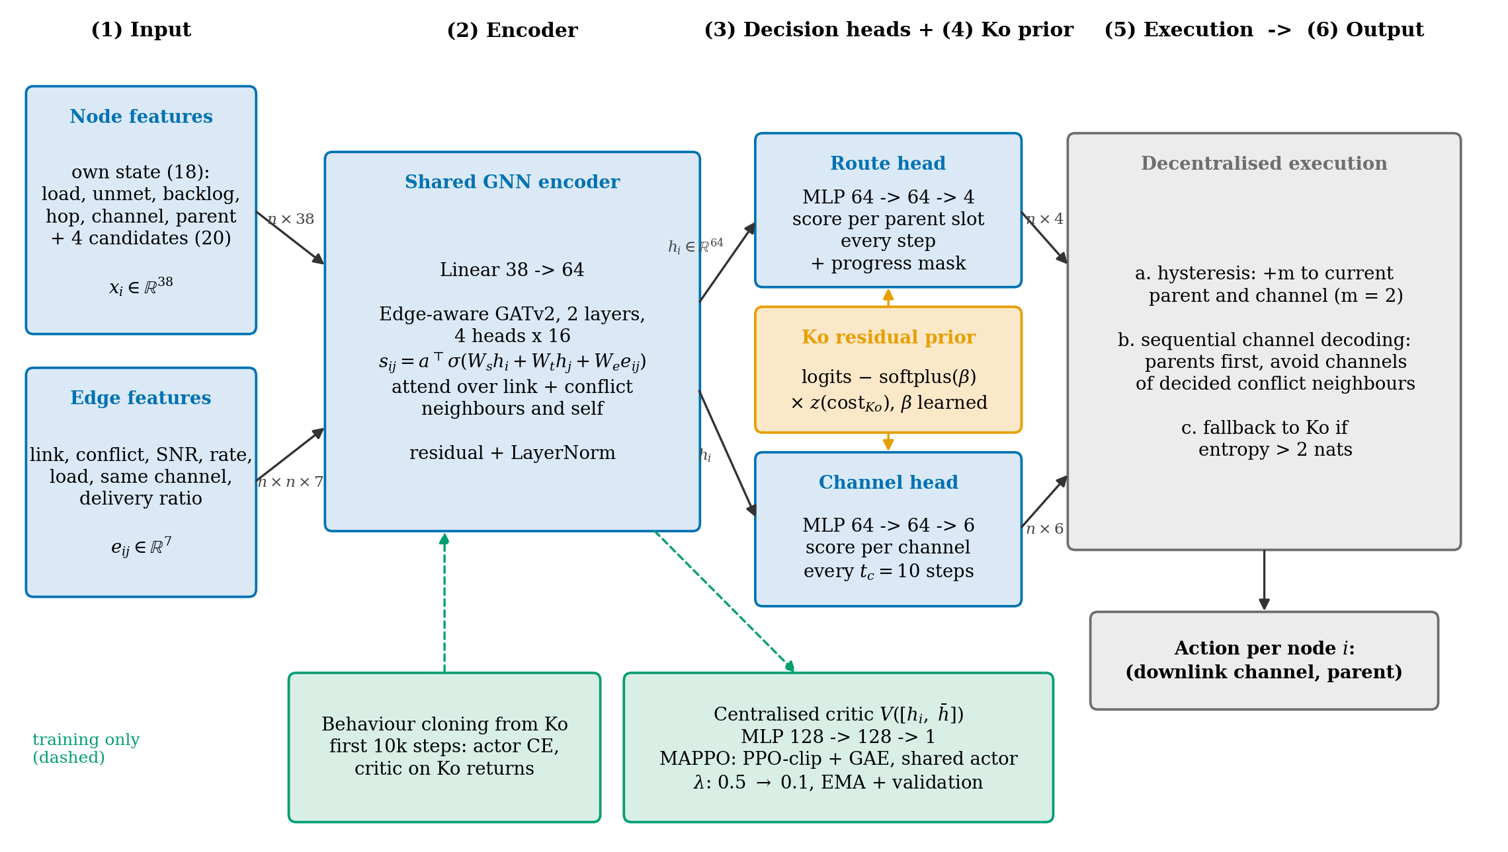
Fig. 1. EGAT-MAPPO architecture (n is the number of nodes, σ is LeakyReLU; green boxes and dashed arrows are used only during training)
The encoder is a two-layer GATv2 with four heads and hidden size 64. The attention score is s_ij = aᵀ LeakyReLU(W_s h_i + W_t h_j + W_e e_ij), where e_ij holds seven features: link, interference, SNR, rate, load, shared channel and delivery ratio. The node embedding goes straight to the decision heads, with no memory across steps. The route head decides every step and the channel head every 10 steps; a progress mask allows only parents that are closer to a gateway. Both heads subtract Ko's cost scaled by a learnable factor: logits − softplus(β)·z(cost_Ko).
Training runs for 100,000 steps. The first 10,000 steps are behaviour cloning from Ko, followed by MAPPO (clip 0.2, GAE λ 0.95, rollout 1,000). The centralised critic is used only during training, and the checkpoint is selected by the composite on validation topologies. At execution, (1) channels are decoded sequentially from parents to children, as for every learned baseline; (2) switch hysteresis adds m to the logits of the current channel and parent, with m = 2 chosen from {0, 0.5, 1, 2, 3, 4} on validation by a worst-case rule; and (3) a node falls back to Ko's action when its policy entropy exceeds 2 nats.
5 Experimental Design
The baselines are M0 (fixed channels, minimum-hop routes), Ko [1], Q-neutral (tabular Q-learning), Yuan [2] and Li [3]. They are adapted to use the same observations, actions, reward form and training budget. Every learned method is trained with five seeds and tested on 20 topologies per scenario. Table 2 lists the scenarios.
Table 2. Test scenarios
Suite | Conditions
S1–S6 | light load, heavy load, hotspot, external interference, load shift and relay failure
B1–B5 | moving hotspot, periodic load, sparse topology, unseen grid and rapid load shifts
C1–C5 | very light load, static traffic, 50 and 80 nodes, and four gateways

The composite of method M against reference R in a scenario is the weighted sum of relative improvements, each clipped to [−1, 1], in aggregate throughput (0.25), Jain fairness (0.20), 5th-percentile flow throughput p5 (0.20), loss rate (0.20) and switch count (0.15). It is averaged over scenarios and shown as a percentage (+0.10 is +10%). Here d = (x_M − x_R)/x_R for higher-is-better metrics, d = (x_R − x_M)/max(x_R, 0.01) for the loss rate and d = (x_R − x_M)/(x_R + 1) for the switch count. For example, against Ko in S2: throughput 66.87 vs. 55.42 Mb/s (d = 20.7%), Jain +4.6%, p5 +21.4%, loss rate 0.240 vs. 0.374 (d = 35.8%) and switches 44.3 vs. 771.4 (d = 94.1%), which weight to a composite of +31.7%. The pre-registered criteria are (1) ≥ +10% against every method on A+B, (2) significant (Holm) in ≥ 60% of scenarios, (3) no scenario worse than Ko by more than 5%, and (4) criterion 1 still holds when any weight changes by ±50%. The 95% confidence interval is a t-interval over the matrix of composites for every pair of training seeds, so it includes the training variance of both methods.
Hysteresis, the margin-selection rule and this confidence interval were added after the first test evaluation, and the airtime model was calibrated after the ns-3 results were seen; all of these changes are recorded with dates. Every learned method was retrained after calibration, and the margin is chosen only on validation. The earlier model had a per-node GRU and tied with Yuan+H, and the ablation on the test set found the model without GRU better (Section 6.4). Because this was found after seeing the test set, we wrote a protocol before running that fixed the model, five seeds, the same margin rule, new topologies 40–59 never used before, and the criteria (P1) beat Yuan+H by at least +5% with a lower bound above 0, (P2) lower bound above 0 against every other baseline, and (P3) all four criteria pass. All of them passed (m = 2 again), so Section 6 reports the model without GRU, and topologies 40–59 are the main reference set.
6 Results
6.1 Main comparison
Table 3 and Fig. 2 show that on the confirmation topologies 40–59, EGAT+H exceeds every baseline adapted from published work by more than 10%. It is significantly better in at least 91% of scenarios, better than Ko in every scenario (lowest S1 +13.2%), and still above 10% under every weight change (lowest Ko +19.1%), so all four criteria pass. The test topologies 0–19 and the new topologies 20–39 point the same way (Ko +25.3% on 20–39). The interval against Li is the widest because one Li training seed trained poorly.
Table 3. Composite of EGAT+H (setting a, A+B) on test topologies 0–19 and confirmation topologies 40–59; brackets give the 95% CI of the seed-pair mean
Baseline | Topologies 0–19 | Scenarios better | Confirmation 40–59 | Scenarios better
Ko | +0.260 [+0.230, +0.290] | 100% / 100% | +0.246 [+0.216, +0.276] | 100% / 100%
Li (GAT-A2C) | +0.203 [+0.069, +0.337] | 100% / 100% | +0.179 [+0.033, +0.324] | 91% / 100%
Yuan (GAT+DQN) | +0.241 [+0.201, +0.282] | 100% / 100% | +0.248 [+0.214, +0.282] | 100% / 100%
M0 | +0.311 [+0.291, +0.331] | 91% / 91% | +0.316 [+0.300, +0.332] | 91% / 91%
Q-neutral | +0.736 [+0.726, +0.746] | 100% / 100% | +0.737 [+0.726, +0.749] | 100% / 100%
Li+H | +0.133 [+0.099, +0.167] | 91% / 91% | +0.107 [+0.075, +0.140] | 82% / 82%
Yuan+H | +0.085 [+0.043, +0.128] | 91% / 100% | +0.067 [+0.031, +0.102] | 91% / 100%

Note: "Scenarios better" is the share of scenarios that are significantly better by Wilcoxon / bootstrap after Holm correction.
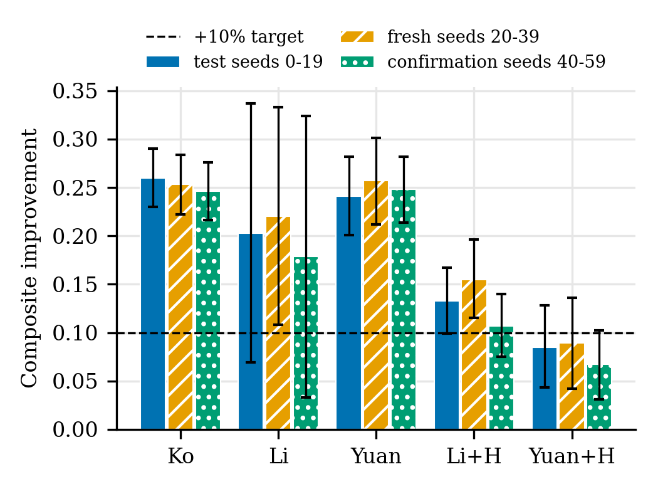
Fig. 2. Composite of EGAT+H against each baseline with 95% CI (dashed line: the +10% target)
6.2 Where the gain comes from
Table 4 splits the composite by metric. Against Ko, +0.139 of the +0.260 comes from stability: EGAT+H switches 42 times per episode against Ko's 616. The remaining +0.122 comes from loss rate (+0.073), throughput (+0.028) and p5 (+0.017). Li+H and Yuan+H switch about as often (43 times), so the stability term is almost 0 and the whole advantage comes from loss rate, p5 and throughput. Table 5 gives the raw values: EGAT+H reaches 53.2 Mb/s against Ko's 47.3 (+12.4%) with a loss rate of 0.172 against 0.248. Its last column is the composite of EGAT+H over each method computed directly (seed-pair mean), while Table 4 uses means over all runs, so the two differ slightly, except for Li, whose variance is high (+25.8% vs. +20.3%).
Table 4. Composite contribution of each metric and switches per episode (setting a, A+B, topologies 0–19)
Baseline | Throughput | Jain | p5 | Loss | Stability | Total | Baseline switches
Ko | +0.028 | +0.002 | +0.017 | +0.073 | +0.139 | +0.260 | 616
Li | +0.030 | −0.001 | +0.050 | +0.073 | +0.107 | +0.258 | 169
Yuan | +0.018 | +0.005 | +0.035 | +0.060 | +0.126 | +0.244 | 351
Li+H | +0.030 | −0.004 | +0.039 | +0.068 | +0.003 | +0.136 | 43
Yuan+H | +0.016 | −0.000 | +0.024 | +0.049 | +0.004 | +0.093 | 43

Table 5. Metric means and the composite by which EGAT+H beats each method (setting a, A+B, topologies 0–19)
Method | Throughput (Mb/s) | Jain | p5 (Mb/s) | Loss rate | Switches / episode | EGAT+H better (composite)
M0 | 26.87 | 0.893 | 0.858 | 0.516 | 0.2 | +31.1%
Ko | 47.32 | 0.777 | 1.410 | 0.248 | 615.5 | +26.0%
Li | 47.06 | 0.790 | 1.220 | 0.245 | 169.1 | +20.3%
Yuan | 49.38 | 0.767 | 1.296 | 0.221 | 351.5 | +24.1%
Li+H | 47.00 | 0.802 | 1.278 | 0.244 | 43.3 | +13.3%
Yuan+H | 49.70 | 0.787 | 1.362 | 0.213 | 43.3 | +8.5%
EGAT+H (this work) | 53.20 | 0.786 | 1.533 | 0.172 | 42.2 | —

6.3 Fairness of the comparison and confirmation
When Li and Yuan get hysteresis by the same rule (margin 1 for both), EGAT+H still beats both significantly, on topologies 0–19 (Li+H +13.3%, Yuan+H +8.5%) and on the confirmation topologies (+10.7% and +6.7%); on 20–39 it beats Yuan+H by +8.9%. The margin over Yuan+H is above 5% but below 10%. All three methods switch about equally often, so the advantage comes from the quality of the channel and route choices, not from switching less.
6.4 Larger networks and ablation
The model trained on 20 nodes beats Ko by +46.5% at 50 nodes and +46.9% at 80 nodes. Table 6 shows the ablation of the earlier model with GRU (three seeds per variant, margin 2). Every interval against the full model contains 0. Removing the Ko prior lowers the composite most (−4.6%), and behaviour cloning has no measurable effect. Removing the GRU (+7.0%) or the edge features (+3.0%) tends to improve it. The model without GRU beats Yuan+H by +8.7% significantly, so it was confirmed with the protocol of Section 5 and became the main model. Trained with all five seeds, the model without GRU beats the model with GRU by +4.9% [+0.7, +9.1] on topologies 40–59.
Table 6. Ablation (setting a, A+B)
Variant | vs. Ko | vs. Yuan+H | vs. full
with GRU (seeds 0–2) | +0.226 | +0.006 | —
no edge features | +0.249 | +0.044 | +0.030
no GRU (main model) | +0.260 | +0.087 | +0.070
no Ko prior | +0.173 | −0.019 | −0.046
no behaviour cloning | +0.220 | +0.014 | +0.001

6.5 Setting with queues kept across switches
When every method keeps its queue across a switch, the results barely change. EGAT+H beats Ko by +0.257 [+0.224, +0.290] on topologies 0–19 and +0.243 [+0.211, +0.276] on the confirmation topologies, loses to Ko in no scenario (Fig. 3), passes all four criteria, and beats Yuan+H by +0.065 [+0.028, +0.101].
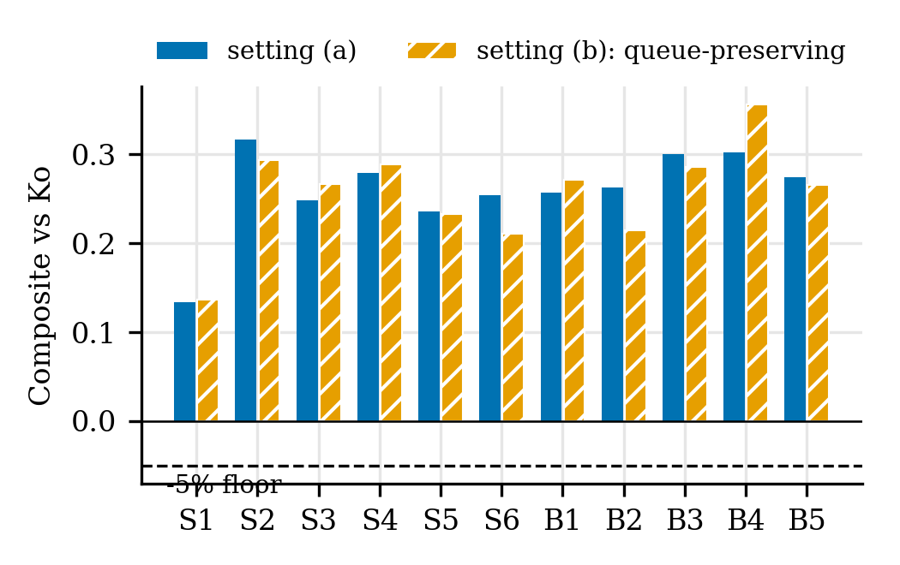
Fig. 3. Composite against Ko per scenario in settings (a) and (b) (dashed line: the −5% bound)
6.6 Calibration and confirmation in ns-3
The trained policies were run, without retraining, in packet-level ns-3.47 (802.11ax, 20 MHz, A-MPDU) in S2, B1 and B3 on topologies 0–4, with and without RTS/CTS. The first airtime model, which shared airtime equally by link count, was 23.5% (rms) off ns-3 and over-estimated congested channels; a model trained on it beat Ko by only +1.5% in ns-3. An interference-domain model with η fitted on S2 and B3 cut the error to 7.4% (7.0% on B1, which was not used for fitting). Every result in Section 6 comes from retraining on this model. Table 7 compares the results in ns-3.
Table 7. Composite of EGAT+H in the simulator and in ns-3 (S2/B1/B3, seed-pair mean [95% CI])
Baseline | Simulator | ns-3 RTS/CTS | ns-3 no RTS/CTS
Ko | +29.1% [+26.3, +32.0] | +23.1% [+15.5, +30.7] | +21.8% [+14.4, +29.2]
Li | +24.6% [+8.7, +40.4] | +43.7% [+35.1, +52.2] | +46.1% [+37.9, +54.3]
Yuan | +27.8% [+22.8, +32.8] | +36.4% [+22.3, +50.4] | +37.2% [+22.6, +51.9]
M0 | +36.3% | +52.6% | +55.5%
Li+H | +16.5% [+12.3, +20.7] | +36.5% [+32.2, +40.8] | +39.5% [+35.7, +43.4]
Yuan+H | +9.0% [+4.6, +13.3] | +16.4% [+0.4, +32.5] | +18.4% [+2.1, +34.6]

In ns-3, EGAT+H beats every method significantly under both MAC settings. The earlier model with GRU beat Ko by only +10.7% and tied with Yuan+H (+2.3%). The model without GRU matches or exceeds Ko's throughput (RTS/CTS: S2 68.1 vs. 67.1, B3 49.8 vs. 43.6 Mb/s) with about 18 times fewer switches. The exception is S2 without RTS/CTS, where Ko's throughput is higher (66.4 vs. 63.8). The lower bound against Yuan+H is close to 0 (+0.4%) because there are only five topologies. The lead over Ko is larger in the simulator than in ns-3 because the simulator still under-estimates Ko's throughput by about 10%.
7 Discussion and Limitations
Suppressing unnecessary switches gives about half of the advantage over Ko, and the mechanism transfers to other methods. Yet when Li and Yuan get the same hysteresis, EGAT-MAPPO still beats them significantly in the simulator and in ns-3, so its channel and route choices are better as well. Removing the GRU mattered, because the model with GRU tied with Yuan+H. The limitations are: (1) the main results come from a flow-level simulator that is still about 7% off ns-3; (2) hysteresis, the airtime model and the GRU removal were chosen after seeing some results, although they were confirmed on new topologies with a pre-registered protocol; (3) the margin over Yuan+H (+6.7%) is below 10%; (4) Yuan and Li had to be adapted from their original problems; (5) Ko is kept as in its original paper without hysteresis, so the comparison with Ko should be read with the part that excludes stability (+12.2%); and (6) the ns-3 confirmation covers only three scenarios and five topologies.
8 Conclusion
EGAT-MAPPO decides channels and routes jointly in a decentralised way. In a simulator calibrated against ns-3, its composite exceeds every baseline adapted from published work by more than 10% and it passes all pre-registered criteria on three topology sets, including a confirmation set fixed before running. With the same hysteresis given to the baselines it is still significantly better, and in ns-3 it significantly beats every method. Future work is to widen the margin over Yuan+H, extend the ns-3 confirmation and reduce the calibration error.
References
[1] B.-J. Ko, V. Misra, J. Padhye and D. Rubenstein, “Distributed Channel Assignment in Multi-Radio 802.11 Mesh Networks,” IEEE WCNC, pp. 3978–3983, 2007. doi:10.1109/WCNC.2007.727
[2] S. Yuan, Y. Zhang, T. Ma, Z. Cheng and D. Guo, “Graph convolutional reinforcement learning for resource allocation in hybrid overlay–underlay cognitive radio network with network slicing,” IET Communications, 2022. doi:10.1049/cmu2.12527
[3] Z. Li, G. Li, Z. Wu, W. Zhang and A. Bazzi, “Dynamic Allocation of C-V2X Communication Resources Based on Graph Attention Network and Deep Reinforcement Learning,” Sensors, 25(16), 5209, 2025.
[4] P. Veličković et al., “Graph Attention Networks,” ICLR, 2018.
[5] S. Brody, U. Alon and E. Yahav, “How Attentive are Graph Attention Networks?,” ICLR, 2022.
[6] J. Schulman, F. Wolski, P. Dhariwal, A. Radford and O. Klimov, “Proximal Policy Optimization Algorithms,” arXiv:1707.06347, 2017.
[7] J. Schulman, P. Moritz, S. Levine, M. Jordan and P. Abbeel, “High-Dimensional Continuous Control Using Generalized Advantage Estimation,” ICLR, 2016.
[8] C. Yu et al., “The Surprising Effectiveness of PPO in Cooperative Multi-Agent Games,” NeurIPS Datasets and Benchmarks, 2022.
[9] K. N. Ramachandran, E. M. Belding, K. C. Almeroth and M. M. Buddhikot, “Interference-Aware Channel Assignment in Multi-Radio Wireless Mesh Networks,” IEEE INFOCOM, 2006.
[10] ns-3 Project, “ns-3 Manual,” simulator documentation. https://www.nsnam.org/docs/manual/html/index.html
[11] A. Raniwala and T. Chiueh, “Architecture and Algorithms for an IEEE 802.11-Based Multi-Channel Wireless Mesh Network,” IEEE INFOCOM, 2005.
[12] M. Alicherry, R. Bhatia and L. Li, “Joint Channel Assignment and Routing for Throughput Optimization in Multi-radio Wireless Mesh Networks,” ACM MobiCom, 2005.
[13] M. Kodialam and T. Nandagopal, “Characterizing the Capacity Region in Multi-Radio Multi-Channel Wireless Mesh Networks,” ACM MobiCom, 2005.
[14] R. Draves, J. Padhye and B. Zill, “Routing in Multi-Radio, Multi-Hop Wireless Mesh Networks,” ACM MobiCom, 2004.

