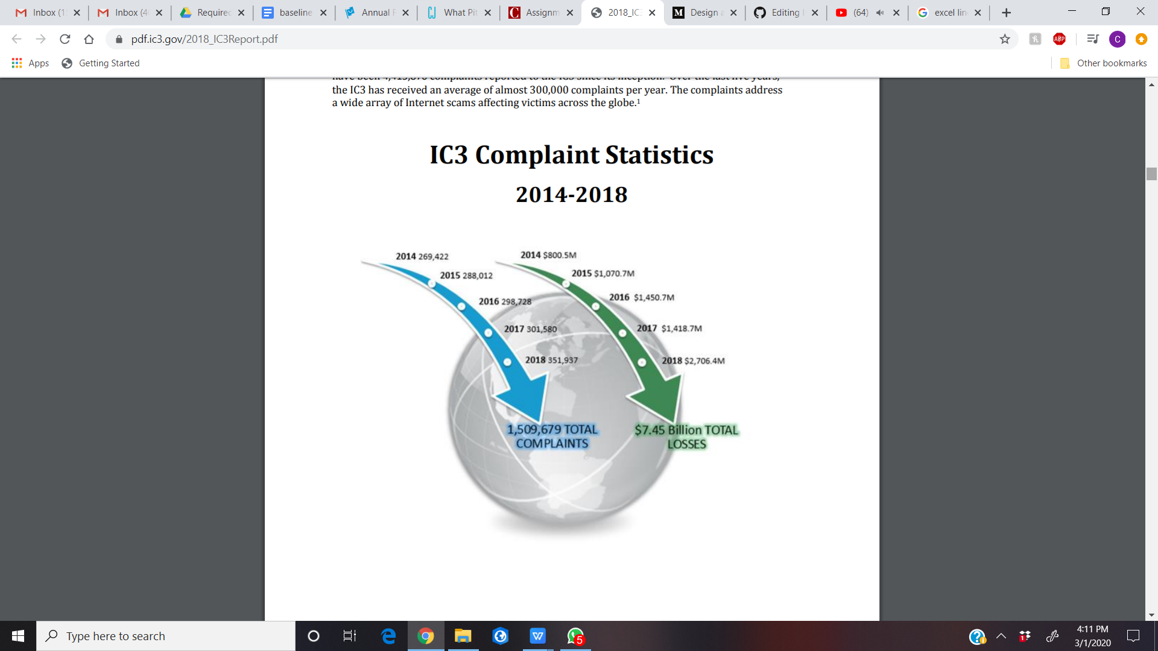

Source: FBI 2018 Internet Crime Report; Pg.5 IC3 Complaint Statistics 2014-18