**You are Here: Mapping the Tree of Life (2018)**

**This Lesson Plan is still a WIP - I will be updating periodically with feedback from the SciREN Networking event**

**Email me if you are interested in developing this lesson soon!**

**Teacher feedback survey:** [**http://goo.gl/tLw7sE**](http://goo.gl/tLw7sE)

|  |  |
| --- | --- |
| Author: | Cynthia L. Darnell |
| Author Affiliation and Location: | Department of Biology, Duke University, Durham, NC |
| Author Website | https://github.com/CindyDarnell |
| Author Contact Information | cynthia.darnell@duke.edu  darnell.cynthia@gmail.com |
| Abstract to Lesson Plan | Recent advances in DNA sequencing technologies have lead to an explosion of data and a need for bioinformatic analyses. One application of large scale sequencing is reconstructing the tree of life based on statistical modeling. The goals of this lesson plan are to 1. familiarize students with current sequencing technologies, 2. provide updated information on biological classifications, and 3. encourage critical thinking and problem-solving around big datasets. |
| Introduction. | How do we organize biological organisms? What criteria do we use to determine relatedness?  DNA (forensics, paternity tests)  History - Franklin, Watson, Crick  discuss structures, bases, Central Dogma  DNA replication → DNA polymerase, mitosis/binary fission  Sequencing Technologies |
| List of Standards Addressed  Common Core, NC Essential Science, Next Gen, etc.  Optional: Standards Mapping Grid | NC Essential Science Standards Bio3.1, Bio3.3, Bio3.5  Next Gen Science Standards HS-LS1.1 |
| Learning Objectives using Measurable Verbs (what students will be able to do) |  |
| Appropriate Grade Levels | 9-12 |
| Group Size/# of students activities are designed for | 2-4 |
| Setting | indoors, classroom/computer lab |
| Approximate Time of Lesson | multi-day (3-5 50 minute sections) |
| Resources Needed for Students | Assorted candy, posterboard, tape, markers;  Computer and internet access |
| Resources Needed for Educators | Dataset of gene sequences (provided, see github below) |
| Apps/Websites Needed | www.ebi.ac.uk/Tools/msa/clustalo/  www.itol.embl.de  www.github.com/CindyDarnell/YouAreHere/ (sequences and tutorial coming soon) |
| Lesson Activity 1  (Warm-up) | **Introduction**  How do we organize biological organisms? What criteria do we use to determine relatedness? |
| **Background**  Classification  Comparative Biology  Cladograms |
| **Step by Step Activity**  "Candy Phylogeny"  In small groups, arrange assorted candy into cladogram. Tape candy to posterboard and draw in tree with markers.  (example characteristics: shape, color, ingredients, manufacturer, number of pieces, melting temperature, etc) |
| **Reflection/Assessment**  Compare trees across the classroom. Which one is "right"?  How did you decide what characteristics to use  Parsimony, number of branches - statistical likelihood |
| Lesson Activity 2  (Bioinformatics) | **Introduction**  DNA (forensics, paternity tests)  History - Franklin, Watson, Crick  discuss structures, bases, Central Dogma  DNA replication → DNA polymerase, mitosis/binary fission  A new domain → Woese and Archaea = 3 domain tree  what did he use to tree organisms |
| **Background**  Sanger - termination - short, low depth - cloning, shotgun sequencing  Next gen/HTS - reversible fluorescent dyes - short, high depth - genome, transcriptomics  3rd gen/Long read - reversible fluorescent dyes - long reads, low depth - genome sequencing, DNA modifications  Nanopore - electrical current - long reads, low depth, cheap - genome sequencing, DNA modifications  Metagenomics - microbiome: human and environmental |
| **Step by Step Activity**  "Intro to Bioinformatics"  conserved genes, variable genes, etc  FASTA format, clustalo algorithm (extension: statistics)  generate trees using itol (Interactive Tree of Life) webtool |
| **Reflection/Assessment**  compare trees - how similar/different? computing times?  Woese used 16S rRNA gene - highly conserved  Extension - current tree of life discussion (2 domain tree made possible by sequencing)  Extension - bioethics: who owns your DNA? (23andme, etc) |
| Final Product/Assessment (e.g. quiz, blog, presentation, essay, etc.) | Presentation of final cladogram and methodolgy to peers |
| Feedback Form for Teachers | What extensions are of particular interest/most relevant to your curriculum? |

**Images:**

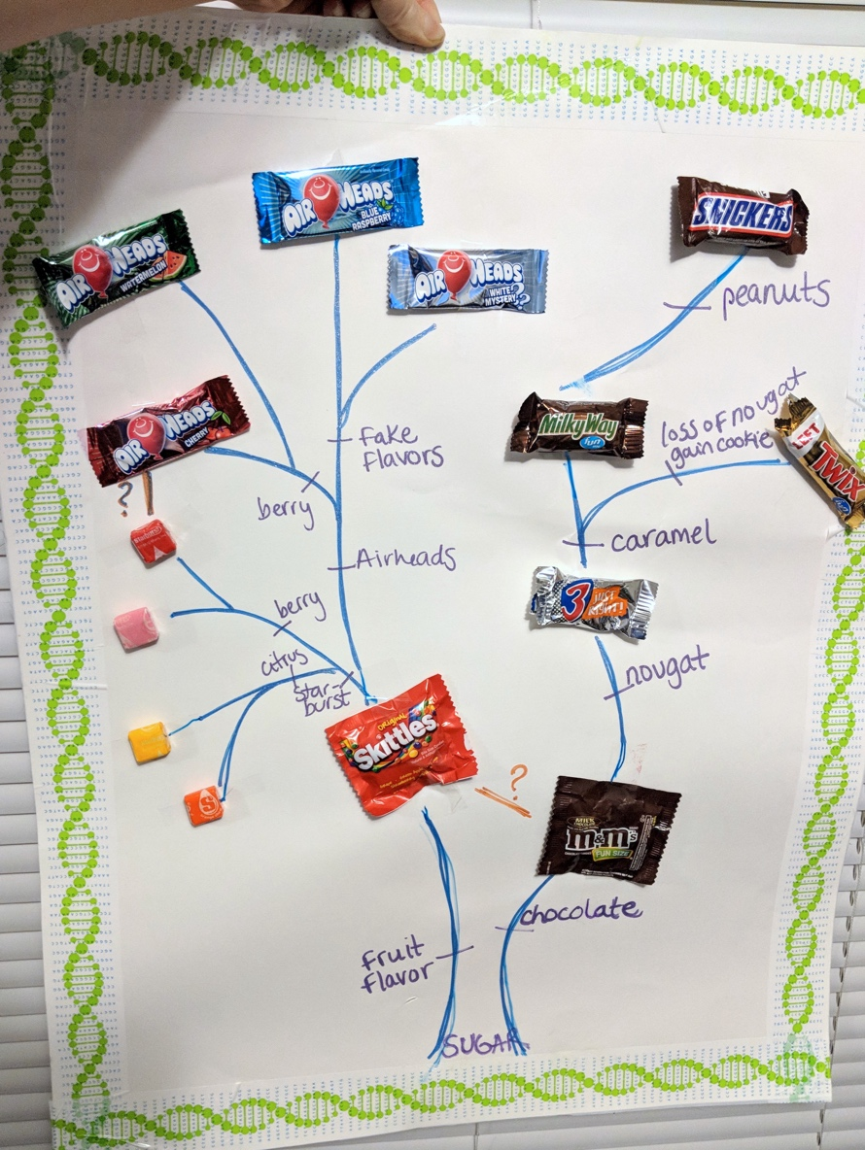

**Appendices:**

**Background Reading for Teachers:**

https://github.com/CindyDarnell/YouAreHere/blob/master/Sequencing_technologies.pdf