* This project’s ideas are summarized in “project summary.pdf”
* More details of this project’s design, implementation and results can be found in “thesis-yutongLiu-568983-submit-v2.pdf”
* This project used open-source data from Kaggle (link below), 3 out of 7 datasets are used - studentInfo.csv, studentVle.csv and vle.csv

<https://www.kaggle.com/datasets/anlgrbz/student-demographics-online-education-dataoulad>

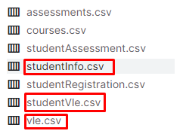

* The file “data structure of all strategies.xlsx” shows the details of strategy 1, 2, 3 data structures
* Python codes

|  |  |
| --- | --- |
| file | details |
|  | Step1: three raw datasets from Kaggle website |
|  | Step2: process raw data to create two temporary datasets |
|  | Step3: process temp data to produce the 6 datasets.   * S1 was produced using Python, * S2 and S3 were produced using RapidMiner (not included in the shared folder) |
|  | Step4: the 6 datasets were produced |
|  | Step5: using 4 traditional machine learning to train models, implemented in RapidMiner (not included in the shared folder)  (In the left screenshot of RapidMiner, planA = S1, planB = S2, planD = S3) |
|  | Step6: using 2 deep learning to train models, implemented using Python |