NPRB2301: Estimation of shark body size from eye lenses (IN PROCESS)
April 20, 2026


Objective
The purpose of this analysis is to estimate body size of Pacific sleeper sharks and Pacific spiny dogfish from images of sequentially peeled eye lenses, based on the presumed linear relationship between eye lens diameter and total body length. The estimation of body size at the time of formation of each lens layer analyzed for delta C-14 and stable isotope composition is intended to facilitate estimation of growth rates and life history reconstruction of individual sharks.

Introduction
Vertebrate eye lenses grow continuously throughout life, adding sequential layers around an embryonic core over time. Other researchers have demonstrated linear relationships between the fish eye lens diameter and total length, including for the elasmobranchs porbeagle shark Lamna nasus, Atlantic spiny dogfish Squalus acanthias, thorny skate Amblyraja radiata, round ray Rajella fyllae, and leopard sharks Triakis semifasciata (Quaeck-Davies et al. 2018; Leifsdottir and Campana 2023; Kuntz et al 2025). In this subanalysis, we describe the relationship between whole lens diameter and the diameter of the hardened portion of the lens (i.e., apoptotic layers) to the total length of Pacific sleeper sharks Sominosus pacificus and Pacific spiny dogfish Squalus suckleyi to estimate the total length at the time of formation of each peeled eye layer in order to link delta C-14 and stable isotope values to body size.

Methods

Imaging and measurements
Eye lenses were dissected from frozen eye globes and photographed against a 10 x 10 mm grid background to spatially calibrate images for measurements (Figure 1). For most individuals, a photograph was taken of the whole, intact lens and of the lens following each sequential peel to a small central nucleus. Eye lenses differed in appearance. While the majority of whole lenses were spherical, a few were oblong in shape; many appeared firmer and more opaque, whereas other lenses were surrounded with a clear jelly layer (Figure 2). Measurements were generally taken through the equator at the widest point of the solid lens, unless the capsule was clearly beginning to delaminate from the rest of the lens. In those cases, the lens was measured where it appeared most spherical (Figure 3). Some lenses were too irregular to measure. The condition of the lens was noted when taking measurements. All measurements were made using ImagePro v.10-11 (Media Cybernetics) and converted from pixels to mm in R statistical computing software. Images of samples with observations outside the 99% confidence limits of the regression of the whole lens diameter (LD_{w}) or first hardened lens diameters (LD_{h}) to the total length at capture (TLc) were re-examined in case of measurement error of the diameters.

Comparison of capsule diameter to the diamter of the first hard layer
The outermost layer of the whole lens is termed the “capsule”. Just medial of the capsule is a layer of cuboidal epithelial cells, followed by the the pre-apoptotic layers, and the post-apoptotic hardened layers which are composed of crystalline proteins (Kuntz et al. 2025, Quack-Davies et al. 2018). Studies have suggested that the ratio of the whole lens diameter (LD_{w}) and the first hardened layer (LD_{h}) is consistent across the life of the fish, regardless of species (Leiffsdottir and Campana 2023). A regression of the LD_{h} against the LD_{w} was conducted by species, and a t-test was performed to test if the slopes of the lines were significantly different from 1. A slope of 1 would be expected if the LD_{w} and LD_{h} increased equally as the eye grows. Similarly, we also examined the relationships of the LD_{h}:LD_{w} to total body length at the time of capture (TL_{c}) and the LD_{h}:LD_{w} to LD_{w}, but tested if those slopes are significantly different from zero. In these cases a slope of zero would be expected if the ratio of LD_{h}:LD_{w} was conserved as the eye or fish grows.

Relationship of LD_{w} and LD_{h} to TL
Measurement error in TL_{c} is a known source of uncertainty for this study. Samples were collected from many platforms and science crew, likely resulting in inconsistencies in total length measurements (e.g., straight line vs over the curve of the body, limited deck space for laying out large specimen, and placement of the caudal fin). It is not possible to account for this uncertainty and therefore, total length is assumed measured without error for all analyses.
The relationships between LD_{w} and TL_{c} was described using separate linear models for each species. The equation followed the form:
$$LD_{w}=a_{i}+TL_{c}*b_{i}$$
Where i is the species. The slope and intercept parameters are b and a, respectively.
Similarly, the relationship between LD_{h} and TL_{c} was described using the same equation
$$LD_{h}=c_{i}+TL_{c}*d_{i}$$
but the slope and intercept parameters were c and d, respectively.

Eye lens diameter at Age-0
Kuntz et al. (in review) demonstrate the the diameter at age-0 can be identified by a significant peak or decline in the stable isotope values occurring after parturition, when the pups transition from maternal nourishment to self-feeding. A GAM was fit to each individual d13C and d15n data. The first derivative of the d13c models, or when the slope of the model changed from negative to positive, was used to identify the minimum for each individual. A mean layer diameter at the model minimum across individuals is assumed to be a proxy for the hardened lens diameter at birth (with 95% confidence intervals).
Similarly, the first peak of the 15n should also correspond to birth.

Estimating fish length at the time of layer formation
The above equation can be rewritten to estimate the total length at the time of layer formation (TL_{t}) following Kuntz et al. (2025):
$$TL_{t}=\left(LD_{t}−a_{i},j\right)/b_{i},j$$
where LD_{t} is the diameter of the lens following each sequential peel and the a_{i,j} and b_{i,j} parameters are from Table 2.
Two sets of TL_{t} were estimated for each animal: using all of the lamina diameters; and using only the lamina diameters greater than the estimated diameter at Age-0. Separating the embryonic growth from post-natal growth allows for assumptions of different growth patterns during gestation and after pupping.

Results

Comparison of capsule diameter to the diamter of the first hard layer
Paired LD_{w} and LD_{h} were available from 40 Pacific sleeper sharks and 8 Pacific spiny dogfish with total length at time of capture. The slope of the regression line between LD_{h} and LD_{w} was significantly different from 1 (alpha = 0.05) for Pacific Sleeper Shark, but not Pacific Spiny Dogfish (Table 1, Model = “LDh vs LDw”, Figure 4). The slopes of the regression lines of the ratio of LD_{h}:LD_{w} relative to the TL_{c} and relative to the LD_{w} were significantly different from zero for Pacific sleeper sharks, but not for Pacific spiny dogfish (Table 1, Model = “ratio vs TLc” and “ratio vs LDw”, respectively, Figure 5).

Relationship of LD_{w} and LD_{h} to TL
Paired LD_{w} and TL_{c} data were available from 65 Pacific sleeper sharks and 21 spiny dogfish, while paired LD_{h} and TL_{c} data were was available from 62 Pacific sleeper sharks and 23 spiny dogfish (Figure 6). The regression of both of the LD_{w} and LD_{h} to TL_{c} for Pacific sleeper shark had R2 > 0.7343, suggesting that the linear regression explained most of the variability in the data. The regression of both of the LD_{w} and LD_{h} to TL_{c} for Spiny Dogfish had R2 > 0.9382, suggesting that the linear regression explained most of the variability in the data. NEED TO DO THE influential evaluations still. The spiny dogfish relationship was likely improved by the inclusion of the embryo eyes.

Eye lens diameter at Age-0
The gam fits for each individual by species are in Figure 7. The mean of the first derivative, or localized minima, across all individuals in a species resulted in estimated diameter at age-0 of 5.7518 (5.2903-5.2903, 95% CI) and 5.3363 (4.8599-4.8599, 95% CI) for Pacific sleeper shark and spiny dogfish, respectively. The spiny dogfish are known to be highly mobile, and may move through many regions during the 18-22 month gestation, which may explain the high variability in the d13C curves. Conversely, while it is unknown exactly where adult Pacific sleeper shark reside, it is believed that the adults of the species generally inhabit the abyssal plain or other deep offshore environments. One current hypothesis is that the pregnant females move to nearer to shore to pup and the pups move to shallow nursery areas (e.g., Bering Sea). The consistent valley in the d13c across individuals suggests a similar movement pattern at the same size, possibly from the abyssal environment while in utero to a nearshore nursery habitat after pupping.
The d15n data are more variable across individuals in both species. This could be explained by the large size at birth and the generalize/opportunistic feeding strategy from birth. Even though pups are more gape limited than adults, pups of both species could potentially feed at some of the same trophic levels as the adults. The initial peak of d15n is difficult to identify in most individuals and may be less informative for lens diameter at birth.

Estimatig fish length at the time of layer formation

Discussion
These data analytics are still under development. There are a number of specific tasks, and likely refinements to be completed:
- Test for outliers or other influential data points
- Incorporate uncertainty into the predicted total length estimates
- Investigate potential diameter of age-0
The type and composition of the layer diameters being used to predict length needs to be considered. The ratio of the whole lens diameter to the first hardened layers (or diameter at the first post-apoptotic layer) increases with size of the eye. It is unclear if this is a function of time or size, or both. The LDw includes the pre-apoptotic layers and the capsule surrounding the whole lens. The capsule itself is thin and could potentially be considered the diameter of the pre-apoptotic portion of the lens. The process of apoptosis may occur at different rates throughout the growth trajectory of an animal, resulting in the significant change in the relationship between the LDh and LDw. It would be incorrect to make further predictions without considering the different biological processes between the LDh and LDw.
The majority of the layer diameter data for this study is from the post-apoptotic layers. For consistency, we recommend using the linear model between the LDh and TLc to predict TLt. The LDw is representative to the TLc, not to post-apoptotic processes.

Tables
Table 1: Linear regression model results with the slope, intercept, 95% confidence intervals, standard error, Rsquared, degrees of freedom, t-test p-value at alpha = 0.05, the model and the hypothesis that was tested.
Table 2: Linear regression statistics of the whole lens diameter (LD_{w}) and the first hardened layer (LD_{h}) to total length at capture (TL_{c}) for each species (i), with 95% confidence intervals, standard error, Rsquared, degrees of freedom, t-test p-value at alpha = 0.05, and the model (j).

Figures
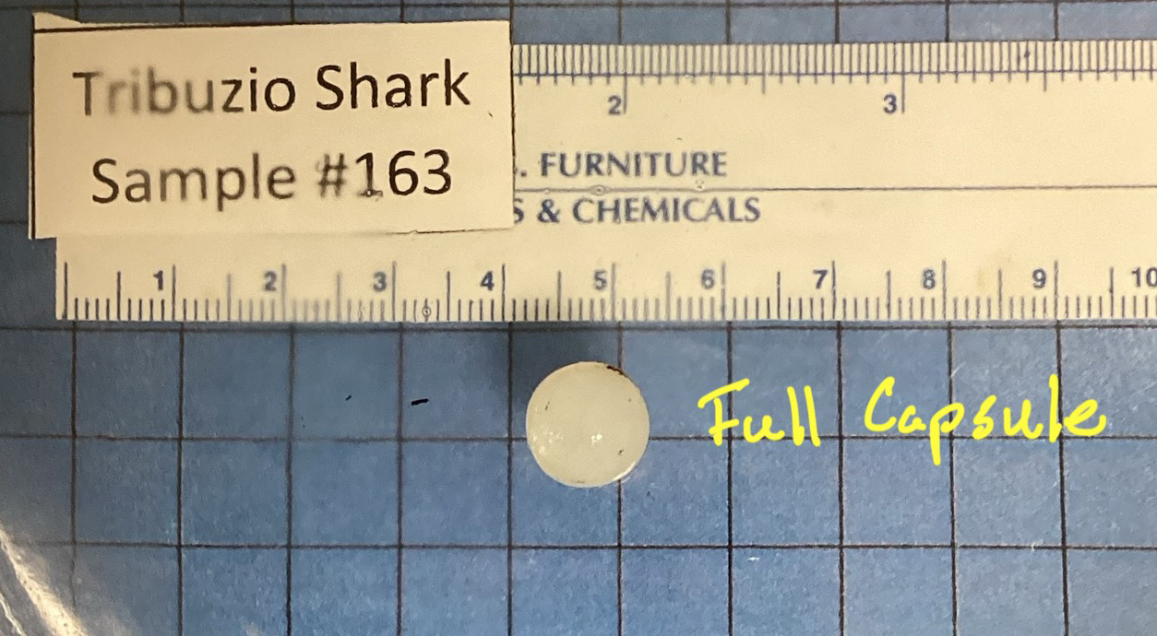
Figure 1: Image showing a whole, intact eye lens against gridded 10 x 10 mm background.

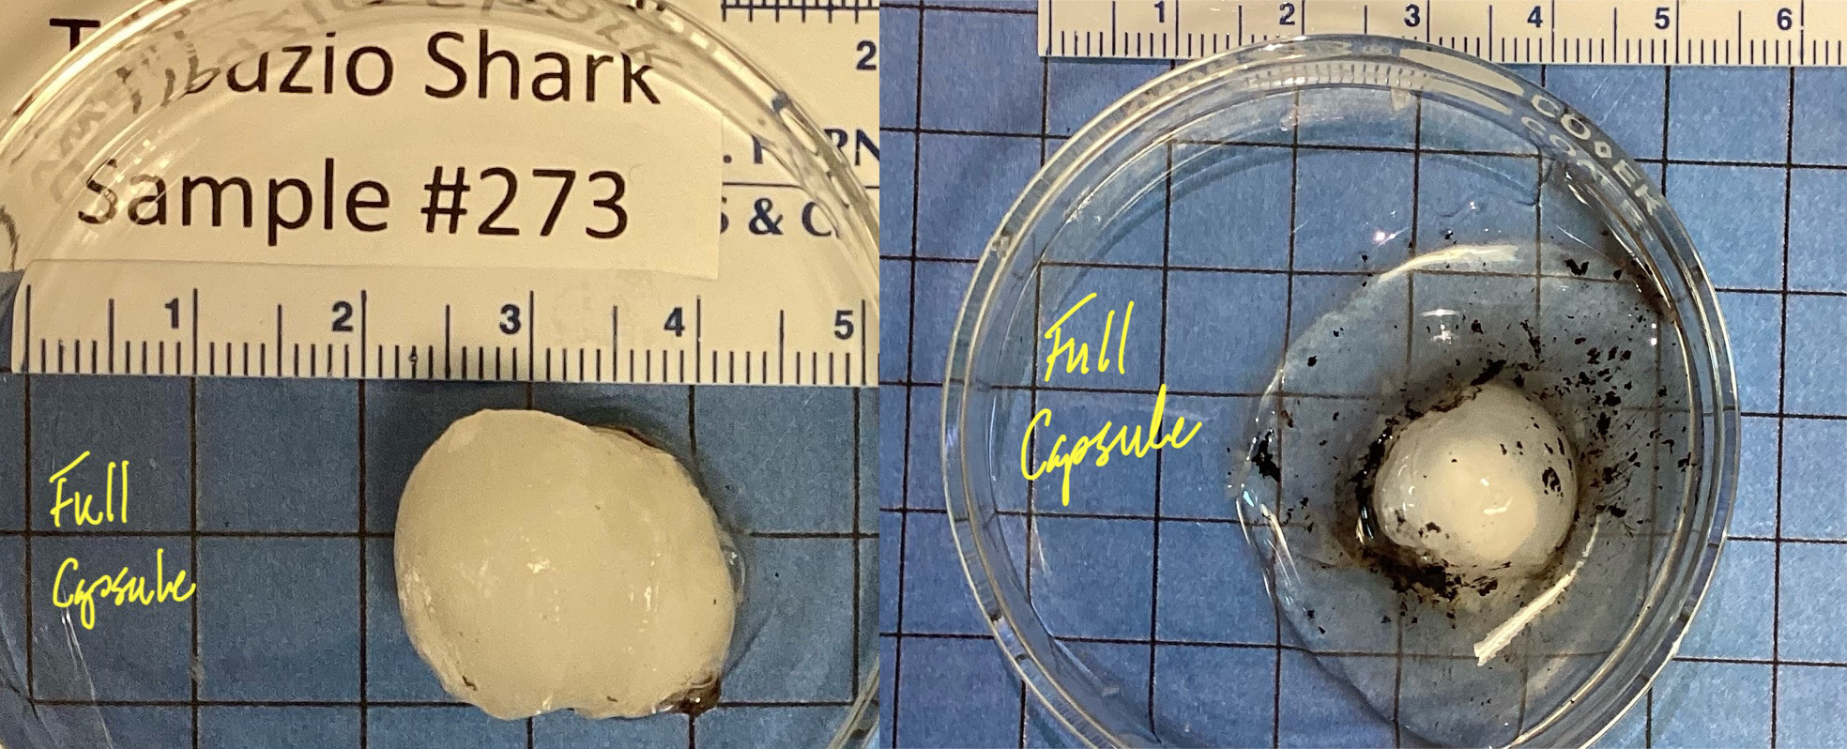
Figure 2: Eye lenses from 2 sharks of about the same length (left = 371 cm TL, right = 403 cm TL). Note the oblong shape of the lens on left and jelly layer surrounding the lens on right.

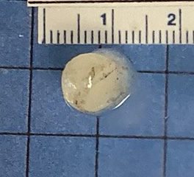
Figure 3: Outer capsule starting to separate from lens. Lens was measured where it is most spherical.

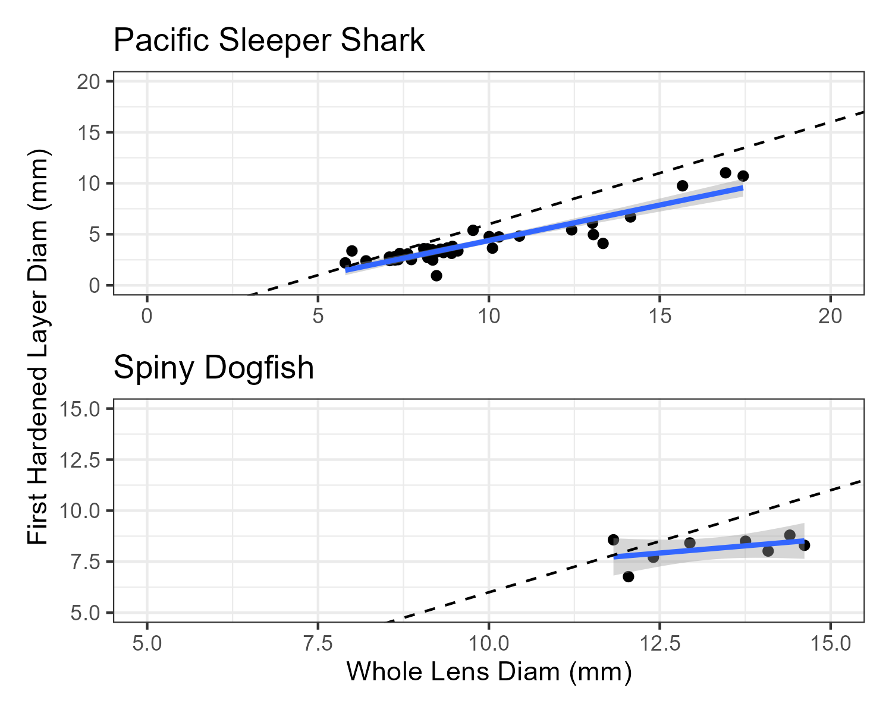
Figure 4: Linear regressions of the diameter (in milimeters) of the whole lens (LD_{w}) and the first hardened layer (LD_{h}). The shaded region represents the 95% confidence interval. The dashed line is the expected 1:1 replacement line, null hypothesis mu = 1.

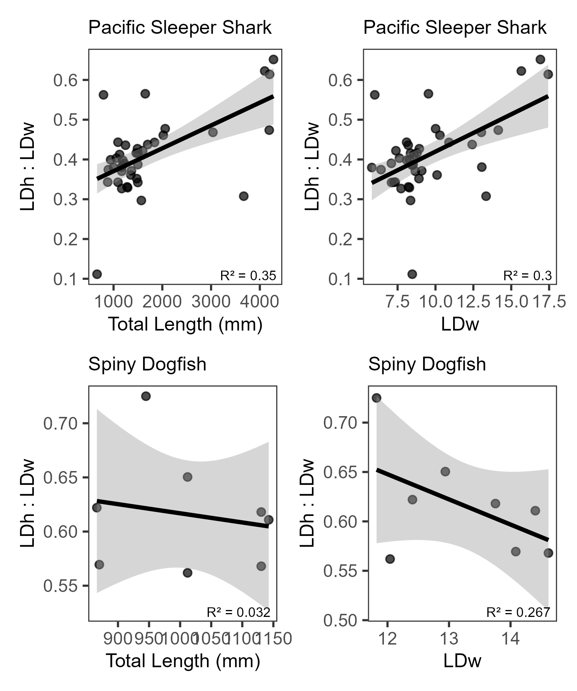
Figure 5: Linear regressions of the ratio of the diameter of the first hardened layer (LD_{h}) to the diameter of the whole lens (LD_{w}) relative to the total length at capture (TL_{c})and to the LD_{w}. Shaded region represents the 95% confidence interval.

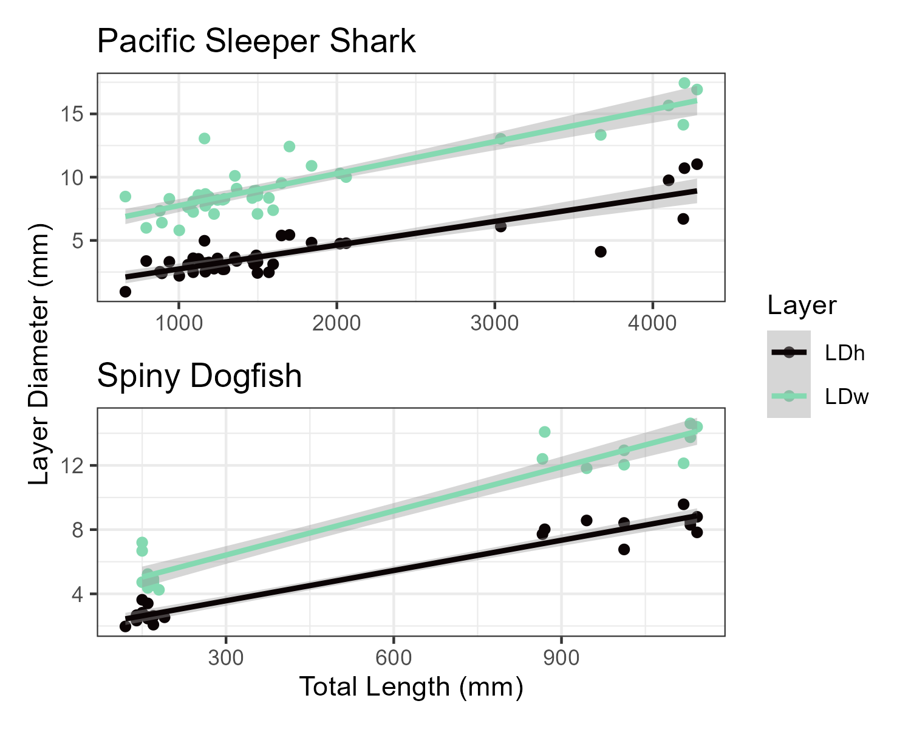
Figure 6: Linear regressions of the LDh and the LDw to the total length at capture. Shaded region represents the 95% confidence interval.

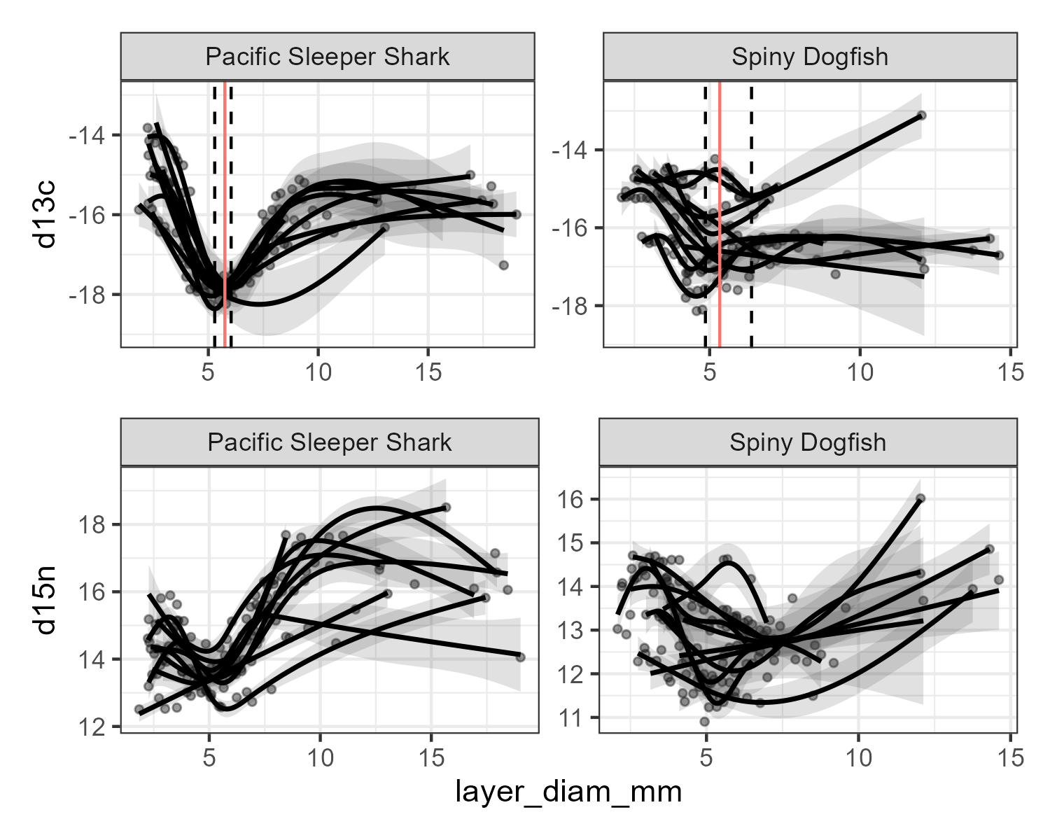
Figure 7: Bulk d13c data with individual GAM models for each animal. Solid vertical lines are the mean layer diameter of the model minimum d13c, Dashed lines are the 95% confidence interval

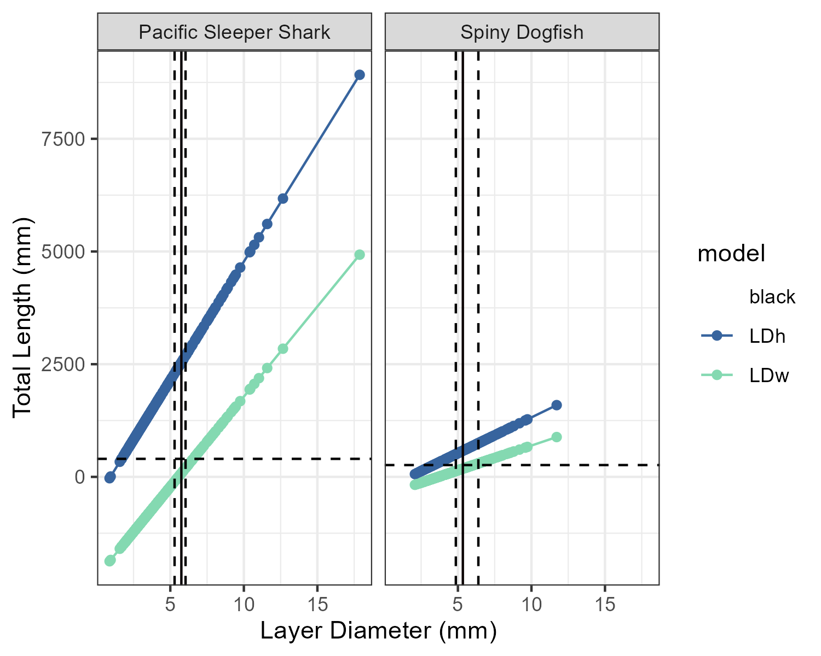
Figure 8: Predicted total lengths (in mm) based on the whole lens diameters (LDw) and first hardenend layer (LDh) linear models. The horizontal dashed line is the estimated size at birth from literature. The vertical solid black line is the estimated diameter at birth based on the d13c data, with 95% confidence intervals in dashed lines.

