NPRB2301: Estimation of shark body size from eye lenses (IN PROCESS)
February 11, 2026
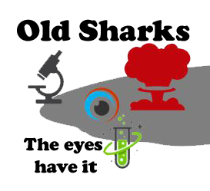

Objective
The purpose of this analysis is to estimate body size of Pacific sleeper sharks and Pacific spiny dogfish from images of sequentially peeled eye lenses, based on the presumed linear relationship between eye lens diameter and total body length. The estimation of body size at the time of formation of each lens layer analyzed for delta C-14 and stable isotope composition is intended to facilitate estimation of growth rates and life history reconstruction of individual sharks.

Introduction
Vertebrate eye lenses grow continuously throughout life, adding sequential layers around an embryonic core over time. Other researchers have demonstrated linear relationships between the fish eye lens diameter and total length, including for the elasmobranchs porbeagle shark Lamna nasus, Atlantic spiny dogfish Squalus acanthias, thorny skate Amblyraja radiata, round ray Rajella fyllae, and leopard sharks Triakis semifasciata (Quaeck-Davies et al. 2018; Leifsdottir and Campana 2023; Kuntz 2025). In this subanalysis, we describe the relationship between whole lens diameter and the diameter of the hardened portion of the lens to the total length of Pacific sleeper sharks Sominosus pacificus and Pacific spiny dogfish Squalus suckleyi to estimate the total length at the time of formation of each peeled eye layer in order to link delta C-14 and stable isotope values to body size.

Methods

Imaging and measurements
Eye lenses were dissected from frozen eye globes and photographed against a 10 x 10 mm grid background to spatially calibrate images for measurements (Figure 1). For most individuals, a photograph was taken of the whole, intact lens and of the lens following each sequential peel to a small central nucleus. Eye lenses differed in appearance. While the majority of whole lenses were spherical, a few were oblong in shape; many appeared firmer and more opaque, whereas other lenses were surrounded with a clear jelly layer (Figure 2). Measurements were generally taken through the equator at the widest point of the solid lens, unless the capsule was clearly beginning to delaminate from the rest of the lens. In those cases, the lens was measured where it appeared most spherical (Figure 3). Some lenses were too irregular to measure. The condition of the lens was noted when taking measurements. All measurements were made using ImagePro v.10-11 (Media Cybernetics) and converted from pixels to mm in R statistical computing software.

Comparison of capsule diameter to the diamter of the first hard layer
The outermost layer of the whole lens is termed the “capsule”. Just medial of the capsule is a layer of jelly-like cuboidal epithelial cells, followed by hardened layers composed of crystalline proteins (Kuntz et al. 2025, Quack-Davies et al. 2018). Studies have suggested that the ratio of the whole lens diameter (LD_{w}) and the first hardened layer (LD_{h}) is consistent across the life of the fish, regardless of species (Leiffsdottir and Campana 2023). A regression of the LD_{h} against the LD_{w} was conducted by species, and a t-test was performed to test if the slopes of the lines were significantly different from 1. A slope of 1 would be expected if the LD_{w} and LD_{h} increased equally as the eye grows. Similarly, we also examined the relationships of the LD_{h}:LD_{w} to total body length at the time of capture (TL_{c}) and the LD_{h}:LD_{w} to LD_{w}, but tested if those slopes are significantly different from zero. In these cases a slope of zero would be expected if the ratio of LD_{h}:LD_{w} was conserved as the eye or fish grows.

Relationship of LD_{w} and LD_{h} to TL
The relationships between LD_{w}, LD_{h}, and TLc was described using separate linear models for each species and layer diameter type. The equation followed the form:
$$LD=a_{i},j+TL_{c}*b_{i},j$$
Where LD is either LD_{w} or LD_{h}, i is the species and j is either w or h for the LD_{w} or LD_{h} regression. The slope and intercept parameters are b and a, respectively.
Images of samples with observations outside the 99% confidence limits of the fitted LD_{w} or LD_{h} ~ TLc relationships were re-examined for measurement errors. The R package ‘olsrr’ was used to examine residual patterns, check for highly influential observations, and run diagnostics.

Eye lens diameter at Age-0
Kuntz et al. (in review) demonstrate the the diameter at age-0 can be identified by a significant peak or decline in the stable isotope values occuring after parturition, when the pups transition from maternal nourisment to self-feeding.

Estimating fish length at the time of layer formation
The above equation can be rewritten to estimate the total length at the time of layer formation (TL_{t}) following Kuntz (2025):
$$TL_{t}=\left(LD_{t}−a_{i},j\right)/b_{i},j$$
where LD_{t} is the diameter of the lens following each sequential peel and the a_{i,j} and b_{i,j} parameters are from Table 2.

Results

Comparison of capsule diameter to the diamter of the first hard layer
Paired LD_{w} and LD_{h} were available from 36 Pacific sleeper sharks and 7 Pacific spiny dogfish with total length at time of capture. The slope of the regression line between LD_{h} and LD_{w} was significantly different from 1 (alpha = 0.05) for Pacific Sleeper Shark, but not Pacific Spiny Dogfish (Table 1, Model = “LDh vs LDw”, Figure 4). The slopes of the regression lines of the ratio of LD_{h}:LD_{w} relative to the TL_{c} and relative to the LD_{w} were significantly different from zero for Pacific sleeper sharks, but not for Pacific spiny dogfish (Table 1, Model = “ratio vs TLc” and “ratio vs LDw”, respectively, Figure 5).

Relationship of LD_{w} and LD_{h} to TL
Paired LDw and TLc data were available from 54 Pacific sleeper sharks and 20 spiny dogfish, while paired LDh and TLc data were was available from 52 Pacific sleeper sharks and 52 spiny dogfish. NEED TO DO THE influential evaluations still

Eye lens diameter at Age-0

Estimatig fish length at the time of layer formation

Tables
Table 1: Linear regression slope statistics, with 95% confidence intervals, standard error, Rsquared, degrees of freedom, t-test p-value at alpha = 0.05, the model and the hypothesis that was tested
Table 2: Linear regression statistics of the whole lens diameter (LD_{w}) and the first hardened layer (LD_{h}) to total length at capture (TL_{c}) for each species (i), with 95% confidence intervals, standard error, Rsquared, degrees of freedom, t-test p-value at alpha = 0.05, and the model (j).

Figures
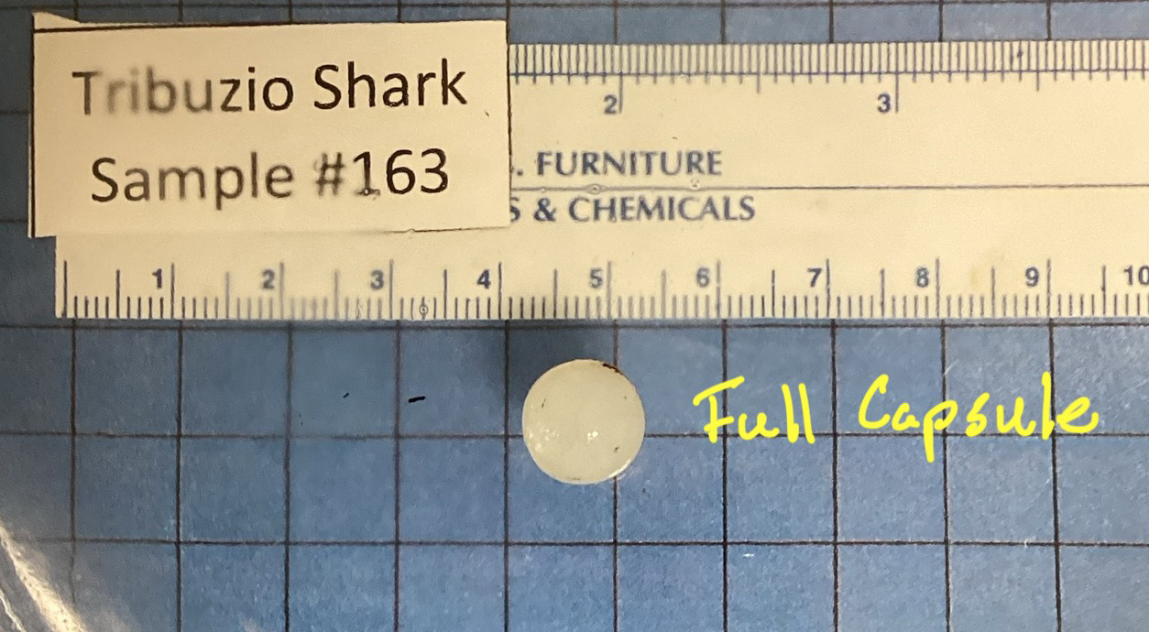
Figure 1: Image showing a whole, intact eye lens against gridded 10 x 10 mm background.

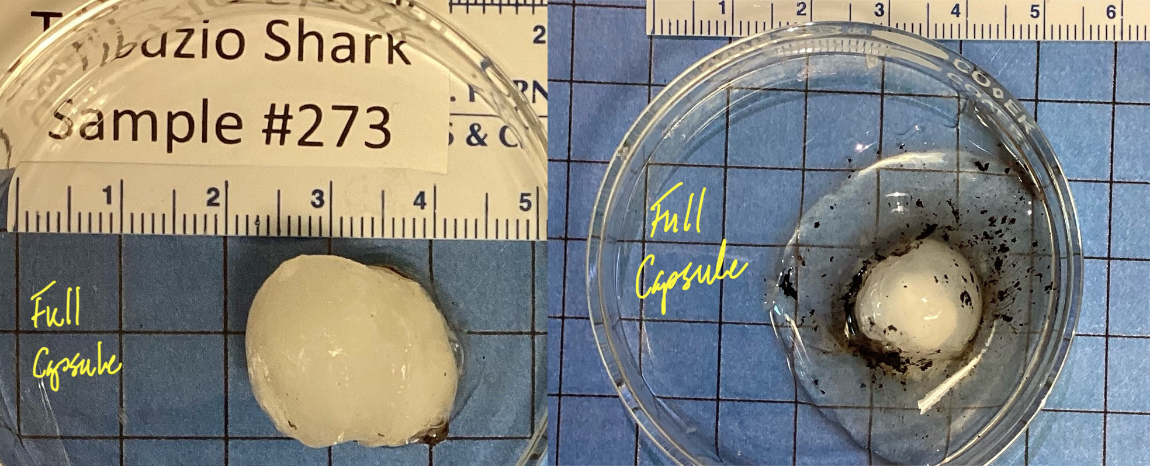
Figure 2: Eye lenses from 2 sharks of about the same length (left = 371 cm TL, right = 403 cm TL). Note the oblong shape of the lens on left and jelly layer surrounding the lens on right.

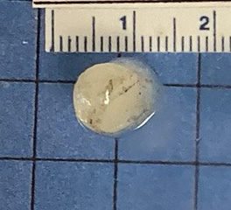
Figure 3: Outer capsule starting to separate from lens. Lens was measured where it is most spherical.

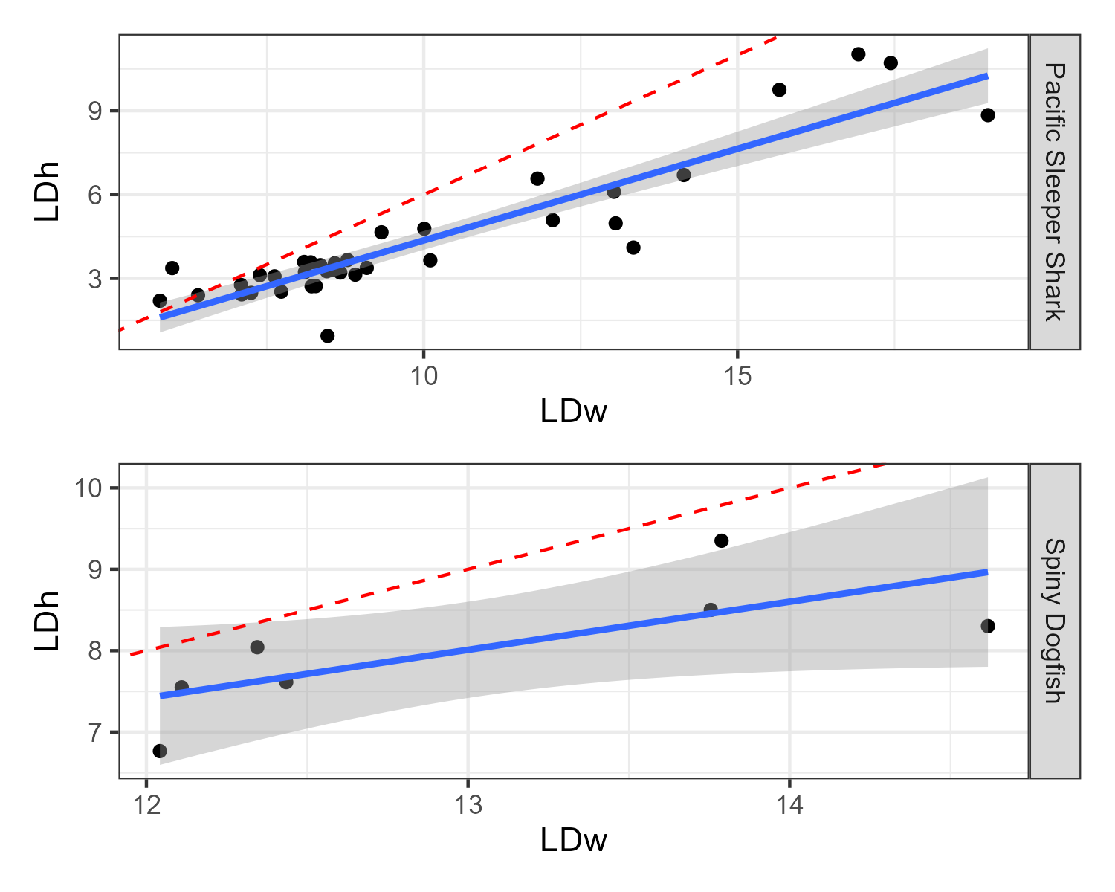
Figure 4: Linear regressions of the diameter of the whole eye (LDw) and the first hardened layer (LDh). Shaded region represents the 95% confidence interval. The red dashed line is the expected 1:1 replacement line, null hypothesis mu = 1.

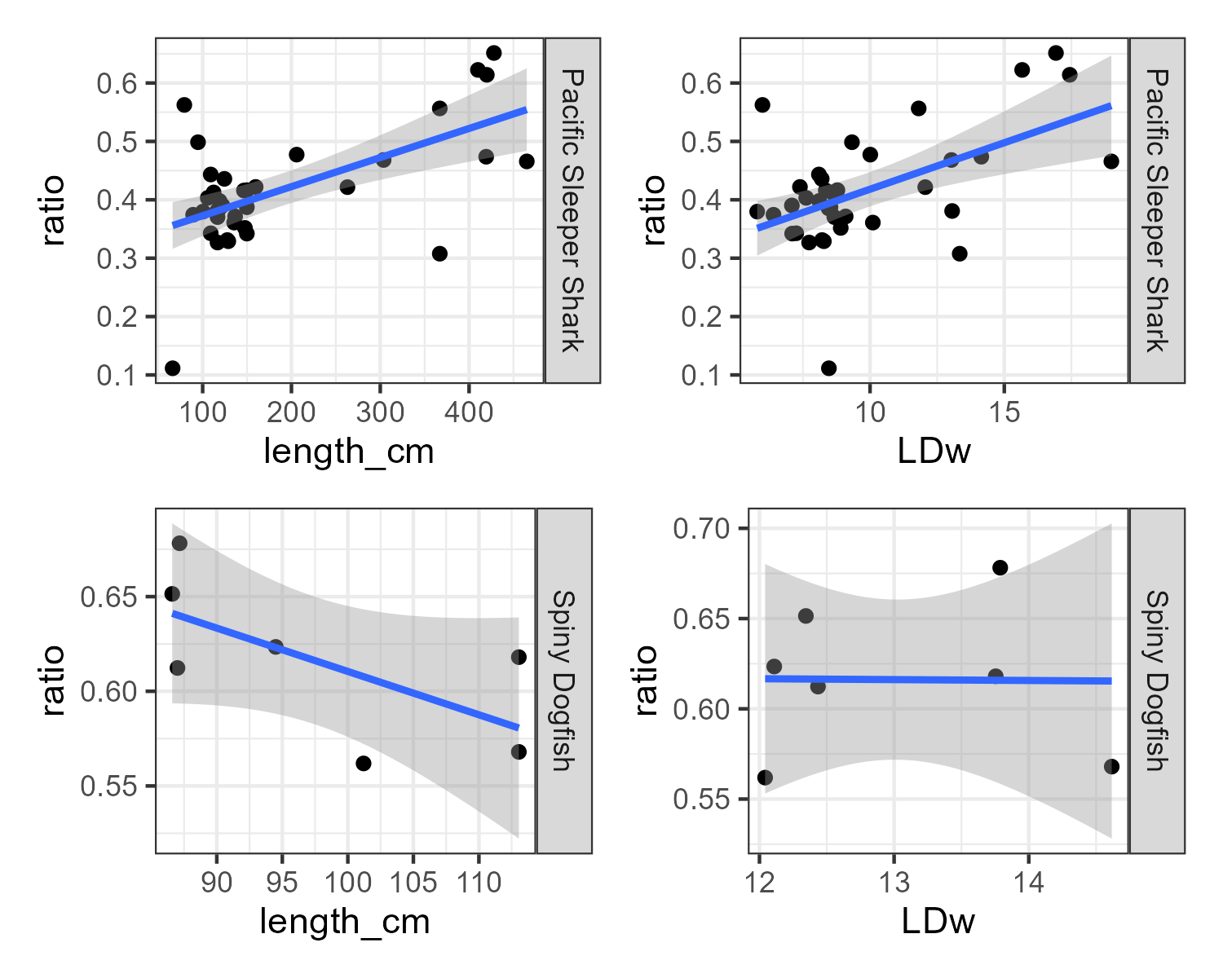
Figure 5: Linear regressions of the ratio of the LDh to LDw relative to the total length at capture and to the LDw. Shaded region represents the 95% confidence interval.

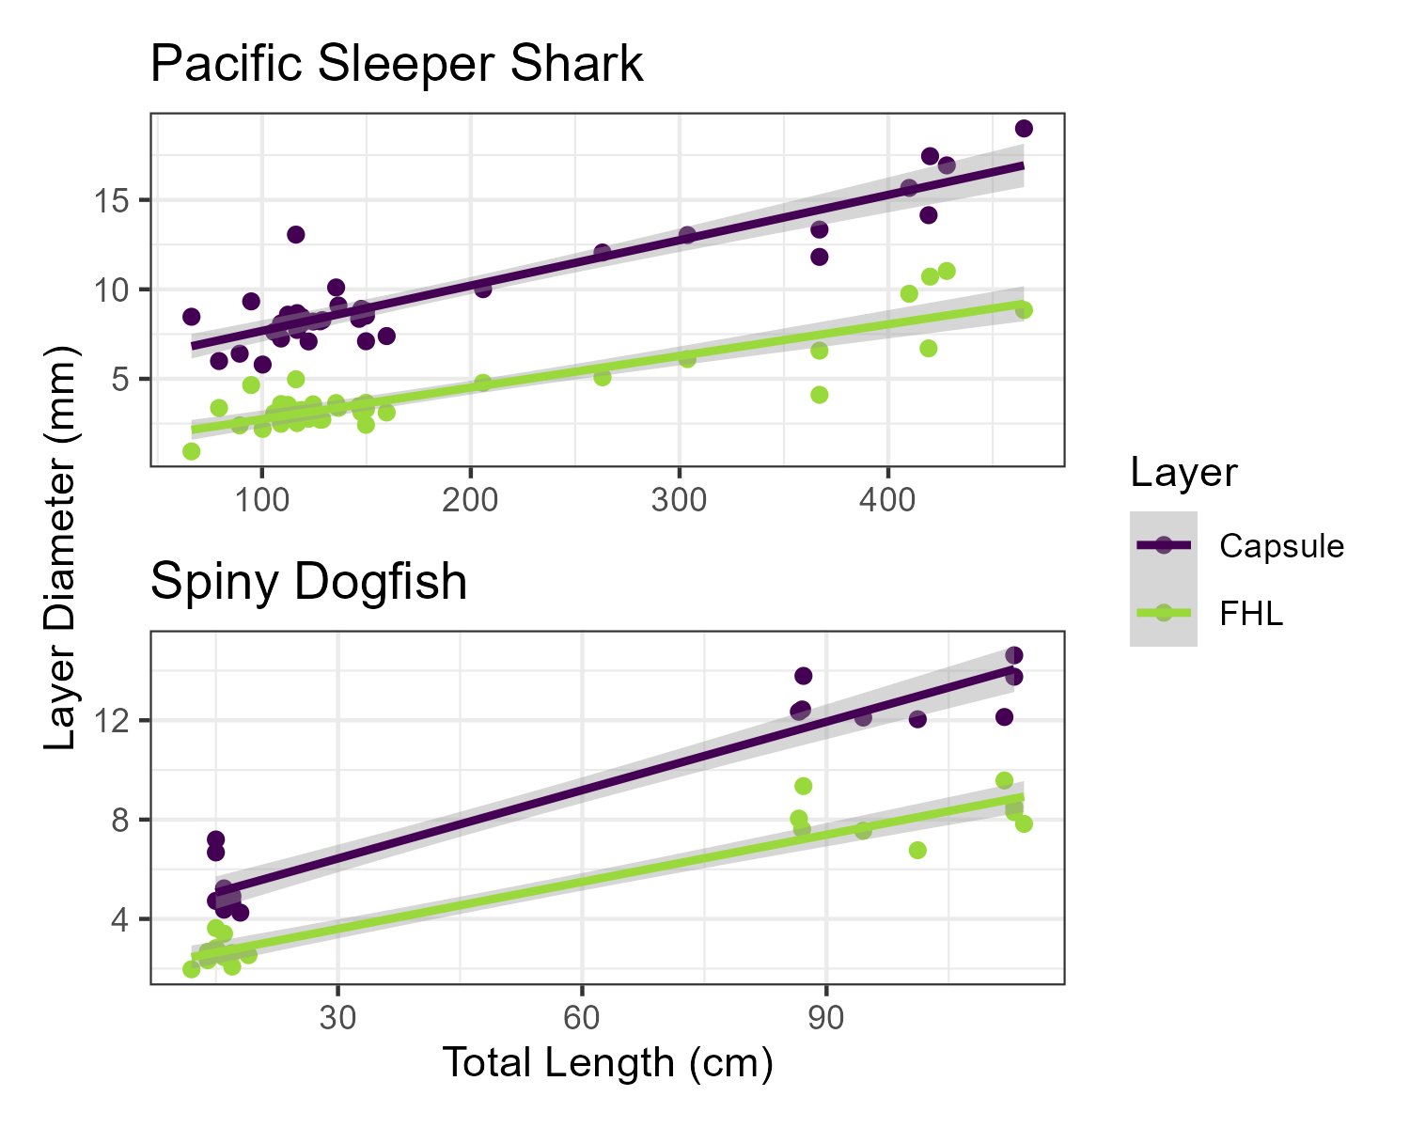
Figure 6: Linear regressions of the LDh and the LDw to the total length at capture. Shaded region represents the 95% confidence interval.

