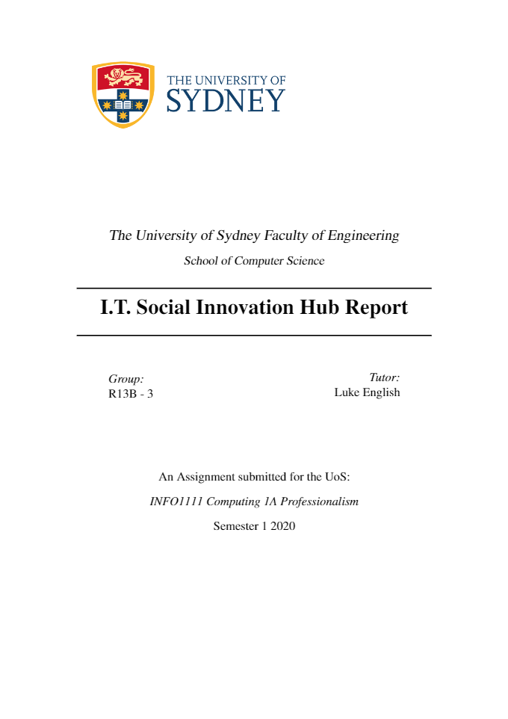

Background

Our IT Social Innovation Hub aims to deliver shared economic, societal, and environmental value in Asia’s developing economies through innovative IT solutions in pollution and resource management.

The past two decades has seen China – Asia’s largest economy and global economic powerhouse – experience rapid growth (double-digit GDP), industrialisation, and urbanisation (Bai, Zhu, An, Peng, and Li, 2018). China is the world’s largest exporter and manufacturer and home to one of the most vibrant digital economies. However, this has engendered serious problems in natural resource depletion (60% of Chinese water supply is marked polluted), degradation of major ecosystems (ruin of the Yellow River) and pollution extending well beyond its borders (Lin and Nakamura, 2018). Furthermore, considering China’s dominance in the automobile and manufacturing industry and its heavy reliance on raw materials (coal and plastics), there exists a unique opportunity for innovative technology-based approaches in systems thinking (Bai, et al., 2018).

Backed by the ambitious policies of the China Council for International Cooperation on Environment and Development (CCIED) to improve the country’s productivity of resource use by a factor of 7-10 (Lin and Nakamura, 2018). Our application for the Asia Development Bank (ADB) tender enables us to harness the forces of innovation and entrepreneurship to address systemic issues in pollution and completely rewrite the rules of global resource management. Starting in China.

Our Approach

Our analysis into the value chains of the world’s largest consumer goods organisations – Coca-Cola Company, Unilever and Amcor – reveals that there is an enormous opportunity to improve the environmental and economic impacts of waste consumption in supply chains that have become increasingly global (Unilever, 2020). We are challenging the traditional linear “take-make-dispose” model of consumption, where products get manufactured, bought, used briefly and then disposed of and shifting towards our idea of a circular system of waste management.

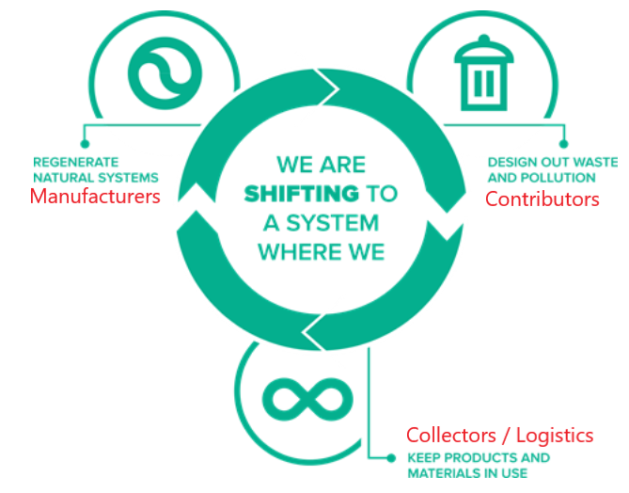

Our Hub will provide technical assistance and make catalytic investments in early-stage private companies to accelerate the deployment of impactful technologies that fit into our circular waste model. Operationally, our Hub comprises three core divisions in the resource management value chain:

1. **Manufacturers**
2. **Contributors**
3. **Collectors and Logistics**

**Manufacturers**

China has an enormous market potential for raw materials remanufacturing. Our hub will endorse innovative technology companies that understand the principles of closed loop industrial processing outlined by Prof. Henrik Thunman of Chalmers University, and work towards recapturing the value of raw materials so that they lead additional useful lives rather than ending up in landfill (Chalmers, 2020). One example lies in China’s domestic automotive industry which, although booming, has amassed a stockpile of over 310 million cars as of 2018 (Li, Qiao, and Shi, 2019). Given the average roadworthy lifespan of a vehicle is 10 years, this means that by 2020 over 10 million vehicles will be added to landfill. This presents a huge market opportunity for auto parts remanufacturing forecasted at US 18 billion by 2025 (Li, et al., 2019). Our commercialised technologies will drive towards creating innovative remanufacturing processes, reducing the need for virgin materials which has the potential to cut material inputs by as much as 70% in addition to an emissions reduction of 60% (Liu, Xu and Yang, 2018).

**Contributors**

The goal in this business division is to create effective post-consumer models that improve the economics and uptake of recycling consumer goods and materials. According to the World Economic Forum, consumer packaging waste represents an $80–$120 billion loss to the global economy every year (Zhang, Mauzerall, Zhu, Liang, Ezzati, and Remais, 2010). Our target demographic here is “everyday people”, as we all generate waste, almost everyone is a potential candidate of our contributor segment. The vision is for contributors to provide recycled materials which serve as the raw inputs for our circular waste model. Various companies could be brought into this division of the hub including, advertising and incentive-based businesses as well as any companies that are utilising technologies to make it easier for contributors to recycle. One example could be a company that utilises computer vision in smartphone apps to allow contributors to identify which household items are recyclable.

**Collectors**

This aspect of the business relates to the stakeholders dedicated to gathering materials and resources. Technologies that will assist at this stage include data systems and inventory management software to track and record contributor supply chains. For example, we could use linear barcoding technology to store information (e.g. account numbers) and then develop economies around tracking and paying contributors based on their contribution (i.e. linear barcodes will be used to scan customer ids on their bin, to be associated with an account). In comparison to QR codes – which can hold more information – linear barcodes will be preferred as the required scanning equipment is of lower expense (needing only 1D scanners), and these barcodes are more reliable when scratched or damaged. Hence, label manufacturers and data companies will be required to produce these barcodes and develop systems to integrate with the Hub.

**Logistics**

Focused on selling and transporting the goods to clients, this part of the hub is concerned with the more traditional aspects of business and is the main point of contact for customers looking to purchase finished goods. In addition to this, the logistics component will take part in this cycle by transporting the waste to the hub, and then distributing the plastic products that are produced. One example are smart bin companies that maximise the efficiency of the recycling process. Smart bin technology involves fitting fill-level sensors to report the capacity of the bin. This can be used to provide data insights tracking the capacity of the bin and coupled with garbage collection fleet data enabling the use of predictive technology to optimise route planning for bin collection and reducing associated costs (Smart City Solutions, 2019).

Finance and Funding

The forecasted setup overheads of the Hub are estimated to cost $4,000,000 which will be financed on a grant basis by ADB’s Technical Assistance Special Fund. Due to the nature of the market segment (i.e. high growth), we have chosen a highly leveraged capital structure for the Hub in a bid to multiply the potential returns of the business in the long run.

Figure 1 Proposed Capital Structure of Hub

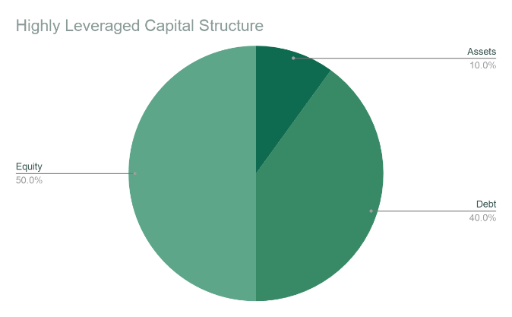

The cost of capital has been evaluated in terms of debt and equity financing instruments.

**Equity Financing:** comprises, venture capital, angel investment, private placements, and public (IPO) offerings. Advantages include increased liquidity, easier access to capital, strong incentive for management, customer recognition and establishes a market value for the Hub. However. Market value may not reflect intrinsic value (i.e. mispricing, takeover threats) and may present mandatory reporting requirements.

**Debt Financing:** As internal forecasts indicate high growth and improving financial strength, short-term debt financing options should be explored. These include short-term bank loans, business loans, bonds, notes and bills. Debt financing is beneficial as it allows for asset-liability maturities matching, reduces short term pressures to report high earnings and grants management with greater flexibility to restructure. Unfortunately, debt financing means that the firm will be leveraged to the hilt which may hinder its ability to raise new capital in the short-run and this financial instrument typically requires collateral in the form of firm assets.

**Proposed Start-up Budget**

|  |  |
| --- | --- |
| **Investment in Technology Divisions** | |
| Division 1: Contributors | $750,000 |
| Division 2: Collectors | $750,000 |
| Division 3: Manufacturers | $750,000 |
| Division 4: Logistics | $750,000 |
| **Sub Total** | **3,000,000‬** |
| **Organisational Cost Breakdown** | |
| **Fixed Costs** | |
| Incorporation Fees  Rental Lease | $50,000 |
| $100,000 |
| Utilities | $100,000 |
| Insurance | $100,000 |
| Office Supplies | $50,000 |
| **Variable Costs** | |
| Salaries  Taxes/annum (gross income dep) | 25-50% |
| 27.5 – 30% |
| Marketing (gross income dep) | 7 – 8% |
| Accounting (gross income dep) | 7 – 8% |

Risks and Return on Investment (ROI)

**Key Business Risks**

|  |  |  |  |
| --- | --- | --- | --- |
|  | Phase | Potential Impact | Possible Mitigation Measures |
| **1** | Manufacturers | Low conversion rate in the process of recycling | • Investment in research and development of garbage conversion rate |
| Safety hazard in factories | • Strict management of production safety |
| **2** | Contributors | Misclassification of garbage may lead to more serious pollution | • Promotion of proper waste segregation  • Bonus for correct garbage classification |
| High learning cost for elderly users | • Develop a more user-friendly interface |
| **3** | Collectors | Huge amounts of scanning devices may cause secondary pollution | • The design for scanning devices takes care to use recyclable materials |
| Improper disposal of garbage in transit | • Strict monitoring and management of transition |
| **4** | Logistics | Damage to goods | • Improving the professionalism of employees  • Improvement of logistics vehicles |
| Delay of transition | • Improving the compensation system for delay  • Building subregional warehousing and logistics |
| Environmental pollution during transport | • Switching to electric vehicles to get rid of exhaust emissions |

***Note:*** *Our belief is that risk management is scalable to the business and hence we intend to perform risk analysis iteratively throughout the lifecycle of the business.*

**Return on Investment (ROI)**

The return on investment (ROI) for our Hub can be measured in threefold, shared-value creation for the Chinese population, the environment and our investor’s bottom line. By recognising that pollution and waste management is a societal issue we utilise our model to work towards reducing pollution and make tangible steps to meeting the CCIED’s productivity of resource target by a factor of 7-10. If achieved the target represents an accumulated savings of over 70 billion for businesses and households in China by 2040 (Li, Qiao, and Shi, 2019).

|  |  |
| --- | --- |
|  | * Specifically target 12.5 on substantially reducing waste generation through prevention, reduction, recycling, and reuse. Our model reinforces this at every stage of the cycle. |
|  | * Challenges the traditional linear “take-make-dispose” model of consumption and ensures that materials constantly flow around a closed loop system. |
|  | * Our rapid development of digital technologies presents significant opportunities to further industrial innovation and circular development across the value chain. |

Furthermore, our model contributes to the following UN Sustainable Development Goals (SDG’s):

We also recognise the commercial viability of our Hub and its stakeholders are integral to its operations and hence we intend to capitalise on this market opportunity to yield higher profit margins and dividends.

Skills Needed

For our project, strong leadership is necessary. A leader with technical skills is significant and we need a CEO who has ability to design the project to achieve great results and organizational skills to assign responsibilities and allocate appropriate resources for teamwork. In details, our CEO should let all members have a great understanding of the individual work and how to make project as successful as possible by addressing the limit of our team and the accessible way to maximize our efforts.

Linking our project to business needs is also a significant aspect that ensure the promotion of the project development and maintenance for our CEO. For problem solving, our CEO should also act a partnership with the administrators and managers with a good communication and evaluate results frequently, pointing out the inadequate parts timely. We also need software engineers to develop software to collect and analyse a variety of data by communicating with our client to focus on and achieve our result. Our software engineers should also act in a status that fits the interests of our client and public.

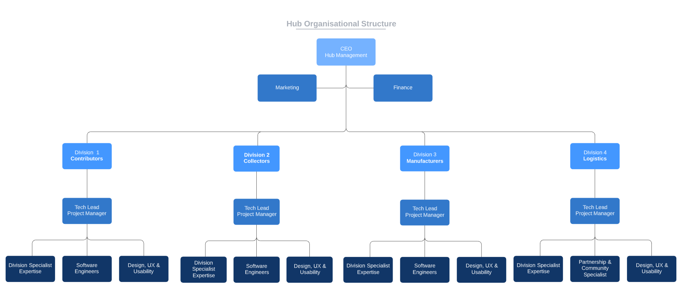**Proposed Organisation Structure of Business**



Expansion Timeline

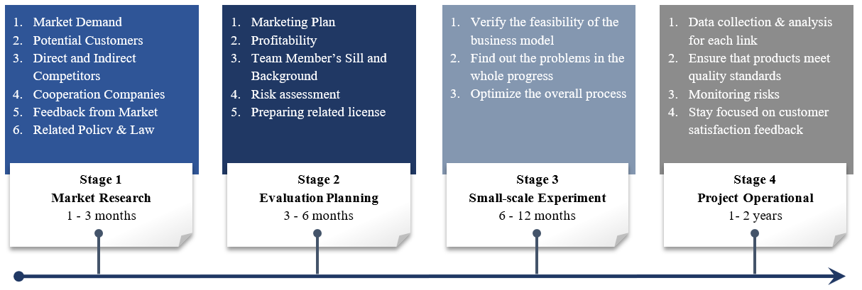

Further considerations:

(i) take a country-specific approach and build-on and expand the existing ecosystem

(ii) involve industry and target demographic to ensure ‘demand pull’ for technology solutions; (iii) leverage ADB’s existing government and corporate networks to help deploy and scale solutions.

Conclusion

Ultimately China and other countries tackling the increasing challenges of pollution and waste will need a unified framework with clear priorities and the right incentives to enable environmentally conscious businesses to thrive. Our application for the Asia Development Bank (ADB) tender is the first step to achieving this, providing a clear framework and model to empower businesses at every stage of the value chain to adopt circular waste management principles. Backed by the ambitious policies of the China Council for International Cooperation on Environment and Development (CCIED), we believe that China’s cities have the opportunity to take centre stage in this transition in addressing systemic issues in pollution and circular waste management at home and abroad.

Bibliography

All plastic waste could be recycled into new plastic | Chalmers . (2020). Retrieved 20 May 2020, from <https://www.chalmers.se/en/departments/see/news/Pages/All-plastic-waste-could-be-recycled-into-new-high-quality-plastic.aspx>

Bai, M., Zhu, L., An, L., Peng, G., & Li, D. (2018). Estimation and prediction of plastic waste annual input into the sea from China. *Acta Oceanologica Sinica*, *37*(11), 26-39. doi: 10.1007/s13131-018-1279-0

Choi, Y. & Zhang, N. (2018). *Special Issue of Sustainable Asia Conference 2014* (2. Edition). London: MDPI AG.

Hambrick, D., & Fredrickson, J. (2001). Are you sure you have a strategy? *The Academy of Management Executive*, 15(4), 48–59. https://doi.org/10.5465/ame.2001.5897655

Hao, J., He, K., Duan, L., Li, J., & Wang, L. (2007). Air pollution and its control in China. *Frontiers Of Environmental Science & Engineering In China*, *1*(2), 129-142. doi: 10.1007/s11783-007-0024-2

Kan, H. (2009). Environment and Health in China: Challenges and Opportunities. *Environmental Health Perspectives*, *117*(12). doi: 10.1289/ehp.0901615

Lin, C., & Nakamura, S. (2018). Approaches to solving China’s marine plastic pollution and CO2 emission problems. *Economic Systems Research*, *31*(2), 143–157. doi: 10.1080/09535314.2018.1486808

Liu, W., Xu, Z., & Yang, T. (2018). Health Effects of Air Pollution in China. *International Journal Of Environmental Research And Public Health*, *15*(7), 1471. doi: 10.3390/ijerph15071471

Li, X., Qiao, Y., & Shi, L. (2019). Has China's war on pollution slowed the growth of its manufacturing and by how much? Evidence from the Clean Air Action. *China Economic Review*, *53*, 271-289. doi: 10.1016/j.chieco.2018.08.015

Ness, D. (2008). Sustainable urban infrastructure in China: Towards a Factor 10 improvement in resource productivity through integrated infrastructure systems. *The International Journal of Sustainable Development and World Ecology* 64(2), p. 10-12.

Rethinking plastic packaging – towards a circular economy, (2020)  Retrieved 3 May 2020, from https://www.unilever.com/sustainable-living/reducing-environmental-impact/waste-and-packaging/rethinking-plastic-packaging/?fbclid=IwAR0q3LxbCH9qvTviIAtEmDnnuyXRLXS8-0RPGAH2iTYQc_kI7zsRamw9LTE

Rice, J., Liao, T., Martin, N., & Galvin, P. (2012). The role of strategic alliances in complementing firm capabilities. Journal Of Management & Organization, 18(6), 858-869. <https://doi.org/10.5172/jmo.2012.18.6.858>

Smartbin | Smart Monitoring and IoT Waste Management | Smart City Solutions. (2019). Retrieved 20 May 2020, from <https://www.smartbin.com/>

Taylor, C., & Okazaki, S. (2015). Do Global Brands Use Similar Executional Styles Across Cultures? A Comparison of U.S. and Japanese Television Advertising. Journal of Advertising, 44(3), 276–288. <https://doi.org/10.1080/00913367.2014.996306>

Unilever. (2020). *Sustainable Living*. Retrieved from the Unilever website: https://www.unilever.com.au/sustainable-living/

Wang, J., Zheng, L., & Li, J. (2018). A critical review on the sources and instruments of marine microplastics and prospects on the relevant management in China. *Waste Management & Research*, *36*(10), 898–911. doi: 10.1177/0734242x18793504

Wang, S., & Hao, J. (2012). Air quality management in China: Issues, challenges, and options. *Journal Of Environmental Sciences*, *24*(1), 2-13. doi: 10.1016/s1001-0742(11)60724-9

Wei, L., & Liu, Y. (2012). Present Status of e-waste Disposal and Recycling in China. *Procedia Environmental Sciences*, *16*, 506-514. doi: 10.1016/j.proenv.2012.10.070

Zhang, J., Mauzerall, D., Zhu, T., Liang, S., Ezzati, M., & Remais, J. (2010). Environmental health in China: progress towards clean air and safe water. *The Lancet*, *375*(9720), 1110-1119. doi: 10.1016/s0140-6736(10)60062-1