Project Model

Lynn Fan

4/26/2020

library(tidyverse)

## ── Attaching packages ──────────────────────────────────────────────────────────────────────────────────────────────────── tidyverse 1.3.0 ──

## ✔ ggplot2 3.2.1 ✔ purrr 0.3.3  
## ✔ tibble 2.1.3 ✔ dplyr 0.8.3  
## ✔ tidyr 1.0.0 ✔ stringr 1.4.0  
## ✔ readr 1.3.1 ✔ forcats 0.4.0

## ── Conflicts ─────────────────────────────────────────────────────────────────────────────────────────────────────── tidyverse_conflicts() ──  
## ✖ dplyr::filter() masks stats::filter()  
## ✖ dplyr::lag() masks stats::lag()

library(dplyr)  
library(glmnet)

## Loading required package: Matrix

##   
## Attaching package: 'Matrix'

## The following objects are masked from 'package:tidyr':  
##   
## expand, pack, unpack

## Loaded glmnet 3.0-2

library(car)

## Loading required package: carData

##   
## Attaching package: 'car'

## The following object is masked from 'package:dplyr':  
##   
## recode

## The following object is masked from 'package:purrr':  
##   
## some

library(MASS)

##   
## Attaching package: 'MASS'

## The following object is masked from 'package:dplyr':  
##   
## select

library(data.table)

##   
## Attaching package: 'data.table'

## The following objects are masked from 'package:dplyr':  
##   
## between, first, last

## The following object is masked from 'package:purrr':  
##   
## transpose

library(bayesm)  
library(ggplot2)  
library(R2admb)  
library(glmmADMB)

##   
## Attaching package: 'glmmADMB'

## The following object is masked from 'package:MASS':  
##   
## stepAIC

## The following object is masked from 'package:stats':  
##   
## step

library(lme4)

## Registered S3 methods overwritten by 'lme4':  
## method from  
## cooks.distance.influence.merMod car   
## influence.merMod car   
## dfbeta.influence.merMod car   
## dfbetas.influence.merMod car

##   
## Attaching package: 'lme4'

## The following object is masked from 'package:glmmADMB':  
##   
## VarCorr

library(tidyr)  
library(mcmc)  
library(dplyr)  
library(reshape2)

##   
## Attaching package: 'reshape2'

## The following objects are masked from 'package:data.table':  
##   
## dcast, melt

## The following object is masked from 'package:tidyr':  
##   
## smiths

library(bayesplot)

## This is bayesplot version 1.7.1

## - Online documentation and vignettes at mc-stan.org/bayesplot

## - bayesplot theme set to bayesplot::theme_default()

## * Does _not_ affect other ggplot2 plots

## * See ?bayesplot_theme_set for details on theme setting

library(varhandle)  
library(loo)

## This is loo version 2.2.0

## - Online documentation and vignettes at mc-stan.org/loo

## - As of v2.0.0 loo defaults to 1 core but we recommend using as many as possible. Use the 'cores' argument or set options(mc.cores = NUM_CORES) for an entire session.

## Data Cleanup

data <- read.table("rawdata.txt",   
 col.names=c('stops', 'pop', 'past.arrests', 'precinct', 'eth', 'crime'),   
 fill=FALSE,   
 strip.white=TRUE)

## Exploratory Data Analysis

r <- c(mean(data$stops), var(data$stops))  
c(mean=r[1], var=r[2], ratio=r[2]/r[1])

## mean var ratio   
## 146.0222 47254.9317 323.6147

Overdispersed, so we should do Negative Binomial instead of Poisson.

png('ran_effect.png')  
data %>%   
 group_by(precinct) %>%  
 ggplot(., mapping = aes(x = as.factor(precinct), y = stops)) +  
 geom_boxplot() + theme(axis.text.x = element_text(angle = 90, hjust=1)) +  
 labs(title="number of stops by precincts", x="precincts")  
dev.off()

## quartz_off_screen   
## 2

stops<-data$stops ; ethi<-as.factor(data$eth) ; precinct<-as.factor(data$precinct);arrest=data$past.arrests  
overdisp_fun <- function(model) {  
 rdf <- df.residual(model)  
 rp <- residuals(model,type="pearson")  
 Pearson.chisq <- sum(rp^2)  
 prat <- Pearson.chisq/rdf  
 pval <- pchisq(Pearson.chisq, df=rdf, lower.tail=FALSE)  
 c(chisq=Pearson.chisq,ratio=prat,rdf=rdf,p=pval)  
}  
# Poisson with random effects  
fit.poi <- glmer(stops~1+ethi+(1|precinct),family = poisson(link = "log"), nAGQ = 100)  
summary(fit.poi)

## Generalized linear mixed model fit by maximum likelihood (Adaptive  
## Gauss-Hermite Quadrature, nAGQ = 100) [glmerMod]  
## Family: poisson ( log )  
## Formula: stops ~ 1 + ethi + (1 | precinct)  
##   
## AIC BIC logLik deviance df.resid   
## 113922.4 113941.6 -56957.2 113914.4 896   
##   
## Scaled residuals:   
## Min 1Q Median 3Q Max   
## -20.035 -7.453 -3.245 3.249 77.185   
##   
## Random effects:  
## Groups Name Variance Std.Dev.  
## precinct (Intercept) 0.3368 0.5803   
## Number of obs: 900, groups: precinct, 75  
##   
## Fixed effects:  
## Estimate Std. Error z value Pr(>|z|)   
## (Intercept) 5.301655 0.067142 78.96 <2e-16 ***  
## ethi2 -0.447714 0.006061 -73.87 <2e-16 ***  
## ethi3 -1.414280 0.008558 -165.26 <2e-16 ***  
## ---  
## Signif. codes: 0 '***' 0.001 '**' 0.01 '*' 0.05 '.' 0.1 ' ' 1  
##   
## Correlation of Fixed Effects:  
## (Intr) ethi2   
## ethi2 -0.035   
## ethi3 -0.025 0.276

overdisp_fun(fit.poi)

## chisq ratio rdf p   
## 144223.2372 160.9634 896.0000 0.0000

# Negative Binomial  
fit.nb <- glmer.nb(stops~1+ethi+(1|precinct), verbose=TRUE)

## theta.ml: iter 0 'theta = 0.610130'

## theta.ml: iter1 theta =0.810456

## theta.ml: iter2 theta =0.914262

## theta.ml: iter3 theta =0.931802

## theta.ml: iter4 theta =0.932198

## theta.ml: iter5 theta =0.932198

## th := est_theta(glmer(..)) = 0.9321982 --> dev.= -2*logLik(.) = 10427.73

## Warning in glmer.nb(stops ~ 1 + ethi + (1 | precinct), verbose = TRUE): no  
## 'data = *' in glmer.nb() call ... Not much is guaranteed

## 1: th= 0.4591337260, dev=10641.90596216, beta[1]= 5.42176950  
## 2: th= 1.892680533, dev=10727.25392378, beta[1]= 5.41299236

## boundary (singular) fit: see ?isSingular

## 3: th= 0.1913211266, dev=11357.19917246, beta[1]= 5.44992947  
## 4: th= 0.8616480080, dev=10430.74019060, beta[1]= 5.40699784  
## 5: th= 0.8779870295, dev=10429.47790274, beta[1]= 5.40706944  
## 6: th= 0.9433502167, dev=10427.80377650, beta[1]= 5.40742909  
## 7: th= 1.230782015, dev=10469.02080218, beta[1]= 5.40958304  
## 8: th= 0.9322493059, dev=10427.72947553, beta[1]= 5.40736521  
## 9: th= 0.9318378247, dev=10427.72942708, beta[1]= 5.40735768  
## 10: th= 0.9319417111, dev=10427.72942344, beta[1]= 5.40736519  
## 11: th= 0.9319250090, dev=10427.72942319, beta[1]= 5.40736519  
## 12: th= 0.9319094760, dev=10427.72942324, beta[1]= 5.40736012  
## 13: th= 0.9319250090, dev=10427.72942319, beta[1]= 5.40736372

summary(fit.nb)

## Generalized linear mixed model fit by maximum likelihood (Laplace  
## Approximation) [glmerMod]  
## Family: Negative Binomial(0.9319) ( log )  
## Formula: stops ~ 1 + ethi + (1 | precinct)  
##   
## AIC BIC logLik deviance df.resid   
## 10437.7 10461.7 -5213.9 10427.7 895   
##   
## Scaled residuals:   
## Min 1Q Median 3Q Max   
## -0.9623 -0.6824 -0.3317 0.2750 6.7019   
##   
## Random effects:  
## Groups Name Variance Std.Dev.  
## precinct (Intercept) 0.1942 0.4407   
## Number of obs: 900, groups: precinct, 75  
##   
## Fixed effects:  
## Estimate Std. Error z value Pr(>|z|)   
## (Intercept) 5.40736 0.08201 65.935 < 2e-16 ***  
## ethi2 -0.56572 0.09288 -6.091 1.12e-09 ***  
## ethi3 -1.52446 0.09599 -15.881 < 2e-16 ***  
## ---  
## Signif. codes: 0 '***' 0.001 '**' 0.01 '*' 0.05 '.' 0.1 ' ' 1  
##   
## Correlation of Fixed Effects:  
## (Intr) ethi2   
## ethi2 -0.568   
## ethi3 -0.575 0.527

overdisp_fun(fit.nb)

## chisq ratio rdf p   
## 1.047986e+03 1.170934e+00 8.950000e+02 2.867296e-04

n <- nrow(data)  
precinct.number <- unique(data$precinct)  
n.precinct <- length(precinct.number)  
precincts <- rep(NA,n)  
pblack <- rep(NA,n.precinct)  
for (i in 1:n.precinct) {  
 temp <- data[data$precinct==i,]  
 blackpop <- temp[temp$eth==1,]$pop[1]  
 totalpop <- temp[temp$eth==1,]$pop[1]+temp[temp$eth==2,]$pop[1]+temp[temp$eth==3,]$pop[1]  
 pblack[i]<-blackpop/totalpop  
}  
precinct.category <- ifelse (pblack < .1, 1, ifelse (pblack < .4, 2, 3))  
arrests <- data$past.arrests  
dcjs <- log(arrests*15/12)  
dcjs[which(!is.finite(dcjs))] <- 0  
crime <- data$crime  
pop <- data$pop  
stop_df <- as.data.frame (cbind(stops, ethi, precinct, crime, precinct.category, arrests, dcjs))  
stop_df$ethi <- as.factor(ethi)  
# Multilevel analysis of NYC police stops  
  
# lmer() fits  
M1 <- as.list (rep (NA, 12))  
M2 <- as.list (rep (NA, 12))  
index <- 0  
for (j in 1:3){  
 for (k in 1:4){  
 index <- index + 1  
 ok <- precinct.category==j & crime==k  
 M1[[index]] <- glmer(stops~1+dcjs+ethi+(1|precinct), #Poisson with random effect  
 family=poisson(link="log"), subset=ok, data=stop_df)  
 #Negative Binomial  
 M2[[index]] <- glmer.nb(stops~1+dcjs+ethi+(1|precinct), verbose=TRUE,subset=ok,data=stop_df,nAGQ=0)  
 }  
}

## theta.ml: iter 0 'theta = 16.005300'

## theta.ml: iter1 theta =28.0078

## theta.ml: iter2 theta =47.4186

## theta.ml: iter3 theta =77.8122

## theta.ml: iter4 theta =124.182

## theta.ml: iter5 theta =193.545

## theta.ml: iter6 theta =296.19

## theta.ml: iter7 theta =448.003

## theta.ml: iter8 theta =674.091

## theta.ml: iter9 theta =1013.84

## theta.ml: iter10 theta =1527.57

## theta.ml: iter11 theta =2305.62

## theta.ml: iter12 theta =3481.94

## theta.ml: iter13 theta =5255.63

## theta.ml: iter14 theta =7924.1

## theta.ml: iter15 theta =11933

## theta.ml: iter16 theta =17951

## theta.ml: iter17 theta =26981.3

## theta.ml: iter18 theta =40529

## theta.ml: iter19 theta =60852.1

## Warning in theta.ml(Y, mu, weights = object@resp$weights, limit = limit, :  
## iteration limit reached

## th := est_theta(glmer(..)) = 60852.13 --> dev.= -2*logLik(.) = 682.4184   
## 1: th= 29971.37919, dev= 682.34334344, beta[1]= -1.11567969  
## 2: th= 123550.5970, dev= 682.45547003, beta[1]= -1.11659032  
## 3: th= 12489.08043, dev= 682.13828787, beta[1]= -1.11400540  
## 4: th= 7270.572483, dev= 681.88975432, beta[1]= -1.11195732  
## 5: th= 5204.202615, dev= 681.65736979, beta[1]= -1.11002498  
## 6: th= 4232.595389, dev= 681.47230657, beta[1]= -1.10847403  
## 7: th= 3725.115859, dev= 681.33872254, beta[1]= -1.10734785  
## 8: th= 3442.383982, dev= 681.24791369, beta[1]= -1.10657913  
## 9: th= 3278.482087, dev= 681.18840690, beta[1]= -1.10607408  
## 10: th= 3181.111120, dev= 681.15027960, beta[1]= -1.10574983  
## 11: th= 3122.384037, dev= 681.12618599, beta[1]= -1.10554475  
## 12: th= 3086.632072, dev= 681.11108966, beta[1]= -1.10541618  
## 13: th= 3064.741125, dev= 681.10168025, beta[1]= -1.10533587  
## 14: th= 3051.289474, dev= 681.09583443, beta[1]= -1.10528614  
## 15: th= 3043.005434, dev= 681.09220981, beta[1]= -1.10525527  
## 16: th= 3037.896864, dev= 681.08996519, beta[1]= -1.10523601  
## 17: th= 3034.743884, dev= 681.08857623, beta[1]= -1.10522416  
## 18: th= 3032.796871, dev= 681.08771715, beta[1]= -1.10521696  
## 19: th= 3031.594176, dev= 681.08718596, beta[1]= -1.10521213  
## 20: th= 3030.851108, dev= 681.08685757, beta[1]= -1.10520955  
## 21: th= 3030.391957, dev= 681.08665458, beta[1]= -1.10520787  
## 22: th= 3030.108222, dev= 681.08652911, beta[1]= -1.10520679  
## 23: th= 3029.932877, dev= 681.08645156, beta[1]= -1.10520608  
## 24: th= 3029.824513, dev= 681.08640363, beta[1]= -1.10520562  
## 25: th= 3029.757542, dev= 681.08637401, beta[1]= -1.10520548  
## 26: th= 3029.706684, dev= 681.08635151, beta[1]= -1.10520530  
## 27: th= 3029.706684, dev= 681.08635151, beta[1]= -1.10520530

## theta.ml: iter 0 'theta = 6.681820'

## theta.ml: iter1 theta =11.5403

## theta.ml: iter2 theta =19.4024

## theta.ml: iter3 theta =31.716

## theta.ml: iter4 theta =50.4175

## theta.ml: iter5 theta =78.2957

## theta.ml: iter6 theta =120.251

## theta.ml: iter7 theta =187.13

## theta.ml: iter8 theta =306.843

## theta.ml: iter9 theta =546.648

## theta.ml: iter10 theta =996.849

## theta.ml: iter11 theta =1718.91

## theta.ml: iter12 theta =2810.2

## theta.ml: iter13 theta =4440.42

## theta.ml: iter14 theta =6873.08

## theta.ml: iter15 theta =10507.7

## theta.ml: iter16 theta =15945.9

## theta.ml: iter17 theta =24091.6

## theta.ml: iter18 theta =36300.9

## theta.ml: iter19 theta =54608

## Warning in theta.ml(Y, mu, weights = object@resp$weights, limit = limit, :  
## iteration limit reached

## th := est_theta(glmer(..)) = 54608.02 --> dev.= -2*logLik(.) = 857.4893   
## 1: th= 26895.98211, dev= 857.25633627, beta[1]= 0.29984549  
## 2: th= 110872.9306, dev= 857.60426731, beta[1]= 0.29849855  
## 3: th= 11207.56177, dev= 856.61937263, beta[1]= 0.30234592  
## 4: th= 6524.530825, dev= 855.84625294, beta[1]= 0.30543582  
## 5: th= 4670.193504, dev= 855.12234114, beta[1]= 0.30838083  
## 6: th= 3798.283993, dev= 854.54516613, beta[1]= 0.31076280  
## 7: th= 3342.877511, dev= 854.12818438, beta[1]= 0.31250154  
## 8: th= 3089.157072, dev= 853.84455638, beta[1]= 0.31369225  
## 9: th= 2942.073335, dev= 853.65862257, beta[1]= 0.31447655  
## 10: th= 2854.693713, dev= 853.53946054, beta[1]= 0.31498056  
## 11: th= 2801.992682, dev= 853.46414691, beta[1]= 0.31529966  
## 12: th= 2769.909267, dev= 853.41695289, beta[1]= 0.31549986  
## 13: th= 2750.264575, dev= 853.38753545, beta[1]= 0.31562475  
## 14: th= 2738.193213, dev= 853.36925840, beta[1]= 0.31570234  
## 15: th= 2730.759207, dev= 853.35792572, beta[1]= 0.31575052  
## 16: th= 2726.174834, dev= 853.35090763, beta[1]= 0.31578030  
## 17: th= 2723.345385, dev= 853.34656482, beta[1]= 0.31579885  
## 18: th= 2721.598157, dev= 853.34387875, beta[1]= 0.31581022  
## 19: th= 2720.518872, dev= 853.34221788, beta[1]= 0.31581725  
## 20: th= 2719.852051, dev= 853.34119110, beta[1]= 0.31582167  
## 21: th= 2719.440014, dev= 853.34055641, beta[1]= 0.31582428  
## 22: th= 2719.185393, dev= 853.34016410, beta[1]= 0.31582595  
## 23: th= 2719.028040, dev= 853.33992162, beta[1]= 0.31582692  
## 24: th= 2718.930796, dev= 853.33977176, beta[1]= 0.31582765  
## 25: th= 2718.870697, dev= 853.33967913, beta[1]= 0.31582800  
## 26: th= 2718.825062, dev= 853.33960880, beta[1]= 0.31582826  
## 27: th= 2718.825062, dev= 853.33960880, beta[1]= 0.31582836

## theta.ml: iter 0 'theta = 0.220793'

## theta.ml: iter1 theta =0.40472

## theta.ml: iter2 theta =0.734929

## theta.ml: iter3 theta =1.33002

## theta.ml: iter4 theta =2.40162

## theta.ml: iter5 theta =4.301

## theta.ml: iter6 theta =7.55052

## theta.ml: iter7 theta =12.8182

## theta.ml: iter8 theta =20.8427

## theta.ml: iter9 theta =32.4058

## theta.ml: iter10 theta =48.3966

## theta.ml: iter11 theta =69.8888

## theta.ml: iter12 theta =98.1217

## theta.ml: iter13 theta =134.231

## theta.ml: iter14 theta =178.474

## theta.ml: iter15 theta =228.683

## theta.ml: iter16 theta =278.121

## theta.ml: iter17 theta =315.042

## theta.ml: iter18 theta =330.74

## theta.ml: iter19 theta =332.918

## Warning in theta.ml(Y, mu, weights = object@resp$weights, limit = limit, :  
## iteration limit reached

## th := est_theta(glmer(..)) = 332.9184 --> dev.= -2*logLik(.) = 804.8207   
## 1: th= 163.9716327, dev= 793.66688602, beta[1]= -1.36057114  
## 2: th= 675.9379666, dev= 811.88139027, beta[1]= -1.48091290  
## 3: th= 68.32701610, dev= 774.65129909, beta[1]= -1.22302681  
## 4: th= 39.77686956, dev= 761.83626636, beta[1]= -1.10736785  
## 5: th= 28.47188293, dev= 754.40677891, beta[1]= -1.02119653  
## 6: th= 23.15627759, dev= 750.21586695, beta[1]= -0.96100827  
## 7: th= 20.37988727, dev= 747.82200424, beta[1]= -0.92066545  
## 8: th= 18.83307799, dev= 746.42608120, beta[1]= -0.89436727  
## 9: th= 17.93638047, dev= 745.59702917, beta[1]= -0.87754518  
## 10: th= 17.40366970, dev= 745.09788146, beta[1]= -0.86691862  
## 11: th= 17.08237733, dev= 744.79452759, beta[1]= -0.86026004  
## 12: th= 16.88678045, dev= 744.60902468, beta[1]= -0.85610925  
## 13: th= 16.76701639, dev= 744.49513807, beta[1]= -0.85353014  
## 14: th= 16.69342320, dev= 744.42504372, beta[1]= -0.85193087  
## 15: th= 16.64810171, dev= 744.38183456, beta[1]= -0.85094039  
## 16: th= 16.62015303, dev= 744.35517250, beta[1]= -0.85032747  
## 17: th= 16.60290326, dev= 744.33871074, beta[1]= -0.84994841  
## 18: th= 16.59225127, dev= 744.32854304, beta[1]= -0.84971400  
## 19: th= 16.58567140, dev= 744.32226144, beta[1]= -0.84956905  
## 20: th= 16.58160612, dev= 744.31838012, beta[1]= -0.84947951  
## 21: th= 16.57909413, dev= 744.31598166, beta[1]= -0.84942417  
## 22: th= 16.57754183, dev= 744.31449946, beta[1]= -0.84938992  
## 23: th= 16.57658253, dev= 744.31358348, beta[1]= -0.84936873  
## 24: th= 16.57598967, dev= 744.31301739, beta[1]= -0.84935561  
## 25: th= 16.57562328, dev= 744.31266754, beta[1]= -0.84934761  
## 26: th= 16.57534633, dev= 744.31240303, beta[1]= -0.84934148  
## 27: th= 16.57534633, dev= 744.31240318, beta[1]= -0.84934146

## theta.ml: iter 0 'theta = 6.367940'

## theta.ml: iter1 theta =10.2142

## theta.ml: iter2 theta =14.9763

## theta.ml: iter3 theta =19.5793

## theta.ml: iter4 theta =22.4725

## theta.ml: iter5 theta =23.2757

## theta.ml: iter6 theta =23.3238

## theta.ml: iter7 theta =23.324

## theta.ml: iter8 theta =23.324

## th := est_theta(glmer(..)) = 23.32396 --> dev.= -2*logLik(.) = 700.1186   
## 1: th= 11.48770215, dev= 683.30365569, beta[1]= -1.55019502  
## 2: th= 47.35559379, dev= 726.12403723, beta[1]= -2.00100782  
## 3: th= 4.786928061, dev= 674.43384558, beta[1]= -0.92033123  
## 4: th= 4.161655243, dev= 673.90290301, beta[1]= -0.77880802  
## 5: th= 3.294099069, dev= 673.36267368, beta[1]= -0.50869929  
## 6: th= 2.211951594, dev= 673.06472999, beta[1]= 0.06149685  
## 7: th= 2.320348258, dev= 673.07013702, beta[1]= -0.01355320  
## 8: th= 2.195955918, dev= 673.06451803, beta[1]= 0.07332785  
## 9: th= 2.182882497, dev= 673.06437617, beta[1]= 0.08497234  
## 10: th= 1.715256416, dev= 673.25491377, beta[1]= 0.47866658  
## 11: th= 2.127157847, dev= 673.06722691, beta[1]= 0.12418215  
## 12: th= 2.182846090, dev= 673.06475025, beta[1]= 0.08269641  
## 13: th= 2.187866887, dev= 673.06418670, beta[1]= 0.08312717  
## 14: th= 2.188511184, dev= 673.06436344, beta[1]= 0.08482379  
## 15: th= 2.185715388, dev= 673.06490800, beta[1]= 0.08427020  
## 16: th= 2.187044838, dev= 673.06435549, beta[1]= 0.08561931  
## 17: th= 2.187769604, dev= 673.06496702, beta[1]= 0.08309039  
## 18: th= 2.188112964, dev= 673.06432098, beta[1]= 0.08463423  
## 19: th= 2.187960877, dev= 673.06492579, beta[1]= 0.08290310  
## 20: th= 2.187829728, dev= 673.06430183, beta[1]= 0.08459129  
## 21: th= 2.187903377, dev= 673.06491781, beta[1]= 0.08293394  
## 22: th= 2.187866887, dev= 673.06430501, beta[1]= 0.08460476

## theta.ml: iter 0 'theta = 10.388200'

## theta.ml: iter1 theta =16.8575

## theta.ml: iter2 theta =25.8566

## theta.ml: iter3 theta =36.8388

## theta.ml: iter4 theta =47.7094

## theta.ml: iter5 theta =55.1196

## theta.ml: iter6 theta =57.5782

## theta.ml: iter7 theta =57.7849

## theta.ml: iter8 theta =57.7862

## theta.ml: iter9 theta =57.7862

## th := est_theta(glmer(..)) = 57.78624 --> dev.= -2*logLik(.) = 1101.886   
## 1: th= 28.46134463, dev= 1076.65990376, beta[1]= -0.32799663  
## 2: th= 117.3258026, dev= 1135.11708624, beta[1]= -0.30120361  
## 3: th= 11.85984869, dev= 1062.16682109, beta[1]= -0.31415665  
## 4: th= 8.527038855, dev= 1061.50877375, beta[1]= -0.28844948  
## 5: th= 9.259513575, dev= 1061.44895202, beta[1]= -0.29651938  
## 6: th= 9.184047021, dev= 1061.44796116, beta[1]= -0.29528671  
## 7: th= 9.172907631, dev= 1061.44849085, beta[1]= -0.29501177  
## 8: th= 9.212297961, dev= 1061.44846146, beta[1]= -0.29618614  
## 9: th= 9.194827680, dev= 1061.44807621, beta[1]= -0.29526042  
## 10: th= 9.176250094, dev= 1061.44850914, beta[1]= -0.29504295  
## 11: th= 9.188163373, dev= 1061.44846848, beta[1]= -0.29614064  
## 12: th= 9.181068078, dev= 1061.44804748, beta[1]= -0.29512568  
## 13: th= 9.187582899, dev= 1061.44855596, beta[1]= -0.29515112  
## 14: th= 9.185397446, dev= 1061.44853247, beta[1]= -0.29513124  
## 15: th= 9.182909052, dev= 1061.44853936, beta[1]= -0.29510605  
## 16: th= 9.184562814, dev= 1061.44854875, beta[1]= -0.29512165  
## 17: th= 9.183612339, dev= 1061.44854254, beta[1]= -0.29511272  
## 18: th= 9.184244033, dev= 1061.44854612, beta[1]= -0.29511868  
## 19: th= 9.183880985, dev= 1061.44854375, beta[1]= -0.29511527  
## 20: th= 9.184047021, dev= 1061.44854510, beta[1]= -0.29511681

## theta.ml: iter 0 'theta = 6.596650'

## theta.ml: iter1 theta =10.154

## theta.ml: iter2 theta =14.2736

## theta.ml: iter3 theta =17.9897

## theta.ml: iter4 theta =20.1156

## theta.ml: iter5 theta =20.6171

## theta.ml: iter6 theta =20.6394

## theta.ml: iter7 theta =20.6395

## th := est_theta(glmer(..)) = 20.63946 --> dev.= -2*logLik(.) = 1046.116   
## 1: th= 10.16551473, dev= 1032.56918268, beta[1]= 0.83367738  
## 2: th= 41.90515909, dev= 1078.43202850, beta[1]= 0.85008532  
## 3: th= 4.235972266, dev= 1038.10567900, beta[1]= 0.91363082  
## 4: th= 7.913392892, dev= 1031.92376260, beta[1]= 0.84632097  
## 5: th= 8.193297459, dev= 1031.89631365, beta[1]= 0.84425264  
## 6: th= 8.258400227, dev= 1031.89534533, beta[1]= 0.84358415  
## 7: th= 8.258026200, dev= 1031.89484104, beta[1]= 0.84399785  
## 8: th= 8.226136212, dev= 1031.89559318, beta[1]= 0.84429406  
## 9: th= 8.245830742, dev= 1031.89532427, beta[1]= 0.84385043  
## 10: th= 8.252105510, dev= 1031.89513355, beta[1]= 0.84410892  
## 11: th= 8.255764196, dev= 1031.89528017, beta[1]= 0.84373461  
## 12: th= 8.257162118, dev= 1031.89503049, beta[1]= 0.84407395  
## 13: th= 8.257696139, dev= 1031.89527813, beta[1]= 0.84371074  
## 14: th= 8.258169063, dev= 1031.89500977, beta[1]= 0.84406702  
## 15: th= 8.257888307, dev= 1031.89527853, beta[1]= 0.84370671  
## 16: th= 8.258026200, dev= 1031.89500466, beta[1]= 0.84406822

## theta.ml: iter 0 'theta = 20.965100'

## theta.ml: iter1 theta =30.2205

## theta.ml: iter2 theta =38.5708

## theta.ml: iter3 theta =43.1268

## theta.ml: iter4 theta =44.0821

## theta.ml: iter5 theta =44.1158

## theta.ml: iter6 theta =44.1159

## th := est_theta(glmer(..)) = 44.11587 --> dev.= -2*logLik(.) = 1062.737   
## 1: th= 21.72830369, dev= 1046.72300853, beta[1]= 0.13888976  
## 2: th= 89.57028221, dev= 1094.54045587, beta[1]= 0.00986151  
## 3: th= 9.054189019, dev= 1046.80514749, beta[1]= 0.31916985  
## 4: th= 14.07074337, dev= 1044.37062887, beta[1]= 0.21323946  
## 5: th= 14.07889854, dev= 1044.37013401, beta[1]= 0.21361024  
## 6: th= 14.49714760, dev= 1044.37081383, beta[1]= 0.20774950  
## 7: th= 14.23721193, dev= 1044.36778289, beta[1]= 0.21135176  
## 8: th= 14.18505140, dev= 1044.36829791, beta[1]= 0.21209671  
## 9: th= 14.33594381, dev= 1044.36801940, beta[1]= 0.20997329  
## 10: th= 14.27167994, dev= 1044.36774684, beta[1]= 0.21086984  
## 11: th= 14.26415613, dev= 1044.36777760, beta[1]= 0.21097707  
## 12: th= 14.29619248, dev= 1044.36779579, beta[1]= 0.21052728  
## 13: th= 14.28103793, dev= 1044.36776113, beta[1]= 0.21073917  
## 14: th= 14.27406123, dev= 1044.36776546, beta[1]= 0.21083754  
## 15: th= 14.26880563, dev= 1044.36777116, beta[1]= 0.21091160  
## 16: th= 14.27058198, dev= 1044.36777163, beta[1]= 0.21088676  
## 17: th= 14.27258946, dev= 1044.36776984, beta[1]= 0.21085847  
## 18: th= 14.27126055, dev= 1044.36776982, beta[1]= 0.21087711  
## 19: th= 14.27202734, dev= 1044.36776986, beta[1]= 0.21086637  
## 20: th= 14.27167994, dev= 1044.36776978, beta[1]= 0.21087124

## theta.ml: iter 0 'theta = 6.752810'

## theta.ml: iter1 theta =10.2475

## theta.ml: iter2 theta =14.3831

## theta.ml: iter3 theta =18.3071

## theta.ml: iter4 theta =20.7815

## theta.ml: iter5 theta =21.4835

## theta.ml: iter6 theta =21.5273

## theta.ml: iter7 theta =21.5275

## theta.ml: iter8 theta =21.5275

## th := est_theta(glmer(..)) = 21.52747 --> dev.= -2*logLik(.) = 977.3329   
## 1: th= 10.60288085, dev= 953.69206997, beta[1]= -1.21703349  
## 2: th= 43.70810732, dev= 1007.99396796, beta[1]= -1.90055665  
## 3: th= 4.418222826, dev= 938.44235614, beta[1]= -0.50479347  
## 4: th= 2.635552354, dev= 937.94710794, beta[1]= -0.09224963  
## 5: th= 3.276860535, dev= 937.31322161, beta[1]= -0.26078825  
## 6: th= 3.288377013, dev= 937.31343601, beta[1]= -0.26346951  
## 7: th= 3.275152156, dev= 937.31273253, beta[1]= -0.26017971  
## 8: th= 3.014319145, dev= 937.40517457, beta[1]= -0.19541395  
## 9: th= 3.172959779, dev= 937.32700956, beta[1]= -0.23540413  
## 10: th= 3.235735307, dev= 937.31559997, beta[1]= -0.25047137  
## 11: th= 3.260039899, dev= 937.31366821, beta[1]= -0.25640905  
## 12: th= 3.269371536, dev= 937.31335397, beta[1]= -0.25887261  
## 13: th= 3.273281873, dev= 937.31294200, beta[1]= -0.25746460  
## 14: th= 3.274719765, dev= 937.31330650, beta[1]= -0.25999352  
## 15: th= 3.275804593, dev= 937.31289261, beta[1]= -0.25830130  
## 16: th= 3.275401350, dev= 937.31329606, beta[1]= -0.26017278  
## 17: th= 3.274986991, dev= 937.31286859, beta[1]= -0.25830432  
## 18: th= 3.275247337, dev= 937.31329503, beta[1]= -0.26013869  
## 19: th= 3.275089067, dev= 937.31287261, beta[1]= -0.25829680  
## 20: th= 3.275152156, dev= 937.31329556, beta[1]= -0.26011557

## Warning in checkConv(attr(opt, "derivs"), opt$par, ctrl =  
## control$checkConv, : Model failed to converge with max|grad| = 0.00120311  
## (tol = 0.001, component 1)

## theta.ml: iter 0 'theta = 16.111700'

## theta.ml: iter1 theta =25.2129

## theta.ml: iter2 theta =36.2259

## theta.ml: iter3 theta =46.9926

## theta.ml: iter4 theta =54.2758

## theta.ml: iter5 theta =56.6948

## theta.ml: iter6 theta =56.9003

## theta.ml: iter7 theta =56.9017

## theta.ml: iter8 theta =56.9017

## th := est_theta(glmer(..)) = 56.90167 --> dev.= -2*logLik(.) = 611.3818   
## 1: th= 28.02566505, dev= 597.45513844, beta[1]= 0.44007628  
## 2: th= 115.5298068, dev= 629.91508469, beta[1]= 0.51041861  
## 3: th= 11.67830091, dev= 589.36084979, beta[1]= 0.38463594  
## 4: th= 8.334165173, dev= 588.56246706, beta[1]= 0.36796143  
## 5: th= 8.008263360, dev= 588.52963855, beta[1]= 0.36651198  
## 6: th= 7.387894954, dev= 588.49514036, beta[1]= 0.36398030  
## 7: th= 5.122904000, dev= 588.69601094, beta[1]= 0.36491459  
## 8: th= 7.205961305, dev= 588.49282716, beta[1]= 0.36329089  
## 9: th= 7.190509344, dev= 588.49206625, beta[1]= 0.36344022  
## 10: th= 6.317098758, dev= 588.52878948, beta[1]= 0.36128127  
## 11: th= 6.843481963, dev= 588.49750319, beta[1]= 0.36220359  
## 12: th= 7.055926682, dev= 588.49317859, beta[1]= 0.36285723  
## 13: th= 7.133581301, dev= 588.49270358, beta[1]= 0.36317584  
## 14: th= 7.168660809, dev= 588.49264247, beta[1]= 0.36328770  
## 15: th= 7.182156097, dev= 588.49226917, beta[1]= 0.36388077  
## 16: th= 7.196407553, dev= 588.49277460, beta[1]= 0.36338139  
## 17: th= 7.187317541, dev= 588.49211983, beta[1]= 0.36362277  
## 18: th= 7.192761688, dev= 588.49270761, beta[1]= 0.36331864  
## 19: th= 7.189290016, dev= 588.49213634, beta[1]= 0.36364824  
## 20: th= 7.191369579, dev= 588.49270007, beta[1]= 0.36329201  
## 21: th= 7.190043578, dev= 588.49214134, beta[1]= 0.36365502  
## 22: th= 7.190837912, dev= 588.49269727, beta[1]= 0.36327881  
## 23: th= 7.190331433, dev= 588.49214200, beta[1]= 0.36365442  
## 24: th= 7.190634844, dev= 588.49269614, beta[1]= 0.36327060  
## 25: th= 7.190509344, dev= 588.49214119, beta[1]= 0.36365230

## theta.ml: iter 0 'theta = 13.718200'

## theta.ml: iter1 theta =17.6097

## theta.ml: iter2 theta =19.7313

## theta.ml: iter3 theta =20.1764

## theta.ml: iter4 theta =20.1922

## theta.ml: iter5 theta =20.1922

## th := est_theta(glmer(..)) = 20.19224 --> dev.= -2*logLik(.) = 712.9688   
## 1: th= 9.945242466, dev= 696.19340019, beta[1]= 0.79757612  
## 2: th= 40.99713383, dev= 743.29221173, beta[1]= 0.88255157  
## 3: th= 4.144184766, dev= 688.79184957, beta[1]= 0.97308528  
## 4: th= 4.343495158, dev= 688.84546975, beta[1]= 0.95296384  
## 5: th= 3.977064136, dev= 688.79192724, beta[1]= 0.99173163  
## 6: th= 4.060059860, dev= 688.78623333, beta[1]= 0.98226960  
## 7: th= 4.059992108, dev= 688.78621592, beta[1]= 0.98257076  
## 8: th= 4.028114276, dev= 688.78704280, beta[1]= 0.98577741  
## 9: th= 4.045481528, dev= 688.78638484, beta[1]= 0.98394789  
## 10: th= 4.053045746, dev= 688.78628692, beta[1]= 0.98335515  
## 11: th= 4.056651510, dev= 688.78622994, beta[1]= 0.98266104  
## 12: th= 4.058348830, dev= 688.78622478, beta[1]= 0.98275580  
## 13: th= 4.059364353, dev= 688.78622411, beta[1]= 0.98224442  
## 14: th= 4.059752316, dev= 688.78621173, beta[1]= 0.98259644  
## 15: th= 4.059820063, dev= 688.78622662, beta[1]= 0.98210110  
## 16: th= 4.059684569, dev= 688.78620464, beta[1]= 0.98258663  
## 17: th= 4.059562254, dev= 688.78622796, beta[1]= 0.98209448  
## 18: th= 4.059684569, dev= 688.78620414, beta[1]= 0.98257572

## theta.ml: iter 0 'theta = 0.919633'

## theta.ml: iter1 theta =1.63491

## theta.ml: iter2 theta =2.84507

## theta.ml: iter3 theta =4.74288

## theta.ml: iter4 theta =7.36666

## theta.ml: iter5 theta =10.3314

## theta.ml: iter6 theta =12.6999

## theta.ml: iter7 theta =13.694

## theta.ml: iter8 theta =13.8187

## theta.ml: iter9 theta =13.8204

## theta.ml: iter10 theta =13.8204

## th := est_theta(glmer(..)) = 13.82042 --> dev.= -2*logLik(.) = 677.5277   
## 1: th= 6.806945644, dev= 660.96639966, beta[1]= -0.30578387  
## 2: th= 28.06017677, dev= 705.49337239, beta[1]= -0.92819274  
## 3: th= 2.836455776, dev= 653.88960863, beta[1]= 0.14945489  
## 4: th= 2.955181188, dev= 653.95226511, beta[1]= 0.12807090  
## 5: th= 2.626949205, dev= 653.82612502, beta[1]= 0.19036549  
## 6: th= 1.574775274, dev= 654.30649432, beta[1]= 0.53531692  
## 7: th= 2.546399903, dev= 653.81850635, beta[1]= 0.20733036  
## 8: th= 2.528451733, dev= 653.81795861, beta[1]= 0.21137801  
## 9: th= 2.515054110, dev= 653.81794152, beta[1]= 0.21428738  
## 10: th= 2.521067036, dev= 653.81806613, beta[1]= 0.21305849  
## 11: th= 2.103210121, dev= 653.94078214, beta[1]= 0.32038437  
## 12: th= 2.348994873, dev= 653.83993617, beta[1]= 0.25278831  
## 13: th= 2.450282794, dev= 653.82185801, beta[1]= 0.22873038  
## 14: th= 2.490113996, dev= 653.81879465, beta[1]= 0.21967219  
## 15: th= 2.505498485, dev= 653.81828080, beta[1]= 0.21647382  
## 16: th= 2.511399892, dev= 653.81814967, beta[1]= 0.21526943  
## 17: th= 2.517349149, dev= 653.81809332, beta[1]= 0.21403221  
## 18: th= 2.513657695, dev= 653.81789968, beta[1]= 0.21488734  
## 19: th= 2.512795052, dev= 653.81796379, beta[1]= 0.21549814  
## 20: th= 2.514190987, dev= 653.81812324, beta[1]= 0.21472603  
## 21: th= 2.513328160, dev= 653.81794410, beta[1]= 0.21529933  
## 22: th= 2.513861381, dev= 653.81811434, beta[1]= 0.21468994  
## 23: th= 2.513531819, dev= 653.81793506, beta[1]= 0.21520907  
## 24: th= 2.513735495, dev= 653.81811177, beta[1]= 0.21463267  
## 25: th= 2.513609614, dev= 653.81792585, beta[1]= 0.21513224  
## 26: th= 2.513657695, dev= 653.81801888, beta[1]= 0.21565268

## theta.ml: iter 0 'theta = 12.159800'

## theta.ml: iter1 theta =20.3462

## theta.ml: iter2 theta =32.4899

## theta.ml: iter3 theta =49.3889

## theta.ml: iter4 theta =71.2616

## theta.ml: iter5 theta =96.9624

## theta.ml: iter6 theta =122.869

## theta.ml: iter7 theta =142.586

## theta.ml: iter8 theta =151.148

## theta.ml: iter9 theta =152.374

## theta.ml: iter10 theta =152.396

## theta.ml: iter11 theta =152.396

## th := est_theta(glmer(..)) = 152.396 --> dev.= -2*logLik(.) = 580.8714   
## 1: th= 75.05928028, dev= 571.18259533, beta[1]= -1.45650983  
## 2: th= 309.4158206, dev= 589.47395485, beta[1]= -1.76785967  
## 3: th= 31.27721892, dev= 561.10588599, beta[1]= -1.14899190  
## 4: th= 18.20816901, dev= 557.13717361, beta[1]= -0.89358823  
## 5: th= 13.03322414, dev= 555.62209228, beta[1]= -0.70741421  
## 6: th= 10.59996477, dev= 555.02206979, beta[1]= -0.58293664  
## 7: th= 9.329050675, dev= 554.77343041, beta[1]= -0.50318417  
## 8: th= 8.620986791, dev= 554.66513248, beta[1]= -0.45304433  
## 9: th= 8.210516581, dev= 554.61526958, beta[1]= -0.42184684  
## 10: th= 7.966664116, dev= 554.58992666, beta[1]= -0.40566232  
## 11: th= 7.819590050, dev= 554.57829409, beta[1]= -0.39042135  
## 12: th= 7.730054072, dev= 554.57028229, beta[1]= -0.38217087  
## 13: th= 7.675231147, dev= 554.56655012, beta[1]= -0.37578565  
## 14: th= 7.641543299, dev= 554.56470862, beta[1]= -0.37055358  
## 15: th= 7.620797036, dev= 554.56405738, beta[1]= -0.37370397  
## 16: th= 7.594923995, dev= 554.56131504, beta[1]= -0.36893406  
## 17: th= 7.604796233, dev= 554.56302797, beta[1]= -0.37262138  
## 18: th= 7.598693340, dev= 554.56159403, beta[1]= -0.36891691  
## 19: th= 7.594541774, dev= 554.56238891, beta[1]= -0.37184112  
## 20: th= 7.596755137, dev= 554.56149736, beta[1]= -0.36859002  
## 21: th= 7.595623377, dev= 554.56245616, beta[1]= -0.37167491  
## 22: th= 7.595191127, dev= 554.56142687, beta[1]= -0.36828070  
## 23: th= 7.594777997, dev= 554.56240578, beta[1]= -0.37149696  
## 24: th= 7.595050807, dev= 554.56143835, beta[1]= -0.36814204  
## 25: th= 7.594923995, dev= 554.56241636, beta[1]= -0.37150853

M1[1]

## [[1]]  
## Generalized linear mixed model fit by maximum likelihood (Laplace  
## Approximation) [glmerMod]  
## Family: poisson ( log )  
## Formula: stops ~ 1 + dcjs + ethi + (1 | precinct)  
## Data: stop_df  
## Subset: ok  
## AIC BIC logLik deviance df.resid   
## 692.4676 703.6381 -341.2338 682.4676 64   
## Random effects:  
## Groups Name Std.Dev.  
## precinct (Intercept) 0.5812   
## Number of obs: 69, groups: precinct, 51  
## Fixed Effects:  
## (Intercept) dcjs ethi2 ethi3   
## -1.1428 1.0574 -0.2087 -0.7308

M2[1]

## [[1]]  
## Generalized linear mixed model fit by maximum likelihood (Adaptive  
## Gauss-Hermite Quadrature, nAGQ = 0) [glmerMod]  
## Family: Negative Binomial(3029.707) ( log )  
## Formula: stops ~ 1 + dcjs + ethi + (1 | precinct)  
## Data: stop_df  
## Subset: ok  
## AIC BIC logLik deviance df.resid   
## 693.0864 706.4910 -340.5432 681.0864 63   
## Random effects:  
## Groups Name Std.Dev.  
## precinct (Intercept) 0.5806   
## Number of obs: 69, groups: precinct, 51  
## Fixed Effects:  
## (Intercept) dcjs ethi2 ethi3   
## -1.1052 1.0529 -0.2125 -0.7315

anova(M1[[2]],M2[[2]])

## Data: stop_df  
## Subset: ok  
## Models:  
## M1[[2]]: stops ~ 1 + dcjs + ethi + (1 | precinct)  
## M2[[2]]: stops ~ 1 + dcjs + ethi + (1 | precinct)  
## Df AIC BIC logLik deviance Chisq Chi Df Pr(>Chisq)   
## M1[[2]] 5 867.71 878.88 -428.86 857.71   
## M2[[2]] 6 865.34 878.74 -426.67 853.34 4.3706 1 0.03656 *  
## ---  
## Signif. codes: 0 '***' 0.001 '**' 0.01 '*' 0.05 '.' 0.1 ' ' 1

negative binomial with overdispersion effect

how do we know proposal distribution? MVN Poisson GLM with random effects If NB: link function for negative binomial, try a bayesian glm package, see the parametization, and change the link for negative binomial, the r parameter: you need to sample both from beta and r for posterior sampling

prior for beta: MVN or whatever in the package prior for r: uninformative uniform distribution

stop_clean <- as.data.frame(cbind(stop_df$stops,stop_df$precinct.category,stop_df$crime,stop_df$dcjs,stop_df$arrests,to.dummy(stop_df$ethi, "ethi")))  
colnames(stop_clean) <- c("stops","precinct.category","crime","dcjs","arrests","black","hispanic","white")

## Using default s_alpha = 2.93  
## Using default s_beta = 2.93/sqrt(nvar)  
##   
## Starting Random Walk Metropolis Sampler for Negative Binomial Regression  
## 69 obs; 4 covariates (including intercept);   
## Prior Parameters:  
## betabar  
## [1] 0 0 0 0  
## A  
## [,1] [,2] [,3] [,4]  
## [1,] 0.01 0.00 0.00 0.00  
## [2,] 0.00 0.01 0.00 0.00  
## [3,] 0.00 0.00 0.01 0.00  
## [4,] 0.00 0.00 0.00 0.01  
## a  
## [1] 0.5  
## b  
## [1] 0.1  
##   
## MCMC Parms:   
## R= 1000 keep= 1 nprint= 100  
## s_alpha = 2.38  
## s_beta = 1.19  
##   
## Initializing RW Increment Covariance Matrix...  
## beta_mle = -0.9053304 1.028122 -0.2451014 -1.112769  
## alpha_mle = 5.101863  
## MCMC Iteration (est time to end - min)   
## 100 (0.0)  
## 200 (0.1)  
## 300 (0.0)  
## 400 (0.0)  
## 500 (0.0)  
## 600 (0.0)  
## 700 (0.0)  
## 800 (0.0)  
## 900 (0.0)  
## 1000 (0.0)  
## Total Time Elapsed: 0.02

## Summary of alpha/beta draw

## Summary of Posterior Marginal Distributions   
## Moments   
## tvalues mean std dev num se rel eff sam size  
## 1 5 4.1 1.6 0.27 26 33  
##   
## Quantiles   
## tvalues 2.5% 5% 50% 95% 97.5%  
## 1 5 0.26 0.47 4.4 6.2 6.6  
## based on 900 valid draws (burn-in=100)

## Summary of Posterior Marginal Distributions   
## Moments   
## tvalues mean std dev num se rel eff sam size  
## 1 -1.11 -0.91 0.63 0.079 14 60  
## 2 1.05 1.01 0.13 0.021 25 36  
## 3 -0.21 -0.27 0.22 0.029 16 56  
## 4 -0.73 -1.11 0.23 0.025 11 82  
##   
## Quantiles   
## tvalues 2.5% 5% 50% 95% 97.5%  
## 1 -1.11 -1.96 -1.84 -0.92 0.211 0.55  
## 2 1.05 0.63 0.78 1.02 1.166 1.19  
## 3 -0.21 -0.77 -0.60 -0.26 0.075 0.13  
## 4 -0.73 -1.54 -1.46 -1.09 -0.761 -0.65  
## based on 900 valid draws (burn-in=100)

## [1] 0.435

betadraws <- out$betadraw #posterior beta  
alphadraws <- out$alphadraw #posterior alpha  
z.mcmc <- NULL  
# posterior predictive  
for(i in 1:nrow(betadraws)){   
 z <- simnegbin(X,betadraws[i,],alphadraws[i]) #sampling from the posterior  
 z.mcmc <- rbind(z.mcmc, z)  
}  
ppc_dens_overlay(data1$stops, z.mcmc[940:1000,])

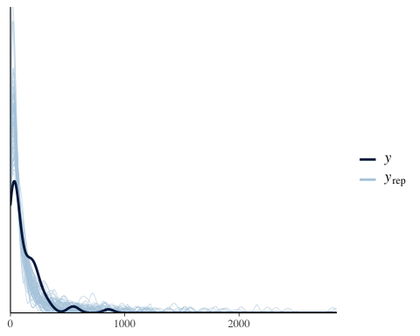

ppc_stat_2d(data1$stops, z.mcmc, stat = c("mean", "var"))

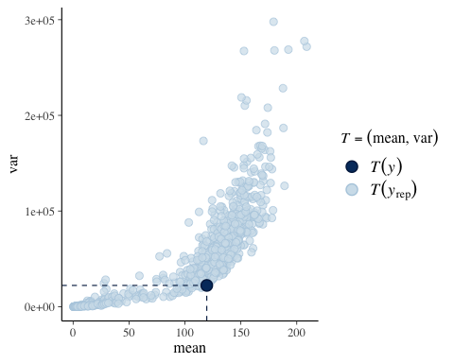

#### Figure 10.5 (traceplots & ACF)  
par(mar=c(2.75,2.75,.5,.5),mgp=c(1.7,.7,0))  
par(mfrow=c(1,3))  
blabs<-c(expression(betadraws[,1]),expression(betadraws[,2]),expression(betadraws[,3],expression(betadraws[,4])))  
thin<-c(1,(1:100)*(R/100))  
j<-4  
plot(thin,betadraws[thin,j],type="l",xlab="iteration",ylab=blabs[j])  
abline(h=mean(betadraws[,j]) )  
  
acf(betadraws[,j],ci.col="gray",xlab="lag")  
acf(betadraws[thin,j],xlab="lag/10",ci.col="gray") #ACF of thinned chain

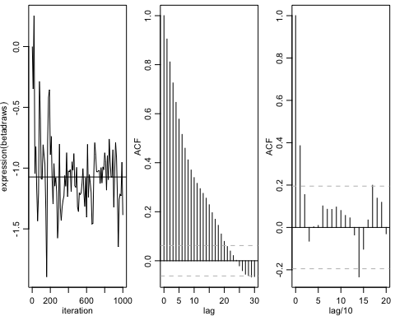

## Using default s_alpha = 2.93  
## Using default s_beta = 2.93/sqrt(nvar)  
##   
## Starting Random Walk Metropolis Sampler for Negative Binomial Regression  
## 96 obs; 4 covariates (including intercept);   
## Prior Parameters:  
## betabar  
## [1] 0 0 0 0  
## A  
## [,1] [,2] [,3] [,4]  
## [1,] 0.01 0.00 0.00 0.00  
## [2,] 0.00 0.01 0.00 0.00  
## [3,] 0.00 0.00 0.01 0.00  
## [4,] 0.00 0.00 0.00 0.01  
## a  
## [1] 0.5  
## b  
## [1] 0.1  
##   
## MCMC Parms:   
## R= 1000 keep= 1 nprint= 100  
## s_alpha = 2.38  
## s_beta = 1.19  
##   
## Initializing RW Increment Covariance Matrix...  
## beta_mle = -0.5819138 0.9908039 -0.366685 -1.165407  
## alpha_mle = 4.576123  
## MCMC Iteration (est time to end - min)   
## 100 (0.0)  
## 200 (0.0)  
## 300 (0.0)  
## 400 (0.0)  
## 500 (0.0)  
## 600 (0.0)  
## 700 (0.0)  
## 800 (0.0)  
## 900 (0.0)  
## 1000 (0.0)  
## Total Time Elapsed: 0.00

## Summary of alpha/beta draw

## Summary of Posterior Marginal Distributions   
## Moments   
## tvalues mean std dev num se rel eff sam size  
## 1 5 3.6 1.6 0.31 36 25  
##   
## Quantiles   
## tvalues 2.5% 5% 50% 95% 97.5%  
## 1 5 0.072 0.12 4.1 5.2 5.5  
## based on 900 valid draws (burn-in=100)

## Summary of Posterior Marginal Distributions   
## Moments   
## tvalues mean std dev num se rel eff sam size  
## 1 -0.30 -0.51 0.73 0.117 23 39  
## 2 0.94 0.93 0.19 0.036 32 28  
## 3 -0.37 -0.34 0.23 0.038 24 36  
## 4 -1.04 -1.29 0.49 0.089 30 29  
##   
## Quantiles   
## tvalues 2.5% 5% 50% 95% 97.5%  
## 1 -0.30 -2.03 -1.29 -0.60 0.702 1.694  
## 2 0.94 0.24 0.48 0.99 1.079 1.113  
## 3 -0.37 -1.08 -0.55 -0.34 -0.025 0.072  
## 4 -1.04 -3.03 -2.30 -1.18 -0.840 -0.508  
## based on 900 valid draws (burn-in=100)

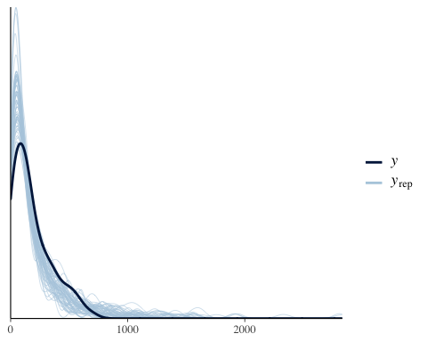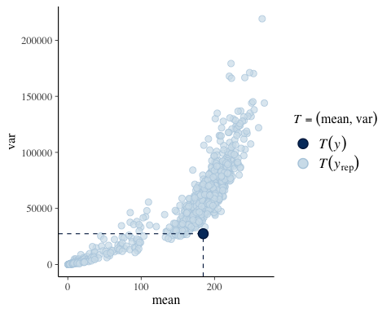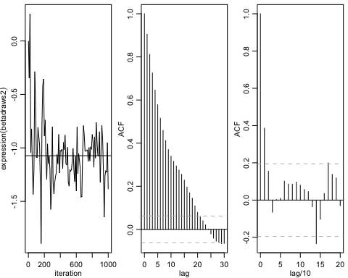

## Using default s_alpha = 2.93  
## Using default s_beta = 2.93/sqrt(nvar)  
##   
## Starting Random Walk Metropolis Sampler for Negative Binomial Regression  
## 60 obs; 4 covariates (including intercept);   
## Prior Parameters:  
## betabar  
## [1] 0 0 0 0  
## A  
## [,1] [,2] [,3] [,4]  
## [1,] 0.01 0.00 0.00 0.00  
## [2,] 0.00 0.01 0.00 0.00  
## [3,] 0.00 0.00 0.01 0.00  
## [4,] 0.00 0.00 0.00 0.01  
## a  
## [1] 0.5  
## b  
## [1] 0.1  
##   
## MCMC Parms:   
## R= 1000 keep= 1 nprint= 100  
## s_alpha = 2.38  
## s_beta = 1.19  
##   
## Initializing RW Increment Covariance Matrix...  
## beta_mle = 0.310728 0.8832016 -0.6048846 -1.086839  
## alpha_mle = 5.995455  
## MCMC Iteration (est time to end - min)   
## 100 (0.0)  
## 200 (0.0)  
## 300 (0.0)  
## 400 (0.0)  
## 500 (0.0)  
## 600 (0.0)  
## 700 (0.0)  
## 800 (0.0)  
## 900 (0.0)  
## 1000 (0.0)  
## Total Time Elapsed: 0.00

## Summary of alpha/beta draw

## Summary of Posterior Marginal Distributions   
## Moments   
## tvalues mean std dev num se rel eff sam size  
## 1 5 4.9 1.6 0.25 22 41  
##   
## Quantiles   
## tvalues 2.5% 5% 50% 95% 97.5%  
## 1 5 0.51 1.2 5 7.3 7.8  
## based on 900 valid draws (burn-in=100)

## Summary of Posterior Marginal Distributions   
## Moments   
## tvalues mean std dev num se rel eff sam size  
## 1 0.36 0.27 0.413 0.046 11.4 75  
## 2 0.86 0.87 0.091 0.014 20.4 43  
## 3 -0.56 -0.58 0.189 0.018 8.5 100  
## 4 -1.08 -1.03 0.175 0.022 13.7 64  
##   
## Quantiles   
## tvalues 2.5% 5% 50% 95% 97.5%  
## 1 0.36 -0.47 -0.39 0.27 0.96 1.03  
## 2 0.86 0.65 0.69 0.89 0.99 1.01  
## 3 -0.56 -0.96 -0.90 -0.60 -0.27 -0.22  
## 4 -1.08 -1.37 -1.30 -1.05 -0.76 -0.69  
## based on 900 valid draws (burn-in=100)

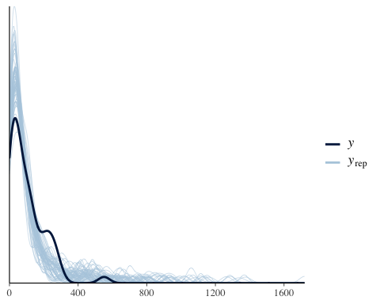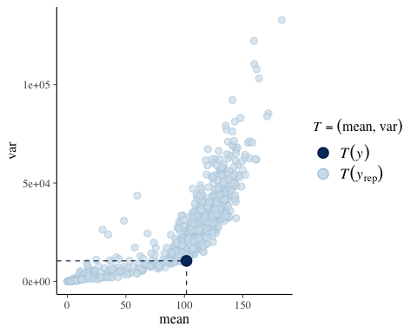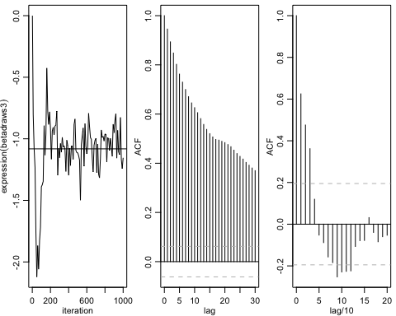

## Using default s_alpha = 2.93  
## Using default s_beta = 2.93/sqrt(nvar)  
##   
## Starting Random Walk Metropolis Sampler for Negative Binomial Regression  
## 69 obs; 4 covariates (including intercept);   
## Prior Parameters:  
## betabar  
## [1] 0 0 0 0  
## A  
## [,1] [,2] [,3] [,4]  
## [1,] 0.01 0.00 0.00 0.00  
## [2,] 0.00 0.01 0.00 0.00  
## [3,] 0.00 0.00 0.01 0.00  
## [4,] 0.00 0.00 0.00 0.01  
## a  
## [1] 0.5  
## b  
## [1] 0.1  
##   
## MCMC Parms:   
## R= 1000 keep= 1 nprint= 100  
## s_alpha = 2.38  
## s_beta = 1.19  
##   
## Initializing RW Increment Covariance Matrix...  
## beta_mle = 0.6551693 0.9996903 -0.2505309 -0.9235909  
## alpha_mle = 6.650405  
## MCMC Iteration (est time to end - min)   
## 100 (0.0)  
## 200 (0.0)  
## 300 (0.0)  
## 400 (0.0)  
## 500 (0.0)  
## 600 (0.0)  
## 700 (0.0)  
## 800 (0.0)  
## 900 (0.0)  
## 1000 (0.0)  
## Total Time Elapsed: 0.00

## Summary of alpha/beta draw

## Summary of Posterior Marginal Distributions   
## Moments   
## tvalues mean std dev num se rel eff sam size  
## 1 5 5.3 2.2 0.42 32 28  
##   
## Quantiles   
## tvalues 2.5% 5% 50% 95% 97.5%  
## 1 5 0.068 0.12 5.7 8 8.6  
## based on 900 valid draws (burn-in=100)

## Summary of Posterior Marginal Distributions   
## Moments   
## tvalues mean std dev num se rel eff sam size  
## 1 0.32 0.60 0.34 0.044 15 56  
## 2 1.05 0.96 0.12 0.023 31 29  
## 3 -0.13 -0.31 0.21 0.036 26 35  
## 4 -0.75 -0.87 0.26 0.043 25 35  
##   
## Quantiles   
## tvalues 2.5% 5% 50% 95% 97.5%  
## 1 0.32 -0.33 0.021 0.63 1.043 1.121  
## 2 1.05 0.58 0.640 0.99 1.089 1.110  
## 3 -0.13 -0.98 -0.774 -0.28 -0.063 -0.024  
## 4 -0.75 -1.22 -1.171 -0.92 -0.288 -0.060  
## based on 900 valid draws (burn-in=100)

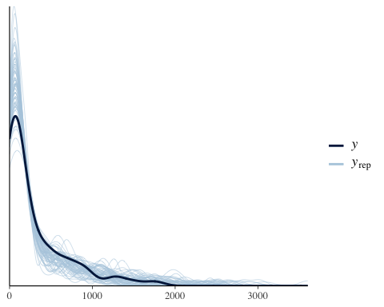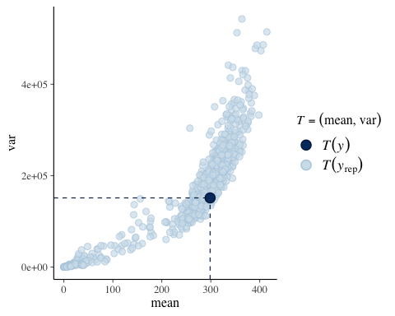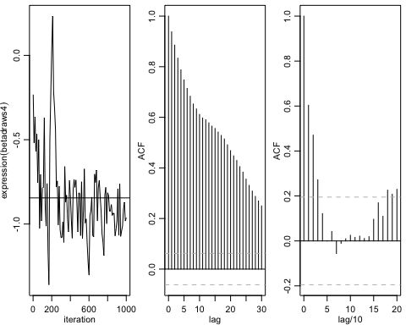

## Using default s_alpha = 2.93  
## Using default s_beta = 2.93/sqrt(nvar)  
##   
## Starting Random Walk Metropolis Sampler for Negative Binomial Regression  
## 69 obs; 4 covariates (including intercept);   
## Prior Parameters:  
## betabar  
## [1] 0 0 0 0  
## A  
## [,1] [,2] [,3] [,4]  
## [1,] 0.01 0.00 0.00 0.00  
## [2,] 0.00 0.01 0.00 0.00  
## [3,] 0.00 0.00 0.01 0.00  
## [4,] 0.00 0.00 0.00 0.01  
## a  
## [1] 0.5  
## b  
## [1] 0.1  
##   
## MCMC Parms:   
## R= 1000 keep= 1 nprint= 100  
## s_alpha = 2.38  
## s_beta = 1.19  
##   
## Initializing RW Increment Covariance Matrix...  
## beta_mle = -0.3607132 0.8890698 -0.02683061 -0.2347519  
## alpha_mle = 4.596502  
## MCMC Iteration (est time to end - min)   
## 100 (0.0)  
## 200 (0.0)  
## 300 (0.0)  
## 400 (0.0)  
## 500 (0.0)  
## 600 (0.0)  
## 700 (0.0)  
## 800 (0.0)  
## 900 (0.0)  
## 1000 (0.0)  
## Total Time Elapsed: 0.00

## Summary of alpha/beta draw

## Summary of Posterior Marginal Distributions   
## Moments   
## tvalues mean std dev num se rel eff sam size  
## 1 5 3.8 1.2 0.18 23 39  
##   
## Quantiles   
## tvalues 2.5% 5% 50% 95% 97.5%  
## 1 5 0.25 0.82 3.9 5.4 5.7  
## based on 900 valid draws (burn-in=100)

## Summary of Posterior Marginal Distributions   
## Moments   
## tvalues mean std dev num se rel eff sam size  
## 1 -0.8493 -0.3596 0.431 0.047 11 82  
## 2 0.9616 0.8710 0.078 0.011 19 45  
## 3 0.1663 -0.0062 0.262 0.037 18 50  
## 4 0.0042 -0.2215 0.253 0.034 17 53  
##   
## Quantiles   
## tvalues 2.5% 5% 50% 95% 97.5%  
## 1 -0.8493 -1.23 -0.99 -0.351 0.273 0.40  
## 2 0.9616 0.69 0.75 0.880 0.975 0.98  
## 3 0.1663 -0.38 -0.33 -0.028 0.457 0.84  
## 4 0.0042 -0.62 -0.53 -0.239 0.097 0.59  
## based on 900 valid draws (burn-in=100)

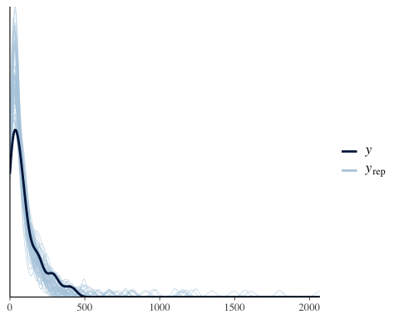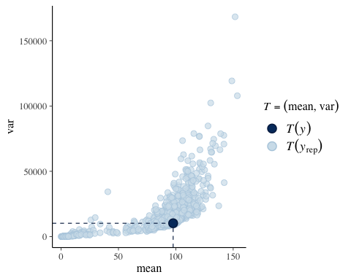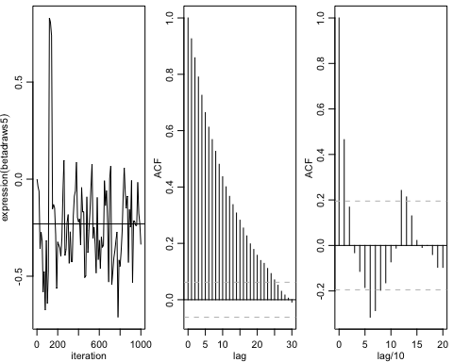

## Using default s_alpha = 2.93  
## Using default s_beta = 2.93/sqrt(nvar)  
##   
## Starting Random Walk Metropolis Sampler for Negative Binomial Regression  
## 69 obs; 4 covariates (including intercept);   
## Prior Parameters:  
## betabar  
## [1] 0 0 0 0  
## A  
## [,1] [,2] [,3] [,4]  
## [1,] 0.01 0.00 0.00 0.00  
## [2,] 0.00 0.01 0.00 0.00  
## [3,] 0.00 0.00 0.01 0.00  
## [4,] 0.00 0.00 0.00 0.01  
## a  
## [1] 0.5  
## b  
## [1] 0.1  
##   
## MCMC Parms:   
## R= 1000 keep= 1 nprint= 100  
## s_alpha = 2.38  
## s_beta = 1.19  
##   
## Initializing RW Increment Covariance Matrix...  
## beta_mle = 0.4576326 0.5854973 0.3810144 -0.2822934  
## alpha_mle = 5.867237  
## MCMC Iteration (est time to end - min)   
## 100 (0.0)  
## 200 (0.0)  
## 300 (0.0)  
## 400 (0.0)  
## 500 (0.0)  
## 600 (0.0)  
## 700 (0.0)  
## 800 (0.0)  
## 900 (0.0)  
## 1000 (0.0)  
## Total Time Elapsed: 0.00

## Summary of alpha/beta draw

## Summary of Posterior Marginal Distributions   
## Moments   
## tvalues mean std dev num se rel eff sam size  
## 1 5 4.8 1.8 0.31 26 33  
##   
## Quantiles   
## tvalues 2.5% 5% 50% 95% 97.5%  
## 1 5 0.3 0.61 5 7.3 7.9  
## based on 900 valid draws (burn-in=100)

## Summary of Posterior Marginal Distributions   
## Moments   
## tvalues mean std dev num se rel eff sam size  
## 1 0.085 0.36 0.528 0.0789 20 43  
## 2 0.679 0.58 0.053 0.0058 11 82  
## 3 0.155 0.35 0.245 0.0359 19 45  
## 4 -0.383 -0.30 0.211 0.0238 11 75  
##   
## Quantiles   
## tvalues 2.5% 5% 50% 95% 97.5%  
## 1 0.085 -0.97 -0.59 0.46 0.95345 1.10  
## 2 0.679 0.48 0.50 0.58 0.67975 0.69  
## 3 0.155 -0.27 -0.14 0.37 0.62771 0.74  
## 4 -0.383 -0.73 -0.66 -0.29 0.00078 0.12  
## based on 900 valid draws (burn-in=100)

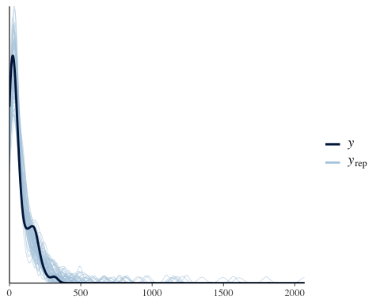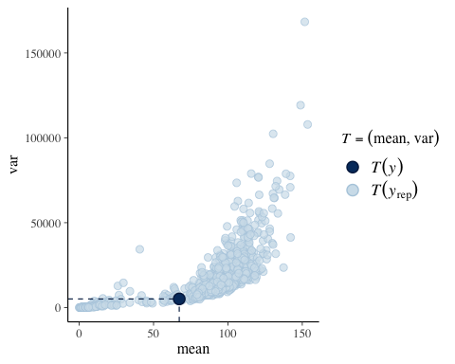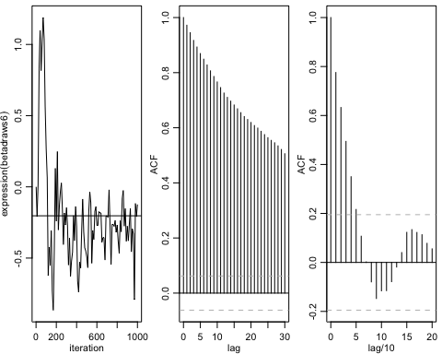

## Using default s_alpha = 2.93  
## Using default s_beta = 2.93/sqrt(nvar)  
##   
## Starting Random Walk Metropolis Sampler for Negative Binomial Regression  
## 96 obs; 4 covariates (including intercept);   
## Prior Parameters:  
## betabar  
## [1] 0 0 0 0  
## A  
## [,1] [,2] [,3] [,4]  
## [1,] 0.01 0.00 0.00 0.00  
## [2,] 0.00 0.01 0.00 0.00  
## [3,] 0.00 0.00 0.01 0.00  
## [4,] 0.00 0.00 0.00 0.01  
## a  
## [1] 0.5  
## b  
## [1] 0.1  
##   
## MCMC Parms:   
## R= 1000 keep= 1 nprint= 100  
## s_alpha = 2.38  
## s_beta = 1.19  
##   
## Initializing RW Increment Covariance Matrix...  
## beta_mle = 0.9277311 0.9371275 -0.07766996 -0.6674303  
## alpha_mle = 6.341949  
## MCMC Iteration (est time to end - min)   
## 100 (0.0)  
## 200 (0.0)  
## 300 (0.0)  
## 400 (0.0)  
## 500 (0.0)  
## 600 (0.0)  
## 700 (0.0)  
## 800 (0.0)  
## 900 (0.0)  
## 1000 (0.0)  
## Total Time Elapsed: 0.00

## Summary of alpha/beta draw

## Summary of Posterior Marginal Distributions   
## Moments   
## tvalues mean std dev num se rel eff sam size  
## 1 5 4.8 2.4 0.48 37 24  
##   
## Quantiles   
## tvalues 2.5% 5% 50% 95% 97.5%  
## 1 5 0.047 0.061 5.6 7.5 7.9  
## based on 900 valid draws (burn-in=100)

## Summary of Posterior Marginal Distributions   
## Moments   
## tvalues mean std dev num se rel eff sam size  
## 1 8.4e-01 0.582 0.882 0.172 34 26  
## 2 9.3e-01 0.922 0.073 0.010 18 50  
## 3 -8.7e-05 -0.088 0.187 0.025 16 53  
## 4 -5.2e-01 -0.636 0.223 0.036 23 39  
##   
## Quantiles   
## tvalues 2.5% 5% 50% 95% 97.5%  
## 1 8.4e-01 -1.99 -1.72 0.836 1.35 1.509  
## 2 9.3e-01 0.72 0.76 0.931 1.02 1.035  
## 3 -8.7e-05 -0.42 -0.37 -0.092 0.26 0.336  
## 4 -5.2e-01 -1.02 -0.90 -0.655 -0.18 -0.078  
## based on 900 valid draws (burn-in=100)

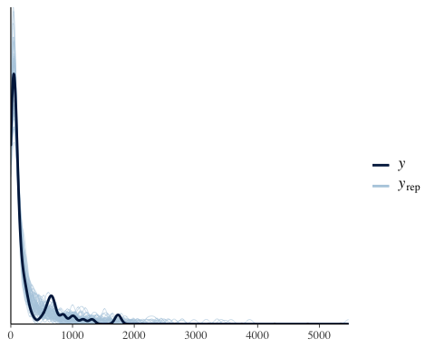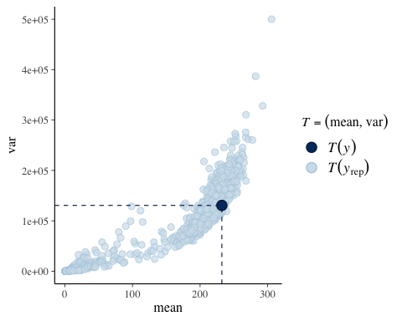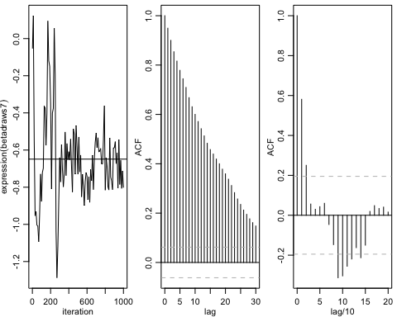

## Using default s_alpha = 2.93  
## Using default s_beta = 2.93/sqrt(nvar)  
##   
## Starting Random Walk Metropolis Sampler for Negative Binomial Regression  
## 96 obs; 4 covariates (including intercept);   
## Prior Parameters:  
## betabar  
## [1] 0 0 0 0  
## A  
## [,1] [,2] [,3] [,4]  
## [1,] 0.01 0.00 0.00 0.00  
## [2,] 0.00 0.01 0.00 0.00  
## [3,] 0.00 0.00 0.01 0.00  
## [4,] 0.00 0.00 0.00 0.01  
## a  
## [1] 0.5  
## b  
## [1] 0.1  
##   
## MCMC Parms:   
## R= 1000 keep= 1 nprint= 100  
## s_alpha = 2.38  
## s_beta = 1.19  
##   
## Initializing RW Increment Covariance Matrix...  
## beta_mle = 0.171047 0.7535497 0.6024082 0.1326003  
## alpha_mle = 4.706306  
## MCMC Iteration (est time to end - min)   
## 100 (0.0)  
## 200 (0.0)  
## 300 (0.0)  
## 400 (0.0)  
## 500 (0.0)  
## 600 (0.0)  
## 700 (0.0)  
## 800 (0.0)  
## 900 (0.0)  
## 1000 (0.0)  
## Total Time Elapsed: 0.00

## Summary of alpha/beta draw

## Summary of Posterior Marginal Distributions   
## Moments   
## tvalues mean std dev num se rel eff sam size  
## 1 5 4 1.5 0.27 30 30  
##   
## Quantiles   
## tvalues 2.5% 5% 50% 95% 97.5%  
## 1 5 0.095 0.18 4.3 5.8 6.2  
## based on 900 valid draws (burn-in=100)

## Summary of Posterior Marginal Distributions   
## Moments   
## tvalues mean std dev num se rel eff sam size  
## 1 0.21 0.019 0.684 0.1235 29 30  
## 2 0.76 0.751 0.065 0.0074 12 75  
## 3 0.48 0.597 0.189 0.0268 18 47  
## 4 0.20 0.133 0.223 0.0322 19 47  
##   
## Quantiles   
## tvalues 2.5% 5% 50% 95% 97.5%  
## 1 0.21 -2.24 -1.55 0.15 0.69 0.83  
## 2 0.76 0.61 0.65 0.75 0.85 0.89  
## 3 0.48 0.27 0.30 0.59 0.95 1.03  
## 4 0.20 -0.17 -0.14 0.10 0.56 0.76  
## based on 900 valid draws (burn-in=100)

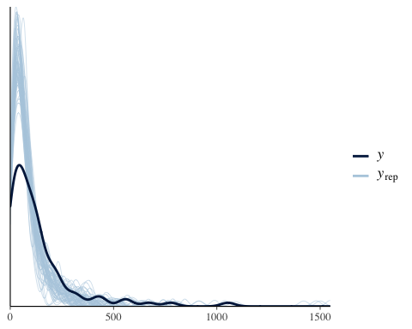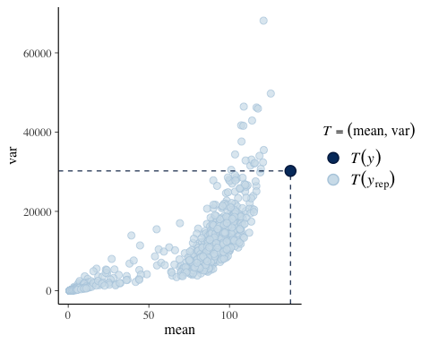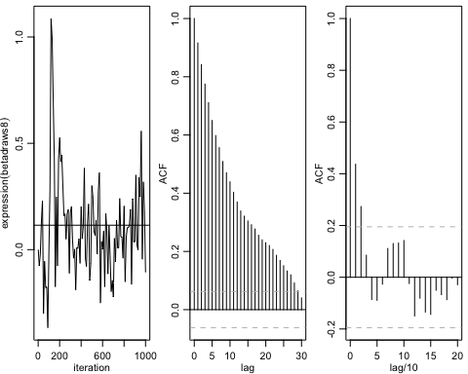

## Using default s_alpha = 2.93  
## Using default s_beta = 2.93/sqrt(nvar)  
##   
## Starting Random Walk Metropolis Sampler for Negative Binomial Regression  
## 96 obs; 4 covariates (including intercept);   
## Prior Parameters:  
## betabar  
## [1] 0 0 0 0  
## A  
## [,1] [,2] [,3] [,4]  
## [1,] 0.01 0.00 0.00 0.00  
## [2,] 0.00 0.01 0.00 0.00  
## [3,] 0.00 0.00 0.01 0.00  
## [4,] 0.00 0.00 0.00 0.01  
## a  
## [1] 0.5  
## b  
## [1] 0.1  
##   
## MCMC Parms:   
## R= 1000 keep= 1 nprint= 100  
## s_alpha = 2.38  
## s_beta = 1.19  
##   
## Initializing RW Increment Covariance Matrix...  
## beta_mle = 0.1915881 0.6428964 0.07613809 -0.2388481  
## alpha_mle = 4.369725  
## MCMC Iteration (est time to end - min)   
## 100 (0.0)  
## 200 (0.0)  
## 300 (0.0)  
## 400 (0.0)  
## 500 (0.0)  
## 600 (0.0)  
## 700 (0.0)  
## 800 (0.0)  
## 900 (0.0)  
## 1000 (0.0)  
## Total Time Elapsed: 0.00

## Summary of alpha/beta draw

## Summary of Posterior Marginal Distributions   
## Moments   
## tvalues mean std dev num se rel eff sam size  
## 1 5 3.9 0.99 0.15 20 43  
##   
## Quantiles   
## tvalues 2.5% 5% 50% 95% 97.5%  
## 1 5 0.77 1.6 4 5.2 5.4  
## based on 900 valid draws (burn-in=100)

## Summary of Posterior Marginal Distributions   
## Moments   
## tvalues mean std dev num se rel eff sam size  
## 1 -0.260 0.136 0.310 0.0399 15 60  
## 2 0.720 0.645 0.045 0.0051 11 75  
## 3 0.093 0.056 0.152 0.0208 17 53  
## 4 -0.130 -0.265 0.190 0.0220 12 69  
##   
## Quantiles   
## tvalues 2.5% 5% 50% 95% 97.5%  
## 1 -0.260 -0.57 -0.39 0.144 0.636 0.697  
## 2 0.720 0.56 0.58 0.645 0.714 0.729  
## 3 0.093 -0.30 -0.19 0.076 0.256 0.282  
## 4 -0.130 -0.66 -0.55 -0.260 0.016 0.048  
## based on 900 valid draws (burn-in=100)

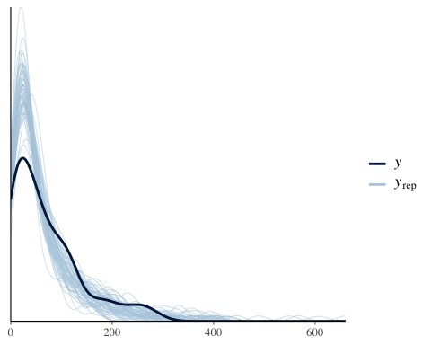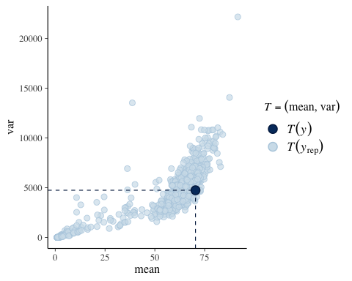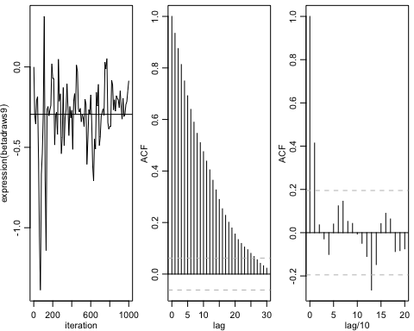

## Using default s_alpha = 2.93  
## Using default s_beta = 2.93/sqrt(nvar)  
##   
## Starting Random Walk Metropolis Sampler for Negative Binomial Regression  
## 60 obs; 4 covariates (including intercept);   
## Prior Parameters:  
## betabar  
## [1] 0 0 0 0  
## A  
## [,1] [,2] [,3] [,4]  
## [1,] 0.01 0.00 0.00 0.00  
## [2,] 0.00 0.01 0.00 0.00  
## [3,] 0.00 0.00 0.01 0.00  
## [4,] 0.00 0.00 0.00 0.01  
## a  
## [1] 0.5  
## b  
## [1] 0.1  
##   
## MCMC Parms:   
## R= 1000 keep= 1 nprint= 100  
## s_alpha = 2.38  
## s_beta = 1.19  
##   
## Initializing RW Increment Covariance Matrix...  
## beta_mle = 0.4841367 1.050877 0.001844416 -0.5463842  
## alpha_mle = 4.266917  
## MCMC Iteration (est time to end - min)   
## 100 (0.0)  
## 200 (0.0)  
## 300 (0.0)  
## 400 (0.0)  
## 500 (0.0)  
## 600 (0.0)  
## 700 (0.0)  
## 800 (0.0)  
## 900 (0.0)  
## 1000 (0.0)  
## Total Time Elapsed: 0.00

## Summary of alpha/beta draw

## Summary of Posterior Marginal Distributions   
## Moments   
## tvalues mean std dev num se rel eff sam size  
## 1 5 3.5 1.4 0.26 31 28  
##   
## Quantiles   
## tvalues 2.5% 5% 50% 95% 97.5%  
## 1 5 0.085 0.16 3.8 5.1 5.4  
## based on 900 valid draws (burn-in=100)

## Summary of Posterior Marginal Distributions   
## Moments   
## tvalues mean std dev num se rel eff sam size  
## 1 0.983 0.5927 0.45 0.053 13 69  
## 2 0.940 0.9783 0.17 0.033 33 27  
## 3 -0.096 -0.0099 0.18 0.021 12 69  
## 4 -0.605 -0.4084 0.42 0.078 31 29  
##   
## Quantiles   
## tvalues 2.5% 5% 50% 95% 97.5%  
## 1 0.983 -0.26 -0.14 0.5916 1.39 1.57  
## 2 0.940 0.46 0.56 1.0174 1.16 1.21  
## 3 -0.096 -0.38 -0.30 -0.0056 0.26 0.34  
## 4 -0.605 -0.86 -0.79 -0.5243 0.71 0.96  
## based on 900 valid draws (burn-in=100)

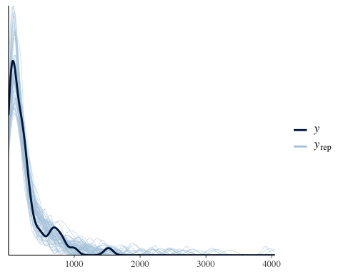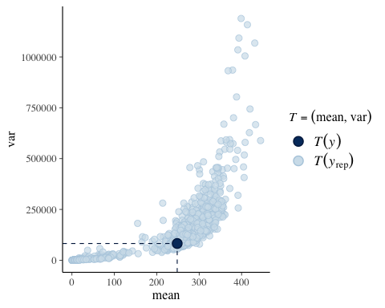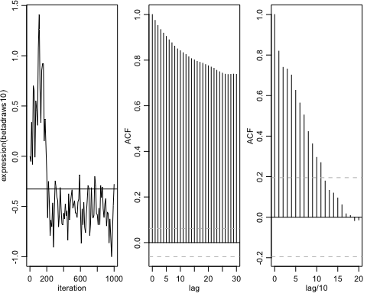

## Using default s_alpha = 2.93  
## Using default s_beta = 2.93/sqrt(nvar)  
##   
## Starting Random Walk Metropolis Sampler for Negative Binomial Regression  
## 60 obs; 4 covariates (including intercept);   
## Prior Parameters:  
## betabar  
## [1] 0 0 0 0  
## A  
## [,1] [,2] [,3] [,4]  
## [1,] 0.01 0.00 0.00 0.00  
## [2,] 0.00 0.01 0.00 0.00  
## [3,] 0.00 0.00 0.01 0.00  
## [4,] 0.00 0.00 0.00 0.01  
## a  
## [1] 0.5  
## b  
## [1] 0.1  
##   
## MCMC Parms:   
## R= 1000 keep= 1 nprint= 100  
## s_alpha = 2.38  
## s_beta = 1.19  
##   
## Initializing RW Increment Covariance Matrix...  
## beta_mle = -0.1683736 0.8602028 0.1906381 0.3314953  
## alpha_mle = 4.650683  
## MCMC Iteration (est time to end - min)   
## 100 (0.0)  
## 200 (0.0)  
## 300 (0.0)  
## 400 (0.0)  
## 500 (0.0)  
## 600 (0.0)  
## 700 (0.0)  
## 800 (0.0)  
## 900 (0.0)  
## 1000 (0.0)  
## Total Time Elapsed: 0.02

## Summary of alpha/beta draw

## Summary of Posterior Marginal Distributions   
## Moments   
## tvalues mean std dev num se rel eff sam size  
## 1 5 4.1 1 0.11 12 75  
##   
## Quantiles   
## tvalues 2.5% 5% 50% 95% 97.5%  
## 1 5 1.5 2.8 4.1 5.8 6.2  
## based on 900 valid draws (burn-in=100)

## Summary of Posterior Marginal Distributions   
## Moments   
## tvalues mean std dev num se rel eff sam size  
## 1 0.22 -0.23 0.41 0.0539 15.2 56  
## 2 0.78 0.87 0.07 0.0089 14.8 60  
## 3 0.15 0.21 0.16 0.0162 8.8 100  
## 4 0.38 0.32 0.21 0.0285 16.1 53  
##   
## Quantiles   
## tvalues 2.5% 5% 50% 95% 97.5%  
## 1 0.22 -1.18 -0.854 -0.22 0.40 0.51  
## 2 0.78 0.74 0.763 0.86 0.98 1.02  
## 3 0.15 -0.11 -0.051 0.21 0.48 0.54  
## 4 0.38 -0.14 -0.054 0.35 0.61 0.65  
## based on 900 valid draws (burn-in=100)

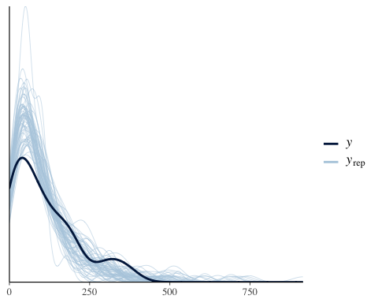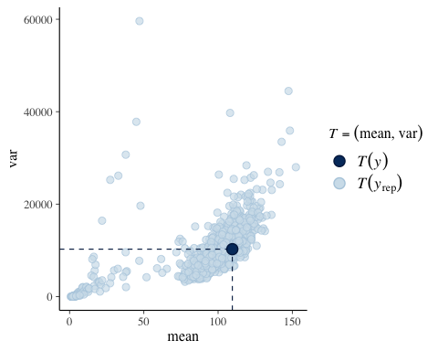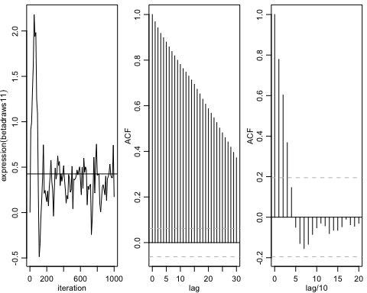

## Using default s_alpha = 2.93  
## Using default s_beta = 2.93/sqrt(nvar)  
##   
## Starting Random Walk Metropolis Sampler for Negative Binomial Regression  
## 60 obs; 4 covariates (including intercept);   
## Prior Parameters:  
## betabar  
## [1] 0 0 0 0  
## A  
## [,1] [,2] [,3] [,4]  
## [1,] 0.01 0.00 0.00 0.00  
## [2,] 0.00 0.01 0.00 0.00  
## [3,] 0.00 0.00 0.01 0.00  
## [4,] 0.00 0.00 0.00 0.01  
## a  
## [1] 0.5  
## b  
## [1] 0.1  
##   
## MCMC Parms:   
## R= 1000 keep= 1 nprint= 100  
## s_alpha = 2.38  
## s_beta = 1.19  
##   
## Initializing RW Increment Covariance Matrix...  
## beta_mle = -0.2179628 0.7337058 -0.3181977 -0.8984002  
## alpha_mle = 7.57096  
## MCMC Iteration (est time to end - min)   
## 100 (0.0)  
## 200 (0.0)  
## 300 (0.0)  
## 400 (0.0)  
## 500 (0.0)  
## 600 (0.0)  
## 700 (0.0)  
## 800 (0.0)  
## 900 (0.0)  
## 1000 (0.0)  
## Total Time Elapsed: 0.00

## Summary of alpha/beta draw

## Summary of Posterior Marginal Distributions   
## Moments   
## tvalues mean std dev num se rel eff sam size  
## 1 5 6 2.2 0.33 21 41  
##   
## Quantiles   
## tvalues 2.5% 5% 50% 95% 97.5%  
## 1 5 0.29 1.2 6.1 9.4 9.9  
## based on 900 valid draws (burn-in=100)

## Summary of Posterior Marginal Distributions   
## Moments   
## tvalues mean std dev num se rel eff sam size  
## 1 -0.372 -0.32 0.464 0.0545 12.4 69  
## 2 0.742 0.73 0.068 0.0099 18.9 47  
## 3 -0.093 -0.29 0.181 0.0182 9.1 90  
## 4 -0.594 -0.88 0.206 0.0265 14.9 60  
##   
## Quantiles   
## tvalues 2.5% 5% 50% 95% 97.5%  
## 1 -0.372 -1.28 -1.02 -0.30 0.320 0.592  
## 2 0.742 0.54 0.63 0.74 0.833 0.853  
## 3 -0.093 -0.67 -0.60 -0.28 -0.015 0.085  
## 4 -0.594 -1.26 -1.21 -0.89 -0.524 -0.327  
## based on 900 valid draws (burn-in=100)

