PixelGrams
Design Brief

Digital Heritage & Multimedia University of Bologna Academic Year 2024/25

Laura Bortoli - Qinghao Chen - Claudia Romanello
CineFiles25

The Context: The Museum and Its Collection

The Grotta dei Cervi (Cave of the Deer) of Porto Badisco, near Otranto in Puglia, is one of the most significant Neolithic cave sanctuaries in Europe. Discovered in 1970, it extends for over 700 metres and features three main corridors divided into twelve zones, with paintings gathered in 81 groups. The pictograms were produced using pigments derived from subfossil guano (brilliant brown), clays and ground bones (yellowish brown), and ochre (red). Most images are abstract (spirals, sinuous lines, complex motifs) while figurative scenes depict deer, hunters with bows, and dogs.
The cave has been closed to the public since 1987. Human presence (breath, warmth, and light) would destroy the fragile microclimate preserving the paintings. Only researchers with special authorisation may enter.

  - 3D Documentation

A high-resolution, full-colour 3D model of the cave was developed starting in 2005 by the University of Salento, led by Professor Virginia Valzano, in collaboration with the Visual Information Technology Group of the IIT-NRC (Canada) and CASPUR (Rome). The model was produced using photogrammetry (overlapping photographs taken from multiple angles, processed computationally to reconstruct geometry without physically touching the walls) combined with 3D scanning. As of September 2025, a permanent exhibition at the Castello Aragonese di Otranto includes a 3D digital twin of Corridor 2, the corridor containing the most significant pictograms. This is the asset the VR experience would be built on: the game engine imports and renders it in real time for the headsets.

  - Institutional Goals

Goal | Description
Engagement | Let more people know about this cultural heritage treasure (largely unknown due to its inaccessibility) and increase its national and international visibility.
Museum Sustainability | Allow visitors to experience the cave without  entering it, preserving the humid

 | environment that keeps the pictograms intact and well-preserved.
Accessibility and Diversification | Create a virtual environment with no barriers,  accessible to everyone regardless of age, language, cultural background, or physical limitation.
Cognitive Goals | Concentration, curiosity, embodiment, and storytelling. Education happens through immersion, not instruction. Culture triggers emotion; emotion drives action.
Table 1. Institutional goals of the PixelGrams VR experience.

  - Star Assets

The Shaman pictogram (the most iconographically charged image in the cave) as well as the full pictogram ensemble, the mystery of ritual practice, and the 3D model by Professor Valzano are the core star assets. The ability to virtually access a location inaccessible to almost every living person is itself the most powerful asset.

  - Physical Structure

The cave extends for over 1,500 metres of galleries across three main tortuous corridors, with five entrance cavities leading to four painted corridors, reaching depths of up to 28 metres below sea level. Internal conditions - constant temperature, high humidity (the faugnu microclimate), near-total darkness - have preserved the paintings across six millennia, but make the space acutely sensitive to human presence.

  - The Twelve Zones

The painted corridors are organised into twelve named zones. The second corridor - the richest and most accessible - contains the experience’s primary narrative and ritual spaces:

Zone | Description
Zone III — Red Hall | First room of the second corridor, 4 m high.

 | Contains the foundational mythological narrative: two women and a hunter indicating the way. Notable figure: the Fish Woman, with fins instead of feet.
Zone IV — Androgen Hall | A large natural anthropomorphic figure (2 m tall), surrounded by threadlike beings in various poses. One of the most complex figurative compositions in the cave, merging human and natural form.
Zone V — Lizard Hall and Hall of Ceremonies | A circular room suited to ritual gatherings. The adjoining Hall of Ceremonies depicts six figures in a posture suggesting marathon runners in motion — evidence of communal ceremonial performance.
Zone VIII — Sanctuary | Small handprints on the ceiling — likely female and child — interpreted as ritual markers of passage. Location of the Lady of the Serpents, linked by Marija Gimbutas to a Neolithic Mother Serpent Goddess.
Zone IX — Tabernacle | A small circular room with a significantly lowered ceiling. A cup for collecting liquids likely served as an altar for ritual ablutions. The tunnel beyond was sealed by a structural collapse.
Zones X–XII — Third Corridor | Hall of Arabesques, Hall of Spirals, and the Recondite Hall. Labyrinthine paintings and stalactites before the vault lowers and the cave becomes physically impassable.
Table 2. Key zones of the Grotta dei Cervi, second corridor.

  - The Pictograms

Approximately 3,000 pictograms cover the walls across all corridors, painted in red ochre mixed with black bat guano, and dated primarily between 6000 and 3000 BC. The most frequent subject is the deer (giving the cave its name) followed by hunting scenes, anthropomorphic collectives, agricultural scenes, and dancers. Abstract

geometric motifs (spirals, S-shapes, cymbal forms, rhombi, opposed spirals, chevrons, and dots) correspond closely to forms found in caves from Sardinia and Kosovo to France and Romania. The shamans who painted the spirals are thought to have done so under hallucinogens, blows to the head, or pressure on the eye bulbs - all documented methods of inducing the phosphenic geometries that gave rise to the cave’s abstract imagery.

  - Archaeological Findings

Category | Description
Ceramic Vessels | Anthropomorphic rim vessels with human faces and notched chin bands; anthropomorphic flask vessels (Scaloria Alta style) with faces on the neck; Serra d’Alto style vessels decorated with spirals and S-motifs; graffito vessels bearing a figure closely resembling the Shaman wall painting.
Ceremonial Objects | Pintaderas (terracotta stamps used for body decoration during fertility rites), confirming an active Mother Goddess cult and direct Balkan connections. Rhyta for ritual libation. Ceramic ladles for ceremonial serving. Hard animal matter objects of specialised ritual craft.
Table 3. Archaeological findings from the Grotta dei Cervi.

  - Cultural Connections and UNESCO

The cave’s symbolic vocabulary - spirals, S-motifs, anthropomorphic vessels, cymbal-shaped forms - is shared with sites across southern Italy, Sardinia, Dalmatia, Kosovo, Romania, Bulgaria, and France, including Chauvet Cave, where children’s handprints of the same kind appear. This trans-Adriatic and Mediterranean exchange network suggests not merely trade, but a common mythological and religious system across the Neolithic world. The cave was candidated for UNESCO World Heritage Status in 2006 and is part of the 2024 initiative for Karst Caves of Prehistoric Puglia.

“Along the route, there is a narrative unfolding: a history shared and known to those who frequented the cave. The cave must have been the equivalent of what we consider a sanctuary or a place of worship. It certainly houses the richest collection of symbols dating back to the Neolithic - a true ideological manifesto of prehistory - in the entire Western world.” – Prof. Elettra Ingravallo, Professor of Palaeontology, University of Salento.

The Audience

The audience is intentionally as wide as the human community that once inhabited the cave, and as diverse as the one that shared a universal visual language across prehistoric sites worldwide. Primary audience groups include tourists visiting Otranto and Puglia, cultural heritage enthusiasts, and locals with a connection to the territory.

  - Audience Profile

Dimension | Description
Motivations | The mystery and inaccessibility of the cave. The fact that digital means are the only way to explore it. The richness of Neolithic pictograms representing the beliefs of a community six thousand years ago.
Barriers | Physical inaccessibility of the cave. VR side effects (motion sickness, eye strain). Age restrictions: headsets from age 13. Educational gap: not all visitors know Italian Neolithics.
Capabilities | Basic familiarity with digital devices. Mixed reality and casual gaming literacy assumed. Staff onboarding removes barriers for first-time VR users.
Devices | 4 VR headsets and controllers. Interactive LED display for handprints. Chairs for seated usability. Physical infographic panels at the preamble station.
Table 4. Audience profile summary.

  - User Personas

Attribute | Annunziata, 56, Galatina | Diletta, 32, Verona | Daniel, 27, Shanghai
Goals | Cultural identity.  Curiosity. Time | Memorable cultural  experience. Learning | Understanding  prehistoric people.

 | travel. Wonder. Social interaction. | something surprising about ancient rituals. Immersion without prior knowledge. | Experiencing cultural heritage immersively.  Connecting archaeology and human stories.
Frustrations | Low self-esteem. Complicated technology. Physical strain (carpal tunnel, chronic back pain). | Mental overload. Experiences designed for experts only. Not  understanding what she sees. | Closed cultural  heritage sites. Exhibits that show items with no context. Overly-technical information.
Key traits | Catholic. Low tech literacy. Seeks cultural identity and social bonding. | Young professional. Culturally curious. Seeks emotional impact and surprise. | International student. Archaeologically interested.  Multilingual. Seeks meaningful connection.
Table 5. User personas.

  - User Scenario: Annunziata

56 years old. Catholic. Low tech literacy. Carpal tunnel. Chronic back pain. After a beach day at Porto Badisco, Annunziata visits the Otranto Castle with her family. She sits comfortably in a chair; a staff member shows her the VR controller. The experience opens on a 360° panorama of Porto Badisco at sunset - she recognises the place. She chooses Devotee II, as she is a strong devotee in real life. In the Sanctuary, she is mesmerised by the handprints on the wall of children and women. She leaves her own handprint on the LED display. Afterward, she exchanges impressions of the experience with her husband and children.

The Concept

A multi-character VR experience where visitors physically descend into darkness just as the Neolithic people did thousands of years ago. Each visitor inhabits a role inside the cave and discovers its art through that lens. Education happens through immersion, not instruction. The user journey is the descent into darkness.

  - The Problems We Are Facing

The Grotta dei Cervi has been inaccessible since 1987, making it impossible to visit directly, even for most researchers. It is largely unknown outside academic and local circles. The experience risks feeling like a passive museum visit rather than something genuinely immersive. VR as a medium presents accessibility barriers: physical discomfort, low digital literacy in older audiences, and the need for trained staff.

  - How We Face Them

By hosting the experience at the Castello Aragonese di Otranto, already a heritage destination, the project meets the audience where they already are. A branching narrative with five character roles allows each visitor to engage at their own pace. Groups are encouraged to choose different characters and compare experiences afterward, creating social motivation. The closing handprint activity bridges the ancient and the contemporary, making the experience personally relevant regardless of background.

  - Museological Approach

The project is grounded in interpretive museology, guided by Freeman Tilden’s six principles (Interpreting Our Heritage, 1957). Successful interpretation requires a robust mix of media and sensory experiences designed to stimulate curiosity, challenge intellect, and appeal to emotion. Every design decision begins with the visitor, not the collection. The cave’s pictograms, zones, and artefacts are always encountered through the lens of a specific role, motivation, and emotional state.

  - Case Studies and Inspirations

The VR experience at the Rafa Nadal Academy Museum (Manacor, Mallorca) demonstrated how VR transforms passive observation into active participation. The DDR Museum (Berlin) showed how analogue objects and interactive displays can explain history through touch and embodiment. Both were experienced firsthand by team members.

  - Key Themes

Phosphenic art and altered states of consciousness. The Shaman figure as organiser of symbolic life. The Mother Goddess, a recurring female figure linked to fertility and trans-Adriatic cultural exchange. The ritual community: five interdependent roles reconstructing a full Neolithic ceremony. The universality of abstract visual language: the same geometric forms (spirals, concentric circles, zigzags) appear from California to Colombia, suggesting a neurological rather than purely cultural origin.
Community is a central topic of this project: the whole point is to remind people that we live in communities, that we have duties to them and draw strength from them, and that we share the same basic concepts with other communities across time and space.

Requirements: Needs and MoSCoW

The MoSCoW framework was used to distinguish between what the project absolutely needs, what would improve it, what is possible but non-essential, and what is explicitly out of scope. Requirements were identified by starting from PACT data, then transforming it into information and finally into requirements.

  - MoSCoW Framework

Priority | Requirements
Must | Historically and archaeologically accurate content throughout. VR headsets in an atmospherically lit room at the Castello Aragonese. Five playable character roles. 3D model developed by Professor Valzano. Physical preamble station with infographics and accessibility warnings. Staff presence for onboarding and headset fitting. Experience usable from a seated position. VR side-effect and epilepsy warnings before the experience begins.
Should | Colorblind-safe palette, subtitles, and accessible features. Interactive LED handprint display at exit. Multilingual support (minimum Italian and English). Closing pictogram drawing activity with global visitor comparison. Postcard takeaway with QR code linking to the website. Ambient cave soundscape — dripping water, echoes.
Could | Multiplayer layer for group visitors inside the cave simultaneously. Adjustable text size for visual impairments. Additional world cave comparisons beyond those currently mapped. Kids’ version — not a diluted adult version,  but purpose-built following Tilden’s

 | Interpretative Principles. Soft background ambient sound (constant but not distracting).
Won’t | Physical access to the Grotta dei Cervi. Direct photography or reproduction of pictograms from the cave. A fully autonomous experience without any staff presence. Graphic violence or explicit representation in any version.
Table 6. MoSCoW requirements framework.

  - PACT Analysis

People
International and domestic tourists visiting Otranto and Puglia, cultural heritage enthusiasts, and locals with a connection to the territory. A broad audience, diverse in age, education, cultural background, and familiarity with prehistoric art. Groups need a shared social hook; individuals need a personal emotional journey.

Activities
Each full session lasts approximately 30–45 minutes, running during museum opening hours in scheduled slots to manage 4 headsets. The experience is individual inside VR. The character selection mechanic encourages groups to choose different roles for comparison afterward.

Context
A dim, atmospherically lit room inside the Otranto Castle. The historic stone building may have ambient echoing noise. The space accommodates 4 visitors simultaneously with enough room to move safely wearing headsets. Full accessibility is a hard requirement: colorblind-friendly interface, subtitles and visual cues for deaf users, seated usability for mobility-impaired visitors.

Technologies
3D photogrammetry (cave interior). 360° panorama at sunset (intro). Real-time 2D animation for the fresh painting effect. VR headsets for the main experience. A shared screen displaying the live archive of visitor pictograms. Physical infographic panels at

the preamble station. LED display for handprints. The core VR experience runs on a local network; the website is fully online.

Ideation: The Experience from the Inside

  - User Journey

The visitor journey follows six emotional stages: Ignorance → Curiosity → Exploration
→ Discovery → Reflection → Caring. These stages map directly onto the physical and virtual phases of the experience, from arrival at the preamble station to the closing handprint gesture.
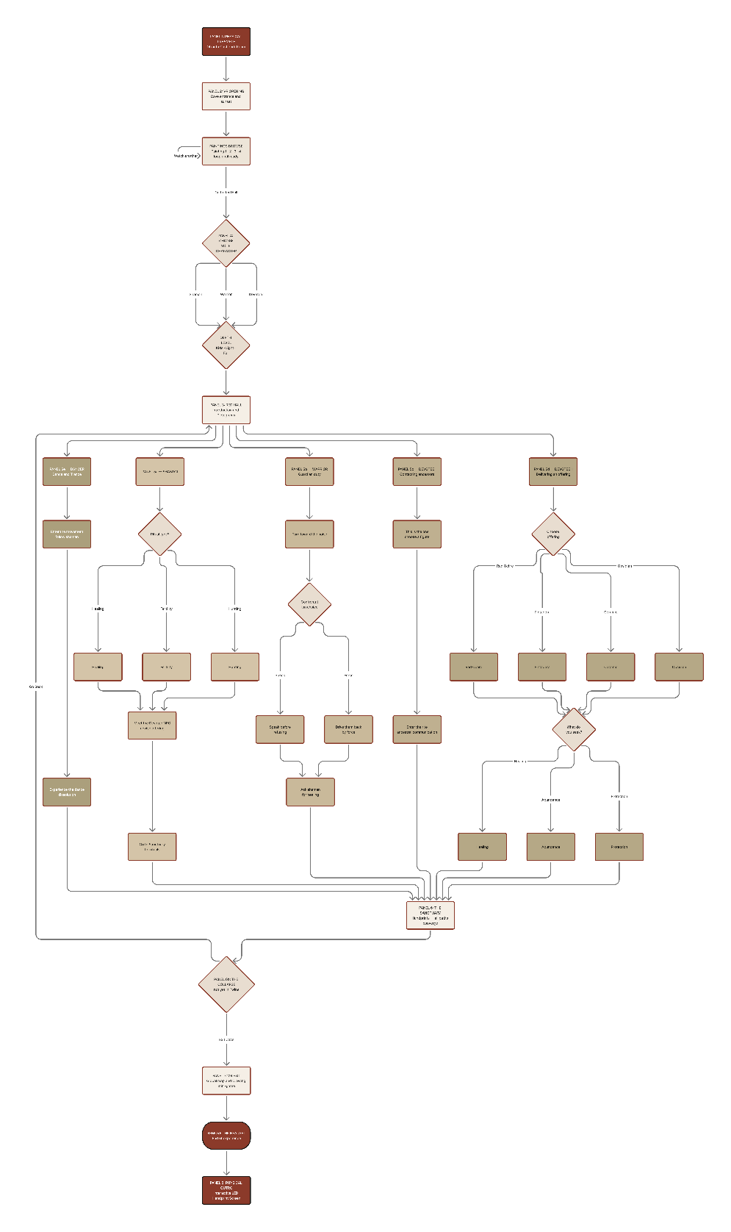
Figure 1. Interaction diagram.

  - The VR Experience Phases

The Opening: The Liminal Threshold
The journey begins at the west entrance of the cave during a Salento sunset. A 360° panorama of the Apulian sea, nowadays. Something draws the visitor into the dark mouth of the cave. We are thrown back in time. A single question defines the journey: Who are you?

Inside the Cave
The educational content (descriptions of paintings, historical context, and significance of symbols) is the same for all characters. What changes is the experience. The Shaman interprets paintings as “phosphenic” visions. Devotee II learns about Neolithic artefacts by choosing the correct votive offering. The Dancer experiences the cave through movement and sound. A 3D model of Professor Valzano serves as academic anchor throughout.

The Finale: Intertextuality and the Sanctuary
At the heart of the cave, the narrative expands globally. The visitor sees paintings linked to identical symbols found in caves worldwide, from California to Colombia, reinforcing the project’s thesis: this visual language is a universal human trait. A moment of absolute darkness and silence recreates the sensory deprivation that ancient shamans used to trigger phosphenic imagery.

The Physical Outro: The Collective Handprint
The visitor removes the headset and finds a touch-reactive LED screen in the Otranto Castle room. It displays a luminous cloud of handprints left by previous visitors.
By placing their own hand on the screen, the visitor’s print is added instantly.

  - Storyboard

The storyboard maps the narrative arc for all five character paths across eight panels: Physical Preamble → VR Opening → Red Hall → Character Paths (5a–5e) → The Sanctuary → The Collapse → VR Exit → Physical Outro.

  - The Five Roles

Role | Description
Shaman | The most complete path. Performs the ritual. Interprets phosphenes as visions.
Guardian | Protects the sacred site. Seeks power or protection in darkness.
Devotee I | Seeks initiation and communication with ancestors.
Devotee II | Brings a votive offering. Asks something of the deity.
Dancer | Keeper of movement and trance. Does not choose to come — is called.
Table 7. The five character roles of the VR experience.

  - Emotional Arcs by Character

Character | Emotional Arc
Shaman | Performs a ritual for a devotee and, after taking sacred substances, enters a visionary state. Every painting becomes a phosphenic vision, every zone a ritual stage. Guides the ceremony — and is transformed by it.
Guardian | After fighting off a robber and sustaining an  injury, enters the cave to seek the Shaman’s help. The cave is not a place of beauty — it is

 | a place of necessity. Power, protection, survival. Leaves changed in a way they did not expect.
Devotee I | Seeks initiation and communication with ancestors. The Shaman performs a powerful ritual on their behalf and what they asked for is granted. Enters seeking something and leaves as something else.
Devotee II | Carries a votive offering and petitions the deity. At the climax, an ancestor appears and speaks directly to them. The object chosen — ceramic, obsidian, or pintadera — was the key. The cave answered.
Dancer | Did not choose to come — was called. Helps the Shaman prepare the ritual; after taking the sacred substances, begins to dance and falls into vivid visions. The cave moves with them. Does not interpret the paintings. Becomes them.
Table 8. Emotional arcs by character..

  - The Closing Activity: Draw Your Pictogram

At the end of the VR journey, visitors face a final challenge: “If you were a Neolithic painter, what would you draw?” The system assigns a universal contemporary concept
(a phone, burn-out, milkshake, etc.) or a concept that existed in the Neolithic Age (a journey, family, death, love, time), and asks visitors to draw it abstractly with marks, shapes, and lines. The visitor’s drawing is placed in a Global Archive alongside every other visitor’s drawing of the same concept. If the drawings converge, then the cave paintings stop being ancient and tell us something about us people of today.

  - Visual Identity

The project’s entire visual language draws from the cave’s own artistic vocabulary. The palette is derived from the cave’s two pigments: red ochre (iron oxide / haematite, #8B3A2A) and black guano (bat guano / manganese, #1C1A17), on a warm limestone

beige ground (#C9B99A). Decorative forms (spirals, concentric circles, labyrinths, grids, dots) serve as both design elements and navigational cues across VR screens, the website, and printed materials. The design aesthetic reflects the museum: rhythmic, repetitive, hypnotic, but without being inaccessible.

  - Foreseen Workflow

The full project follows a twelve-phase production pipeline, from research to public opening and ongoing maintenance:

Phase | Description
1. Research | Collection and analysis of all academic sources — Leone tracings, Graziosi 1980, Valzano’s 3D documentation and publications. Contact with Virginia Valzano for asset permissions and academic consultation.
2. Site Visit | Visit to the Castello Aragonese di Otranto and its permanent exhibition. Assessment of the VR installation room: dimensions, lighting, electrical infrastructure, accessibility, visitor flow.
3. Planning and Concept Design | Definition of core concept, narrative structure, and character roles. Writing of character scripts and branching logic. Storyboard production. PACT analysis and persona development. MoSCoW requirements.
4. Asset Design | Pictogram redraws inspired by published academic tracings. Phosphenic pattern development and visual identity in Adobe Illustrator. UI design across all screens. Website background illustrations.
5–6. Prototyping and Implementation | Lo-fidelity wireframes → mid-fidelity layout  → hi-fidelity Figma prototype. Twine interactive narrative prototype build and

 | HTML export. Website build and publication on GitHub Pages.
7–8. Build, Presentation, and Revision | Final website publication with all project documentation, Twine link, Figma link, bibliography, and credits. Full project review: consistency check across visual identity, narrative content, and museological framework.
9. Testing | User testing of Twine and Figma prototypes with representative target audience users. Accessibility testing: colorblind palette, subtitle readability, seated usability.
10–11. Approval and Installation | Academic approval from course supervisors. Final sign-off on all content, assets, and installation design. Physical setup of four VR headsets, preamble station infographics, and LED handprint display.
12. Opening and Delivery | Public opening of the exhibition. Submission of Design Brief, Twine scenario, Figma prototype, website, and presentation for academic examination.
Table 9. Twelve-phase production workflow.

  - Technologies

Hardware
VR headsets, type Meta Quest 2: the most widely deployed headset in museum contexts, supporting seated usability for visitors with mobility constraints. VR controllers handle primary navigation and role-specific interactions. An interactive LED display, large and touch-reactive, is positioned in the physical room as the post-VR handprint screen. A local server ensures real-time synchronization between the headsets and the LED display without internet dependency, maintaining reliability within the museum environment.

Software

The VR experience is built in Unity or Unreal Engine for real-time 3D rendering and interactive narrative delivery. PTGui is required to stitch the team’s Porto Badisco photographs into the final 360° equirectangular panorama used as the VR opening scene. The website is published on GitHub Pages.

Media Assets Required

Asset | Description
360° Equirectangular Imagery | High-resolution HDR panoramas of the Porto Badisco coastline at sunset. Final version to be photographed and stitched in PTGui by the team.
3D Cave Environment | High-fidelity 3D reconstructions of the 12 zones, optimised from Professor Valzano’s photogrammetric scans (University of Salento / IIT-NRC Canada / CASPUR Rome). Subject to permissions currently being sought.
2D Animated Assets | Phosphenic-style animations for the pictograms, simulating fresh paint appearing on cave walls. Pictogram redraws based on published academic tracings by Maria Laura Leone.
Spatial Audio | Ambient cave audio: echoes, dripping water, coastal sounds for the opening scene. No voiceover: immersive VR requires concentrated focus, not narration.
Table 10. Media assets required for full production.

  - Disruptions

Risk | Mitigation
Production and Installation Costs | A full VR installation with four headsets and  professional prototypes requires significant investment. Partnerships with the Castello

 | Aragonese, regional cultural funds (Puglia Region, MiC), and European heritage programmes (Creative Europe) are the primary mitigation strategy.
Valzano Asset Permissions | The project’s archaeological foundation depends on Valzano’s 3D reconstructions. Permissions are sought through an ongoing academic relationship between the project team and the University of Salento.
VR Discomfort and Health Risks | Motion sickness or anxiety may affect older adults. Mitigated by clear VR warnings at the preamble station, seated-only design, short session duration (estimated 20–25 minutes), and trained staff monitoring throughout.
Low Digital Literacy | Visitors unfamiliar with VR may feel intimidated. Addressed by staff onboarding, the physical preamble station, and a controller design limited to single button presses with no complex gestures required.
Technical Failure | Hardware malfunction or software crashes could interrupt an experience. Mitigation: daily checks before opening, backup headsets on standby, and a printed fallback of key content at the preamble station.
Severe Physical Disabilities | Despite the seated design, visitors with significant motor impairments may find VR controllers difficult. Future development should include eye-tracking navigation as an alternative input method.
Table 11. Disruptions and mitigation strategies.

  - Further Development

Three priority areas for future development have been identified. First, a multiplayer layer allowing a group visiting together to see each other’s characters inside the cave simultaneously, each fulfilling their role in the same ritual. Second, adjustable text

size for visitors with visual impairments. Third, a kids’ version: not a diluted adaptation of the adult experience, but a version specifically for children, following Tilden’s Interpretative Principles.
A children’s version is historically justified: the handprints in the Sanctuary indicate that children were present in and central to these ritual spaces. A kids’ version should approach the cave’s themes: ritual, darkness, community, altered states through age-appropriate narrative lenses that honour Tilden’s principle: interpretation for children must not be a simplification of the adult version, but a fundamentally different creation.

  - Maintenance

VR headsets require regular hardware upkeep: lens cleaning between sessions, battery charging, strap and hygiene maintenance, and periodic firmware and software updates. A modular content architecture, where individual zones, pictogram descriptions, or educational panels can be updated without rebuilding the entire experience, is essential, as archaeological understanding of the Deer Cave is ongoing. Ongoing costs require a sustainable funding model: a modest visitor contribution integrated into the Castello Aragonese ticket price, recurring regional cultural funding applications, and long-term academic partnerships with UniSalento and UniBo for content review.

Twine: Narrative Prototype

An interactive narrative prototype was built in Twine to model the branching logic, decision-making dynamics, and the emotional arc of the experience. The prototype implements all five character paths, with looping video backgrounds, CSS animations, and image-based scene backgrounds drawn from archival photographs of the cave’s pictograms.
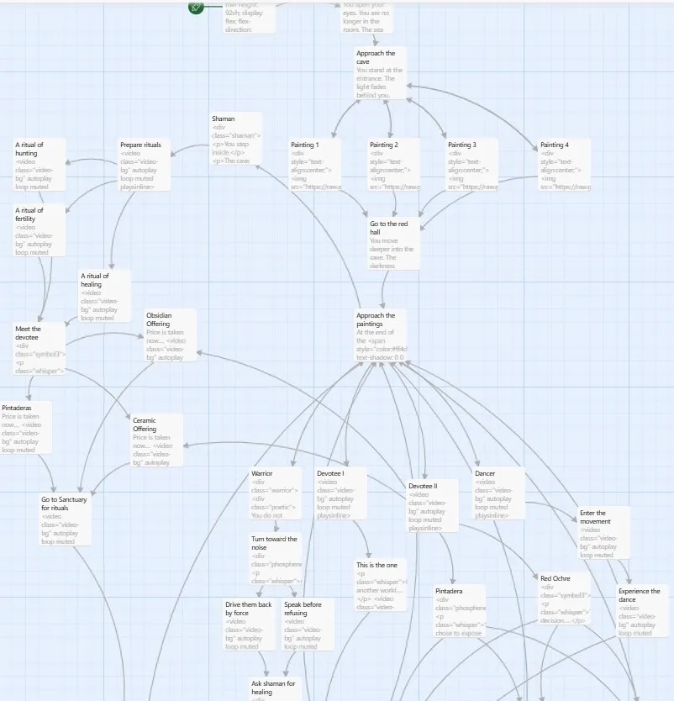
Figure 2. Narrative structure of the Twine prototype, rendered as a flow diagram.
The Twine experience was not embedded directly: its branching logic, custom CSS, and looping video backgrounds are designed for standalone playback and are not suited for inline display. The prototype is available at:
https://cinefiles25.github.io/PixelGrams/twine/index.html

Figma: Hi-Fi Prototype

  - Low-Fidelity Wireframes

Low-fidelity wireframes were developed in Figma across two pages. Page A (External Interface) covers E1 (pre-VR informational panel) and E2 (level selection: Kids / Light
/ Full). Page B (VR and Physical) maps V1 (sunset entrance and character selection), V2 (Red Hall), V3a–e (five character paths), V4 (Sanctuary), V5 (global phosphenic map), and P1 (physical LED handprint screen).

  - High-Fidelity Prototype

A complete hi-fi prototype was developed in Figma, covering the full user journey from physical arrival to post-experience reflection. The journey begins at the pre-VR physical panel (E1). From there, the cave entrance screen (V0) presents a panoramic background with a movement prompt. Users reach the character selection screen (V1), where they choose one of five roles.
All characters pass through the Red Hall (V2) — the shared common space, populated with pictogram imagery and atmospheric lighting. At this branching point, five parallel paths diverge, each with its own narrative screen and a role-specific interaction. All paths converge in the Sanctuary (V4), centred on the handprint moment. The experience continues with the global phosphenic map (V5), showing cave sites across five continents, and concludes with the physical LED handprint display (P1) outside the headset.
The colour system is drawn from the cave itself: light beige, black guano, and red ochre. The typeface is IM Fell English, a Google Font whose hand-drawn quality recalls pictographic writing. No character images are used anywhere in the prototype, by design — users become the character and imagine their own identity freely.
The interface follows Fitt’s Law, Gestalt principles, Hick’s Law, Miller’s Law, and Tidwell’s preattentive variables. Figma plugins were used to check accessibility, colour contrast, and UI quality. A settings menu allows users to adjust sound, colour theme, and font size. Green-dot annotations flag features that could not be fully implemented due to budget or rights constraints.
The prototype is available at:

https://www.figma.com/proto/JYK878ImTlbi3Z7feiOZUZ/Grotta-dei-Cervi-VR—Hi-Fi-Wireframes--Copy-?node-id=1-3&t=NXlmvA55O6wHBzIm-1

Team Roles

Team Member | Contributions
Laura Bortoli | Ideation. Lo-Fi Prototype. Storyboard. Website.
Qinghao Chen (River) | Ideation. Twine Prototype. Interpretation. Mid-Fi Prototype.
Claudia Romanello | Ideation. Research. Hi-Fi Prototype. Presentation.
Table 12. Team roles and contributions.

Sources

  - Bibliography

Aprile, G., Potenza, A., Tiberi, I., “Grotta dei Cervi, un santuario della Preistoria del Mediterraneo”, in XXVIII Valcamonica Symposium 2021: Rock-Art, a Human Heritage, 2021.
Benyon, D., Designing User Experience: A Guide to HCI, UX and Interaction Design, Harlow, Pearson, 2019.
Leone, M. L., La Fosfenica Grotta dei Cervi. Arte Mitologia e Religione dei Pittori di Porto Badisco, 2009.

  - Sitography

Comune di Otranto, La Grotta dei Cervi di Porto Badisco in 3D, https://comune.otranto.le.it/novita/la-grotta-dei-cervi-di-porto-badisco-in-3d/, last accessed on 12/05/2026.
Comune di Otranto, I luoghi della preistoria a Otranto e la Grotta dei Cervi, https://comune.otranto.le.it/novita/i-luoghi-della-preistoria-a-otranto-e-la-grotta-dei-cervi-2/, last accessed on 12/05/2026.
Comune di Otranto, Presentazione dei primi risultati di ricostruzione tridimensionale della Grotta dei Cervi, https://comune.otranto.le.it/novita/presentazione-dei-primi-risultati-di-ricostruzione-tridimensionale-della-grotta-dei-cervi/, last accessed on 12/05/2026.
Fondo Ambiente Italiano, Grotta dei Cervi, https://fondoambiente.it/luoghi/grotta-dei-cervi, last accessed on 12/05/2026.
Focus.it, Ecco la grotta proibita, https://www.focus.it/cultura/storia/ecco-la-grotta-proibita, last accessed on 12/05/2026.

Preistoria in Italia, Grotta dei Cervi, Porto Badisco (LE), https://www.preistoriainitalia.it/scheda/grotta-dei-cervi-porto-badisco-le/, last accessed on 12/05/2026.
Preistoria in Italia, Messaggi femminili dalla preistoria dell’arte. Le artiste di Grotta Chauvet e Grotta dei Cervi, https://www.preistoriainitalia.it/2020/11/20/messaggi-femminili-dalla-preistoria-dellarte-le-artiste-di-grotta-chauvet-e-grotta-dei-cervi/, last accessed on 12/05/2026.
Puglia Tourism, Grotta dei Cervi, https://visit.puglia.it/it/grotta-dei-cervi, last accessed on 12/05/2026.
Valzano, V., “Neolithic Mysteries: Revealing in 3D the Grotta dei Cervi of Porto Badisco”, video lecture, CEIT Otranto, 2020. Available at: https://vimeo.com/407669569.

  - Tools and Software

Category | Tools
Design and Prototyping | Figma (plugins: Unsplash, A11y, Coloors). Adobe Illustrator. PTGui. Canva. Google Fonts.
Narrative and Web | Twine. HTML. CSS. JS. VS Code. GitHub Pages. Mermaid Live Editor.
Research and Planning | Notion. CoToolKit. PACT Framework. Microsoft Word. Microsoft PowerPoint. Claude.
Table 13. Tools and software used in the project.

