**ScreenPlay :_**

**Page-1**

**FADE IN:**

**INT. RAJ’S APARTMENT – NIGHT**

**A modest, dimly lit apartment. Sparse furniture. A ticking wall clock breaks the silence.**

**RAJ (40s), quiet and solitary, sits on a worn-out sofa reading a book. His face is calm, but his eyes carry years of solitude.**

**SFX: CLOCK TICKING. RAIN PATTERING ON WINDOW.**

**He sips tea slowly. The room is neat — almost too neat.**

**SFX: DOORBELL RINGS.**

**Raj looks up. He hesitates, places the book down, and walks to the door.**

**Page-2**

**INT. DOORWAY – CONTINUOUS**

**Raj opens the door. Standing outside is ARUN (30s), well-dressed, smiling.**

**ARUN**

**Hi... I’m Arun. Your uncle’s son — from Vizag. You probably don’t remember me.**

**RAJ**

**(quietly)**

**Vizag?**

**ARUN**

**Yeah. I was passing through Hyderabad. Thought I’d drop by. Family, you know?**

**Raj studies him. A long pause.**

**RAJ**

**Come in.**

**Arun steps inside, looking around with casual curiosity**

**✅ Pre-Production Tasks for Your Script**

**🎬 1. Script Breakdown**

Break down each scene to identify production needs.

**Scene 1: INT. RAJ’S APARTMENT – NIGHT**

**Scene 2: INT. DOORWAY – CONTINUOUS**

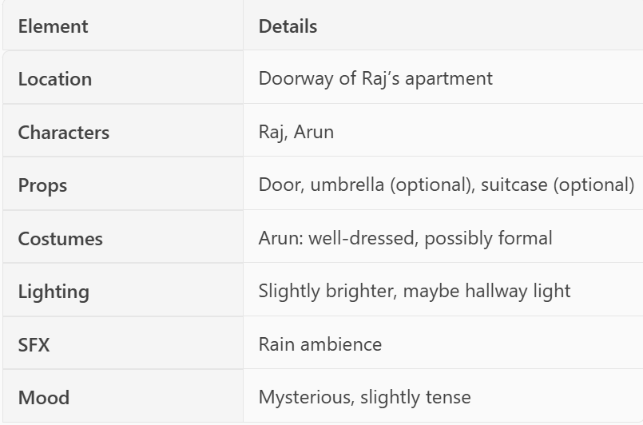

**🎥 2. Visual Planning**

**Plan how each shot will look and feel.**

**Scene 1 – Raj’s Apartment**

| **Shot #** | **Description** | **Type** | **Movement** | **Notes** |
| --- | --- | --- | --- | --- |
| **1** | **Raj reading on sofa** | **Medium Shot** | **Static** | **Establish mood** |
| **2** | **Close-up of ticking clock** | **Insert Shot** | **Static** | **Emphasize silence** |
| **3** | **Raj sipping tea** | **Close-Up** | **Static** | **Show routine** |
| **4** | **Doorbell rings, Raj reacts** | **Close-Up** | **Quick pan** | **Build tension** |
| **5** | **Raj walks to door** | **Tracking** | **Dolly in** | **Follow movement** |

**Scene 2 – Doorway**

| **Shot #** | **Description** | **Type** | **Movement** | **Notes** |
| --- | --- | --- | --- | --- |
| **6** | **Raj opens door, sees Arun** | **Over-the-shoulder** | **Static** | **Reveal character** |
| **7** | **Arun introduces himself** | **Medium Shot** | **Static** | **Dialogue** |
| **8** | **Raj reacts** | **Close-Up** | **Static** | **Suspicion** |
| **9** | **Arun enters, looks around** | **Wide Shot** | **Dolly out** | **Establish space** |

**🧩 3. Storyboarding**

**Sketch or visualize key moments:**

* **Raj alone in dim room**
* **Doorbell moment**
* **Arun at the door**
* **Raj’s suspicious reaction**
* **Arun stepping inside**

**🧑‍🤝‍🧑 4. Casting**

* **Raj: Middle-aged actor with expressive eyes.**
* **Arun: Younger actor with a friendly but mysterious vibe.**

**📍 5. Location Scouting**

* **Find a modest apartment with:** 
  + **A visible doorway**
  + **A sofa setup**
  + **A window for rain sound**
  + **Lighting control**

**🎨 6. Production Design**

* **Set dressing: sparse furniture, neat layout**
* **Props: book, tea cup, clock**
* **Costumes: simple home wear for Raj, formal for Arun**

**🎶 7. Sound & Music Planning**

* **Ambient rain sound**
* **Clock ticking**
* **Doorbell**
* **Optional suspenseful underscore**

**🗓️ 8. Scheduling**

* **Plan shoot for night scenes**
* **Coordinate actor availability**
* **Group shots by location**

**💰 9. Budgeting**

* **Equipment rental (camera, lights, mic)**
* **Location cost (if rented)**
* **Actor fees**
* **Props and costumes**
* **Sound design and post-production**

**🧪 10. Technical Tests**

* **Lighting test for dim mood**
* **Sound test for rain and doorbell**
* **Camera test for doorway framing**