# CINEMETRICS

## FIRST INCREMENT REPORT

All the features we have developed for this increment, describing the design, implementation, testing, and deployment (including the precise descriptions and screenshots).

1. EXISTING SERVICES / REST API:

We have used TMDBI API, which is the rest implemented API which gives the results of the movies. Please find the below link for reference.

<https://www.themoviedb.org/documentation/api>

1. Detail Design of Features:
   * 1. ARCHITECTURE DIAGRAM:

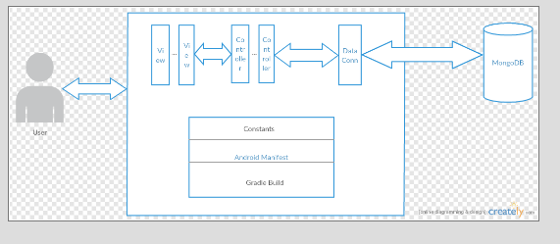

* + 1. CLASS DIAGRAM:

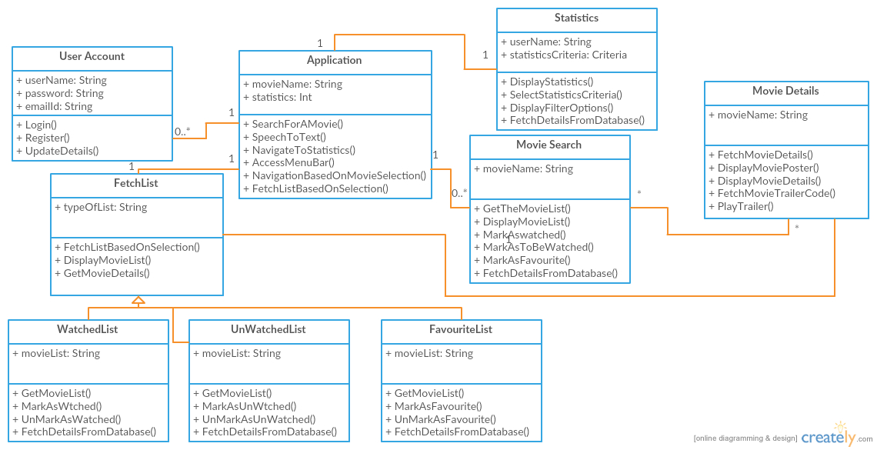

* + 1. LOGO:

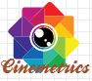

* + 1. LANDING PAGE:

On click of logo in android application, landing page will be loaded. UI wireframe is as below

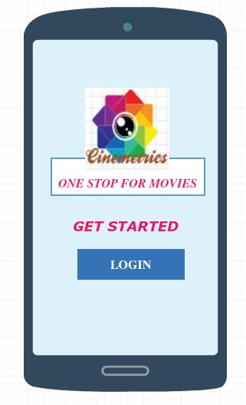

* + 1. LOGIN AND REGISTRATION:

On click of Login in landing page user is redirected to Login screen. Below are the UI wireframe and sequence diagram of login and registration.

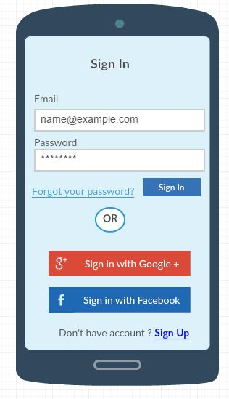 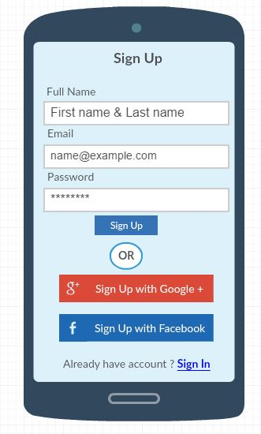

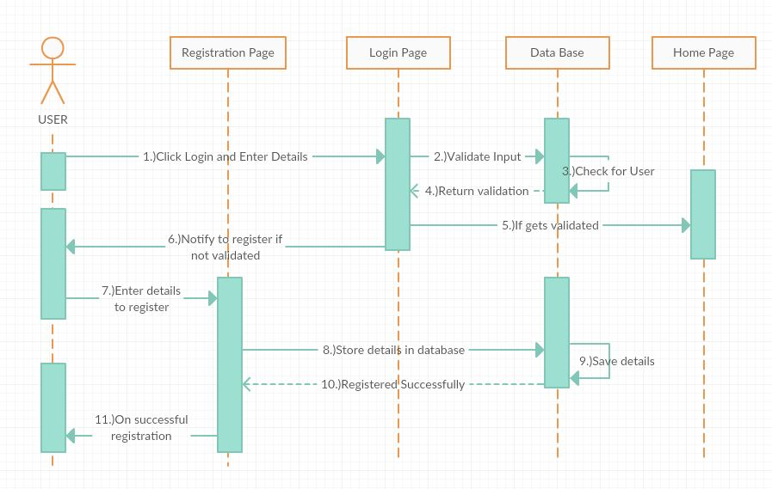

* + 1. GET STARTED:

There are two types of users, Normal user and Registered user.

**Normal user** can click of GET STARTED and view the movie search screen and movie description.

**Registered user** has access to check the movie count and have chance to add the movies to favourite list or watched list or to be watched list.

* + 1. SEARCH SCREEN:

Search screen contains a search bar with mike option along with best movies in the current year. Voice to Text functionality is available. If the user swipes left or right on the movie list then that movie row will be cleared from the list.

Normal User Search Screen:

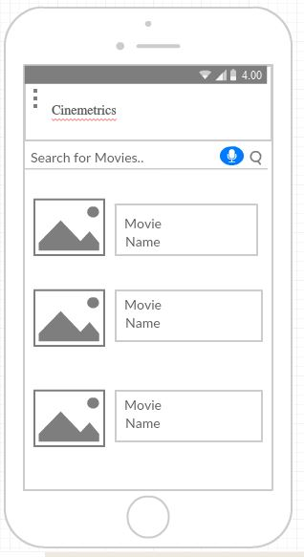

Registered User Search Screen:

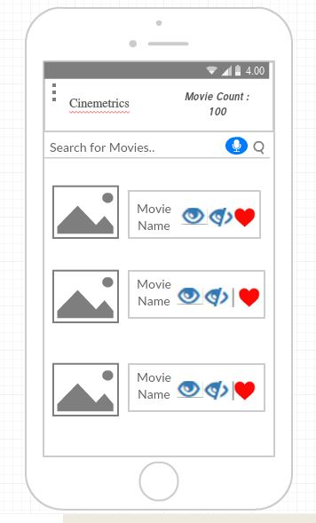

Sequence Diagram:

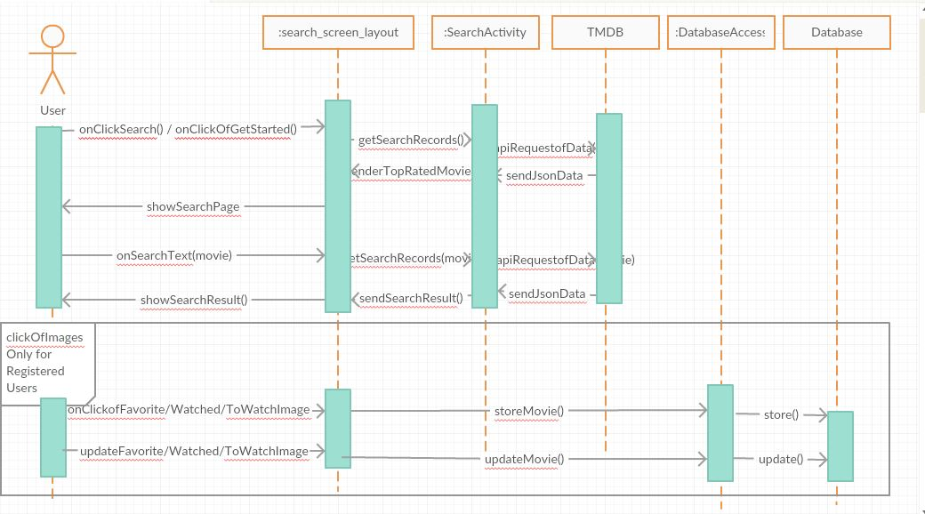

* + 1. SIDE MENU

Side menu for normal user and registered user are as below

Normal User: Registered User:

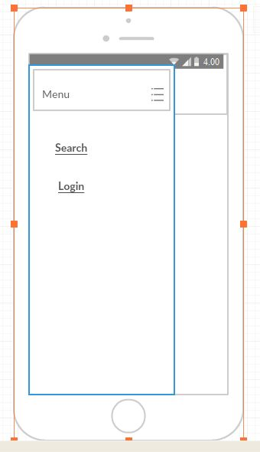 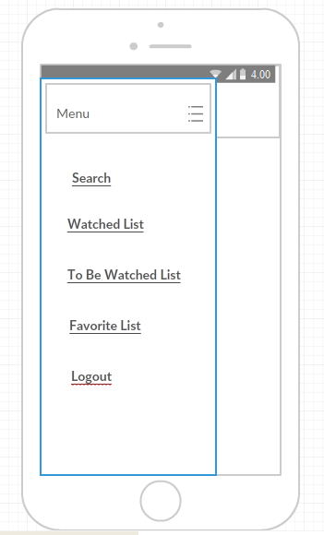

* + 1. MOVIE DESCRIPTION SCREEN

Movie description screen contains the movie details like poster, movie title, release date, genre etc. YouTube trailer is available. If VR enabled trailer is available, then user can view in google cardboard. User can also share the movie description to social media with comments. Below are the UI wireframes and sequence diagram:

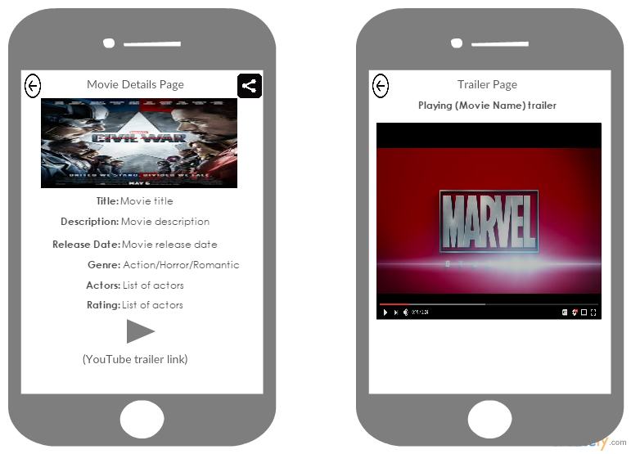

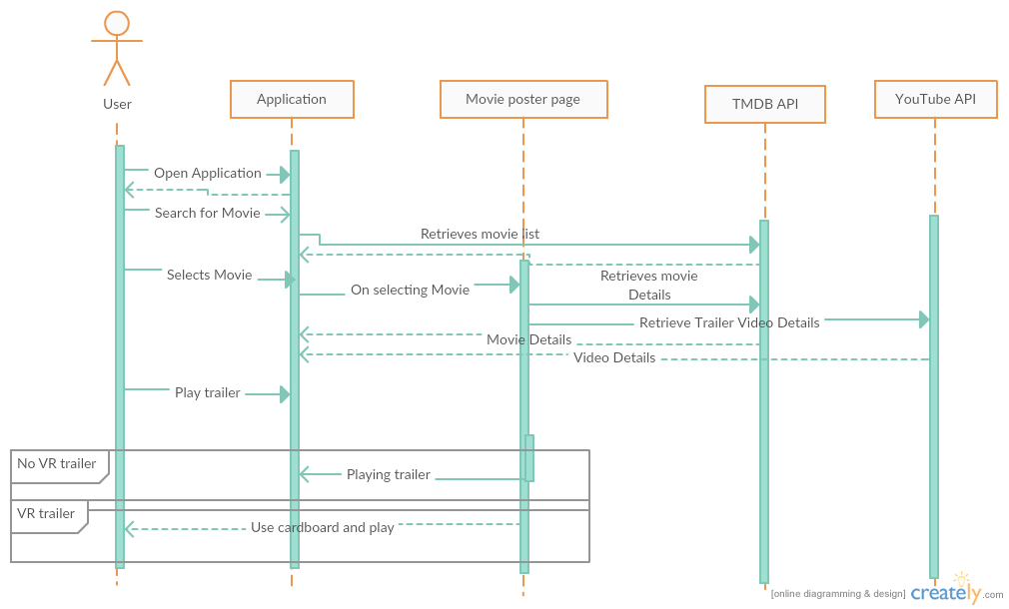

* + 1. STATISTICS PAGE

On click of Movie Count on the search screen, user is redirected to statistics page. Pie chart based on genre of watched list is displayed by default and the description of the chart. User can filter the chart and alter the pie chart by selecting options like language, year etc. Below are the UI wireframes and sequence diagram.

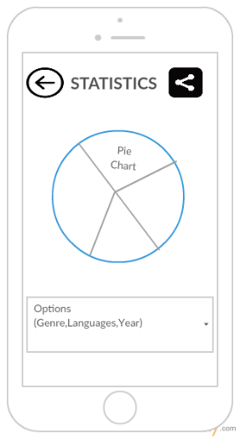

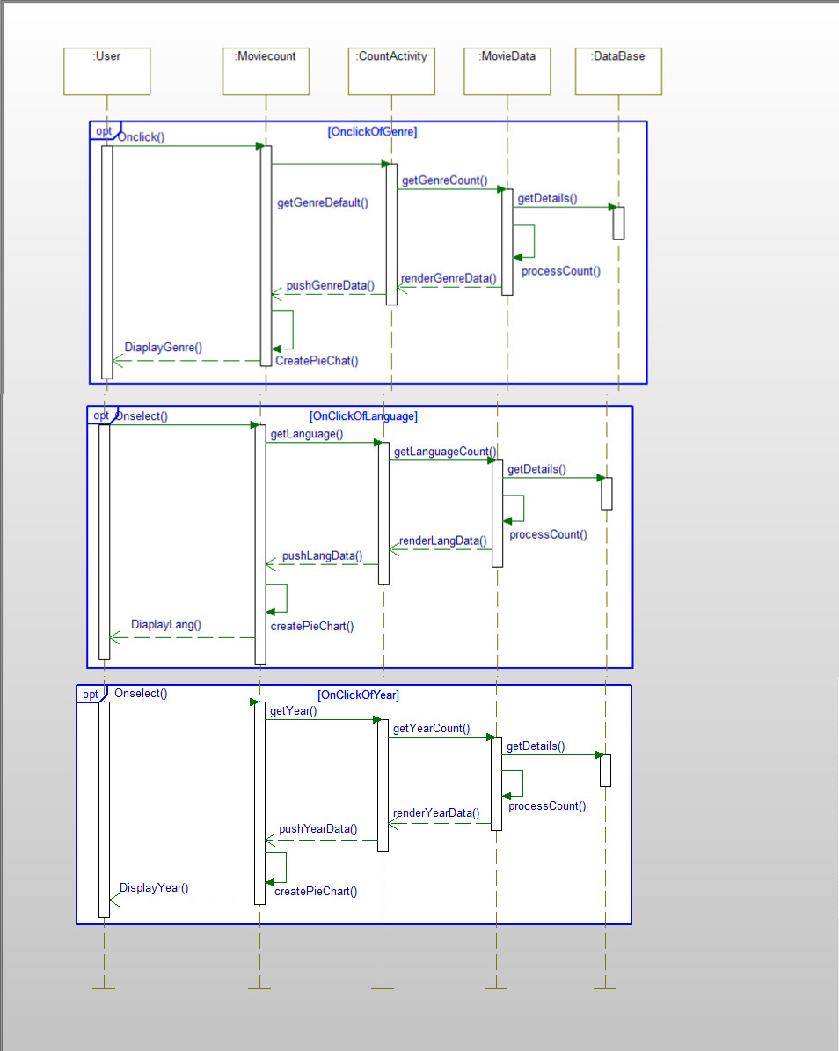

* + 1. WATCHED LIST, TO BE WATCHED LIST, FAVORITES LIST

On selection of Watched List, watched movie details will be shown on the screen.

On selection of To Be Watched List, to be watched movie details will be shown on the screen.

On selection of Favourite List, favourite movie details will be shown on the screen.

When the user toggles the options to add into lists on the search screen or movie description screen, details will be stored into database.

Details will be fetched from database on selection of these pages. User can also toggle these options on these screens. Below are the UI wireframes and sequence diagram.

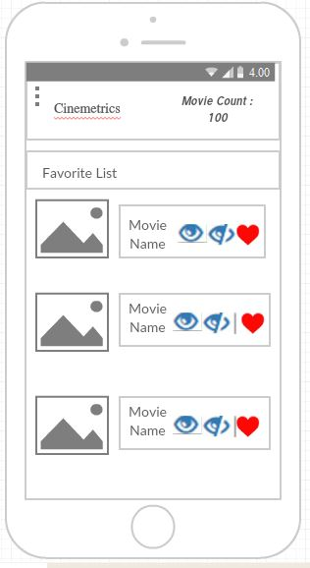 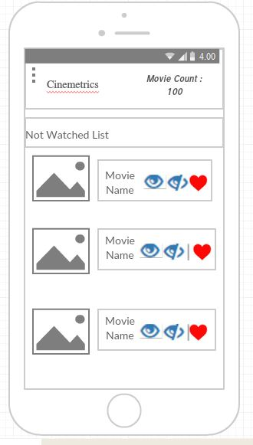 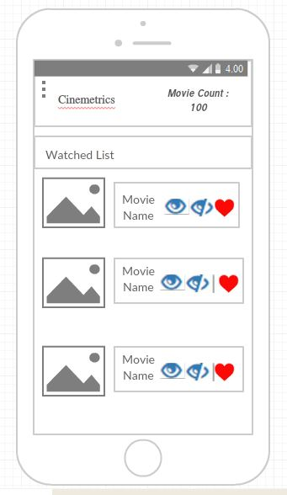

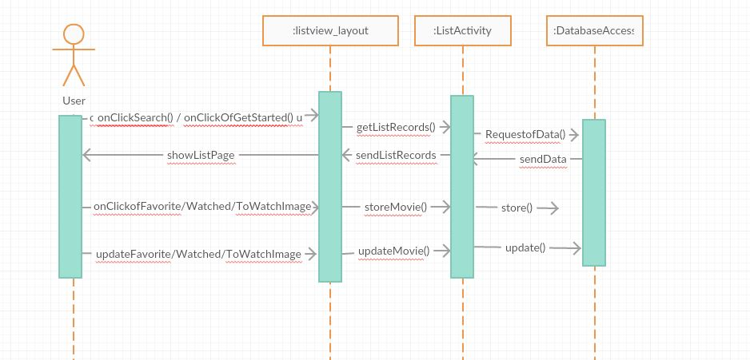

BURNDOWN CHART:

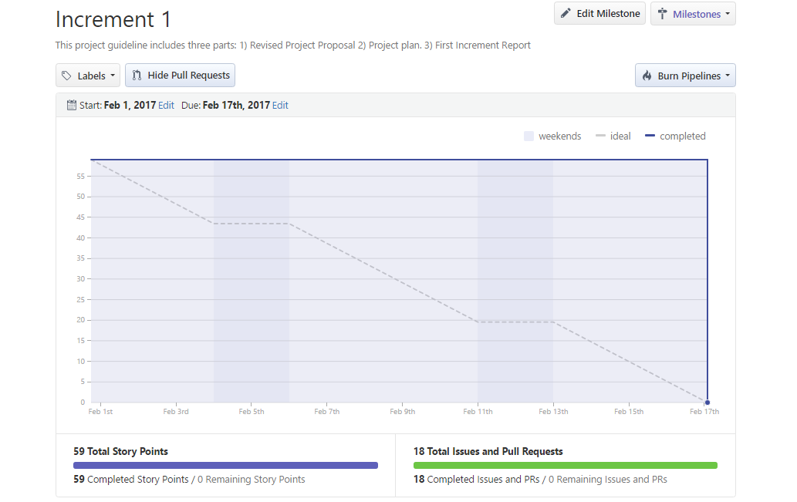

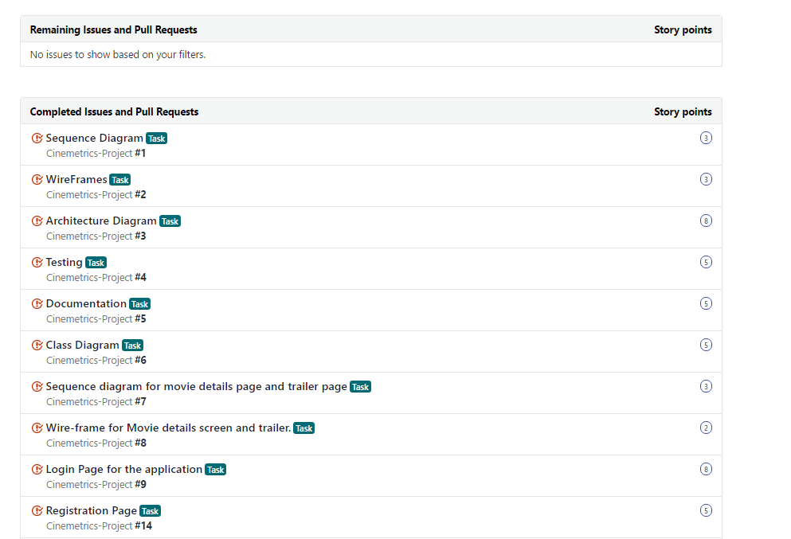

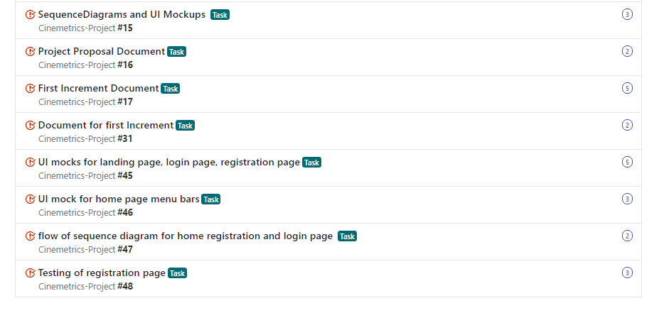

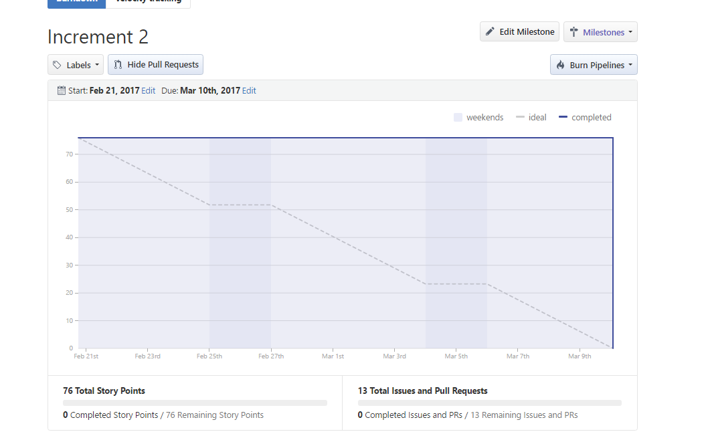

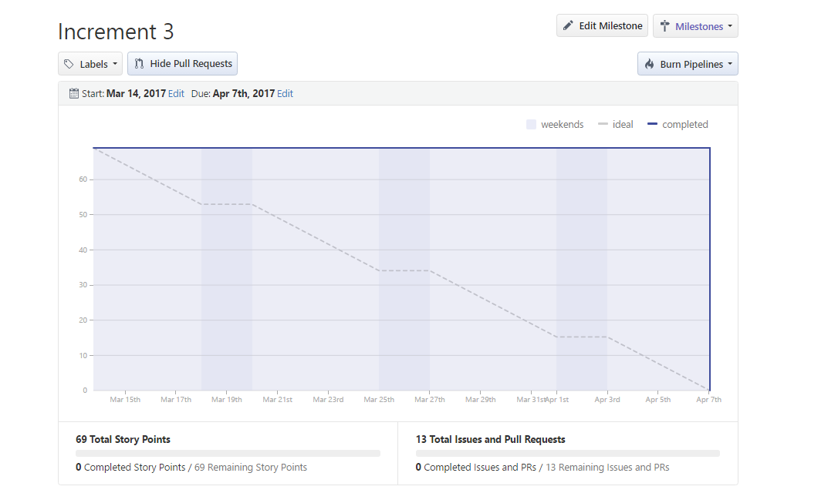

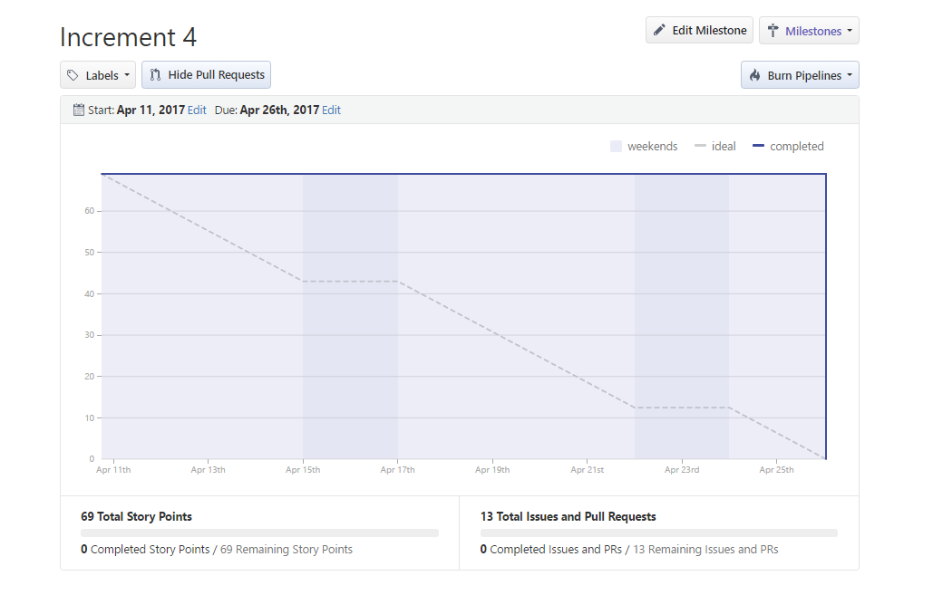

**INCREMENT 1**: Design plan, Architecture Diagram, Class Diagram, UI wireframes and sequence diagrams for all modules, Revised project proposal, Project Documentation, Tasks creation for all increments. Login and Registration pages implementation, testing and deployment.

Below is the github link for the tasks created and user stories:

<https://github.com/Cinemetrics/Cinemetrics-Project/issues?q=is%3Aissue+milestone%3A%22Increment+1%22+is%3Aclosed>

1. IMPLEMENTATION:

Partial implementation of Login page and Registration page is completed in this increment.

1. TESTING:

Testing for the login and registration is performed.

1. DEPLOYMENT:

Below are the screenshots of the implemented code

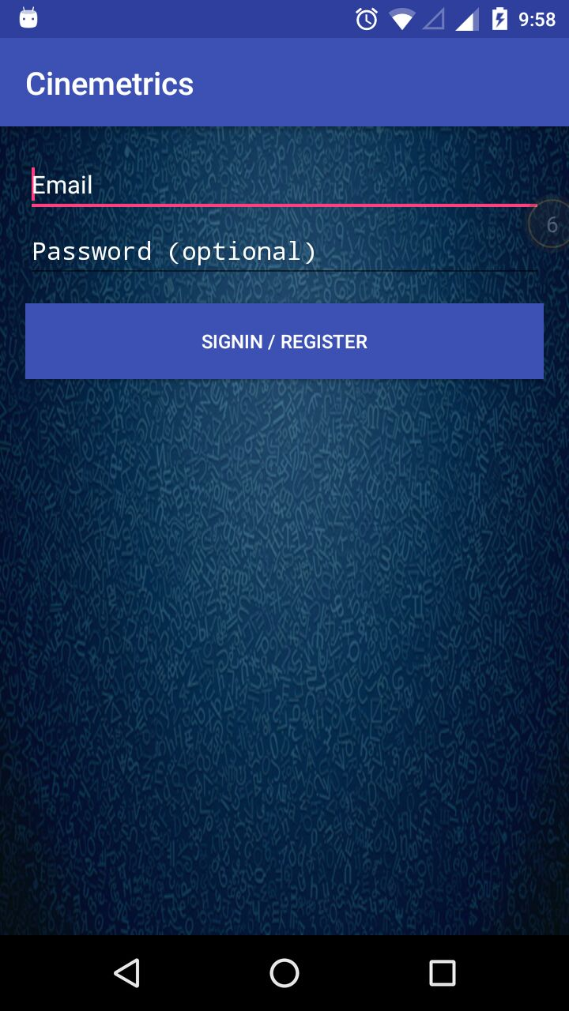 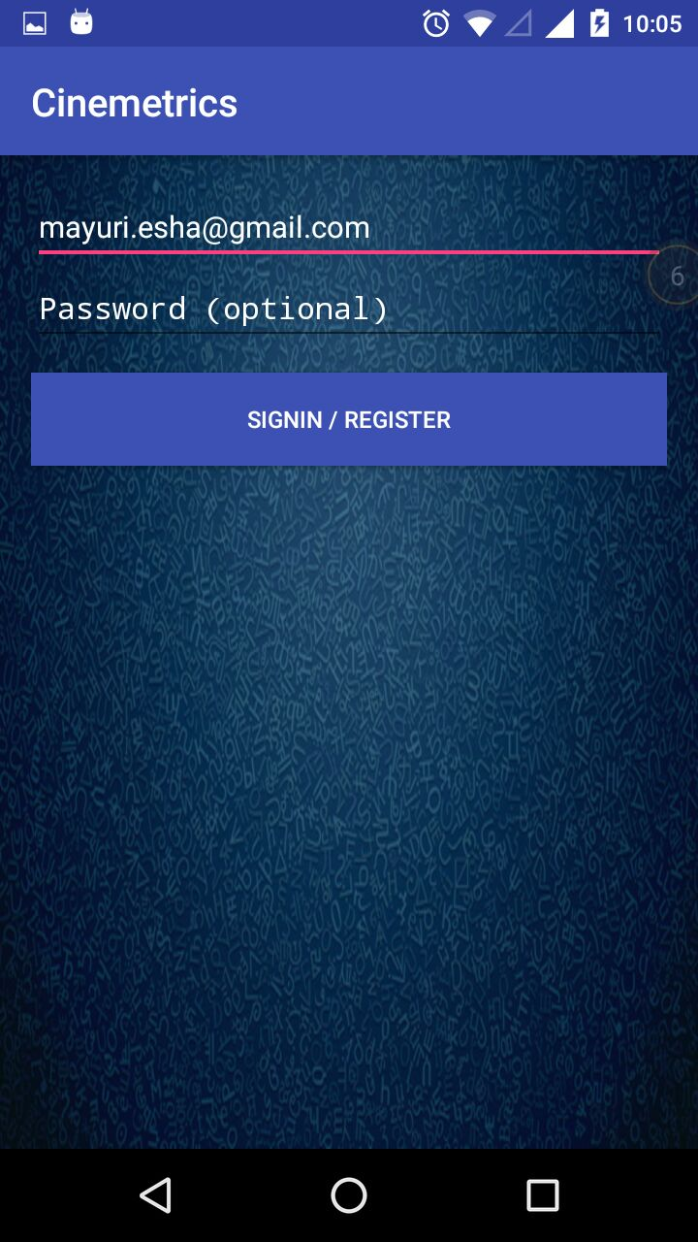

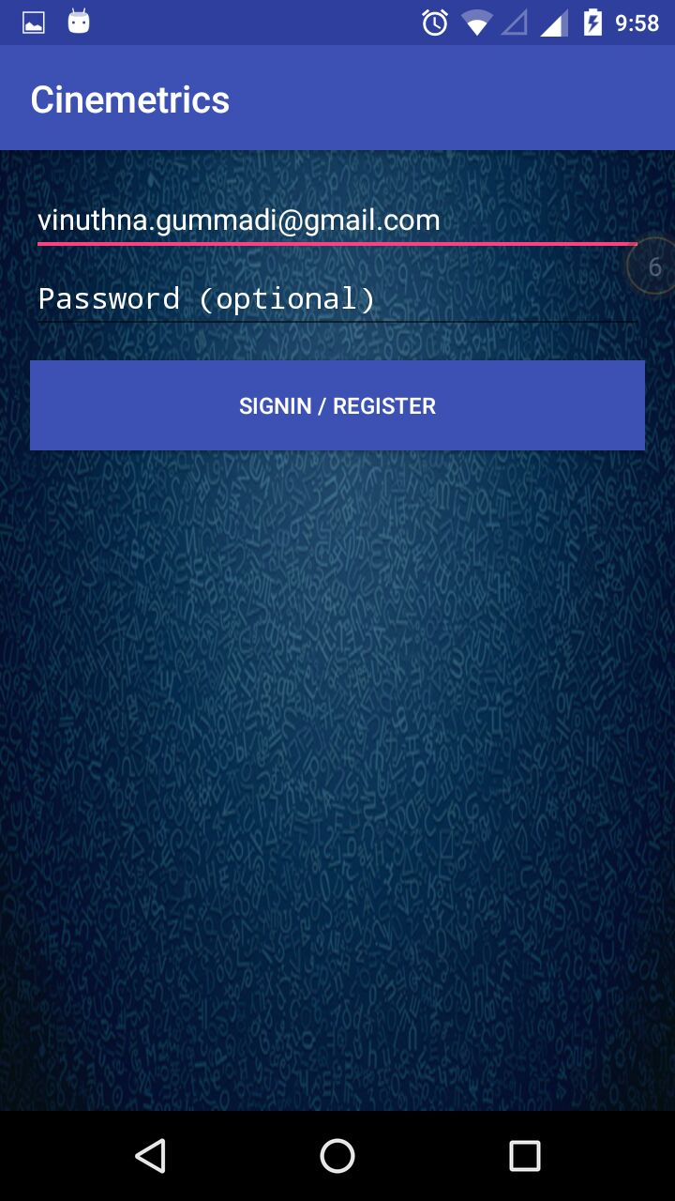

On click of SIGNIN / REGISTER:

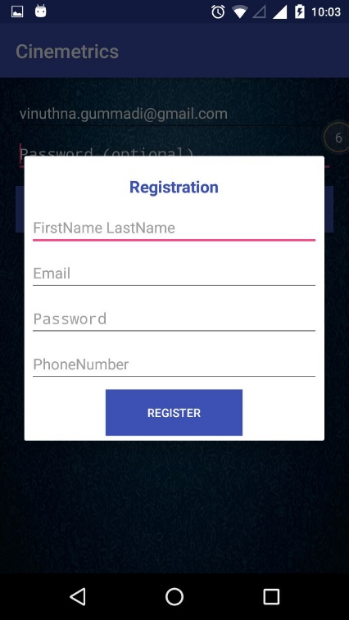 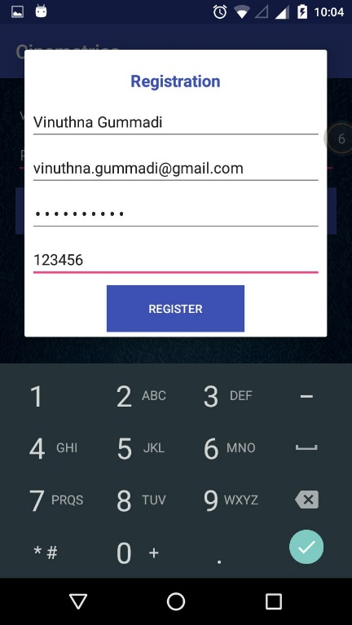

On Click of REGISTER:

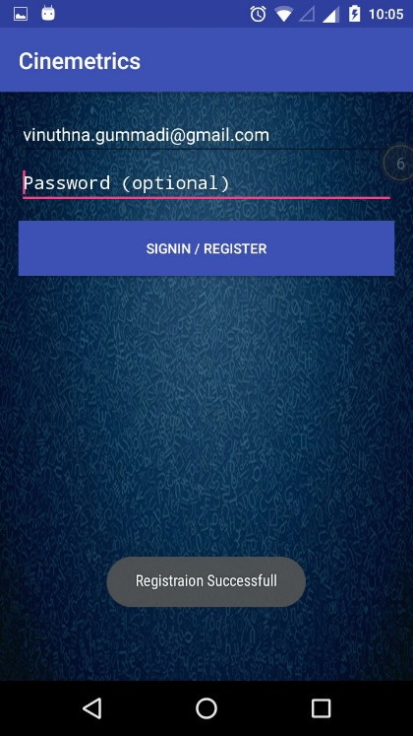

**GIT HUB**

Source code: <https://github.com/Cinemetrics/Cinemetrics-Project/tree/master/Source/Cinemetrics>

WIKI page: <https://github.com/Cinemetrics/Cinemetrics-Project/wiki/First-Increment-Report>

Project Plan: <https://github.com/Cinemetrics/Cinemetrics-Project/wiki/Cinemetrics-Project-Plan>

Implementation: <https://github.com/Cinemetrics/Cinemetrics-Project/wiki/First-Increment-Implementation>

1. PROJECT MANAGEMENT

**Implementation status report**: COMPLETED

**Work completed**:

• **Description**:

Revised Project Proposal, Project Plan. First Increment Report. UI wireframes and sequence diagrams for search screen, watched/to be watched/favourite list screen, side menu. Created tasks assigned for all the increments. Registration Page implementation.

• **Responsibility** (Task, Person):

Vinuthna Gummadi

• **Description**:

Architecture Diagram, UI wireframes and sequence diagrams for statistics page. Created tasks assigned for all increments. Testing of Login Page.

• **Responsibility** (Task, Person):

Penumetcha,Jnana Gayathri

• **Description**:

Class Diagram. UI wireframes and sequence diagram for movie description page. Created tasks assigned for all increments. Login code implementation.

• **Responsibility** (Task, Person):

Mayuri,Esha

• **Description:**

UI wireframes and sequence diagram for login and registration screens. Created tasks assigned for all increments. Login code testing

• **Responsibility** (Task, Person):

Cheldhi,Lavanya

**Work to be completed**

No work pending.

**Issues/Concerns**

No issues

1. Bibliography

<https://www.themoviedb.org/documentation/api>