# CINEMETRICS

## INTRODUCTION:

CINEMETRICS is an android application, to manage and keep track of all movies at one place. With the use of TMDB API, all the movies and series are controlled. This app can be used to check all the movies, collect different movies, add movies to watched list or to be watched. It also shows the count of movies the user watched along with the statistic diagrams, these stats can be shared across social media.

1. PROJECT GOAL AND OBJECTIVES:

2.1. OVERALL GOAL:

Overall goal is to create and deploy Cinemetrics app where the user finds it easy to track down the number of movies he has watched and share to the social media. To create interactive and user-friendly app where the movies can be searched and create lists for favourite, watched and to watch.

2.2. SPECIFIC OBJECTIVE:

* The user can view movie posters with the help of search criteria like title, rating, year, star cast, Oscar-nominated, genre etc.

• On selection of a movie poster, the user can view the movie description, ratings. The user also has an option to mark if the movie is already watched or to be watched or favourite. These will be added to the user’s library. YouTube trailer will also be present and there will be an option to rate the movie or a series.

* VR trailers can be viewed using google cardboard.

• The user will be having different screens where he can check the list of watched movies, list of to be watched movies and favourite movies. If the user changes the status of to be watched a movie to watched then this movie will be cleared from the list.

• On the home screen, the user will be having a count of all movies he watched. On click of the count, he can view a statistical history of the movies watched based on year, genre, star cast etc. These stats can be shared across different applications like Facebook, Twitter, WhatsApp etc.

• The user can also share the watched movie across different applications.

• Additionally, a normal user can search for the movies and description of the movie. If he would like to get the movie count and add movies to the above-mentioned list, he registers his account. He can either create account or signup using Google or Facebook.

* Remainder option is available if user wants to remind about a movie.

2.3. SPECIFIC FEATURES:

* User-friendly search screen for search of different key words.
* Description of movies
* Google cardboard implementation of VR mode YouTube trailers.
* Count of movies the user watched where he can share to social media.
* Statistics of the movies the user watched.

2.4. SIGNIFICANCE:

Cinemetrics will be one stop movie library for the users who wants to maintain the movie database with them and share to the social media.

1. PROJECT PLAN:

3.1. SCHEDULE FOR FOUR INCREMENTS:

Project Modules Stories, Service Design:

* + 1. ARCHITECTURE DIAGRAM:

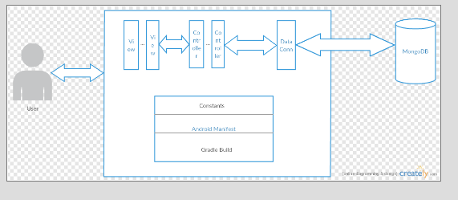

* + 1. CLASS DIAGRAM:

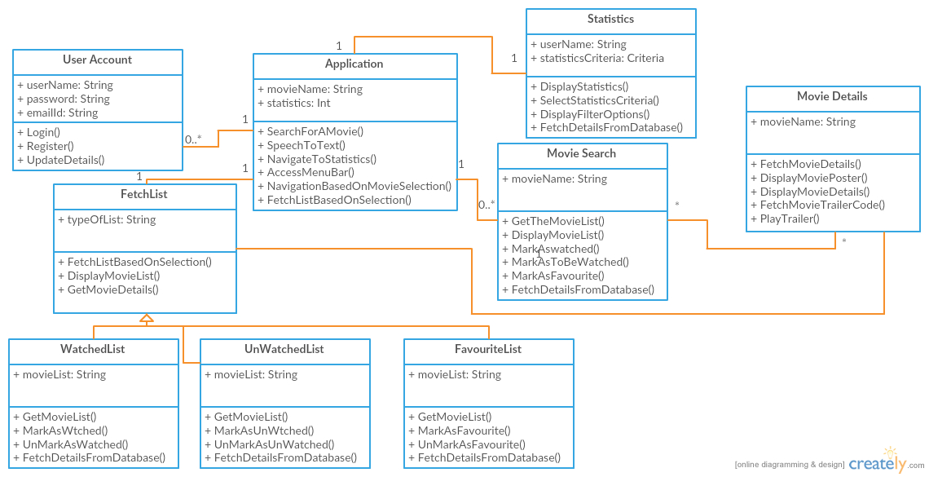

* + 1. LOGO:

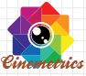

* + 1. LANDING PAGE:

On click of logo in android application, landing page will be loaded. UI wireframe is as below

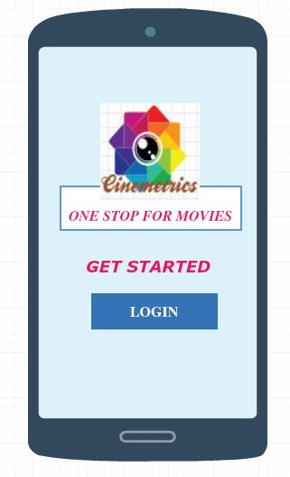

* + 1. LOGIN AND REGISTRATION:

On click of Login in landing page user is redirected to Login screen. Below are the UI wireframe and sequence diagram of login and registration.

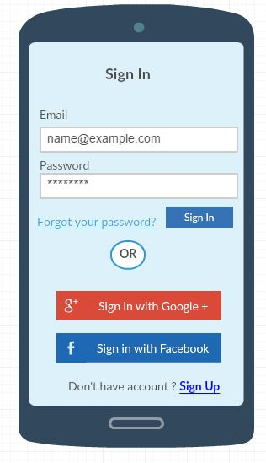 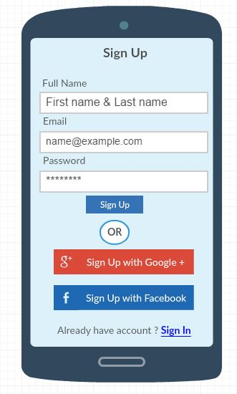

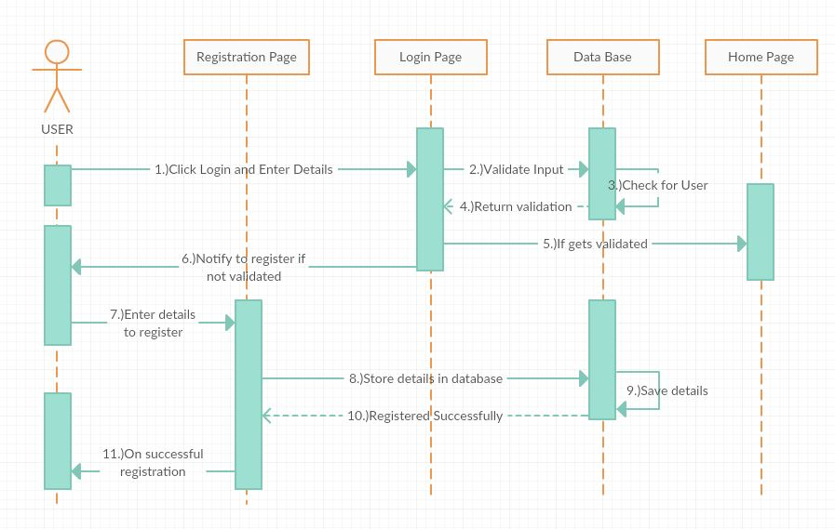

* + 1. GET STARTED:

There are two types of users, Normal user and Registered user.

**Normal user** can click of GET STARTED and view the movie search screen and movie description.

**Registered user** has access to check the movie count and have chance to add the movies to favourite list or watched list or to be watched list.

* + 1. SEARCH SCREEN:

Search screen contains a search bar with mike option along with best movies in the current year. Voice to Text functionality is available. If the user swipes left or right on the movie list then that movie row will be cleared from the list.

Normal User Search Screen:

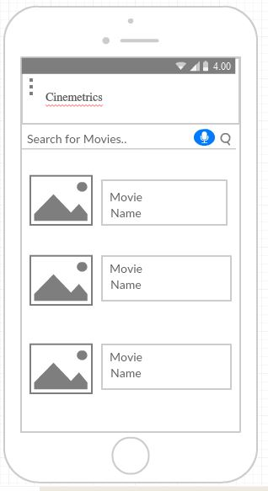

Registered User Search Screen:

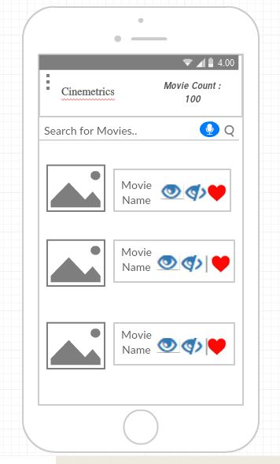

Sequence Diagram:

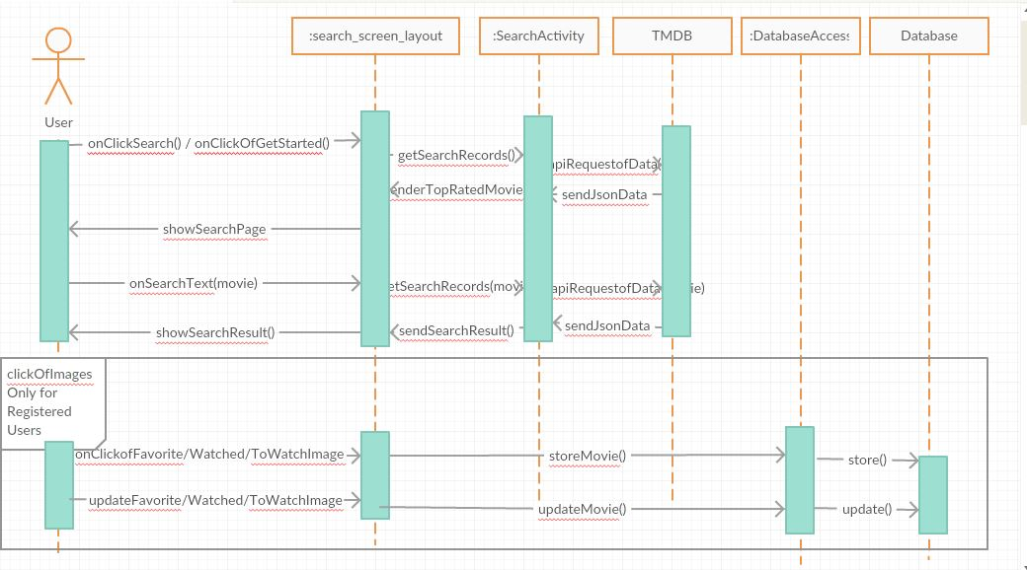

* + 1. SIDE MENU

Side menu for normal user and registered user are as below

Normal User: Registered User:

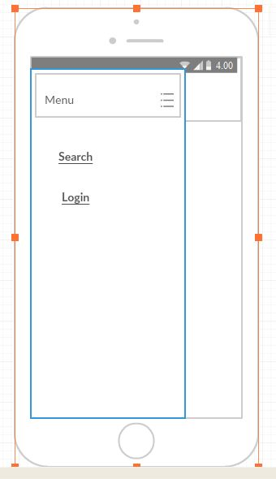 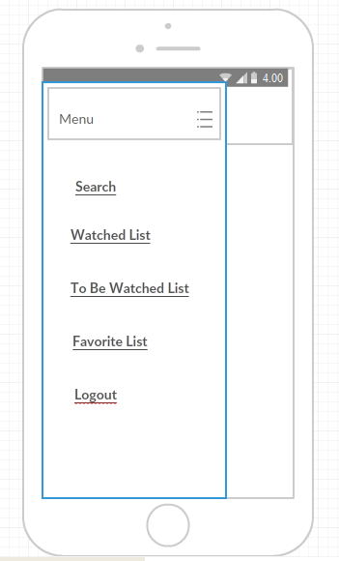

* + 1. MOVIE DESCRIPTION SCREEN

Movie description screen contains the movie details like poster, movie title, release date, genre etc. YouTube trailer is available. If VR enabled trailer is available, then user can view in google cardboard. User can also share the movie description to social media with comments. Below are the UI wireframes and sequence diagram:

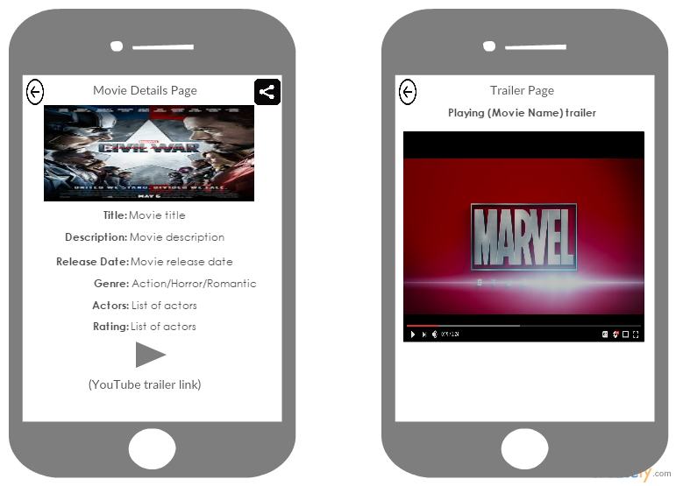

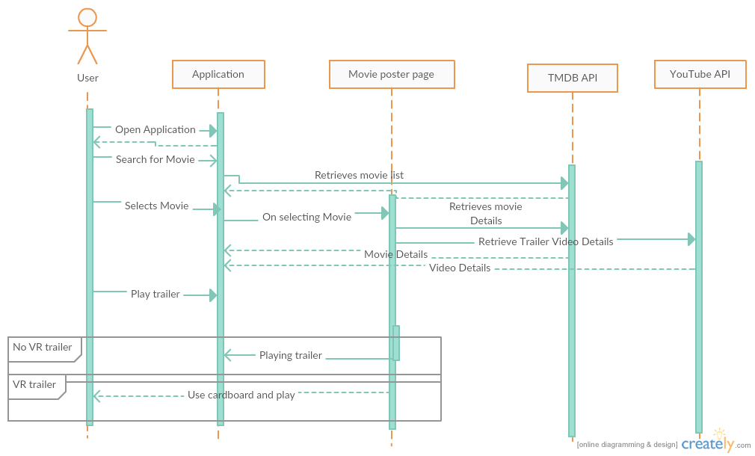

* + 1. STATISTICS PAGE

On click of Movie Count on the search screen, user is redirected to statistics page. Pie chart based on genre of watched list is displayed by default and the description of the chart. User can filter the chart and alter the pie chart by selecting options like language, year etc. Below are the UI wireframes and sequence diagram.

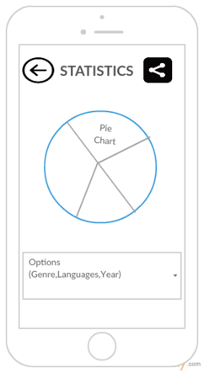

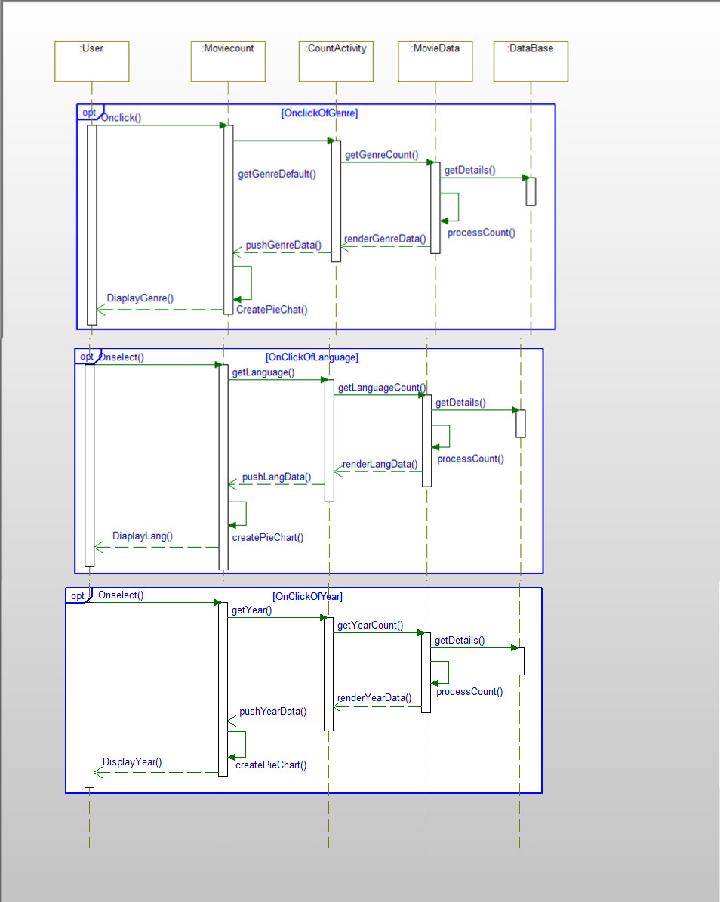

* + 1. WATCHED LIST, TO BE WATCHED LIST, FAVORITES LIST

On selection of Watched List, watched movie details will be shown on the screen.

On selection of To Be Watched List, to be watched movie details will be shown on the screen.

On selection of Favourite List, favourite movie details will be shown on the screen.

When the user toggles the options to add into lists on the search screen or movie description screen, details will be stored into database.

Details will be fetched from database on selection of these pages. User can also toggle these options on these screens. Below are the UI wireframes and sequence diagram.

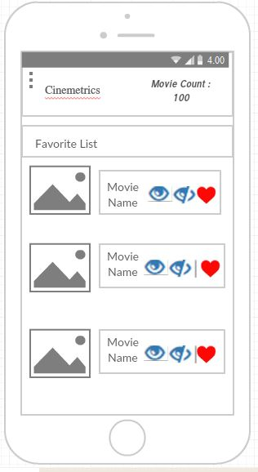 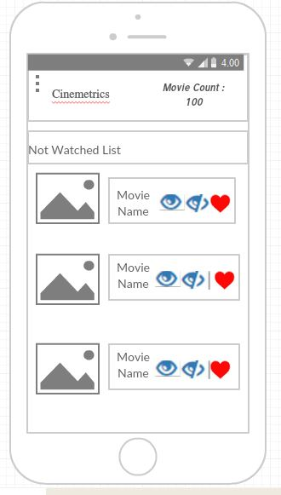 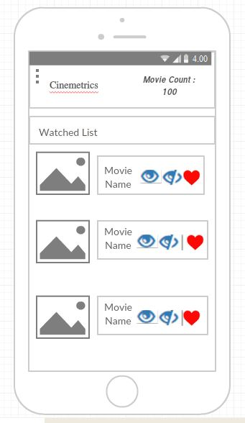

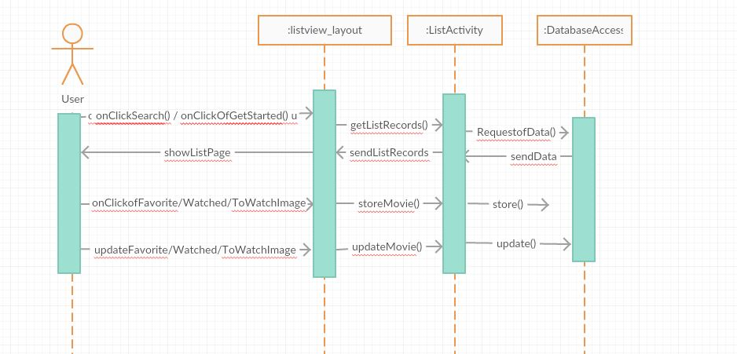

1. PROJECT TIMELINES, MEMBERS AND TASK RESPONSIBILITY

Increment 1: 02/01/2017 to 02/17/2017

Increment 2: 02/02/2017 to 03/10/2017

Increment 3: 03/13/2017 to 04/07/2017

Increment 4: 04/10/2017 to 04/26/2017

**MEMBERS**:

1. Vinuthna Gummadi
2. Penumetcha,Jnana Gayathri
3. Mayuri,Esha
4. Cheldhi,Lavanya

**TASK RESPONSIBILITY**:

The application screens are shared as below:

**Vinuthna**: Normal and Registered User Search Screen, Database Design, Watched List Screen.

**Gayathri**: Statistics Page, Share functionality for images, Favourites List Screen.

**Esha**: Movie Description Page, YouTube trailer, VR Google cardboard compatibility.

**Lavanya**: Landing page, Share functionality, Login validation with database connectivity and Facebook, Google signup.

**INCREMENT 1**: Design plan, Architecture Diagram, Class Diagram, UI wireframes and sequence diagrams for all modules, Revised project proposal, Project Documentation, Tasks creation for all increments. Login and Registration pages implementation, testing and deployment.

**INCREMENT 2**: Search screen, custom list ui implementation, statistics page ui implementation, movie description page implementation, landing page implementation and login page facebook, google integration. Testing and deployment of the above.

**INCREMENT 3**: Database creation, completion of custom list ui screens, statistics page completion, share functionality completion and movie description page completion. Testing and implementation of above.

**INCREMENT 4**: Any enhancements, backdrop issues, changes requested. Integration of all modules and perform Integration testing and Final Testing.

1. BURNDOWN CHART:

