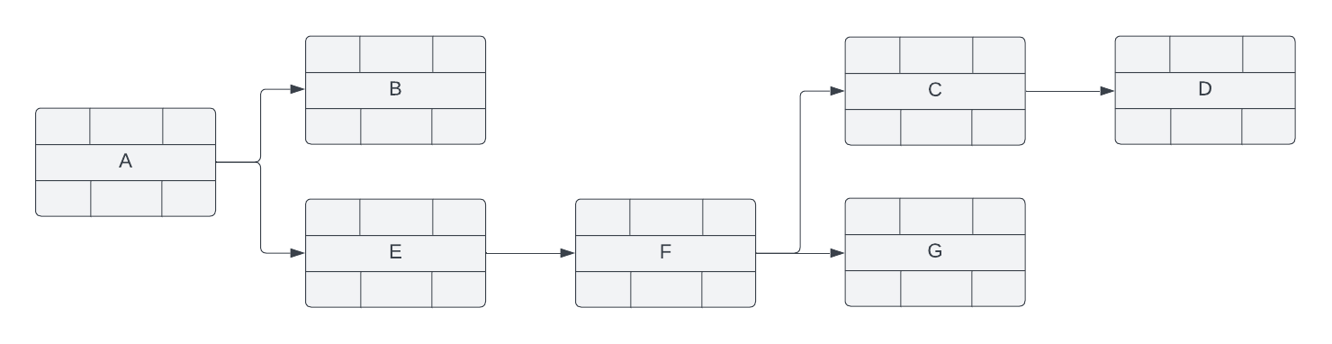
EF:
ES: 1
EF: 1
LF:
1
ES: 2
EF: 4
3
ES: 2
3
EF: 4
ES: 5
EF: 9
5
EF: 10
EF: 13
4
EF: 10
EF: 10
1
EF: 13
EF: 14
2
EF:
LF:
LF:
EF:
LF:
EF:
EF:
LF:
LF:
EF:

