|  |
| --- |
| MVCH Database Proposal |
|  |

Durham College

|  |  |
| --- | --- |
| 04/17/19 | Ian Carlos, Roshan Persaud, Vinay Thapar |

*For Stephen Forbes’ DBAS5206 class

Table of Contents

Introductory Memo 2

Mission Statement 3

Mission Objectives 3

System Description 5

System Boundary 5

Major User Views 6

3nf 7

Functional Dependencies 8

Data Dictionary 11

# 

# Introductory Memo

Mountain View Community Hospital (MVCH) is a non-profit, short-term general hospital that serves the surrounding rural areas and city of Mountain View. Its current information systems are batch-oriented and include functionality to related accounting tasks such as: Patient Accounting, Billing, Accounts Receivable and Financial Accounting.

Nathan Heller, the current head of Information Systems in MVCH has identified a handful of deficiencies within MVCH’s present information systems. These include unable to record/report results of laboratory tests and procedures for medical staff, does not accumulate costs by department or cost centre, and the lack of flexibility to keep up with continuous changes such as management needs and reporting requirements.

In order to mitigate the deficiencies mentioned above, we plan to convert MVCH’s batch-oriented information systems into a more interactive system. An interactive system can process and store information immediately than a batch-oriented system where a set number of tasks is executed simultaneously at a set point of time. This will mainly involve running queries against a database. We will be creating various tables to store related: patient, physician, room and revenue data.

Our project plan will include a mission statement and a list of mission objectives, the system description, 3NF design, a list of all functional dependencies for all tables, and a data dictionary. In a separate attachment (not included here), our database with the corresponding tables filled with sample data (to simulate its functionality) and two generated Crystal Reports: a Room Utilization Report and Physician-Patient Report.

# Mission Statement

The purpose of the MVCH database system is to ensure that all necessary data is easily stored in real-time and accessible throughout the system and to make sure that it is scalable to be able to adapt to changing requirements in the future.

## Mission Objectives

* To maintain (enter, update, and delete) data on patients.
* To maintain (enter, update, and delete) data on physicians.
* To maintain (enter, update, and delete) data on physician specialties.
* To maintain (enter, update, and delete) data on admittances.
* To maintain (enter, update, and delete) data on rooms.
* To maintain (enter, update, and delete) data on cost centres.
* To maintain (enter, update, and delete) data on appointments.
* To maintain (enter, update, and delete) data on medical equipment.
* To maintain (enter, update, and delete) data on item details.
* To maintain (enter, update, and delete) data on patient medical histories.
* To maintain (enter, update, and delete) data on invoices.
* To maintain (enter, update, and delete) data on transactions.
* To maintain (enter, update, and delete) data on treatments.
* To maintain (enter, update, and delete) data on lab results.
* To maintain (enter, update, and delete) data on examinations.
* To perform searches on patients.
* To perform searches on physicians.
* To perform searches on physician specialties.
* To perform searches on invoices.
* To perform searches on rooms.
* To perform searches on lab results.
* To perform searches on medical equipment.
* To track the status of a patient’s readmittance date.
* To track the status of a patient’s discharge date.
* To track the status of a patient’s financial status.
* To track the status of the occupancy of a room.
* To report on daily revenue.
* To report on room utilization.
* To report on revenue analysis.

# System Description

## System Boundary

This diagram shows how a patient books an appointment with the receptionist and then the receptionist checks if the patient record exists in the database, sets up the patient with an appropriate physician capable of resolving their problem. The matched physician checks the patient’s medical history of patient (if it exists) which is only accessible to them and perform an examination. After getting the lab results, either the physician prescribes medicine or admits the patient in the hospital. The receptionist is the one who manages most of the work like enters the record in data base, keeps the track of medical equipment and items, arranges room and nurses for admittances and for operations. The transaction and invoice generation are also done by receptionist for patients.

# 

## Major User Views

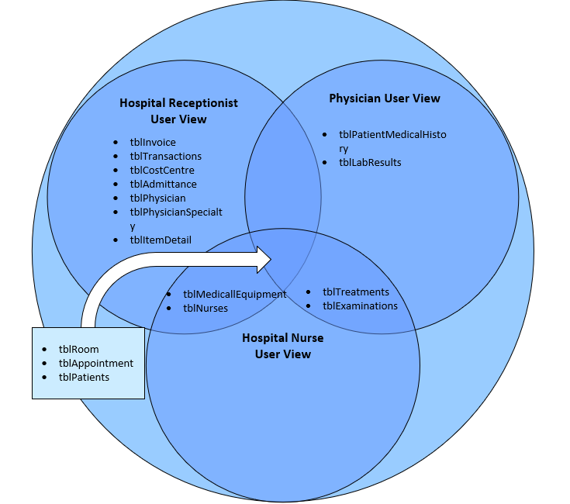

This use case diagram is used to illustrate what kind of access that some of the commonly know users (which is the receptionist, the physician and nurse) have with the database system. As you can see most of the data will be handled by the receptionist, as they usually handle most of the database information. The physician is the only one given access to the patient medical history as well as the lab results of any test done. We also have some shared tables that usually everybody uses like patients, rooms, and appointments as well as tables that would be used by either the nurse/receptionist or by the physician/nurse.

# 

# 3nf

tblPatients (PatientNum, PatientFirstName, PatientLastName, Address, City, Province, PC, Telephone, Sex, HCN, FinancialStatus)

tblPhysician (PhysicianNum, PhysicianSpecialtyID, PhysicianFirstName, PhysicianLastName, PhysicianTelephone)

tblPhysicianSpecialty (PhysicianSpecialtyID, SpecialtyDescription)

tblAdmittance (AdmittanceID, PhysicianNum, PatientNum, RoomNum, DateAdmitted, DateDischarged)

tblRoom (RoomNum, RoomType, Extension)

tblItemDetails (ItemCodeID, CostCentreID, ItemDescription, ItemCost)

tblCostCentre (CostCentreID, CostCentreName)

tblInvoice (InvoiceID, AdmittanceID, FinancialSource, InvoiceDate)

tblTransaction (TransactionID, InvoiceID, ItemCodeID, Charge, TransactionDate)

tblLabResults (LabResultID, PhysicianNum, RecordedDate, LabDetails, TransactionID)

tblExamination (ExaminationID, ExaminedDate, ExamDetails, TransactionID)

tblTreatments (TreatmentID, TreatedDate, TreatmentDetails, TransactionID)

tblAppointments (AppointmentID, PatientNum, PhysicianNum, AppointmentDetails, AppointedDateTime)

tblMedicalEquipment (EquipmentID, Description, TransactionID)

tblNurses (NurseID, NurseFirstName, NurseLastName, Telephone)

tblPatientMedicalHistory (MedicalHistoryID, AdmittanceID, InvoiceID, TransactionID)

# Functional Dependencies

tblPatients tblAdmittances

PatientFirstName → PatientNum PhysicianNum → AdmittanceID

PatientLastName → PatientNum PatientNum → AdmittanceID

Address → PatientNum RoomNum → AdmittanceID

City → PatientNum DateAdmitted → AdmittanceID

Province → PatientNum DateDischarged → AdmittanceID

PC → PatientNum

PatientTelephone → PatientNum tblRoom

Sex → PatientNum RoomType → RoomNum

HCN → PatientNum Extension → RoomNum

FinancialStatus → PatientNum

tblItemDetails

tblPhysician CostCentreID → ItemCodeID

PhysicianSpecialtyID → PhysicianNum ItemDescription → ItemCodeID

PhysicianFirstName → PhysicianNum ItemCost → ItemCodeID

PhysicianLastName → PhysicianNum

PhysicianTelephone → PhysicianNum tblCostCentres

CostCentreName → CostCentreID

tblPhysicianSpecialty

SpecialtyDescription → PhysicianSpecialtyID

tblInvoice tblTreatments

AdmittanceID → InvoiceID TreatedDate → TreatmentID

FinancialSource → InvoiceID TreatmentDetails → TreatmentID

InvoiceDate → InvoiceID TransactionID → TreatmentID

tblTransaction tblAppointments

InvoiceID → TransactionID PatientNum → AppointmentID

ItemCodeID → TransactionID PhysicianNum → AppointmentID

Charge → TransactionID AppointmentDetails → AppointmentID

TransactionDate → TransactionID AppointedDateTime → AppointmentID

tblLabResults tblMedicalEquipment

PhysicianNum → LabResultID EquipmentDescription → EquipmentID

RecordedDate → LabResultID TransactionID → EquipmentID

LabDetails → LabResultID

TransactionID → LabResultID tblNurses

NurseFirstName → NurseID

tblExaminations NurseLastName → NurseID

ExaminedDate → ExaminationID NurseTelephone → NurseID

ExamDetails → ExaminationID

TransactionID → ExaminationID

tblPatientMedicalHistory

AdmittanceID → MedicalHistoryID

InvoiceID → MedicalHistoryID

TransactionID → MedicalHistoryID

# Data Dictionary

tblPatients

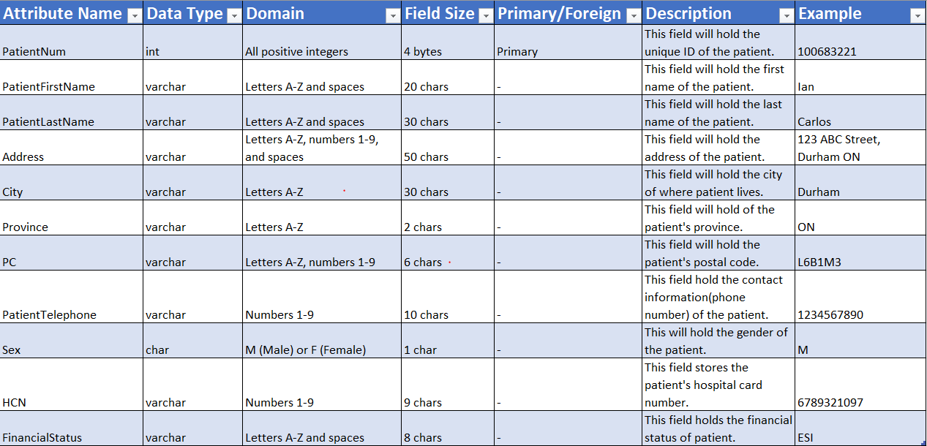

tblPhysicians

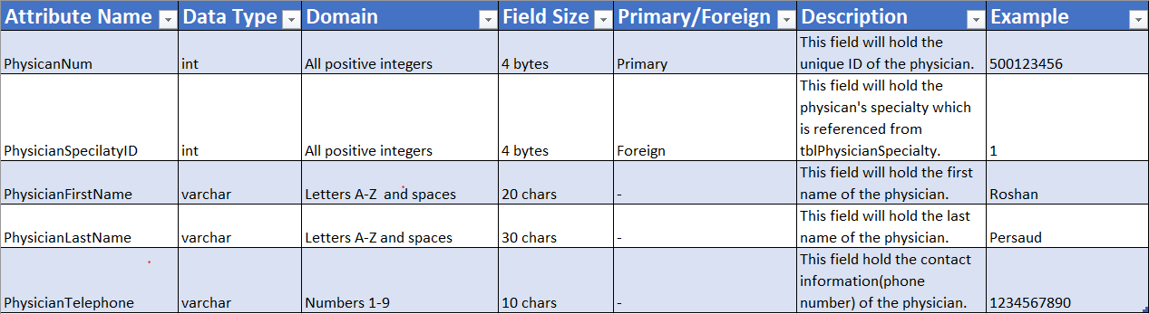

tblPhysicianSpecialty

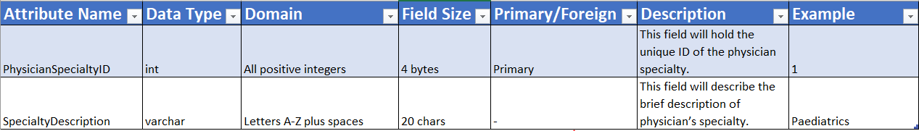

tblAdmittances

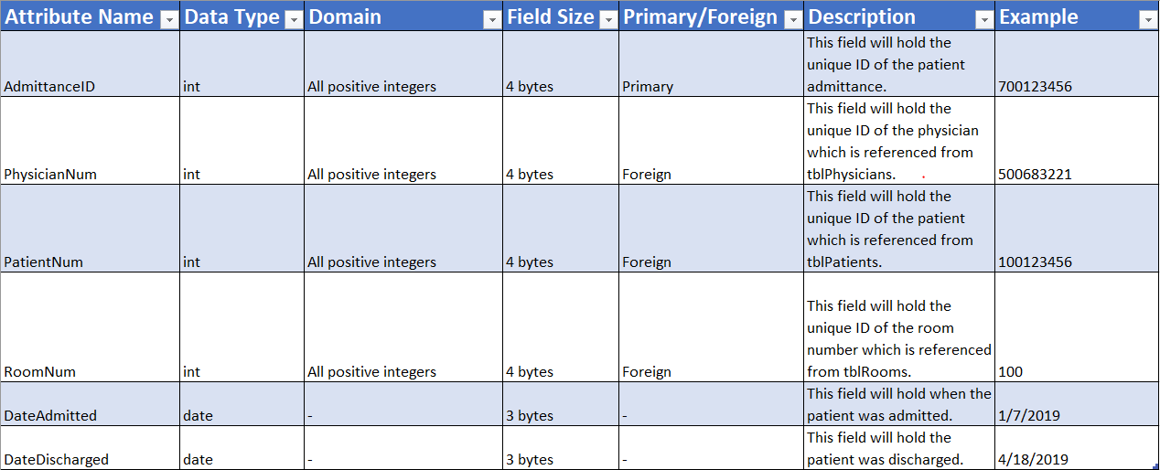

tblRoom

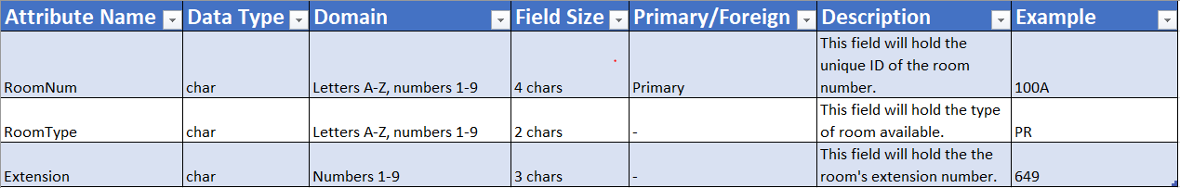

tblItemDetails

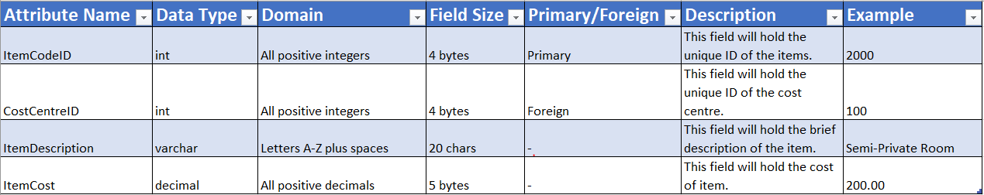

tblCostCentre

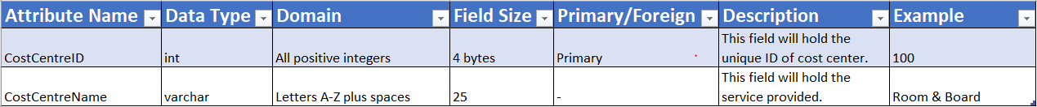

tblInvoice

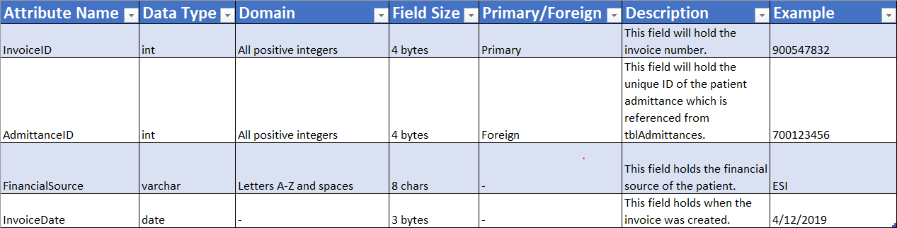

tblTransaction

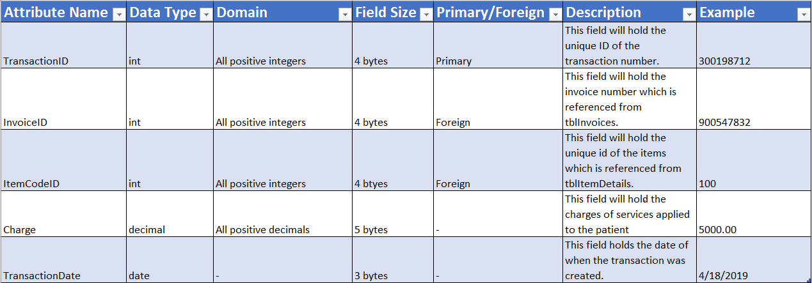

tblLabResults

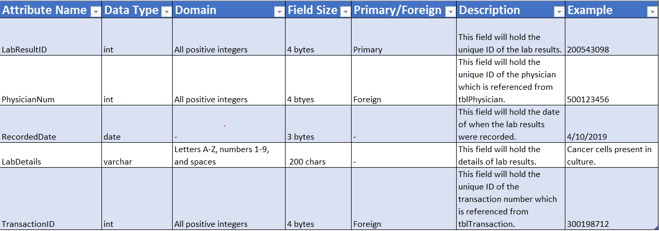

tblExaminations

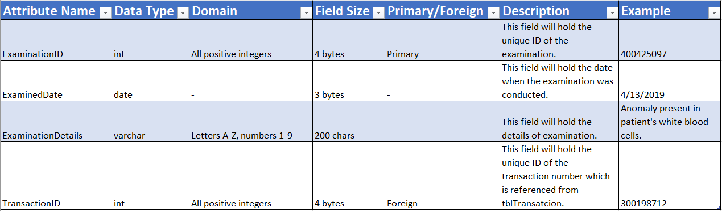

tblTreatments

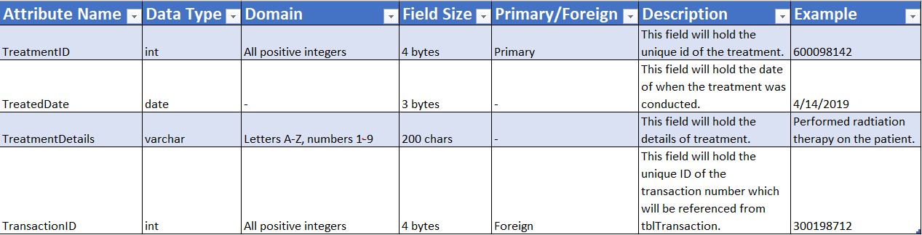

tblAppointments

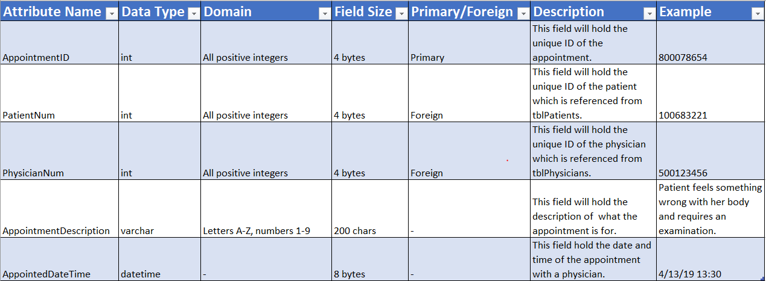

tblMedicalEquipment

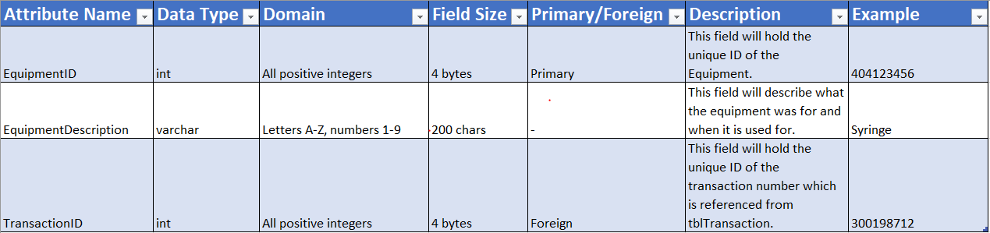

tblNurses

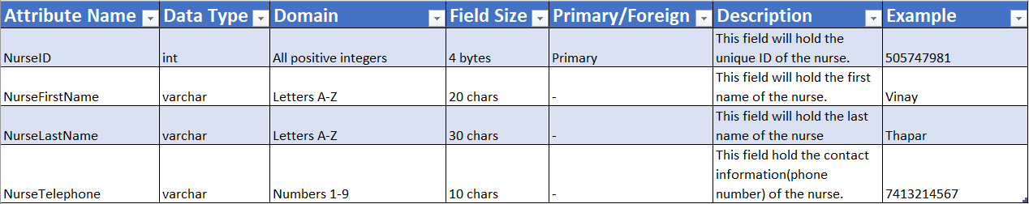

tblPatientMedicalHistory

