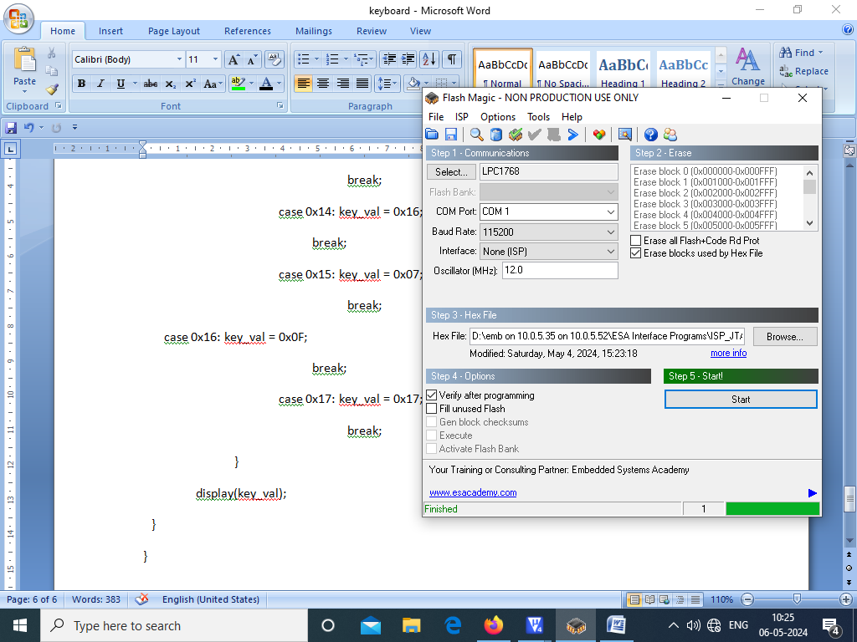

**KEYBOARD INTERFACING PROGRAM:**

#include <LPC17xx.H>

#include "GLCD.h"

#define __FI 1

unsigned char key,key_val;

void delay(unsigned int x) /* Delay routine */

{

for(;x>0;x--);

}

void display(unsigned int i)

{

unsigned char a;

a = (i/0x10) & 0x0f;

{

if(a<=9)

a = a + 0x30;

else

a = a + 0x37;

GLCD_DisplayChar(8,16,__FI,a);

}

a = i%0x10;

{

if(a<=9)

a = a + 0x30;

else

a = a + 0x37;

GLCD_DisplayChar(8,17,__FI,a);

}

}

unsigned char getkey() /* Key Scan function */

{

unsigned long i,s,code,j;

code = 0;

for(i=0x00008000; i<=0x00400000; i<<=1) /* Check for 8 Scan lines */

{

LPC_GPIO0->FIOPIN = i; /* Make 1 scan line high */

delay(32000);

s= LPC_GPIO0->FIOPIN & 0x03800000;

s = s >> 23;

if(s>0) /* Read the scanned line */

{

for(j=0;j<=2;j++) /* Check for 3 keys */

{

s>>=1;

if(s==0)

return(code+j); /* If key Pressed return its code */

}

}

code += 3;

}

}

main()

{

LPC_SC->PCONP |= (1<<15);

LPC_PINCON->PINMODE1 |= 0x000FC000; /* Configure Pull-down Resistor for P0.23,P0.24,P0.25 */

LPC_GPIO0->FIODIR |= 0x007F8000; /* Make portA as input and portC as output */

#ifdef __USE_LCD

GLCD_Init(); /* Initialize graphical LCD */

GLCD_Clear(White); /* Clear graphical LCD display */

GLCD_SetBackColor(Blue);

GLCD_SetTextColor(White);

GLCD_DisplayString(0, 0, __FI, " ESA ");

GLCD_DisplayString(1, 0, __FI, " Bangalore ");

GLCD_DisplayString(2, 0, __FI, " www.esaindia.com ");

GLCD_SetBackColor(White);

GLCD_SetTextColor(Blue);

GLCD_DisplayString(5, 0, __FI, " Calc Keyboard ");

GLCD_DisplayString(8, 0,__FI, " keypressed = ");

#endif

while(1)

{

key = getkey();

switch(key)

{

case 0x00: key_val = 0x00;

break;

case 0x01: key_val = 0x08;

break;

case 0x02: key_val = 0x10;

break;

case 0x03: key_val = 0x01;

break;

case 0x04: key_val = 0x09;

break;

case 0x05: key_val = 0x11;

break;

case 0x06: key_val = 0x02;

break;

case 0x07: key_val = 0x0A;

break;

case 0x08: key_val = 0x12;

break;

case 0x09: key_val = 0x03;

break;

case 0x0A: key_val = 0x0B;

break;

case 0x0B: key_val = 0x13;

break;

case 0x0C: key_val = 0x04;

break;

case 0x0D: key_val = 0x0C;

break;

case 0x0E: key_val = 0x14;

break;

case 0x0F: key_val = 0x05;

break;

case 0x10: key_val = 0x0D;

break;

case 0x11: key_val = 0x15;

break;

case 0x12: key_val = 0x06;

break;

case 0x13: key_val = 0x0E;

break;

case 0x14: key_val = 0x16;

break;

case 0x15: key_val = 0x07;

break;

case 0x16: key_val = 0x0F;

break;

case 0x17: key_val = 0x17;

break;

}

display(key_val);

}

}

