**1)Insert Operation in a Nested Document**

input : db.students.insertMany ([

{id: 3, Name: "Priya", Address: {

Address1: "Vadapalani",

Address2: "Koyembedu",

Address3: "Chennai"

},

Country: "India", State: "Tamilnadu"

}

]);

output : 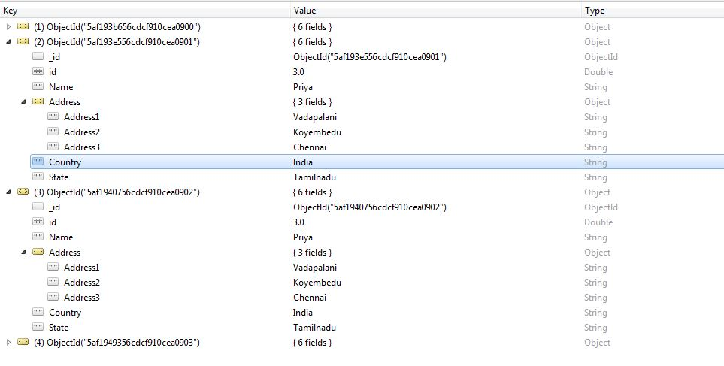

**2) Update Operation in a Nested Document**

input : db.students.update(

{

"id" :3,

"Address.Address1" : "Vadapalani" },

{

$set : { "Address.Address1" : "Ashok Pillar" }

}

)

output : 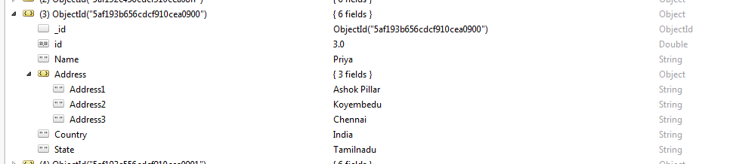

**3) Insert Array of Documents**

input : var sample = [

{

"_id" : 1,

"name" : "Dave Gahan",

"medications" : [

{ "id" : 23,

"name" : "Dilaudid",

"type" : "Rx",

"prescriptions" : [

{ "id" : 13,

"quantity" : 60,

"started" : 2009-01-01

},

{ "id" : 77,

"quantity" : 45,

"started" : 2009-02-01

}

]

},

{ "id" : 41,

"name" : "Oxycodone",

"type" : "Rx"

}

]

}

]

db.Medicines.insert(sample)

output: 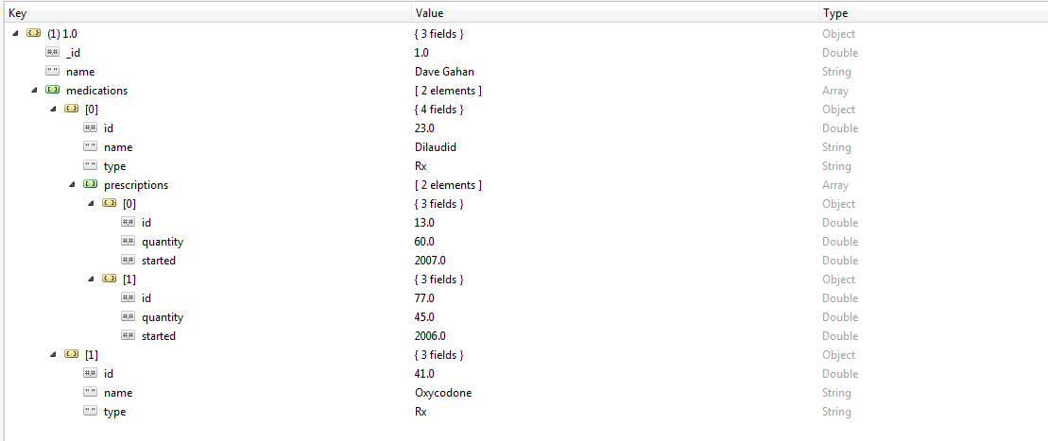

**4)Update Array of Documents**

input : db.Medicines.update(

{

"_id" : 1,

"medications.id" : 23,

"medications.prescriptions.id" : 77 },

{

$set : { "medications.prescriptions.$.quantity" : 30 }

},

)

**5) findAndModify Operation**

input : db.students.findAndModify({

query : { id : 3},

update : { $set : { Name : "Pavi" } },

upsert : true

})

output : 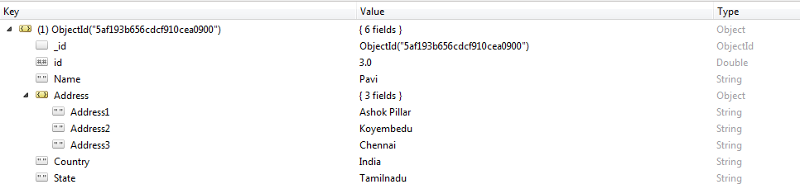

Upsert method : Upsert : true option for the update operation to either update a matching document or, if no matching document exists, create a new document.

**6)Adding another row to the Document**

input : db.Medicines.update (

{ _id : 1 },

{

$push: {

medications : {

$each: [ { id: 24, name: "Priya", "type": "YAZ"}]

}

}

}

)

output : 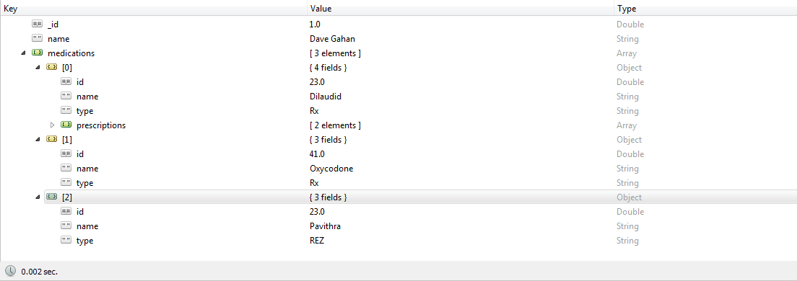

**7) Updating a field in the array of the Document**

input : db.Medicines.updateOne(

{

_id : 1,

"medications.id" : 24

},

{

$set : { "medications.$.name" : "Pinky"

}

}

)

output: 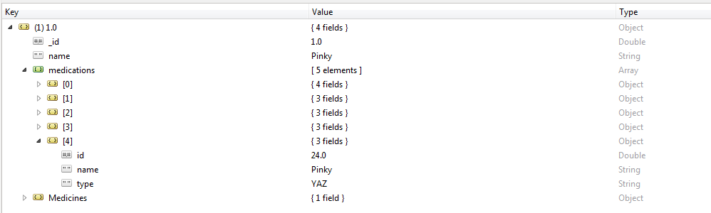

**8) Deleting one column from the Document**

input : db.Medicines.update(

{ "medications.prescriptions.id" : [77.0]

},

{

$pull: {"medications.$.prescriptions":

{ id:[77.0] }

}

})

output : 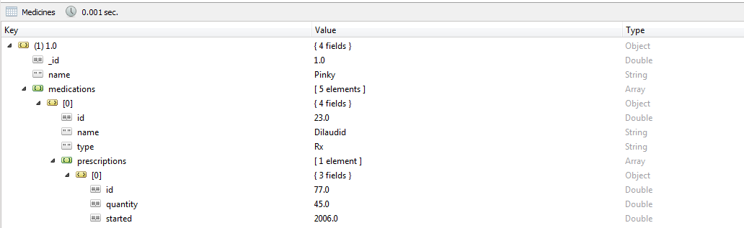

**9)Adding a New field to a existing Document** input : db.Medicines.update (

{ "medications.prescriptions.id" : [77.0]

},

{

$push : {"medications.prescriptions" : {"isprescribedBy" : ["Doctor"] }

}

})