SELECT * FROM coffee_sales;

**--1.CREATING KPIS**

**/*1.1.Total Sales Analysis*/**

**--1.1.1Total Sales for each respective month**

SELECT ROUND(SUM(unit_price * transaction_qty)) AS Total_Sales

--SELECT CONCAT(ROUND(SUM(unit_price * transaction_qty)))/1000 , "K" AS Total_Sales-- to adjust p.ex 98.835K

FROM coffee_sales

WHERE EXTRACT(MONTH FROM transaction_date) = 3; -- March Month

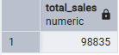

**--1.1.2 Determinate the month-on-month increase or decrease in sales**

**--1.1.3 Calculate the difference in sales between the selected month and the previous month**

WITH monthly_sales AS (

SELECT

EXTRACT(MONTH FROM transaction_date) AS month, -- number of the month

SUM(unit_price * transaction_qty) AS total_sales -- total sales column

FROM coffee_sales

WHERE EXTRACT(MONTH FROM transaction_date) IN (4, 5) -- for months of April and May

GROUP BY EXTRACT(MONTH FROM transaction_date)

)

SELECT

month,

Total_sales,

ROUND(((total_sales - LAG(total_sales) OVER (ORDER BY month))

/ LAG(total_sales) OVER (ORDER BY month)::NUMERIC) * 100,2) AS mom_order_increase_percentage

FROM monthly_sales

ORDER BY month;

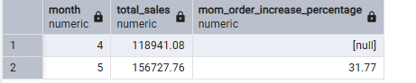

-- Note: Month sales division% = CM-PM/PM*100

**/*1.2. Total orders analysis*/**

**--1.2.1 Calculate total number of orders for each respective month**

SELECT COUNT(transaction_id) AS Total_orders

FROM coffee_sales

WHERE EXTRACT(MONTH FROM transaction_date) = 5; -- May Month

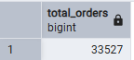

**--1.2.2 Determinate the mom increase or decrease in the number of orders**

**--1.2.3 Calculate the difference in the number of orders between the selected month and previous month**

WITH monthly_orders AS (

SELECT

EXTRACT(MONTH FROM transaction_date) AS month, -- number of the months

COUNT(transaction_id) AS total_orders -- total orders

FROM coffee_sales

WHERE EXTRACT(MONTH FROM transaction_date) IN (4, 5) -- april and may

GROUP BY EXTRACT(MONTH FROM transaction_date)

SELECT

month,

total_orders,

ROUND(((total_orders - LAG(total_orders) OVER (ORDER BY month))

/ LAG(total_orders) OVER (ORDER BY month)::NUMERIC) * 100,2) AS mom_order_increase_percentage

FROM monthly_orders

ORDER BY month;

**/*1.3.Total Quantity Sold Analysis*/**

**--1.3.1 Calculate the total quantity sold for each respective month**

SELECT SUM(transaction_qty) AS Total_Quantaty_Sold

FROM coffee_sales

WHERE EXTRACT(MONTH FROM transaction_date) = 5; -- May Month

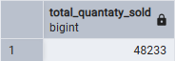

**--1.3.2 Determinate the month-on-month increase or decrease in the total quantity sold**

**--1.3.3 Calculate the difference in the total sold between the selected month and the previous month**

WITH monthly_orders AS (

SELECT

EXTRACT(MONTH FROM transaction_date) AS month, -- number of the months

SUM(transaction_qty) AS total_quantity_sold -- total quantity sold

FROM coffee_sales

WHERE EXTRACT(MONTH FROM transaction_date) IN (4, 5) -- april and may

GROUP BY EXTRACT(MONTH FROM transaction_date)

)

SELECT

month,

total_quantity_sold,

ROUND(((total_quantity_sold - LAG(total_quantity_sold) OVER (ORDER BY month))

/ LAG(total_quantity_sold) OVER (ORDER BY month)::NUMERIC) * 100,2) AS mom_quantity_increase_percentage

FROM monthly_orders

ORDER BY month;

**--2.CHARTS REQUIREMENTS**

**/*2.1.Calendar Heat Map**

💡To do in PBI:

1.1 Implement a calendar heat map that dynamically adjusts based on the select month from a slicer

1.2 Each day on the calendar will be color-coded to represent sales volume, with darker shades indicating higher sales

1.3 Implemt tooltips to display detailed metrics (sales,orders,quantity) qhen hovering over a specific day

**Creating the three metrics*/**

SELECT

CONCAT(ROUND(SUM(unit_price * transaction_qty)/1000.0, 1), 'K') AS Total_Sales, -- 1000.0 forces the division to be decimal, avoiding truncation due to integer division.

CONCAT(ROUND(SUM(transaction_qty)/1000.0,1), 'K') AS Total_Qty_Sold,

CONCAT(ROUND(COUNT(transaction_id)/1000.0,1), 'K') AS Total_Orders

FROM coffee_sales

WHERE transaction_date = '2023-03-27';



**/*2.2.Sales Analysis by Weekdays and Weekends**

**2.2.1 Segment sales data into weekdays and weekend to analyze performance variations*/**

--Note:EXTRACT(DOW FROM date) → retorns 0=Sunday, 1=Monday, ..., 6=Saturday in PostgreSQL

WITH sales_with_day_type AS (

SELECT

CASE

WHEN EXTRACT(DOW FROM transaction_date) IN (0,6) THEN 'Weekends'

ELSE 'Weekdays'

END AS day_type,

unit_price * transaction_qty AS sales

FROM coffee_sales

WHERE EXTRACT(MONTH FROM transaction_date) = 2 -- Feb

)

SELECT

day_type,

CONCAT(ROUND(SUM(sales)/1000.0, 1), 'K') AS total_sales

FROM sales_with_day_type

GROUP BY day_type

ORDER BY day_type;

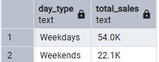

**--2.3. Sales analysis by Store Location**

**--2.3.1 Visualize sales data by different store locations**

SELECT

store_location,

CONCAT(ROUND(SUM(unit_price * transaction_qty)/1000.0, 1), 'K') AS total_sales

FROM coffee_sales

WHERE EXTRACT(MONTH FROM transaction_date) = 5 -- May

GROUP BY store_location

ORDER BY SUM(unit_price * transaction_qty) DESC;

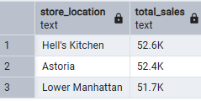

**--2.3.2 Calculate increase or decrease between each month and percentage - sales, quantity and orders**

WITH monthly_by_store AS (

SELECT

store_location,

EXTRACT(MONTH FROM transaction_date) AS month,

SUM(unit_price * transaction_qty) AS total_sales,

SUM(transaction_qty) AS total_quantity_sold,

COUNT(transaction_id) AS total_orders

FROM coffee_sales

WHERE EXTRACT(MONTH FROM transaction_date) IN (4, 5) -- April and May

GROUP BY store_location, EXTRACT(MONTH FROM transaction_date)

)

SELECT

store_location,

month,

total_sales,

total_quantity_sold,

total_orders,

ROUND(

((total_sales - LAG(total_sales) OVER (PARTITION BY store_location ORDER BY month))

/ LAG(total_sales) OVER (PARTITION BY store_location ORDER BY month)::NUMERIC) * 100, 2

) AS mom_sales_percentage,

ROUND(

((total_quantity_sold - LAG(total_quantity_sold) OVER (PARTITION BY store_location ORDER BY month))

/ LAG(total_quantity_sold) OVER (PARTITION BY store_location ORDER BY month)::NUMERIC) * 100, 2

) AS mom_qty_percentage,

ROUND(

((total_orders - LAG(total_orders) OVER (PARTITION BY store_location ORDER BY month))

/ LAG(total_orders) OVER (PARTITION BY store_location ORDER BY month)::NUMERIC) * 100, 2

) AS mom_orders_percentage

FROM monthly_by_store

ORDER BY store_location, month;

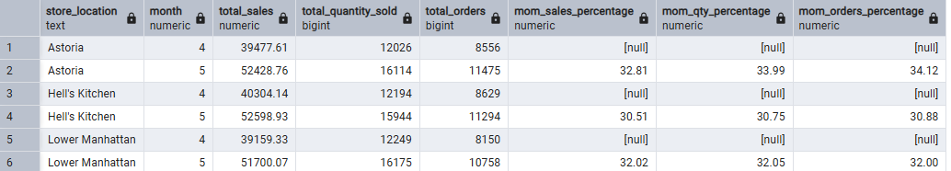

**/* 2.4.Average sales**

**2.4.1 Display daily sales for the selected month with a line chart (avg)*/**

**--first, only calculating total AVG**

SELECT

CONCAT(ROUND(AVG(total_sales)/1000.0,1), 'K') AS Avg_sales

FROM

(

SELECT

SUM(transaction_qty * unit_price) AS total_sales

FROM coffee_sales

WHERE EXTRACT(MONTH FROM transaction_date) = 4 -- april

GROUP BY transaction_date

) AS Internal_query;

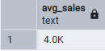

**-- AVG Total sales by Day of month**

SELECT

EXTRACT(DAY FROM transaction_date) AS day_of_month,

SUM(unit_price * transaction_qty) AS total_sales

FROM coffee_sales

WHERE EXTRACT(MONTH FROM transaction_date) = 4 - number of the month

GROUP BY EXTRACT(DAY FROM transaction_date)

ORDER BY day_of_month;

WITH daily_sales AS (

SELECT

EXTRACT(DAY FROM transaction_date) AS day_of_month,

SUM(unit_price * transaction_qty) AS total_sales

FROM coffee_sales

WHERE EXTRACT(MONTH FROM transaction_date) = 4 – number of the month

GROUP BY EXTRACT(DAY FROM transaction_date)

),

average_sales AS (

SELECT AVG(total_sales) AS avg_sales

FROM daily_sales

)

SELECT

ds.day_of_month,

ds.total_sales,

CASE

WHEN ds.total_sales > a.avg_sales THEN 'Above Average'

WHEN ds.total_sales < a.avg_sales THEN 'Below Average'

ELSE 'Equal to Average'

END AS sales_status

FROM daily_sales ds, average_sales a

ORDER BY ds.day_of_month;

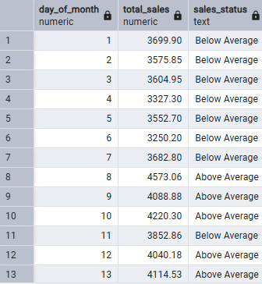

**/*2.5. Sales analysis by product category**

**2.5.1 Analyze sales performance across different product categories to provide insights into wich product categories contribute the most to overall sales*/**

SELECT

product_category,

SUM(unit_price * transaction_qty) AS total_sales

FROM coffee_sales

WHERE EXTRACT(MONTH FROM transaction_date) = 5

GROUP BY product_category

ORDER BY SUM(unit_price * transaction_qty) DESC;

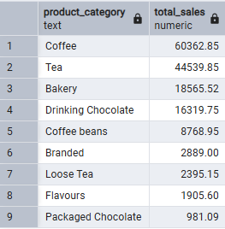

**/*2.6. Top 10 products by sales**

**2.6.1 identify and display the top 10 products based on sales volume and allow user to quicly visualize the best-performing products interms of sales*/**

SELECT

product_type,

SUM(unit_price * transaction_qty) AS total_sales

FROM coffee_sales

WHERE EXTRACT(MONTH FROM transaction_date) = 5 AND product_category = 'Coffee' -- for especific product_category

GROUP BY product_type

ORDER BY SUM(unit_price * transaction_qty) DESC

LIMIT 10; -- to limit top 10

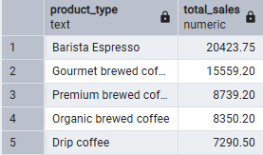

**/*2.7. Sales analysis by days and hours**

**2.7.1 Utilize a heat map to visualize sales patterns by days and hours*/**

SELECT

SUM(unit_price * transaction_qty) AS total_sales,

SUM(transaction_qty) AS total_qty_sold,

COUNT(*) AS total_orders

FROM coffee_sales

WHERE EXTRACT(MONTH FROM transaction_date) = 5 -- May

AND EXTRACT(DOW FROM transaction_date) = 0 -- sunday

AND EXTRACT(HOUR FROM transaction_time) = 14 -- hour No 14

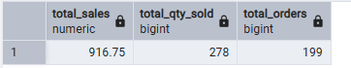

**-- Total sales by hours**

SELECT

EXTRACT(HOUR FROM transaction_time) AS hour_of_day,

SUM(unit_price * transaction_qty) AS total_sales

FROM coffee_sales

WHERE EXTRACT(MONTH FROM transaction_date) = 5 -- May

GROUP BY EXTRACT(HOUR FROM transaction_time)

ORDER BY EXTRACT(HOUR FROM transaction_time);

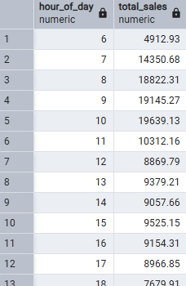

**-- + By store_location**

SELECT

store_location,

EXTRACT(HOUR FROM transaction_time) AS hour_of_day,

SUM(unit_price * transaction_qty) AS total_sales

FROM coffee_sales

WHERE EXTRACT(MONTH FROM transaction_date) = 5 -- May

GROUP BY store_location, EXTRACT(HOUR FROM transaction_time)

ORDER BY store_location, EXTRACT(HOUR FROM transaction_time);

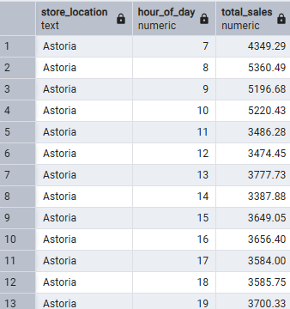

**--Total sales by day of week**

**-- Using TO_CHAR - more simple**

SELECT

TO_CHAR(transaction_date, 'Day') AS day_of_week,

ROUND(SUM(unit_price * transaction_qty)) AS total_sales

FROM coffee_sales

WHERE EXTRACT(MONTH FROM transaction_date) = 5

GROUP BY TO_CHAR(transaction_date, 'Day')

ORDER BY total_sales DESC;

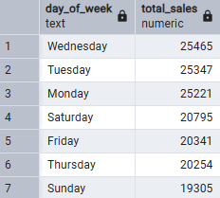

**-- + by store_id**

SELECT

TRIM(TO_CHAR(transaction_date, 'Day')) AS day_of_week,

SUM(unit_price * transaction_qty) AS total_sales

FROM coffee_sales

WHERE store_id = 3

AND EXTRACT(MONTH FROM transaction_date) = 2

GROUP BY TRIM(TO_CHAR(transaction_date, 'Day'))

ORDER BY total_sales DESC;

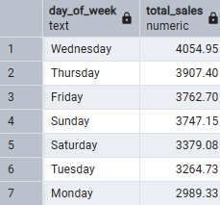

**--Using CASE if needed, to personalize or specify**

SELECT

CASE

WHEN EXTRACT(DOW FROM transaction_date) = 1 THEN 'Monday'

WHEN EXTRACT(DOW FROM transaction_date) = 2 THEN 'Tuesday'

WHEN EXTRACT(DOW FROM transaction_date) = 3 THEN 'Wednesday'

WHEN EXTRACT(DOW FROM transaction_date) = 4 THEN 'Thursday'

WHEN EXTRACT(DOW FROM transaction_date) = 5 THEN 'Friday'

WHEN EXTRACT(DOW FROM transaction_date) = 6 THEN 'Saturday'

ELSE 'Sunday'

END AS Day_of_week,

ROUND(SUM(unit_price * transaction_qty)) AS Total_sales

FROM coffee_sales

WHERE store_id=4 AND EXTRACT (MONTH FROM transaction_date) = 5 -- May

GROUP BY

CASE

WHEN EXTRACT(DOW FROM transaction_date) = 1 THEN 'Monday'

WHEN EXTRACT(DOW FROM transaction_date) = 2 THEN 'Tuesday'

WHEN EXTRACT(DOW FROM transaction_date) = 3 THEN 'Wednesday'

WHEN EXTRACT(DOW FROM transaction_date) = 4 THEN 'Thursday'

WHEN EXTRACT(DOW FROM transaction_date) = 5 THEN 'Friday'

WHEN EXTRACT(DOW FROM transaction_date) = 6 THEN 'Saturday'

ELSE 'Sunday'

END

ORDER BY ROUND(SUM(unit_price * transaction_qty)) DESC;

