**Improving the quality of life and development in a large city**

1.INTRODUCTION

1.1.Problem

São Paulo is the most populous city in the american continent and the richest city in Brazil, but suffers from the inequality of development between the central region and the periphery.

The economic and social development of the peripheries can improve the lives of all, including the inhabitants of the central region.

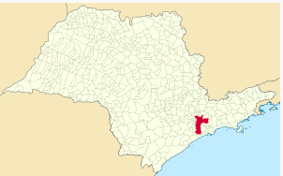

São Paulo is the capital of the state of São Paulo (r.1)

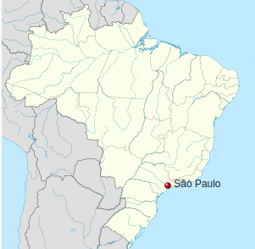

São Paulo is a state of Brazil (r.1)

1.1.Audience

This report is intended for those responsible for urban development in the city of São Paulo

1.2. Purpose

The city of São Paulo is divided into districts (or neighborhoods). Let's compare the central and peripheral districts with regard to nearby venues, the human development index, average monthly salaries and population. Which districts deserve greater attention from the authorities?

2.DATA DESCRIPTION

To compare São Paulo’s central region and peripheral region, we will study where the largest populations, the best salaries, the stores and the services are concentrated.

Let us scrap some Wikipedia pages “List of districts of São Paulo by population”(r2)

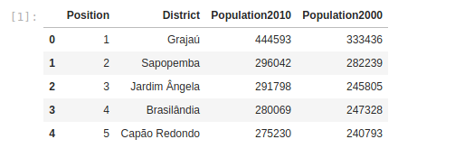

And scrap “List of districts of São Paulo by Human Development Index” (r3)

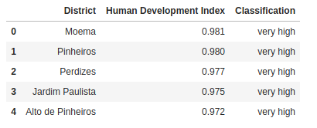

“Human Development Index (HDI) was created to emphasize that people and their capabilities should be the ultimate criteria for assessing the development of a country, not economic growth alone. The HDI can also be used to question national policy choices” (r4). And it is based on long and healthy life, knowledge and descent standard of living.

Let us merge these dataframes and look for districts’ coordinates in Google Maps (r5):

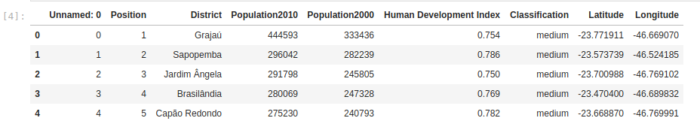

We will explore districts venues with Foursquare API (r6):

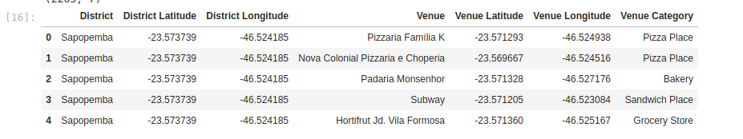Let us scrap wages by district (r7), convert the values to dollars and merge to other dataframes:

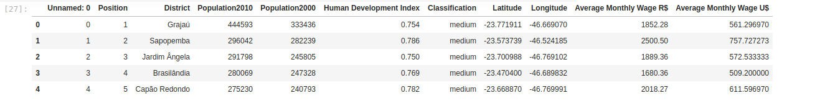

3. REFERENCES

*r1.Wikipedia - São Paulo -* [*https://pt.wikipedia.org/wiki/S%C3%A3o_Paulo*](https://pt.wikipedia.org/wiki/São_Paulo)

*r2.Wikipedia -* *Lista dos distritos de São Paulo por população -* [*https://pt.wikipedia.org/wiki/Lista_dos_distritos_de_S%C3%A3o_Paulo_por_popula%C3%A7%C3%A3o*](https://pt.wikipedia.org/wiki/Lista_dos_distritos_de_São_Paulo_por_população)

*r3.Wikipedia -* *Lista dos distritos de São Paulo por Índice de Desenvolvimento Humano -* [*https://pt.wikipedia.org/wiki/Lista_dos_distritos_de_S%C3%A3o_Paulo_por_%C3%8Dndice_de_Desenvolvimento_Humano*](https://pt.wikipedia.org/wiki/Lista_dos_distritos_de_São_Paulo_por_Índice_de_Desenvolvimento_Humano)

*r4.Human Development Index (HDI) -* [*http://hdr.undp.org/en/content/human-development-index-hdi*](http://hdr.undp.org/en/content/human-development-index-hdi)

*r5.Google Maps*

*r6.Foursquare*

*r7*.*Média de salário em SP vai de R$ 1,2 mil em Marsilac a R$ 10 mil no Campo Belo -*

[*https://g1.globo.com/sao-paulo/noticia/media-de-salario-em-sp-vai-de-r-12-mil-em-marsilac-a-r-10-mil-no-campo-belo.ghtml*](https://g1.globo.com/sao-paulo/noticia/media-de-salario-em-sp-vai-de-r-12-mil-em-marsilac-a-r-10-mil-no-campo-belo.ghtml)