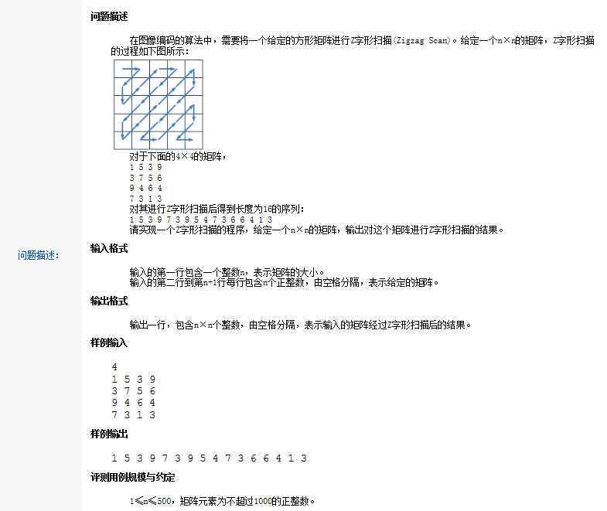

D
// ZScan.cpp : 定义控制台应用程序的入口点。
//

#include "stdafx.h"
#include "iostream"

#define X(x,y) (++y)
#define Y(x,y) (++x)
#define UP(x,y) (++y,--x)
#define DOWN(x,y) (--y,++x)
using namespace std;

bool flag = true;
bool isDown = true;

int main(){

int count = 0;
cin >> count;
int size = count * 2;
int **data = new int*[size]{0};
for (int index = 0; index < size; ++index)
{
data[index] = new int[size]();
}

for (int nRow = 0; nRow < count; ++nRow)
{
for (int nCol = 0; nCol < count; ++nCol)
{
cin >> data[nRow][nCol];
}
}

int nRow_ = 0;
int nCol_ = 0;

cout << data[nRow_][nCol_] << " ";
X(nRow_, nCol_);

while (true){
if ((nRow_ == 0 && nCol_ ==size-1) ||(nRow_=size-1&&nCol_==0))
{
break;
}

while (isDown)
{
if (nCol_ == 0)
{
if (data[nRow_][nCol_])
cout << data[nRow_][nCol_] << " ";
Y(nRow_, nCol_);
isDown = false;
break;
}

if (data[nRow_][nCol_])
{
cout << data[nRow_][nCol_] << " ";
DOWN(nRow_, nCol_);
}
else
{
DOWN(nRow_, nCol_);
}

}

while (!isDown)
{
if (nRow_ == 0 )
{
if (data[nRow_][nCol_])
cout << data[nRow_][nCol_] << " ";
X(nRow_, nCol_);
isDown = true;
break;
}
if (data[nRow_][nCol_])
{
cout << data[nRow_][nCol_] << " ";
UP(nRow_, nCol_);
}
else
{
UP(nRow_, nCol_);
}
}
}
system("pause");
return 0;
}

