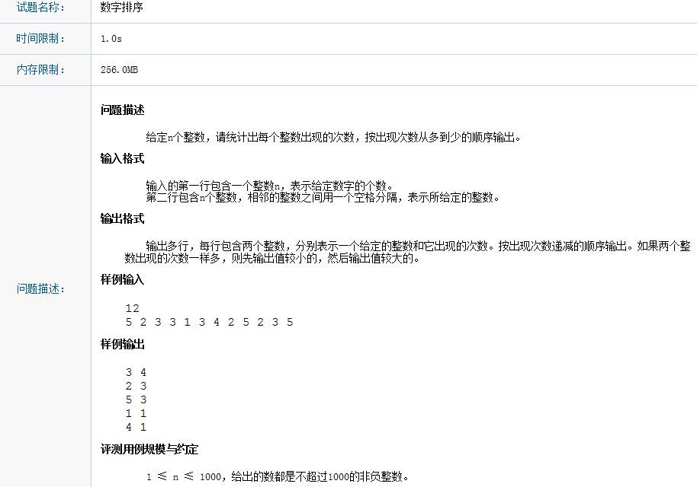

#include "stdafx.h"
#include "map"
#include "vector"
#include "algorithm"
#include "iostream"
using namespace std;

int main(){

multimap<int, int> nnMap;
vector<int> nVec;
vector<int>::iterator nVecIter;
int n = 0;
cin >> n;
for (int nIndex = 0; nIndex < n;++nIndex)
{
int num = 0;
cin >> num;
nVec.push_back(num);
}

sort(nVec.begin(), nVec.end());

int currentnum = nVec.at(0);
int currentrepeat = 0;
for (int nIndex = 0; nIndex < n;++nIndex)
{
if (currentnum != nVec.at(nIndex))
{
nnMap.insert(make_pair(currentrepeat, currentnum));
currentnum = nVec.at(nIndex);
currentrepeat = 1;
}
else
{
++currentrepeat;
}
}

nnMap.insert(make_pair(currentrepeat, currentnum));
nVec.clear();
multimap<int, int>::reverse_iterator mpiter(nnMap.rbegin());
int current = mpiter->first;
for (; mpiter != nnMap.rend();++mpiter)
{
//cout << mpiter->second << " " << mpiter->first << endl;
if (mpiter->first == current)
{
nVec.push_back(mpiter->second);
}
else
{
sort(nVec.begin(), nVec.end());

for (nVecIter = nVec.begin(); nVecIter != nVec.end();++nVecIter)
{
cout << *nVecIter << " " << current << endl;
}
current = mpiter->first;
nVec.clear();
nVec.push_back(mpiter->second);
}
}
sort(nVec.begin(), nVec.end());

for (nVecIter = nVec.begin(); nVecIter != nVec.end(); ++nVecIter)
{
cout << *nVecIter << " " << current << endl;
}
system("pause");
return 0;

}

