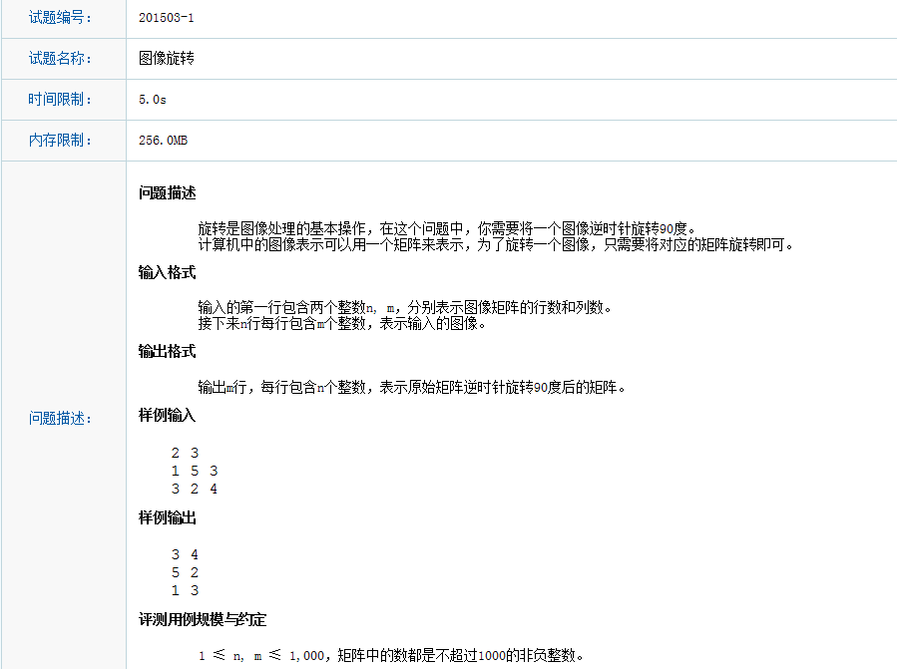

// Reverse.cpp : 定义控制台应用程序的入口点。
//

#include "stdafx.h"
#include "iostream"

using namespace std;
int main()
{
int n, m;
cin >> n >> m;

int **data = new int *[n];

int **tmpdata = new int*[m];

for (int nIndex = 0; nIndex < n;++nIndex)
{
data[nIndex] = new int[m]{0};
}

for (int nIndex = 0; nIndex < m; ++nIndex)
{
tmpdata[nIndex] = new int[n]{0};
}

for (int nRow = 0; nRow < n;++nRow)
{
for (int nCol = 0; nCol < m;++nCol)
{
cin >> data[nRow][nCol];
}
}

for (int nRow = 0; nRow < m; ++nRow)
{
for (int nCol = 0; nCol < n; ++nCol)
{
tmpdata[nRow][nCol] = data[nCol][m-1 - nRow];
}
}

for (int nRow = 0; nRow < m;++nRow)
{
for (int nCol = 0; nCol < n;++nCol)
{
cout << tmpdata[nRow][nCol]<<' ';
}
cout << endl;
}

return 0;
}

