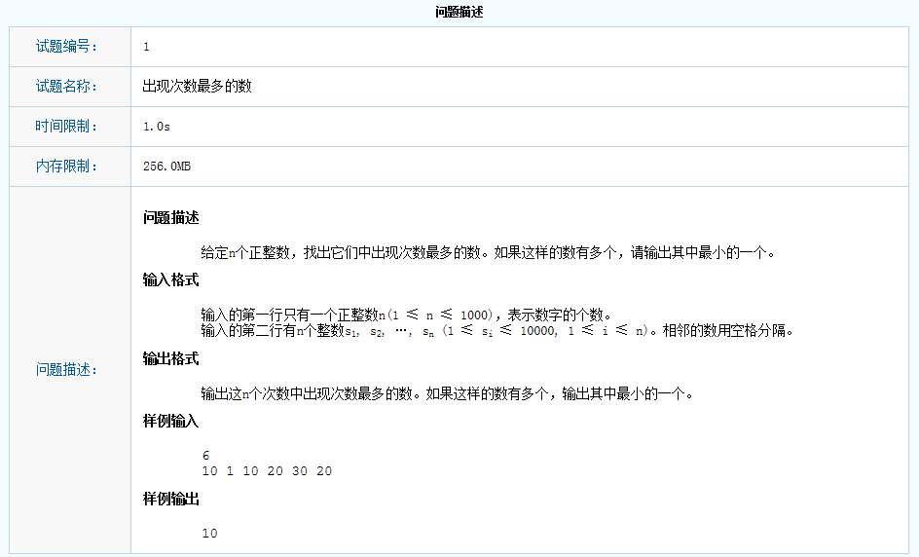

#include "stdafx.h"
#include "iostream"
#include "algorithm"
using namespace std;

int main(){
int buf[1024] = { 0 };
int count = 0;
cin >> count;
for (int index = 0; index < count; ++index){
cin >> buf[index];
}

sort(buf, buf + count);

int currentnum = buf[0];
int repeat = 0;
int maxrepeat = 0;
int maxrepeatnumber = 0;

for (int index = 0; index < count; ++index){
if (currentnum != buf[index]){
if (repeat > maxrepeat){
maxrepeatnumber = currentnum;
maxrepeat = repeat;
}
repeat = 1;
currentnum = buf[index];
}
else{
++repeat;
}
}
maxrepeatnumber = repeat > maxrepeat ? buf[count - 1] : maxrepeatnumber;
cout << maxrepeatnumber;
return 0;
}

