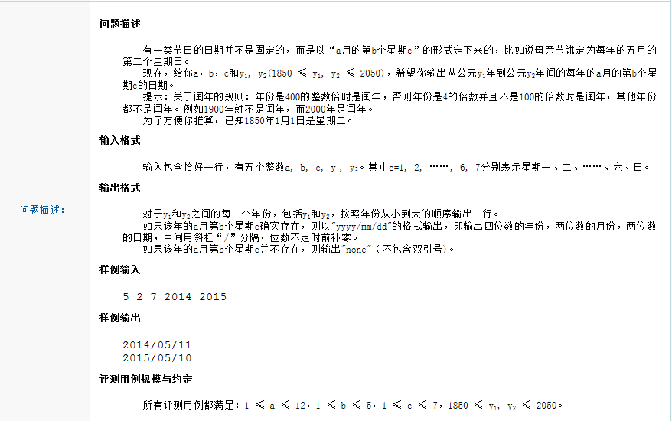

#include"stdafx.h"
#include "iostream"
using namespace std;
bool isLeap(int year);
int DayOfMonth(int year, int month);
int FirstDay(int year, int month);
int FindWeek(int year, int month, int week, int n);
int main()
{

int year1,year2,month,day,week,whichday;
int b,c;
cin >> month >> b >> c >>year1 >> year2;
for (int year = year1; year <= year2;++year)
{
FindWeek(year, month, c, b);
}

return 0;
}

//返回本月第一天是星期几
int FirstDay(int year,int month){
int wholedays = 0;
for (int y1850 = 1850; y1850 < year; ++y1850)
{
wholedays += isLeap(y1850) ? 366 : 365;
}
for (int m = 1; m < month; ++m)
{
wholedays += DayOfMonth(year, m);
}
int week = wholedays % 7 + 2;
//可能出现 week == 8 的情况，所以需要比较week
if (week>7)
{
return 1;
}
else
{
return week;
}
}

//判断是否是闰年
bool isLeap(int year){
if (!(year % 400))
{
return true;
}else if ((!(year % 4)) && year % 100)
{
return true;
}
return false;
}

int DayOfMonth(int year, int month){
switch (month)
{
case 1:
case 3:
case 5:
case 7:
case 8:
case 10:
case 12:
return 31;
break;
case 2:
return isLeap(year) ? 29 : 28;
break;
case 4:
case 6:
case 9:
case 11:
return 30;
break;
default:
break;
}
}

int FindWeek(int year,int month,int week,int n){
int count = 0;
int currentday = 1;
if (week == FirstDay(year,month))
{
++count;
}
else
{
if (week > FirstDay(year, month))
{
currentday += (week - FirstDay(year, month));
}
else
currentday += (7 - (FirstDay(year, month) - week));
++count;
}
//count 为第一次week 的次数， 即1

while (count<n && currentday<=DayOfMonth(year,month))
{
currentday += 7;
++count;
}
if (count != n ||currentday>DayOfMonth(year,month))
cout << "none" << endl;
else
{
printf("%d/%02d/%02d\n", year, month, currentday);
}
return 0;
}

