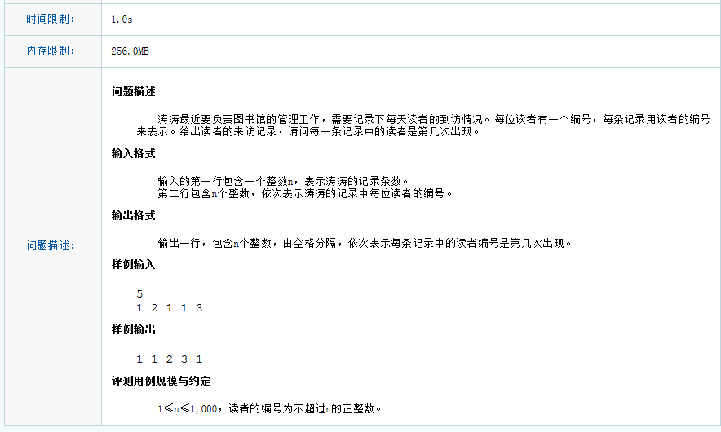

#include "stdafx.h"
#include "iostream"
#include "map"
#include"algorithm"
using namespace std;

int main(){

int n;
cin >> n;
int *p = new int[n]();
int *tmp = new int[n]();
for (int index = 0; index < n;++index)
{
cin >> p[index];
tmp[index] = p[index];
}

sort(p, p + n);

map<int, int> nnMap;

int currentnum = p[0];
int count = 0;
for (int nIndex = 0; nIndex < n; ++nIndex)
{
if (currentnum == p[nIndex])
{
++count;
}
else
{
nnMap.insert(make_pair(currentnum, count));
currentnum = p[nIndex];
count = 1;
}
}
nnMap.insert(make_pair(currentnum, count));
map<int, int> tmpMap(nnMap);
for (int nIndex = 0; nIndex < n;++nIndex)
{
cout << nnMap.find(tmp[nIndex])->second - (--(tmpMap.find(tmp[nIndex])->second)) << " ";
}

return 0;
}

