**use case diagram of UC-1 (Unlock) and UC-4 (RetireUser)**

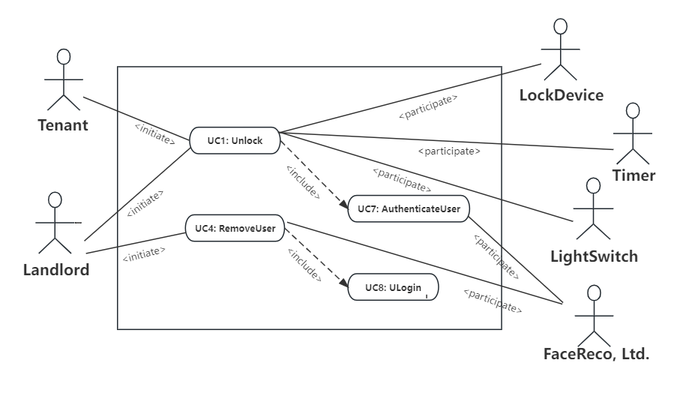

**use case schemas of UC-1 (Unlock)**

**Related Requiremts:** REQ1, REQ3, REQ4, and REQ5 stated in the table of REQs

**Initiating Actor:** Any of: Tenant, Landlord

**Actor’s Goal:** To disarm the lock and enter, and get space lighted up automatically.

**Participating Actors:** LockDevice, LightSwitch, Timer

**Preconditions:**

• The set of valid keys stored in the system database is non-empty.

• The system displays the menu of available functions; at the door keypad the menu choices are “Lock” and “Unlock.”

**Postconditions:** The auto-lock timer has started countdown from autoLockInterval.

**Flow of Events for Main Success Scenario:**

→ 1. **Tenant/Landlord** arrives at the door and selects the menu item “Unlock”

2. include: AuthenticateUser (UC-7)

← 3. **System** (a) signals to the **Tenant/Landlord** the lock status, e.g., “disarmed,” (b) signals to **LockDevice** to disarm the lock, and (c) signals to **LightSwitch** to turn the light on

← 4. **System** signals to the **Timer** to start the auto-lock timer countdown

→ 5. **Tenant/Landlord** opens the door, enters the home [and shuts the door and locks]

**use case schemas of UC-4 (RetireUser)**

**Related Requiremts:** REQ7

**Initiating Actor:** Landlord

**Actor’s Goal:** To remove departed residents at runtime.

**Participating Actors:** Tenant

**Preconditions:** The rental is due and the tenant checks out.

**Postconditions:** The modified data is stored into the database.

**Flow of Events for Main Success Scenario:**

→ 1. **Landlord** selects the menu item “ManageUsers”

2. **Landlord** identification: include Login(UC-8)

← 3. **System** (a) displays the options of activities available to the Landlord (i.e. “Remove User”) and (b) prompts the **Landlord** to make selection

→ 4. **Landlord** selects the activity “Remove User”, and choose the retired user

← 5. **System** (a) deletes the old data of the retired user, and (b) signals completion

**Flow of Events for Extensions (Alternate Scenarios):**

4a. Selected activity entails removing retired users: Include RetireUser(UC-4)

**acceptance tests of UC-1 (Unlock)**

|  |  |  |
| --- | --- | --- |
| **Test-case Identifier:** | TC-1 | |
| **Use Case Tested:** | UC-1, main success scenario, and UC-7 | |
| **Pass/fail Criteria:** | The test passes if the user enters a key that is contained in the database, with less than a maximum allowed number of unsuccessful attempts | |
| **Input Data:** | Numeric keycode, door identifier | |
| **Test Procedure:** | | **Expected Result:** |
| Step 1. Type in an incorrect keycode and a valid door identifier | | System beeps to indicate failure; records unsuccessful attempt in the database; prompts the user to try again |
| Step 2. Type in the correct keycode and door identifier | | System flashes a green light to indicate success; records successful access in the database; disarms the lock device |

**acceptance tests of UC-4 (RetireUser)**

|  |  |  |
| --- | --- | --- |
| **Test-case Identifier:** | TC-4 | |
| **Use Case Tested:** | UC-4 and UC-7 | |
| **Pass/fail Criteria:** | The test passes if the retired user cannot use the previous keycode to enter the door anymore as soon as the landlord remove from the tenant actors, as the data is removed from the database and the retired user fails the authentication | |
| **Input Data:** | Numeric keycode, authentication information of user | |
| **Test Procedure:** | | **Expected Result:** |
| Step 1. After the landlord removes a user, the retired user use the previous keycode to enter the room | | System beeps to indicate failure; records unsuccessful attempt by an unknown user in the database; prompts the user that he or she isn’t a valid tenant |
| Step 2. A user who hasn’t been removed by the landlord use the keycode to enter the room | | System flashes a green light to indicate success;  records successful access in the database;  disarms the lock device |