PRISM: Paper Retrieval using Indexed Structure and Merit
A structure-aware search engine for COVID-19 research papers, evaluated on the 50 TREC-COVID topics
CSD358 hackathon, Track T6 (vertical search for science). Team: Anuran Basu, Aayush Gupta, Anushi Gupta, Pragunie Aditya. Code: https://github.com/CipherEnigma/PRISM.

1. Problem and track relevance
PRISM is a search engine for COVID-19 research papers that ranks by the structure of each paper (title and abstract zones, exact phrases, metadata) and by a static quality score, and that shows why each paper ranked where it did.
The user need. A researcher or clinician facing a literature that had reached 192,509 CORD-19 records by July 2020 needs three things: a ranked list that puts the relevant papers first, queries more precise than a bag of words (an exact phrase such as "contact tracing", Boolean operators, a year or journal filter), and a reason for each result so the ranking can be trusted or challenged. Flat keyword search over concatenated text offers the first only weakly and the other two not at all.
Why it belongs to Track T6. The track asks for a domain search engine that uses document structure instead of flat text: zone and parametric indexes, positional phrase queries, Boolean and proximity operators, static authority and a net score. Scientific papers carry exactly that structure (a title and an abstract that say different things, a date and a journal, citations). PRISM builds each of these hooks from scratch (Section 2) and measures what each one buys (Section 5).
Data. TREC-COVID through its BEIR packaging [1][2]: 171,332 CORD-19 papers (title and abstract), 50 topics and 66,336 relevance judgments. Publication date, journal and DOI come from the CORD-19 metadata.csv of 16 July 2020 [7], which matches every paper; citation counts come from OpenAlex [8].
Prior work that shaped the design. The systems built for TREC-COVID itself, such as Covidex, found that BM25 over well-chosen index units is hard to beat [3], so we compare against BM25 and not only against flat tf-idf. Beel and Gipp showed that Google Scholar's ranking correlates strongly with citation counts [4], while a study of ranking scientific documents from the crowd found that citation impact can correlate negatively with how close a paper is to the reader's need [5]. Together they motivate testing authority as a hypothesis, not assuming it helps. BEIR supplies a published BM25 reference for this collection and a capped Recall@100, which we use to check our baselines [2].

2. How we used IR
The engine is written from scratch in Python (numpy, pandas, nltk). Each IR principle below maps to one module; the pipeline is in Figure 1.
IR principle | Where in the code | Why we chose it
Zone indexes (title, abstract, all) | prism/indexer.py, index.py | Title and abstract carry different evidence. V0 uses the all zone; V1 weights the zones.
Positional postings | indexer.py; boolean_ops.py (phrase_match, near) | Exact phrases and NEAR/k need word positions. Title and abstract are joined with a gap so a phrase cannot cross the boundary.
Parametric index (year, journal, source, month) | index.py (docs_where) | Filters such as year>=2020 return sorted document ids that intersect directly with postings.
Boolean query processing, shortest list first | parser.py, boolean_ops.py, candidates.py | The cost of an AND is bounded by its rarest operand. describe() prints each operand, its document frequency and the intermediate sizes.
lnc.ltc cosine, term at a time | scoring.py (cosine_scores) | Standard vector-space ranking: log tf and cosine normalization on the document, log tf with idf on the query.
BM25 (k1 1.2, b 0.75) | scoring.py (bm25_scores) | A strong reference from outside the core syllabus, to see where the structure ideas stand.
Heap top-K | search.py | Selects K results without sorting every match; ties break on the smaller document id so runs are reproducible.
Champion lists (r = 500) | indexer.py, candidates.py | Cuts candidate generation for long postings. Section 5 measures the speed and quality trade-off.
Static quality g(d) and net score | authority.py, search.py | net(d) = sum over zones of w_z cos(q, d_z) + beta g(d), with g from citation counts (raw or cohort percentile) or recency.
Query-adaptive authority gate | gate.py | beta(q) falls as the query's mean normalized idf (its specificity) rises.
Explainable scores | explain.py | Prints every term's tf, df, idf and weights, each zone cosine, g(d), beta(q) and the net score, reproducing search() exactly.

Analyzer. One function serves documents and queries: lowercase; normalize a short list of domain spellings (covid-19, covid 19, covid19 become covid19; sars-cov-2 becomes sarscov2); tokenize on [a-z0-9]+; drop NLTK stop words and one-character tokens; Porter-stem. A token's position is its index after stop-word removal, so "contact the tracing" also matches the phrase "contact tracing"; we state this as a limitation in Section 6.
Query language. Bare words are ranked and restrict nothing. Quoted phrases, AND, OR, NOT, NEAR/k, title: and abstract: prefixes and filters such as year>=2020 restrict the candidate set, and ranking happens inside it. A hand-written recursive-descent parser turns the query into an AST and reports unbalanced quotes or unknown fields as readable errors.
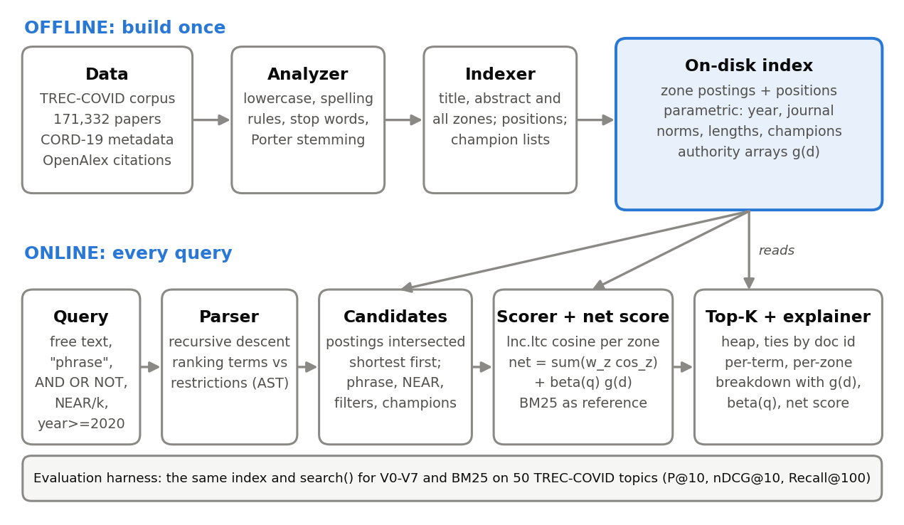
Figure 1. PRISM pipeline. The index is built once; the online path and the evaluation harness read the same index, so every variant is measured on identical data.

3. Beyond IR
The engine is classical IR with no learned models. The techniques from outside IR sit in the data and the evaluation, where they decide whether a claim can be believed.
- Citation data from an external API. Static authority needs a citation count per paper, which neither BEIR nor CORD-19 provides. We look papers up in OpenAlex in batches of 100 by DOI, then by PubMed ID, cache every response and resume without repeating calls. 137,978 of 171,332 papers (80.5%) received a count; the rest get authority 0 and are flagged in the explanation.
- Statistics for small samples. With 25 reporting topics an average difference is not evidence. Every comparison uses a paired bootstrap 95% confidence interval on the mean difference, an exact sign test (wins, losses, ties) and Holm correction across variants.
- Evaluation bias analysis. Unjudged documents count as non-relevant, which can penalize a system for finding papers the judges never saw. We report Judged@10 and a condensed nDCG@10 that drops unjudged papers, and, following BEIR, a capped Recall@100.
- Independent verification. Every reported metric was recomputed from the saved run files with separate code, and tf-idf and BM25 were re-implemented independently over the whole corpus (Section 5.3).

4. Novelty and creativity
We propose three ideas that fix specific weaknesses of the obvious baseline (flat tf-idf with raw citation counts) and test each as an ablation against its own baseline. Claims of novelty are relative to that baseline and to the systems we checked [3][4][5]; we did not do an exhaustive literature search.
Idea | Baseline | Result on the 25 reporting topics (nDCG@10 difference, 95% CI) | Reading
N1 Age-normalized authority: g(d) is a paper's citation percentile within its publication-month cohort (V5) | Raw log citation count (V2) | +0.014 [+0.001, +0.028]; 13 wins, 7 losses, 5 ties; sign test p = 0.26 | Slightly better than raw counts, not significant. On all 50 topics +0.003 [-0.009, +0.016].
N2 Query-adaptive gate: beta(q) falls as query specificity rises (V6) | One fixed beta (V5) | +0.003 [-0.000, +0.008]; 2 wins, 1 loss, 22 ties; p = 1.0 | No effect. The 50 topics span specificity 0.16 to 0.35 only (Figure 2), so the gate has little to react to.
N3 Per-query zone weights from the query's idf mass per zone (V7) | Global zone weights (V6) | -0.005 [-0.019, +0.009]; 8 wins, 6 losses, 11 ties; p = 0.79 | No effect.
N4 Inspectable ranking: per-term, per-zone score trace with the authority source flagged | Opaque score | Reproduces search() scores exactly (tested for V0 to V7) | A working feature; Elasticsearch has a comparable explain API, so we claim no novelty here.

What the tests did show. Authority is not a free win on TREC-COVID, and the kind of authority matters. Raw citation counts add nothing (V2 against V1: -0.005 [-0.030, +0.019]), whereas publication recency, the fallback the plan allowed, gives a small but consistent gain (+0.009 [+0.002, +0.018], 6 wins, 0 losses, 19 ties, p = 0.031). This agrees with the warning in [5] that citation impact can be unrelated or negatively related to a reader's need. We report N1 to N3 as tested ideas with honest, mostly negative, results; the evidence does not support claiming they work.
Other distinctive results. (i) Structure matters more than any authority signal: zone weighting lifts nDCG@10 from 0.331 to 0.560 over flat tf-idf (Section 5). (ii) Champion lists cut median latency from 53 ms to 25 ms at little quality cost (V3 against V2: +0.001 [-0.024, +0.025] on the reporting half, -0.018 [-0.038, +0.001] on all 50, an interval that just includes zero). (iii) The evaluation design (capped recall, pooling-bias check, tune/report split, independent audit) is more careful than the obvious approach of reporting averages on all topics.
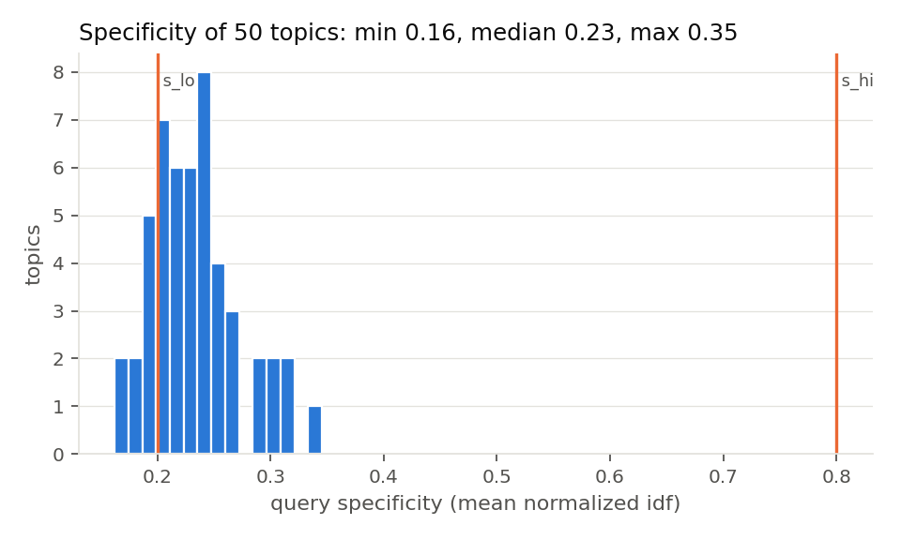
Figure 2. Query specificity of the 50 topics. The gate lowers beta between s_lo and s_hi (orange lines at the default 0.2 and 0.8); every topic falls below 0.35.

5. Evaluation

5.1 Setup
We evaluate on the 50 official TREC-COVID topics with their relevance judgments (a paper is relevant if its qrels score is at least 1; scores 1 and 2 are used as graded gains for nDCG, the two -1 judgments count as non-relevant). Queries are the short question of each topic. The topics are split once, with a fixed seed, into a tuning half and a reporting half of 25; weights and beta are tuned on the tuning half only, and we report the reporting half and all 50. Metrics are P@10, nDCG@10 and Recall@100, plus a capped Recall@100 that divides by min(100, relevant) because every topic has more than 100 relevant papers (mean ceiling of plain Recall@100 about 0.27). Unjudged documents count as non-relevant.
ID | System | Question it answers
V0 | Flat tf-idf (lnc.ltc) over title + abstract | Baseline
V1 | Zone-weighted tf-idf (title 2 : abstract 1) | Does zone structure help?
V2 | V1 + raw log citation authority in a net score | Does citation authority help?
V3 | V2 with champion lists (r = 500) | Speed saved, quality cost
V4 | V2 with phrase boost for quoted phrases | Not separable here: the TREC topics contain no quoted phrases, so V4 = V2
V5 | V2 with age-normalized (cohort percentile) authority | N1 against raw counts
V6 | V5 with the query-adaptive beta(q) | N2 against a fixed beta
V7 | V6 with per-query zone weights | N3 against global weights
R | BM25 on title + abstract (own implementation) | Standard strong baseline, reference only

5.2 Results
Variant | P@10 | nDCG@10 | R@100 | R@100 capped | P@10 | nDCG@10 | R@100 | R@100 capped
V0 | 0.372 | 0.346 | 0.066 | 0.256 | 0.366 | 0.331 | 0.062 | 0.258
V1 | 0.620 | 0.596 | 0.099 | 0.408 | 0.594 | 0.560 | 0.092 | 0.401
V2 | 0.616 | 0.591 | 0.097 | 0.406 | 0.604 | 0.565 | 0.092 | 0.400
V3 | 0.616 | 0.593 | 0.103 | 0.404 | 0.584 | 0.547 | 0.092 | 0.386
V5 | 0.628 | 0.605 | 0.095 | 0.401 | 0.612 | 0.568 | 0.091 | 0.399
V6 | 0.632 | 0.608 | 0.095 | 0.402 | 0.614 | 0.569 | 0.091 | 0.399
V7 | 0.628 | 0.603 | 0.096 | 0.406 | 0.614 | 0.571 | 0.092 | 0.405
R (BM25) | 0.652 | 0.629 | 0.125 | 0.504 | 0.664 | 0.634 | 0.118 | 0.500
Table 1. Reporting half (25 topics, columns 2 to 5) and all 50 topics (columns 6 to 9), default parameters, citation-based authority. R@100 = Recall@100. V4 is identical to V2 and omitted.
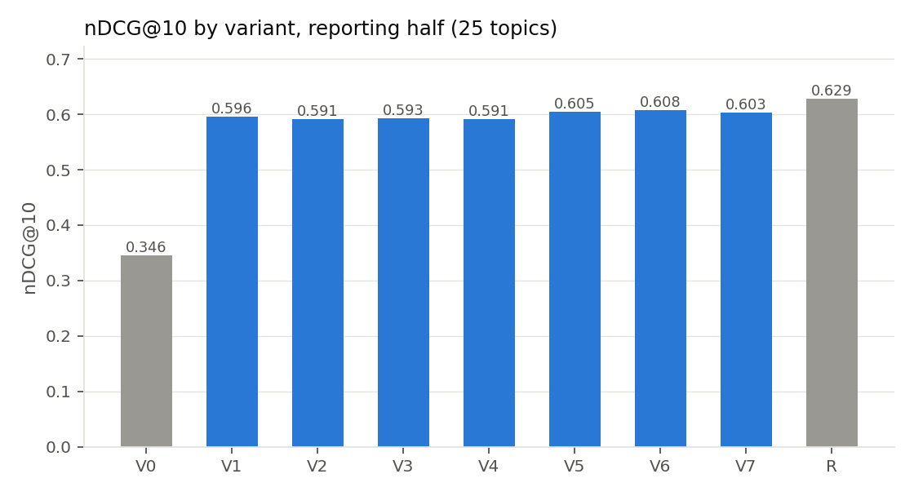
Figure 3. nDCG@10 by variant on the reporting half; grey bars are the baselines (V0, BM25).
Comparison (nDCG@10) | Reporting half (25 topics) | All 50 topics
V1 against V0 (zones against flat tf-idf) | +0.250 [+0.136, +0.366]; 18 W / 7 L; p = 0.043 (Holm 0.26) | +0.229 [+0.154, +0.302]; 38 W / 12 L; p < 0.001 (Holm 0.001)
V1 against R (zones against BM25) | -0.033 [-0.124, +0.060]; 9 W / 15 L / 1 T; p = 0.31 | -0.074 [-0.139, -0.007]; 17 W / 32 L / 1 T; p = 0.044
V5 against R | -0.024 [-0.124, +0.077]; 8 W / 16 L / 1 T; p = 0.15 | -0.066 [-0.131, +0.002]; 16 W / 33 L / 1 T; p = 0.021
V3 against V2 (champion lists) | +0.001 [-0.024, +0.025]; 7 W / 7 L / 11 T; p = 1.0 | -0.018 [-0.038, +0.001]; 11 W / 16 L / 23 T; p = 0.44
Table 2. Paired differences with bootstrap 95% confidence intervals (10,000 resamples) and exact sign tests. W/L/T = wins, losses, ties over topics. Holm = corrected across all variants against V0.
Reading the results. Zone structure is the clear win over flat tf-idf (+0.23 nDCG@10 on all 50 topics, 38 topics better and 12 worse). On the 25 reporting topics the interval also excludes zero, but the Holm-corrected p-value (0.26) does not, so the reporting half alone cannot confirm it; the full 50 can. None of our variants beats BM25, which is the best system (0.634 on all 50). Plain BM25 being hard to beat on TREC-COVID matches the experience of the participating systems [3]. The authority variants (V2, V5 to V7) all sit within noise of V1 on the reporting half, so we do not claim authority improved ranking. Recall@100 is low in absolute terms because of the ceiling described above; the capped form (BM25 0.500 on all 50) is the comparable one.
Tuning does not transfer. Tuning on the 25 tuning topics chose a title weight of 0.5, beta 0 for both citation variants, and a gate of beta_max 0.1 with s_lo 0.188 and s_hi 0.296. On the held-out reporting half the tuned V1 scored 0.578 against 0.596 for the default, and tuned V6 0.544 against 0.608: with 25 topics the grid mostly fits noise, so Table 1 reports the default parameters and the tuned runs are kept as a documented negative result.

5.3 Sanity checks
Check | Ours | Reference
All metrics recomputed from the saved run files with separate code (9 variants x 50 topics) | max difference 5e-7 | per-topic CSVs (rounding only)
Independent lnc.ltc over the whole corpus, same analyzer (nDCG@10) | 0.332 | V0: 0.331
Independent BM25 (k1 1.2, b 0.75), same analyzer | 0.638 | R: 0.634
Independent BM25, sklearn tokenizer, no stemming | 0.592 | our analyzer (stemming, stop list) adds about 0.05
scikit-learn TfidfVectorizer (sublinear, l2) | 0.366 | V0: 0.331 (ours is slightly weaker)
Published BM25 on TREC-COVID, BEIR [2]: nDCG@10 | R: 0.634 | 0.656
Published BM25 on TREC-COVID, BEIR [2]: capped Recall@100 | R: 0.500 | 0.498
BM25 top-10 overlap with rank_bm25 on 25 random queries (test) | mean 0.96, min 0.80 | idf variant differs slightly
V0, V1 and BM25 run on a second machine from the same code and index | identical on all 50 topics | per-topic nDCG@10
Table 3. Independent checks that the numbers are real and the baselines are not weakened.
Pooling bias. TREC-COVID judged only the papers that participating systems retrieved, and unjudged papers count as non-relevant. Only 48% of V0's top ten are judged, against 76% for V1 and 93% for BM25, so V0 is partly penalized for papers nobody assessed. This does not explain the gap: with unjudged papers dropped (condensed nDCG@10, reporting half) V0 scores 0.587 against 0.676 for V1.

5.4 Latency
Median query latency over the 50 topics on one laptop (index in memory): V0 48 ms, V1 55 ms, V2 53 ms, BM25 38 ms, and V3 with champion lists 25 ms (95th percentile 45 ms against 100 ms for V2). Raising the champion size from 200 to 2,000 on the tuning half moved nDCG@10 from 0.451 to 0.535 and the overlap of the top 100 with full postings from 0.49 to 0.94, so r = 1,000 is the knee; the default r = 500 trades a little quality for speed.

6. Limitations and next steps
- We do not beat BM25. The best system is plain BM25 (0.634). Zone-weighted cosine (0.560) closes most of the gap to it from flat tf-idf (0.331) but not all.
- Authority did not help. Citation counts added nothing measurable and recency a small gain. 19.5% of papers have no OpenAlex count and get authority 0, and counts are as of October 2026 for papers published in 2020, so older papers had longer to accumulate them; the cohort percentile (N1) is meant to correct this but its gain was not significant.
- Small sample. 25 reporting topics give paired intervals about 0.03 wide either side, so smaller nDCG@10 differences cannot be confirmed, and tuning on 25 topics overfitted. TREC-COVID relevance judgments also have holes (Section 5.3), so every system's absolute score is understated.
- Index limits. The corpus is title and abstract only (no body text or bibliographies), and stop-word removal lets "contact the tracing" match the phrase "contact tracing". The TREC topics contain no quoted phrases, so the phrase-boost variant could not be evaluated on them.
- Next steps. (1) BM25F, which combines title and abstract inside the BM25 saturation, and a static prior on top, to test whether structure can beat BM25 [6]. (2) Evaluate phrase and proximity queries on our own judged query set, since TREC topics do not use them. (3) Join CORD-19 full text and use citations within the corpus (PageRank-style authority). (4) Judge a set of queries ourselves for a second, independent evaluation.

7. Work division
Member | Role | Components
Member A: Anushi | Data and index | Loader joining BEIR to CORD-19 metadata, analyzer, indexer (zones, positions, champion lists, parametric index), Index class, build and data-statistics scripts
Member B: Anuran | Query engine | Parser, Boolean operations (intersection, union, difference, phrase, NEAR/k), candidate generation, plan printer
Member C: Aayush | Ranking, authority and novelty | Cosine and BM25 scoring, authority (raw and cohort), gate and adaptive zone weights, search(), explainer
Member D: Pragunie | Evaluation and delivery | Metrics, runner, topic split, tuning, statistics, plots, independent audit, citation fetching, index patching, README, this report and the video edit

AI-use declaration
We used AI coding assistants throughout. Claude Code (Anthropic; the models Sonnet 5.5 and Opus 5.5) wrote or modified code in every module: loader, analyzer, indexer, index, parser, Boolean operations, candidates, scoring, authority, gate, search, explainer, the evaluation harness, scripts and tests. It also drafted the README, the sanity-check audit and this report from the numbers we measured. Every AI-assisted change is logged one line per change in AI_USE.md in the repository. The team set the plan and interfaces (spec.md), directed the tools, ran the test suite (305 tests pass) and every evaluation, and decided what to report. No LLM or neural model is part of the search engine itself; rank_bm25 and scikit-learn appear only in tests and cross-checks.

References
[1] E. Voorhees et al. TREC-COVID: Constructing a Pandemic Information Retrieval Test Collection. arXiv:2005.04474, 2020.
[2] N. Thakur et al. BEIR: A Heterogeneous Benchmark for Zero-shot Evaluation of Information Retrieval Models. NeurIPS Datasets and Benchmarks, 2021. arXiv:2104.08663.
[3] E. Zhang et al. Covidex: Neural Ranking Models and Keyword Search Infrastructure for the COVID-19 Open Research Dataset. arXiv:2007.07846, 2020.
[4] J. Beel and B. Gipp. Google Scholar's Ranking Algorithm: The Impact of Citation Counts (preprint).
[5] Learning to Rank Scientific Documents from the Crowd. arXiv:1611.01400.
[6] C. D. Manning, P. Raghavan and H. Schutze. Introduction to Information Retrieval. Cambridge University Press, 2008.
[7] L. L. Wang et al. CORD-19: The COVID-19 Open Research Dataset. arXiv:2004.10706, 2020; metadata.csv release of 16 July 2020, Allen Institute for AI.
[8] OpenAlex, https://openalex.org (citation counts retrieved October 2026).

