**SRES’s**

**SANJIVANI COLLEGE OF**

**ENGINNERING,**

**KOPARGAON – 423603(M.S.)**



**Department of**

**Electronics & Telecommunication Engineering**

**2018-2019**

**GROUP NO : 30**

**PROJECT [STAGE-II]**

**ON**

**“DIGITIZATON OF BATTERY MANAGEMENT SYSTEM AND CHARGING BY SOLAR PANEL”**

**Field of Specialization:**

Power Electronics and drives / Battery System Engineering / Control System / IoT.

**Project Definition:**

The aim of this project is to digitalized the energy storing, dissipating, controlling and converting system (like batteries, Battery Management System and Solar Panel) by introducing concept of “Internet of Things” (IoT), Cloud Computing and displaying it on display (i.e. on Website / Local monitor LCD display) and make it simple to understand and manageable to the consumer.

**ABSTRACT:-**

Battery management system (BMS) is a device that monitors and controls each cell in the battery pack by measuring its parameters. The capacity of the battery pack differs from one cell to another and this increases with number of charging/discharging cycles. The Lithium ion batteries are fully charged at typical cell voltage 4.16 - 4.20 V. Due to the different capacity this voltage is not reached at the same time for all cells in the pack. The lower the capacity the sooner this voltage is reached. When charging series connected batteries with single charger, the voltage on some cells might be higher than maximum allowed charging voltage at the end of charging. Overcharging the cell additionally lowers its capacity and number of charging cycles. The BMS equalizes cells’ voltage by diverting some of the charging current from higher voltage cells – passive balancing. The device temperature is measured to protect the circuit from over-heating due to the passive balancing. Battery pack temperature is monitored by LM35 temperature sensor/s. Current is measured by ACS712 current sensor module working on hall sensor principle. Battery pack current, temperature and cell’s voltage determine state of charge (SOC). State of health (SOH) is determined by comparing cell’s current parameters with the parameters of the new battery pack.

**Objectives:**

* To monitor & control each cell in the battery pack by measuring its parameters.
* To control and monitor the charge & discharge current going of the battery pack.
* To limit the overcharging and undercharging of cells in the battery pack.
* To maintain safe operation of the battery pack.
* To monitor the cells temperature and control the thermal management systems to maintain the pack within a speciﬁed temperature range.
* To efficiently convert the solar energy into the electrical one and preserving it for later use for the appliances.
* To make all above objectives simply understandable and controllable by the consumer by introducing concept of “Internet of Things” (IoT), Cloud Computing and displaying it on display (i.e. on Website / Local monitor display) .

**Scope:**

The main scope of our project is to production of quality electricity from a renewable source i.e solar panels to reduce dependence on fossil fuels and the associated emissions of carbon and harmful pollutants.

Our goal is to design and develope a Digitalized BMS that will handle the task described above.

**Block Diagram:**

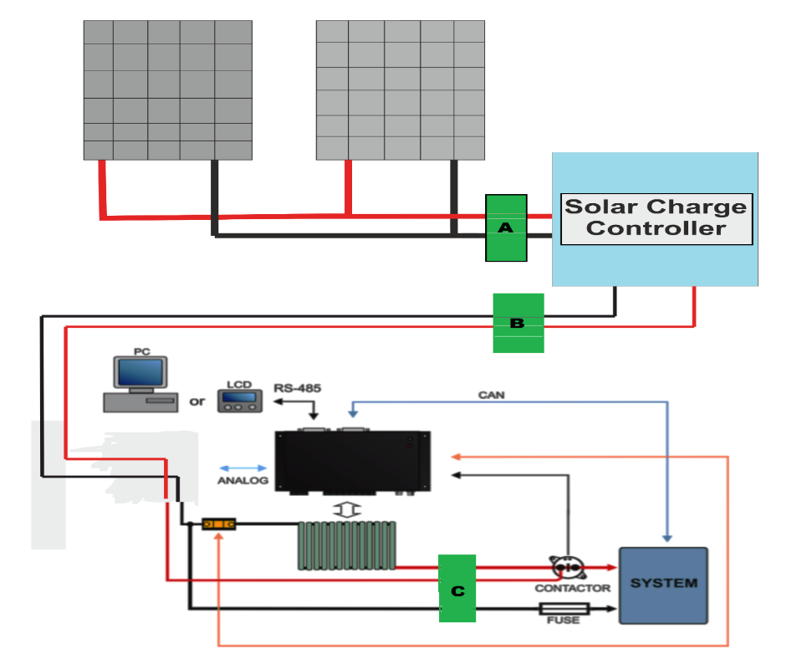

**Implementation:**

Batteries. Batteries use a chemical reaction to do work on charge and produce a voltage between their output terminals. This is commonly referred as electrochemistry. Regardless of the chemistry involved, the result is the same, electricity being converted into chemical enengy, stored as charges, and then released as per the user required for the appliances.

When a battery is charging or discharging, at the basic level, we are leveraging a chemical reaction for lithium ion battery for our benefit. Understanding what occurs at every moment in that chemical reaction is critical, particularly if we are attempting to maximizing the energy output of that chemical reaction. Real time data from the chemical reactions occurring in the battery will provide us with all the information we need to ensure that the battery is as efficient condition as it can be electrochemically.

But there is a problem. Today high costing BMS do not monitor the real time chemical reactions in the battery, they monitor temperature and voltage to determine what is chemically occurring inside the battery. The existing battery charging methodology is not done with precision, rather it is done with brute electrical force. The current is forced into the battery triggers an extreme chemical reaction in the battery that causes the overheating and damage to the battery bank. That heat eventually radiates out to the electrode and cause the other battery to heat it up. The extra generation of the heat damages the full battery pack. So, it is detected by a LM35(temperature sensor) that determines wheather the battery is heating or not and switches the fan automatically to cool it down and prevent further damage.

**Working Model:**

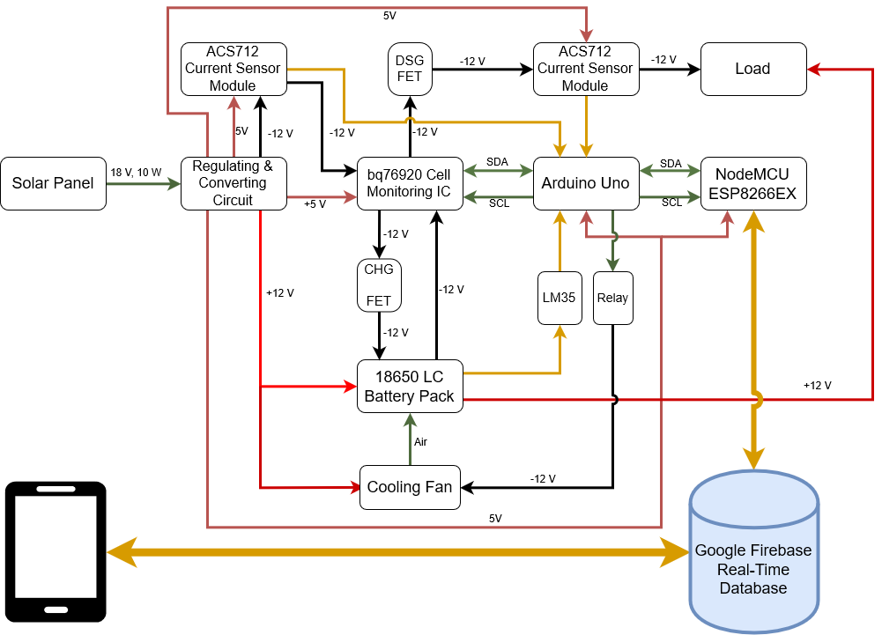

* Firstly the sun enery is beung converted into the the electrons by the solar panel which is being provided with the solar charge controller which prevent the reverse flowing of the generated electrons.
* Since the solar panel supplies 18V pure DC, then it is converted into the 12V DC using the 7812 (Voltage Regulator). The 7812 is the most common, as its regulated 12-volt supply provides a convenient power source for most TTL components.
* Then the regulated power form 7812 (Voltage Regulator) is being tranfered to the relay which works to isolate or change the state of an electric circuit from one state to another i.e from the short between the input to the output and then the second state is disconnected state form input to the output.
* Then the current is being tranfered to the Current Sensor IC(ACS712) to measure current using the Hall Effect principle. It measures the current upto 5 Amp.
* Then the voltage is bring sent to the BMS Module which accurately moniters the battery volatage and current and also prevents the battery being overcharge. It also moniters the discharging rate and prevents the battery pack form over discharging. Since over charging or over discharging leads to alter the life of battery pack i.e. it reduces the life of battery pack.
* The Arduino is being used for the central monitering of the battery pack and the ESP8266 (Node MCU) is used to receive and store the battery pack health on the the firebase server.
* Firebase server is a google based server which allows us to save a limited amount of data on the server. The number of request that can be made to server is limited to.

|  |  |  |  |
| --- | --- | --- | --- |
| **Sr.**  **No.** | **Name of Students** | **Exam Seat No.** | **Signature** |
| **01** | **Maniyar Akib Mansur** | **B150123139** |  |
| **02** | **Muley Rasika Rajesh** | **B150123140** |  |
| **03** | **Sheikh Masem Mandal** | **B150123146** |  |
|  | **Project Guide:- Prof. D. G. Lokhande** | | |