**SRES’s**

**SANJIVANI COLLEGE OF**

**ENGINNERING,**

**KOPARGAON – 423603(M.S.)**



**Department of**

**Electronics & Telecommunication Engineering**

**2018-2019**

**GROUP NO : 31**

**PROJECT [STAGE-I]**

**ON**

**“DIGITALISATION OF BATTERY MANAGEMENT SYSTEM AND CHARGING BY SOLAR PANEL”**

**Field of Specialization:**

Power Electronics and drives / Battery System Engineering / Control System / IoT.

**Project Definition:**

The aim of this project is to digitalized the energy storing, dissipating, controlling and converting system (like batteries, Battery Management System and Solar Panel Resp.) by introducing concept of “Internet of Things” (IoT), Cloud Computing and displaying it on display (i.e. on Website / Local monitor LCD display) and make it simple to understand and manageable to the consumer.

**ABSTRACT:-**

Battery management system (BMS) is a device that monitors and controls each cell in the battery pack by measuring its parameters. The capacity of the battery pack differs from one cell to another and this increases with number of charging/discharging cycles. The Li-poly batteries are fully charged at typical cell voltage 4.16 - 4.20 V. Due to the different capacity this voltage is not reached at the same time for all cells in the pack. The lower the capacity the sooner this voltage is reached. When charging series connected batteries with single charger, the voltage on some cells might be higher than maximum allowed charging voltage at the end of charging. Overcharging the cell additionally lowers its capacity and number of charging cycles. The BMS equalizes cells’ voltage by diverting some of the charging current from higher voltage cells – passive balancing. The device temperature is measured to protect the circuit from over-heating due to the passive balancing. Battery pack temperature is monitored by Dallas DS18B20 digital temperature sensor/s. Maximum 8 temperature sensors per Slave unit may be used. Current is measured by low-side shunt resistor. Battery pack current, temperature and cell’s voltage determine state of charge (SOC). State of health (SOH) is determined by comparing cell’s current parameters with the parameters of the new battery pack.

**Objectives:**

* To monitor & control each cell in the battery pack by measuring its parameters.
* To control and monitor the charge & discharge current going into and out of the battery pack.
* To limit the overcharging and undercharging of cells.
* To maintain safe operation of the pack.
* To Monitor the cells temperature and control the thermal management systems to maintain the pack within a speciﬁed temperature range.
* To efficiently convert the solar energy into the electrical one and preserving it.
* To make all above objectives simply understandable and controllable by the consumer by introducing concept of “Internet of Things” (IoT), Cloud Computing and displaying it on display (i.e. on Website / Local monitor LCD display) .

**Scope:**

The main scope of our project is to production of quality electricity from a renewable source to reduce dependence on fossil fuels and the associated emissions of pollutants.

Our goal is to design and developed an Digitalized BMS that will handle the task described above.

**Block Diagram:**

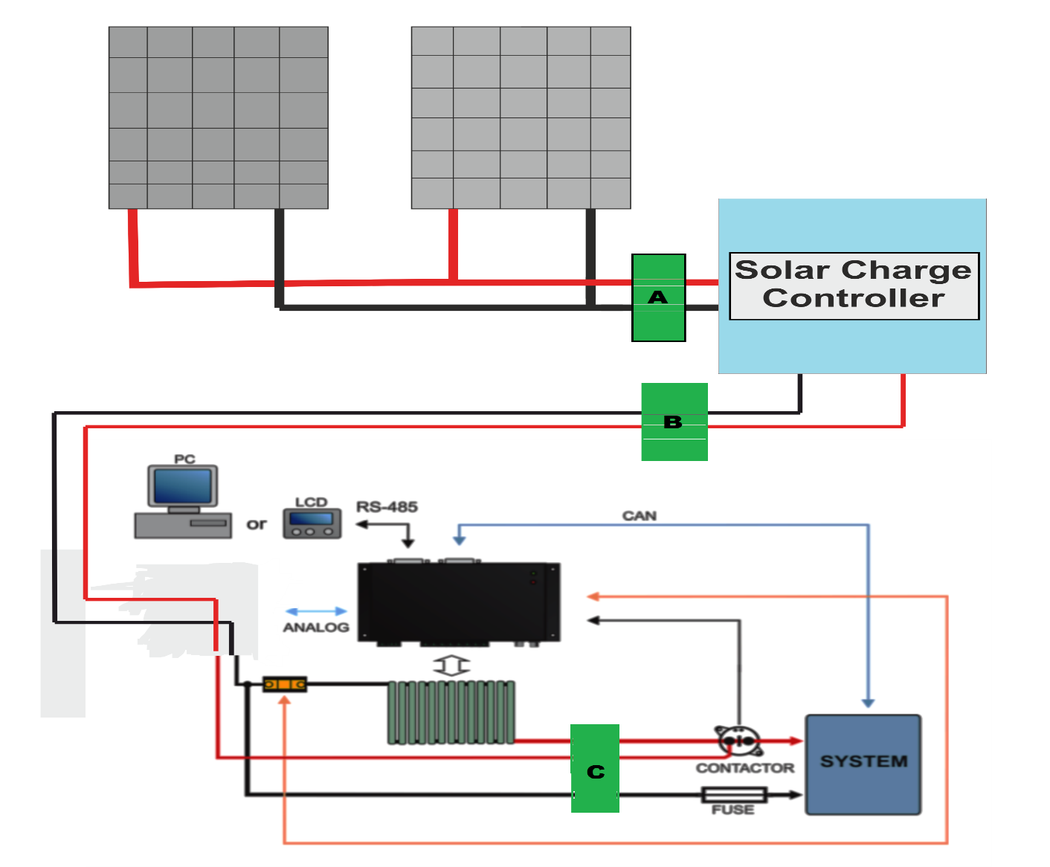

**Implementation:**

Batteries store energy using a chemical reaction. This is commonly referred to as electrochemistry. Regardless of the chemistry involved, the result is the same, electricity being converted, stored, and released.

When a battery is charging or discharging, at the basic level, we are leveraging a chemical reaction for our benefit. Understanding what occurs at every moment in that chemical reaction is critical, particularly if we are attempting to maximize something as important as the energy output of that chemical reaction. Real time data from the chemical reactions occurring in the battery will provide us with all the information we need to ensure that the battery is as efficient as it can be electrochemically.

There is a problem. BMSs of today do not monitor the real time chemical reactions in the battery, they monitor temperature and Voltage to determine what is occurring chemically inside the battery. The existing battery charging methodology is not done with precision, rather it is done with brute electrical force. The Current forced into the battery triggers an extreme chemical reaction in the battery that causes the overheating and damage to the battery. That heat eventually radiates out to the electrode and is detected by a sensor that determines that the battery is fully charged.

**Working:**

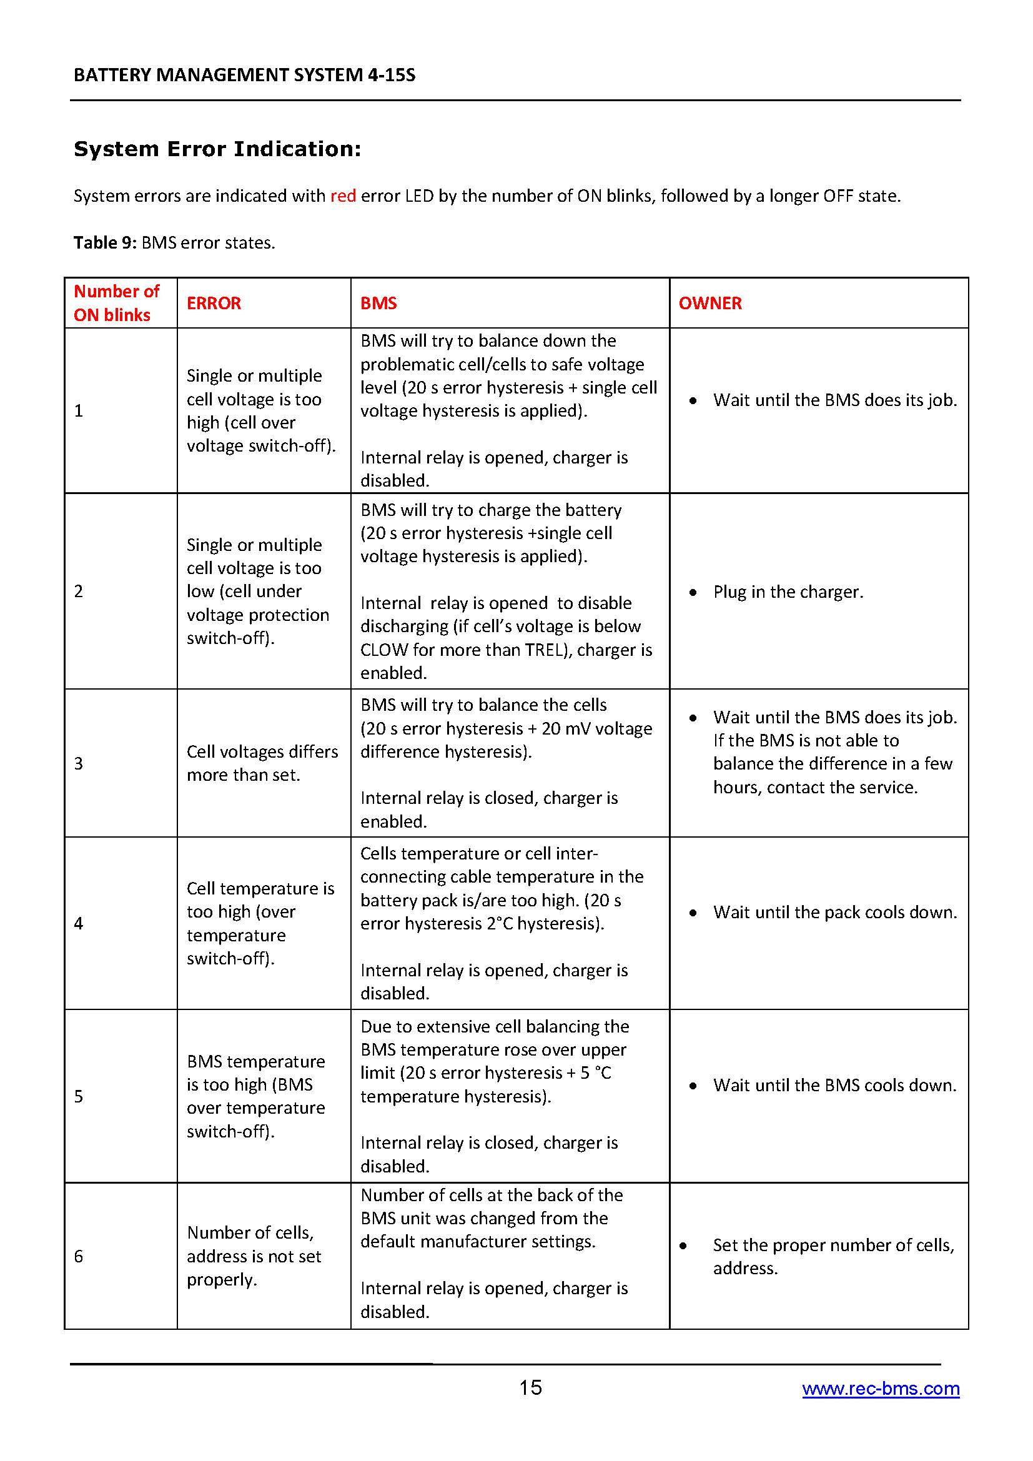

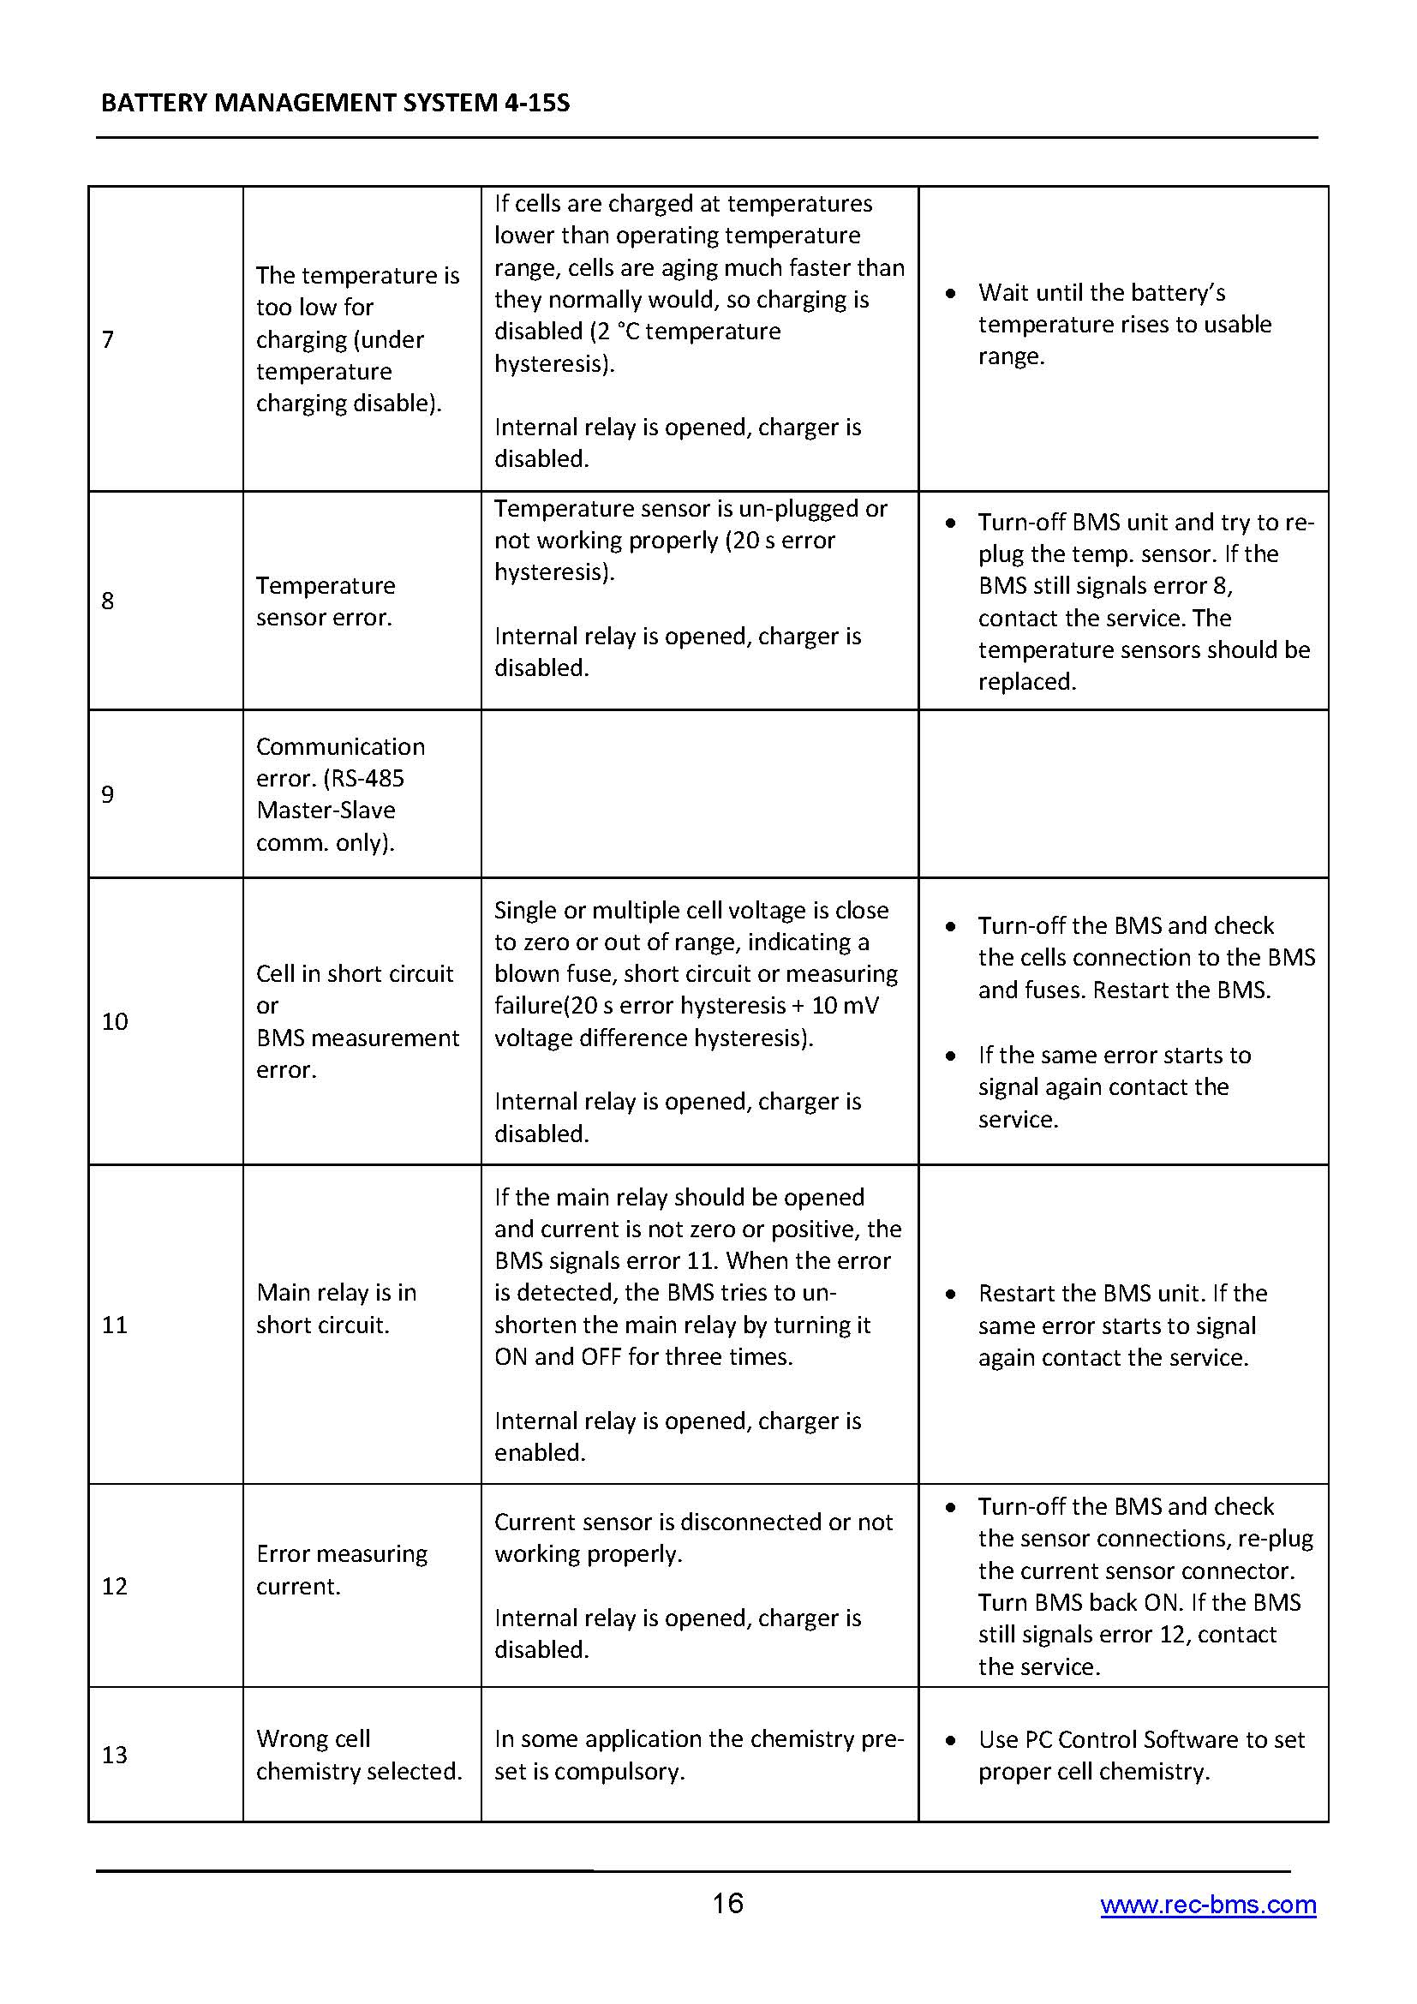

|  |  |  |  |
| --- | --- | --- | --- |
| **Sr.**  **No.** | **Name of Students** | **Exam Seat No.** | **Signature** |
| **01** | **Maniyar Akib Mansur** |  |  |
| **02** | **Muley Rasika Rajesh** |  |  |
| **03** | **Sheikh Masem Mandal** |  |  |
|  | **Project Guide:- Prof. D. G. Lokhande** | | |