Jenkins Pipeline for MyMavenSelenium05
Step 1: Open the Jenkins Dashboard in order to create a new item
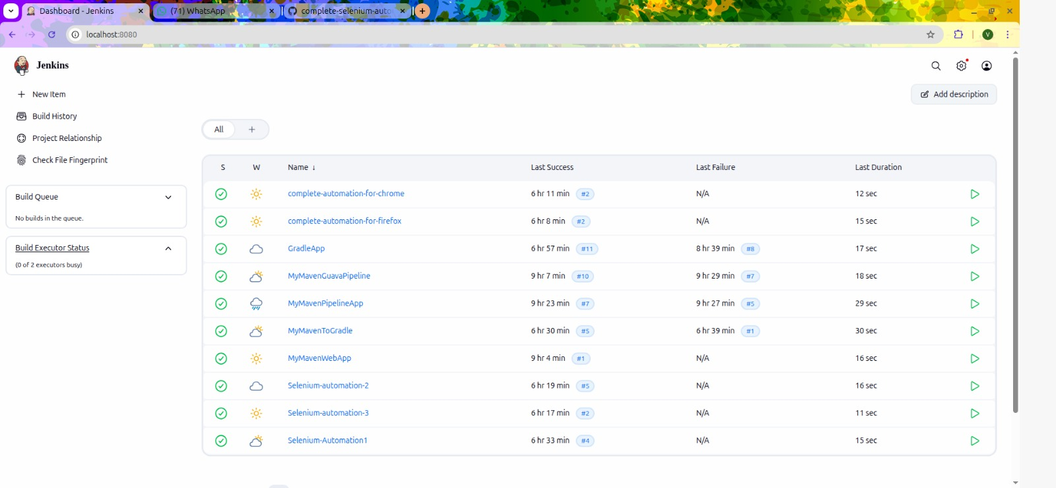

Step 2: Click on New Item in order for creating an New Item and thus give the name as “MyMavenAppSelenium05” and Item type as Pipeline and
Create it
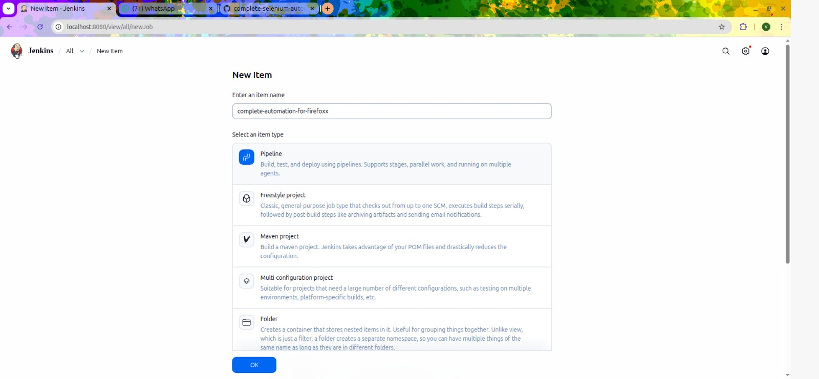

Step 3: Configure the settings by Defining the script as “Pipeline Script from SCM” and SCM as “Git”. Thus, now as we have selected Git, we need to paste the Repository URL of the project given in GitHub and choose Credentials as “GitHub Credentials” which was created earlier.
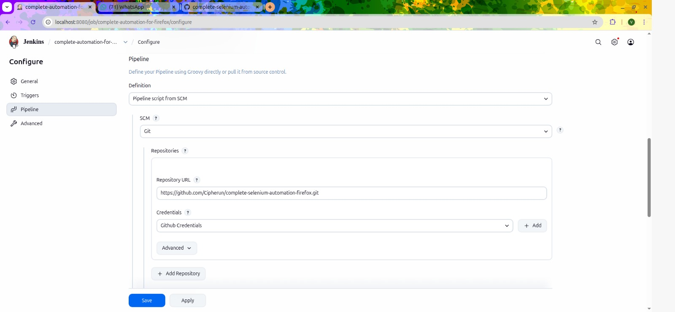

Step 4: Now in Terminal, go to directory created for MyMavenAppSelenium03 and create an new file called “Jenkinsfile”

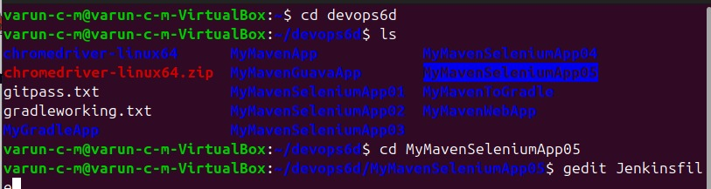

Step 5: Paste the available code inside the Jenkinsfile
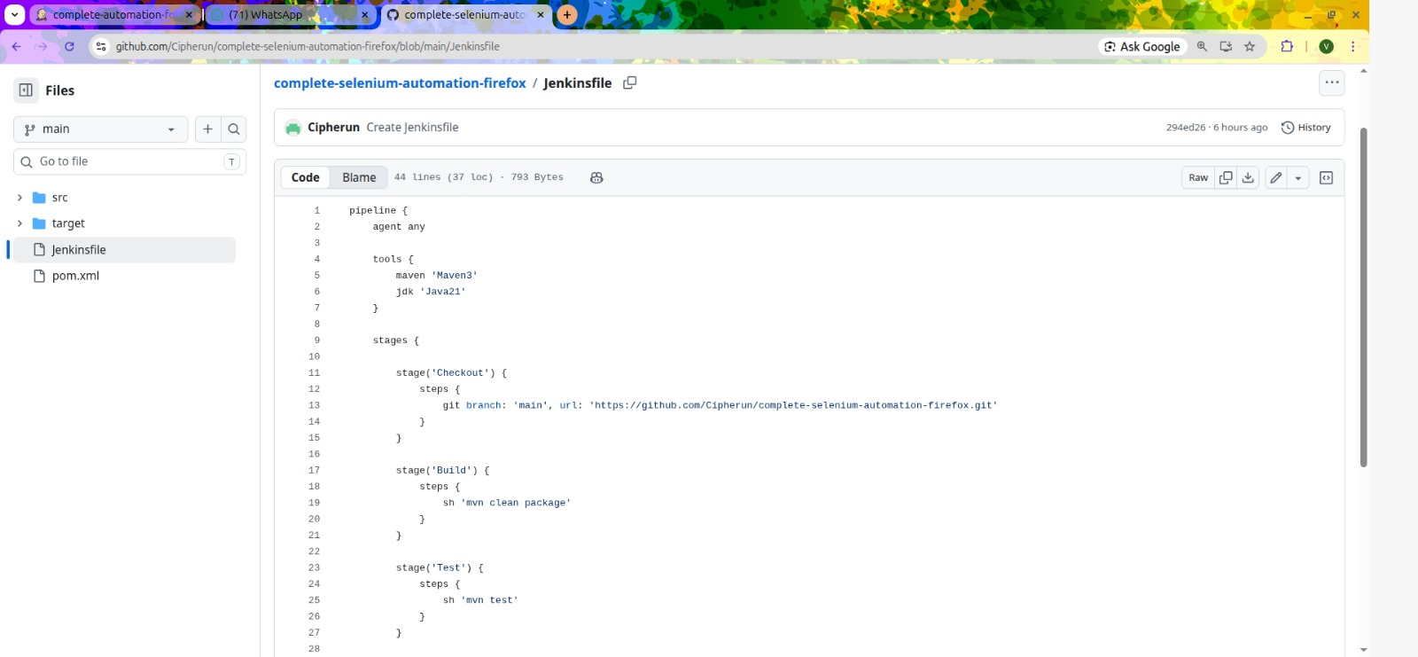

Step 6: We need to update pom.xml also in order to change the versions of source and target from 1.7 to 1.8
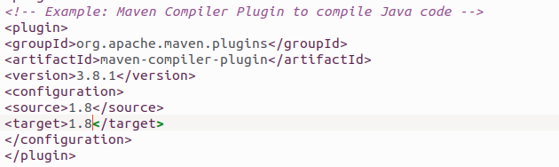

Step 7: Now we need to Push changes and commit by pushing the necessary “Jenkinsfile” to the respective Repo
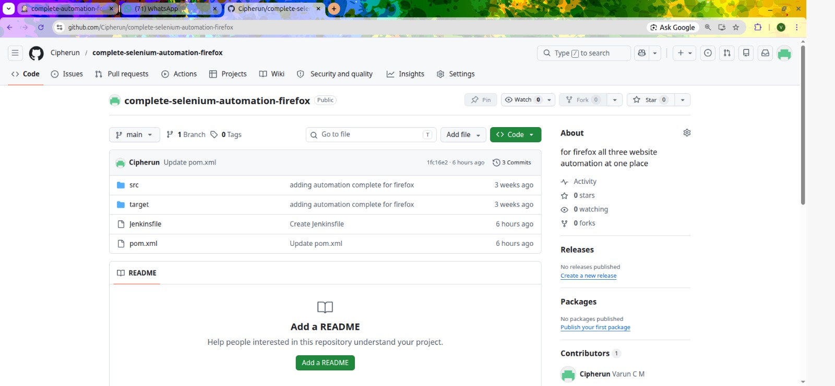

Step 8: Now go to Jenkins and Build the Pipeline and thus check the Stage view for the successful execution.

