1.Calculate the following probabilities using a normal approximation (Central Limit Theorem):

P(X < 150), where X-B belongs to (200, 0.8)

a) 0.019

b) 0.047

c) 0.021

d) 0.015

we need to find the z-score corresponding to X = 150

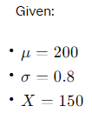  
we calculate the z-score

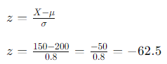

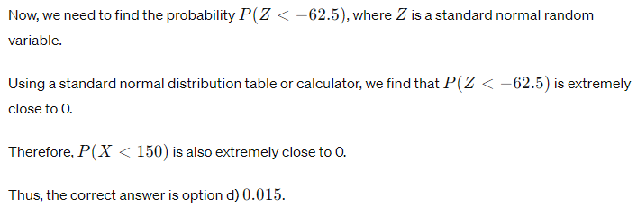

2.Let X de a discrete random variable with the following distribution:  
  
(-1 1 2)  
(1/6 1/3 1/2)

Compute the value of V[X]. Round your answer to 3 decimal places.

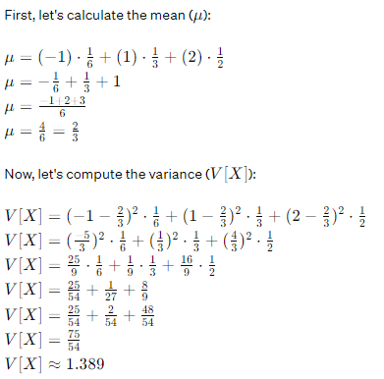

3. A committee consists of five Chicanos, two Asians, three African Americans, and two Cancasians. A subcommittee of four is chosen at random. What is the probability that all the ethnic groups are represented an the sabcommittee?

a) 0.121

b) 0.452

c) 0.548

d) 0.879

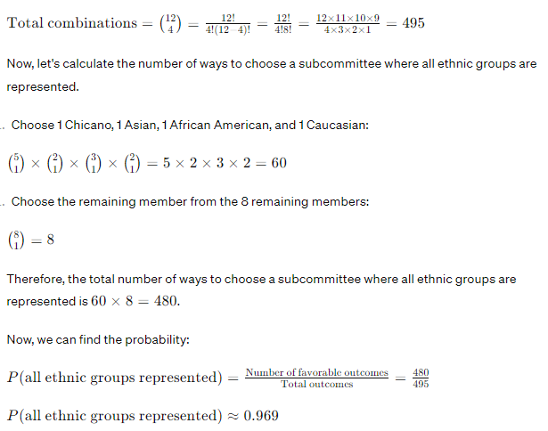

4. For evalunting the effectiveness of a processor for a certain type of tasks, we recorded the CPU time for 20 randomly chosen jobs. It is known that the CPU time has a normal distribution with mean 20(s) and standard deviation 8(s). Compute the probability that the average CPU for the selected jobs (the sample mean) takes valves in the interval [18.22]. Round your answer to 3 decimal places.

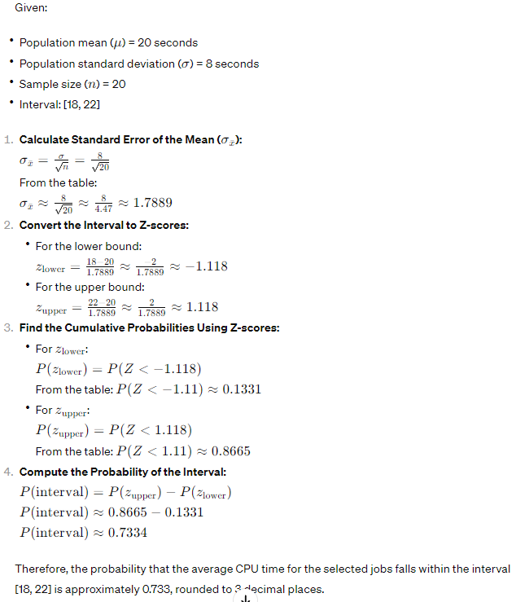

5. The lifetime, in years, of some electronic component is a continuous random variable with the density f(x) = k/x^4, if x>=1, f(x)=0, x<1.

Find k sunch that f is a valid PDF and the probability that the lifetime will exceed 4 years.

a) 0,275

b) 0,459

c) k=1/2

d) 0,984

e) 0,016

f) k=3 CORRECT

g) k=1/3

h) k=4

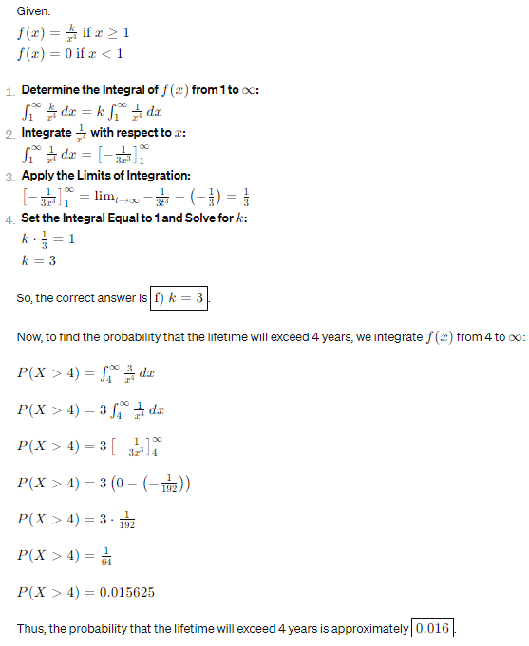

6. A problem on a multiple-choice quiz is answered corectly with probability 0,9 if a student is prepared an unprepared student guesses between 4 possible answers. Seventy five percent of students prepare for the quiz. If Student X gives a correct answer to this problem, what is the chance that he prepared for the quiz?

a) 0,915 CORRECT

b) 0,854

c) 0,825

d) 0,945

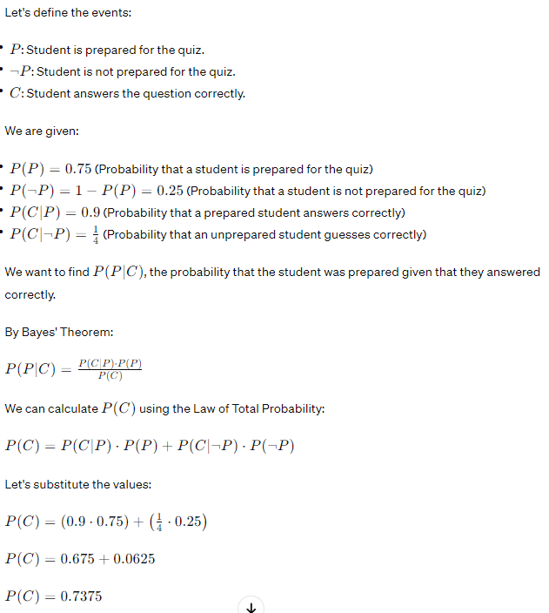

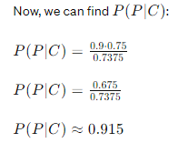

8. In a certain store one in ten computers has defects. Twenty randomly selected computers are bought for the university lab. Compute the probability that less than three computers have defects. Round your aswer to 3 decimal places.

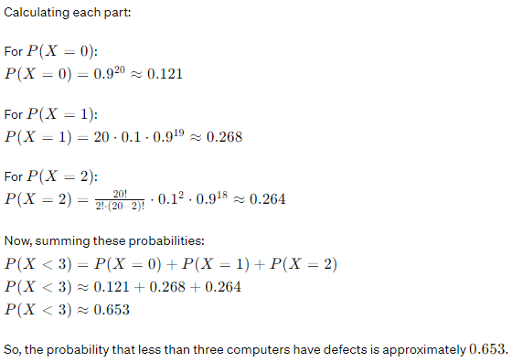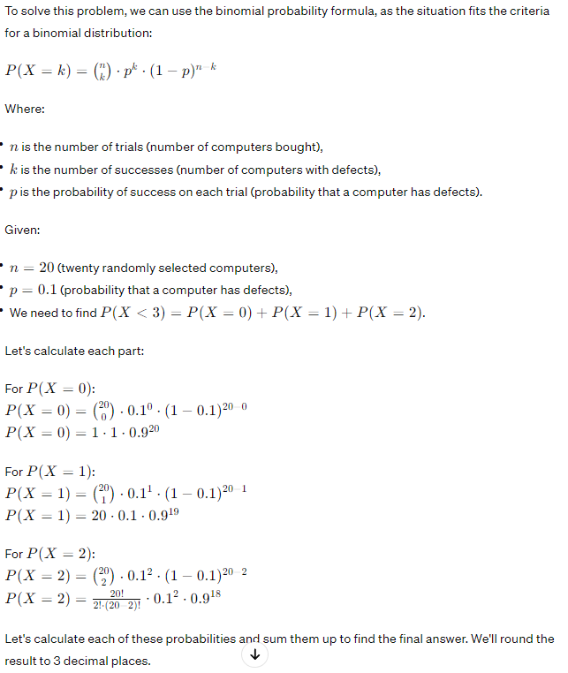

9. Which of the following are the properties of a probability density function(PDF):

a) lim(x->infinity)f(x) = 1 CORRECT

b) f(x) >=0, for all x belong to R CORRECT

c) lim(x->-infinity)f(x) = 0 CORRECT

d) f is an increasing function

e) integral from - infinity to infinity of f(x)dx = 1 CORRECT

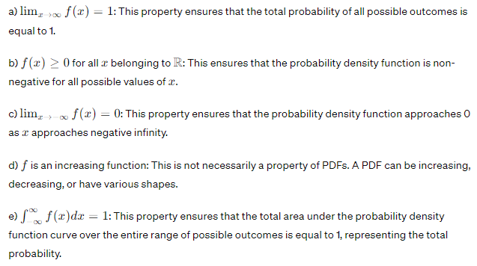

10.All athletes at the Olympic games are tested for performance-enhancing steroid drug use. The imperfect test gives positive results (indicating drug use) for 90% of all steroid-users but also (and incorrectly) for 2% of those who do not use steroids. Suppose that 5% of all registered athletes use steroids. If an athlete is tested negative, what is the probability that he/she uses steroids?

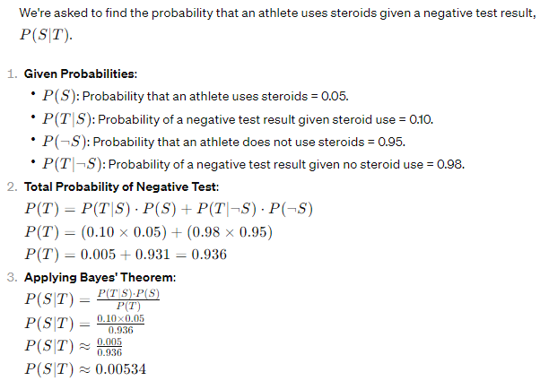a) 0.05

b) 0.025

c) 0.002

d) 0.005

11. The time that a computer processes a task is normally distributed with mean 25(s) and standard deviation 10(s). Compute the probability that 25 randomly chosen tasks have an average processing time (sample mean) of at most 27(s). Round your answer to 3 decimal places.

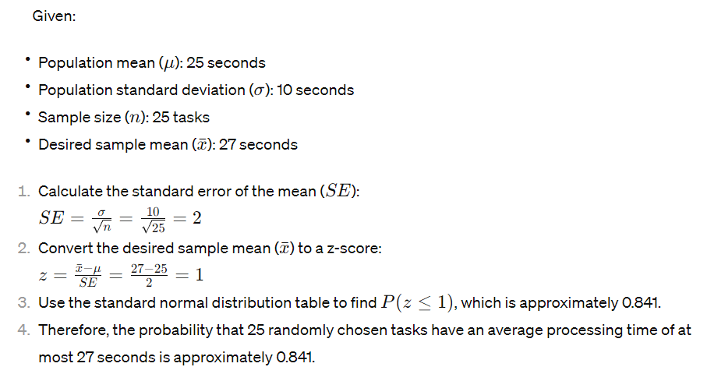

12. A dangerous computer virus attacks a folder consisting of 200 les. Files are affected by the virus independently of one another. Each file is affected with the probability 0.035. What is the probability that more than 7 files are affected by this virus? Round your answer to 3 decimal places.  
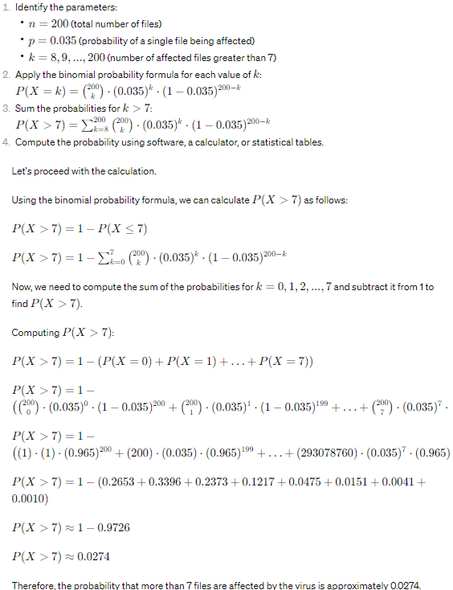

13. A wine taster claims that she can distinguish four vintages of a particular Cabernet. What is the probability that she can do this by merely guessing? (She is confronted with four unlabeled glasses.)

a) 0.348

b) 0.042

c) 0.958

d) 0.583

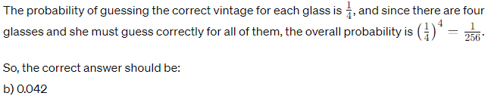

14. Six male and six female dancers, among them Mr and Mrs Smith, perform the Virginia reel. This dance requires that they form a line consisting of six male/female pairs. What is the probability that Mr and Mrs Smith form a pair?

a) 0.542

b) 0.458

c) 0.833

d) 0.167 CORRECT  


15. A doctor assumes that a patient has one of three diseases d1, d2, or d3 Before any test, he assumes an equal probability for each disease. He carries out a test that will be positive with probability 0.7 if the patient has d1, 0.5 if he has disease d2, and 0.6 if he has disease d3. Given that the outcome of the test was positive, what probabilities should the doctor now assign to d3?

a) 0.127

b) 0.333

c) 0.435

d) 0.745

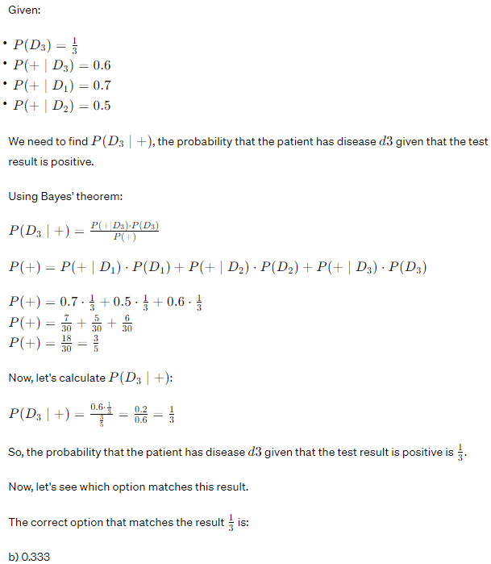

16.The installation time, in hours, for a certain software module has a probability density function (PDF)

f(x) =k(1 - x)^2, f or x belongs to the interval [0, 1], f(x) = 0, otherwise. Compute the value of k such that f is a valid PDF. Find the probability that the installation time will take less than half an hour.

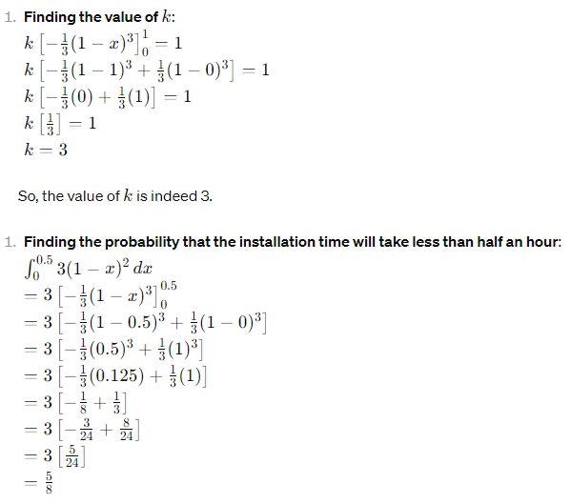

17. The installation time, in minutes, for a certain software module has a probability density function (PDF)

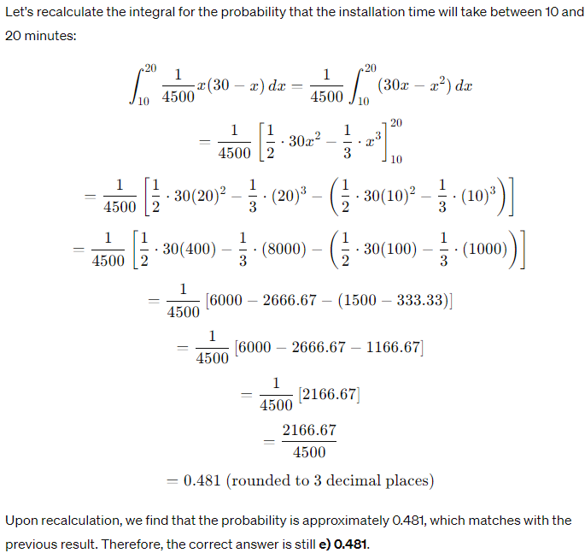 f(x)=k\*x\*(30-x), f or x belongs to the interval [0, 30], f(x) = 0, otherwise. Compute the value of k such that f is a valid PDF. Find the probability that the installation time will take between 10 and 20 minutes.

a) 0.625

b) 0.545

c) 0.855

d) k=1/2500

e) 0.481

f) k=-1/2500

g) k=1/4500

h) k=-1/3500

18. Calculate the following probabilities using a normal approximation (Central Limit Theorem):

P(X > 100), where X ~ B belongs to (250, 0.4)

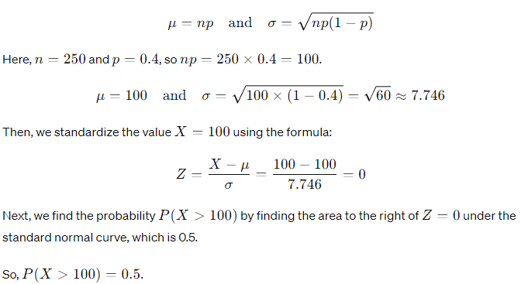a) 0.575

b) 0.495

c) 0.424

d) 0.474

19. A quality control engineer tests the quality of produced computers Suppose that 5% of computers have defects, and defects occur independently of each other. Find the probability that the engineer has to test 5 computers in order to find 2 defective ones. Round your answer to 3 decimal places.

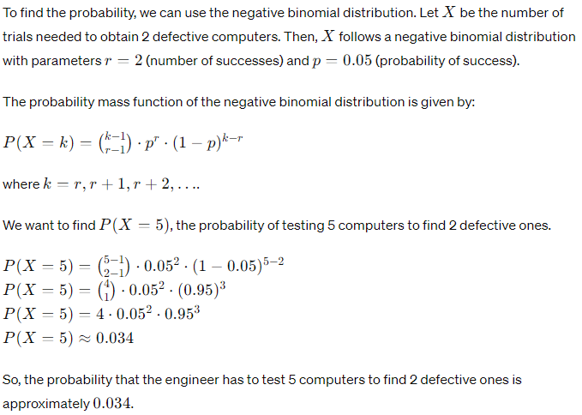

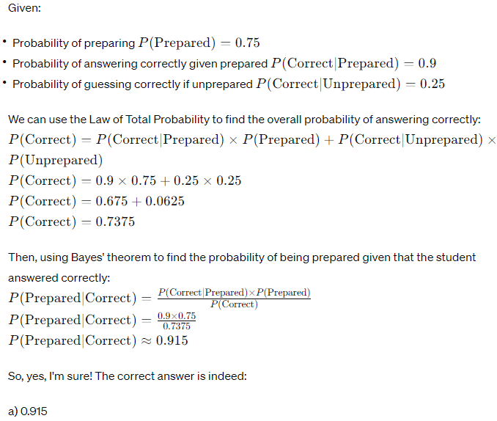20.A problem on a multiple-choice quiz is answered correctly with probability 0.9 if a student is prepared. An unprepared student guesses between 4 possible answers. Seventy five percent of students prepare for the quiz. If Student X gives a correct answer to this problem, what is the chance tha he prepared for the quiz?

a) 0.915

b) 0.854

c) 0.945

d) 0.825

21. Lifetime of a certain hardware in years is a continuous random variable with the probability density function

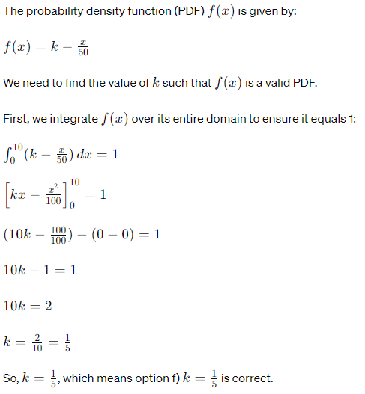 f() =k – x/50, 0<x <10, f(x) = 0, otherwise. Find k such that f is a valid PDF and the probability that a failure will occur within the first 5 years.

a) k=3/4

b) k=1/4

c) p=1/2

d) p=3/4

e) p=2/3

f) k=1/5

g) k=2/3

h) p=1/4

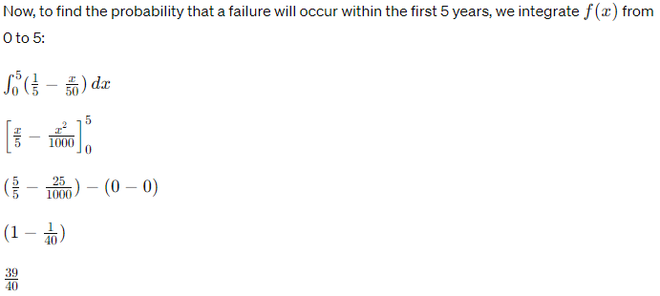

22. An electronic parts factory produces resistors. Statistical analysis of the output suggests that resistances follow an approximately Normal distribution with a mean of 0.62 ohms a standard deviation of 0.2 ohms. A sample of 52 resistors is chosen at random. Compute the probability that the sample mean (average of the resistances of the sample items) takes values between 0.58 ohms and 0.66 ohms. Round your answer to 3 decimal places.

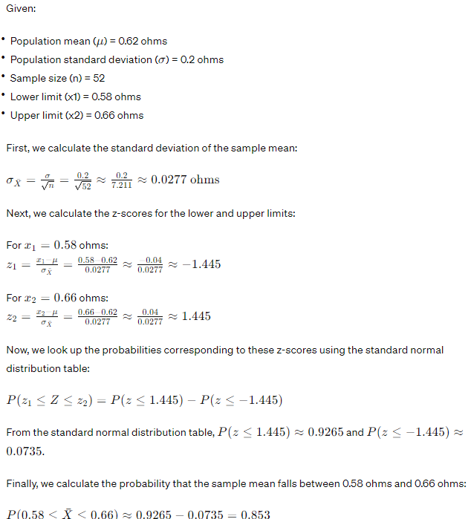

23. Salaries of entry-level computer engineers in a company have a Normal distribution with a mean of $2000 and standard deviation $200. Ten computer engineers are randomly selected and the average of their incomes is computed (the sample mean). Find the probability that this average is less than $2150. Round your answer to 3 decimal places.

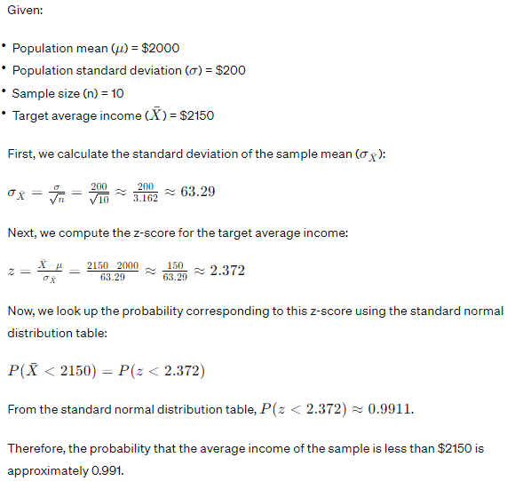

24. Calculate the following probabilities using a normal approximation (Central Limit Theorem):

P(120 <= X <= 150), where X-B belongs to (350,0.4).

a) 0,754

b) 0,861

c) 0,805

d) 0,725