Lab4  
***Exercise1***

**1. Make Reservation:**

**Description:**

The customer accesses the company's website to make a reservation. They fill out a form indicating the start and end dates needed, the preferred vehicle, and the pickup office. After submission, the system checks vehicle availability. If available, it computes the price, registers the reservation, and generates a rental number along with a rental agreement.

**Flow of Events:**

1. Customer accesses the company's website.

2. Customer fills out the reservation form with details.

3. System checks vehicle availability.

If vehicle available:

4. System computes the price.

5. System registers the reservation and generates a rental number.

6. System creates a rental agreement.

7. Customer receives rental number and agreement.

else

8. Customer is informed that the requested vehicle is not available.

9. Customer is offered the option to indicate a new set of preferences or to cancel the reservation.

**2. Check Availability:**

**Description:**

The system checks the availability of a vehicle of a given type at the requested pickup office for a requested rental period. If available, the vehicle is reserved for the requested period.

**Flow of Events:**

1. System receives a request to check vehicle availability.

2. System checks availability of the requested vehicle type at the specified pickup office for the requested rental period.

If vehicle available:

3. System reserves the vehicle for the requested period.

3. Initiate Rental:

**Description:**

A customer arrives at a pickup office and provides a rental number to the rental officer. The system retrieves the corresponding rental agreement. If accepted by the customer, a rental agreement is printed and insurance options are presented. Upon selection, the system records the preference and generates an insurance policy to be signed along with the rental agreement.

**Flow of Events:**

1. Customer arrives at pickup office and provides rental number.

2. Rental officer enters rental number into the system.

3. System retrieves rental agreement.

4. Rental agreement is discussed with the customer.

If accepted:

5. System prints rental agreement.

6. System presents insurance options.

7. Customer selects insurance option.

8. System records preference and generates insurance policy.

9. Customer signs rental agreement and insurance policy.

**4. Process Vehicle Returns:**

**Description:**

The customer returns the rented vehicle to the rental officer, who records mileage and fuel level in the system. The system computes fuel consumption and updates the rental account. Payment is made, and the rental officer registers the payment. In case of damage, an insurance claim form is generated.

**Flow of Events:**

1. Customer returns vehicle to rental officer.

2. Rental officer records mileage and fuel level.

3. System computes fuel consumption and updates rental account.

4. Customer pays rental amount.

5. Rental officer registers payment.

If vehicle damaged:

6. Rental officer registers vehicle damage.

7. System generates insurance claim form.

**5. Provide Management Reports:**

**Description:**

The system can generate various management reports. The manager selects a report type, and the system generates and displays the requested report. Printing is optional.

**Flow of Events:**

1. Manager selects report type.

2. System generates and displays requested report.

If printing requested:

3. System prints report.

*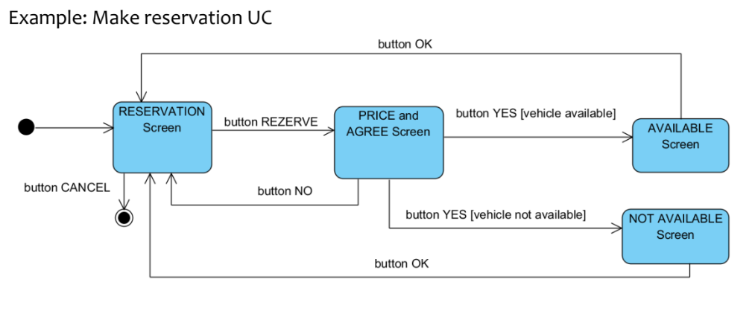****Exercise2***

**RESERVATION SCREEN**

* Start Date (Date picker)
* End Date (Date picker)
* List of Vehicle Types (Dropdown menu or radio buttons)
* List of Pickup Offices (Dropdown menu)
* **Buttons**: Submit Reservation, Cancel Reservation

**PRICE AND AGREE SCREEN**

* Rental Price (Display field)
* Rental Number (Display field)
* Rental Agreement (Text box or document viewer)
* **Buttons**: Accept Agreement and Proceed, Cancel Reservation

**CHECK AVAILABILITY SCREEN**

* Vehicle Type (Dropdown menu or radio buttons)
* Pickup Office (Dropdown menu)
* Rental Period (Start Date and End Date pickers)
* **Buttons**: Check Availability, Cancel

**INITIATE RENTAL SCREEN**

* Rental Number Input (Text field)
* Buttons: Submit, Cancel

**PROCESS VEHICLE RETURNS SCREEN**

* Mileage (Input field)
* Fuel Level (Input field)
* **Buttons**: Calculate Fuel Consumption, Register Payment, Damage Report (if applicable)

**PROVIDE MANAGEMENT REPORTS SCREEN**

* Report Type (Dropdown menu)
* Buttons: Generate Report, Print Report (optional)

**RESERVATION SUCCESSFUL/FAILED SCREEN**

* **Button:** Home page

***FLOW OF SCREENS***

1. **Reservation Process:**
   * Reservation Screen
     + If vehicle available:
       - Price and Agreement Screen
         * If customer accepts:

Reservation Confirmation Screen

1. **Check Availability Process:**
   * Check Availability Screen
     + If vehicle available:
       - Availability Confirmation Screen
     + If vehicle not available:
       - No Availability Screen
2. **Initiate Rental Process:**
   * Initiate Rental Screen
     + If rental number valid:
       - Rental Agreement Screen
         * If customer accepts:

Insurance Options Screen

If insurance selected:

Insurance Policy Screen

1. **Process Vehicle Returns Process:**
   * Process Vehicle Returns Screen
     + If payment required:
       - Payment Screen
         * If vehicle damaged:

Damage Report Screen

* + - If no payment required:
      * Return Confirmation Screen

1. **Provide Management Reports Process:**
   * Management Reports Screen
     + If report requested:
       - Report Display Screen
         * If printing requested:

Print Report Screen

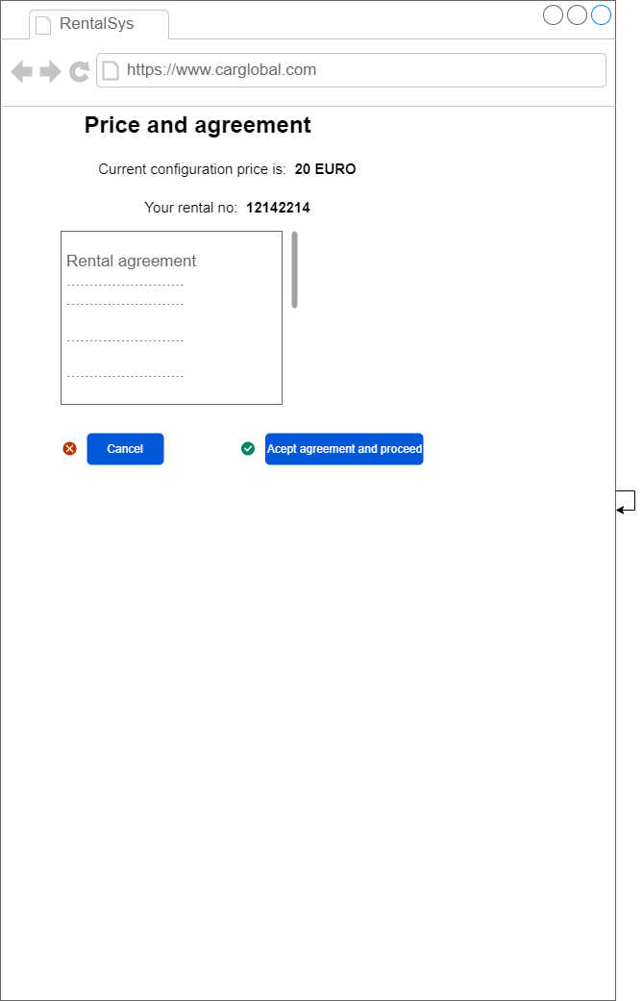***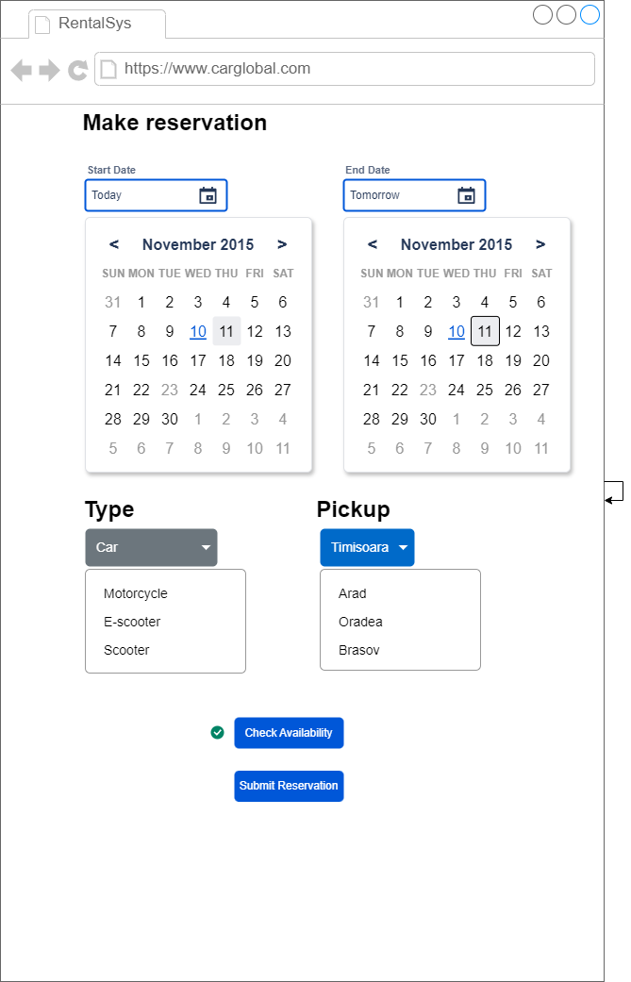Exercise3***



