**Student :** Popa Ioan-Ciprian **Subgroup :** 5

**Homework**

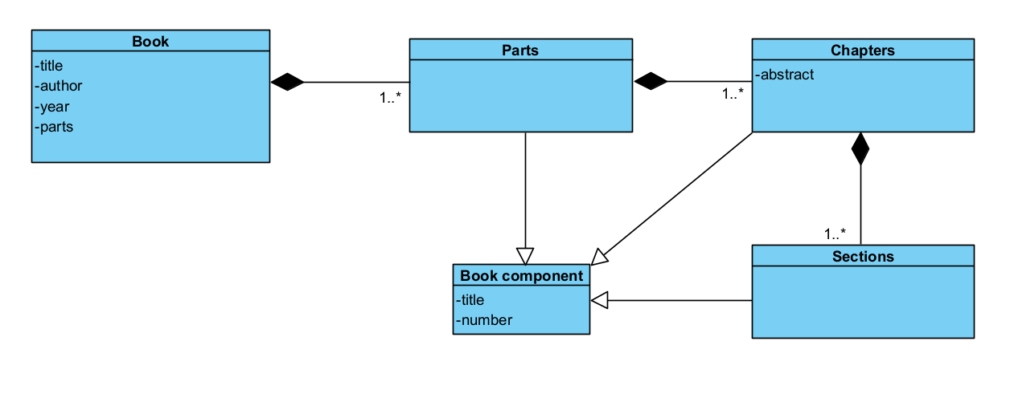**Lab 6  
1.**

Code:  
public class Parts extends BookComponent{

Private list <Chapters> chapters = newArrayList<>();

Private Book book;

}

public Chapters extends BookComponent{  
private abstract;

Private List<Sections> sections = newArrayList<>();

Private Parts parts;  
}

Public Sections extends BookComponent{

Private Chapter chapter;  
}  
  
  
  
  
  
  
  
  
  
  
  
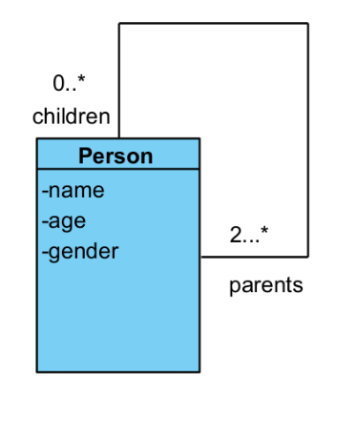2.

class Person {

private String name;

private int age;

private String gender;

private ArrayList<Person> parents;

public Person(String name, int age, String gender) {

this.name = name;

this.age = age;

this.gender = gender;

this.parents = new ArrayList<>();

}

public String getName() {

return name;

}

public int getAge() {

return age;

}

public String getGender() {

return gender;

}

public void addParent(Person parent) {

parents.add(parent);

}

public ArrayList<Person> getParents() {

return parents;

}

}

class Parent extends Person {

private ArrayList<Person> children;

public Parent(String name, int age, String gender) {

super(name, age, gender);

children = new ArrayList<>();

}

public void addChild(Person child) {

children.add(child);

child.addParent(this);

}

public ArrayList<Person> getChildren() {

return children;

}

}

class Child extends Person {

public Child(String name, int age, String gender) {

super(name, age, gender);

}

}

public class FamilyTree {

public static void main(String[] args) {

Parent parent1 = new Parent("Popa", 21, "Male");

Parent parent2 = new Parent("Roxana", 22, "Female");

Child child1 = new Child("Georgiana", 19, "Female");

Child child2 = new Child("Arthur", 8, "Male");

parent1.addChild(child1);

parent2.addChild(child1);

parent2.addChild(child2);

System.out.println("Parents of " + child1.getName() + ":");

for (Person parent : child1.getParents()) {

System.out.println(parent.getName())

}

}

}