**Student :** Popa Ioan-Ciprian **Subgroup :** 5

**Homework**

**Lab 7**

***Exercise 1***

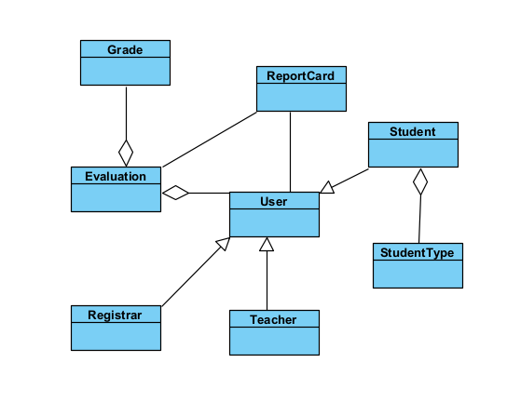

***Exercise 2***

