**Student :** Popa Ioan-Ciprian **Subgroup :** 5

**Homework**

**Lab 2**

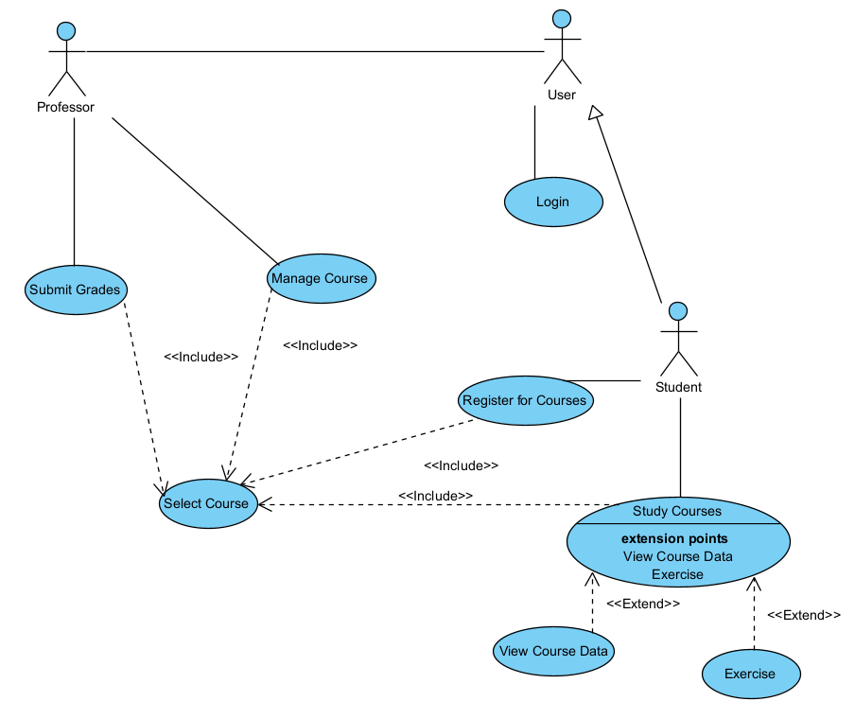***Exercise 1***

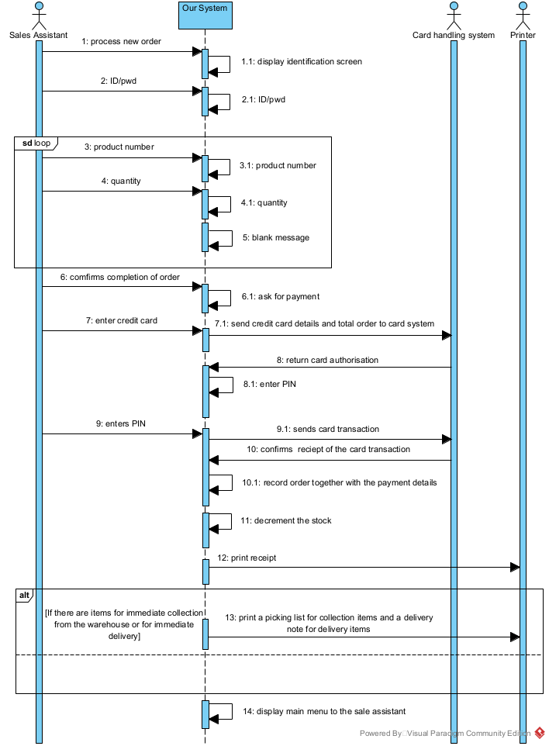***Exercise 2***

***Exercise 3  
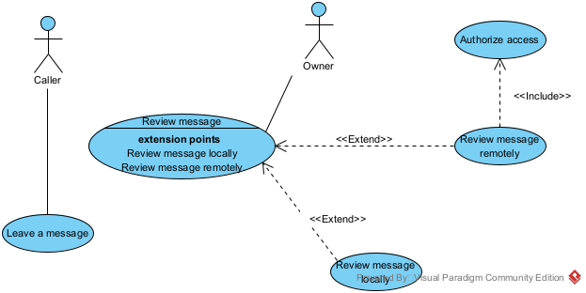  
Exercise 4***

**Use Case: _-==Borrow Copy of Book==-_**

**Description:**

This use case allows a library member to borrow a copy of a book from the library. The member needs to be registered in the library system and must be logged in. The member searches for the desired book either by title, author, or category. Once the book is found, the member selects the desired copy to borrow. The system checks if the member has not reached the maximum limit of borrowed books. If the conditions are met, the book is borrowed, and the member receives a confirmation message.

**Actors:**

-Library Member

**Preconditions:**

-The member must be logged in.

-The book must be available for borrowing.

-The member must not have reached the maximum limit of borrowed books.

**Flow of Events:**

1. The member logs in to the library system.

2. The member searches for the desired book.

3. The member selects a copy of the book to borrow.

4. The system checks if the member is eligible to borrow the book.

5. If eligible, the book is borrowed, and the system updates the member's borrowing record.

6. The system sends a confirmation message to the member.

**Alternate Flows:**

-If the book is not available for borrowing, the system displays a message indicating the unavailability of the book.

-If the member has reached the maximum limit of borrowed books, the system displays a message indicating the limit has been reached.

**_-==Use Case: Extend Loan==-_**

**Description:**

This use case allows a library member to extend the loan period for a borrowed book. The member needs to be registered in the library system and must be logged in. The member selects the book for which they want to extend the loan period. The system checks if the book is eligible for loan extension. If eligible, the loan period is extended, and the member receives a confirmation message.

**Actors:**

-Library Member

**Preconditions:**

-The member must be logged in.

-The book must be eligible for loan extension.

**Flow of Events:**

1. The member logs in to the library system.

2. The member selects the book for which they want to extend the loan period.

3. The system checks if the book is eligible for loan extension.

4. If eligible, the loan period is extended, and the system updates the member's borrowing record.

5. The system sends a confirmation message to the member.

**Alternate Flows:**

-If the book is not eligible for loan extension, the system displays a message indicating the ineligibility.

-If the member has already reached the maximum number of loan extensions, the system displays a message indicating the limit has been reached.

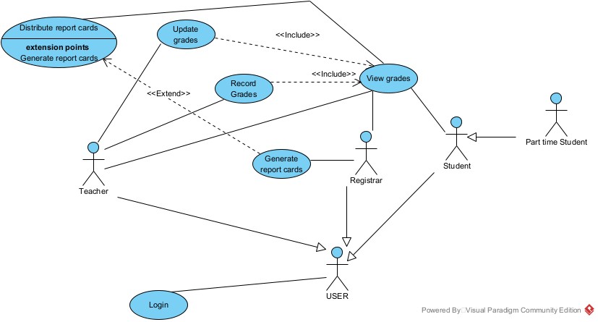

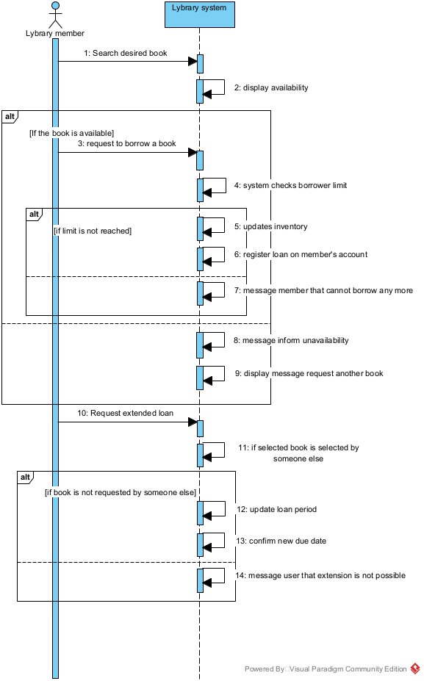***Exercise 5***

***Use Case: Borrow Copy of Book***

**Description:**

This use case allows a library member to borrow a copy of a book from the library. The member needs to be registered in the library system and must be logged in. The member searches for the desired book either by title, author, or category. Once the book is found, the member selects the desired copy to borrow. The system checks if the member has not reached the maximum limit of borrowed books. If the conditions are met, the book is borrowed, and the member receives a confirmation message.

**Actors:**

* Library Member

**Preconditions:**

* The member must be logged in.
* The book must be available for borrowing.
* The member must not have reached the maximum limit of borrowed books.

**Flow of Events:**

1. The member logs in to the library system.
2. The member searches for the desired book.
3. The member selects a copy of the book to borrow.
4. The system checks if the member is eligible to borrow the book.
5. If eligible, the book is borrowed, and the system updates the member's borrowing record.
6. The system sends a confirmation message to the member.

**Alternate Flows:**

If the book is not available for borrowing, the system displays a message indicating the unavailability of the book.

If the member has reached the maximum limit of borrowed books, the system displays a message indicating the limit has been reached.

***Use Case: Extend Loan***

**Description:**

This use case allows a library member to extend the loan period for a borrowed book. The member needs to be registered in the library system and must be logged in. The member selects the book for which they want to extend the loan period. The system checks if the book is eligible for loan extension. If eligible, the loan period is extended, and the member receives a confirmation message.

**Actors:**

* Library Member

**Preconditions:**

* The member must be logged in.
* The book must be eligible for loan extension.

**Flow of Events:**

1. The member logs in to the library system.
2. The member selects the book for which they want to extend the loan period.
3. The system checks if the book is eligible for loan extension.
4. If eligible, the loan period is extended, and the system updates the member's borrowing record.
5. The system sends a confirmation message to the member.

**Alternate Flows:**

* If the book is not eligible for loan extension, the system displays a message indicating the ineligibility.
* If the member has already reached the maximum number of loan extensions, the system displays a message indicating the limit has been reached.

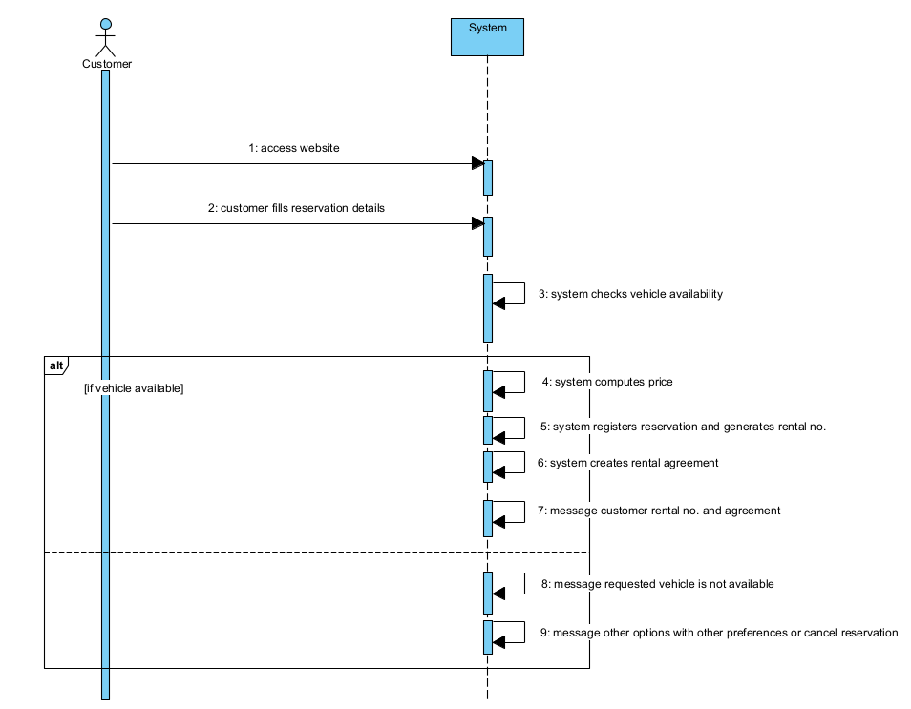***Exercise 6  
Make reservation***

***Check availability***

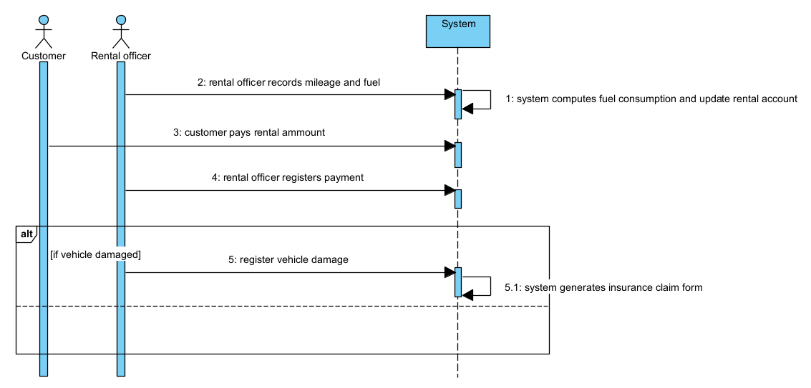

***Initiate rental***

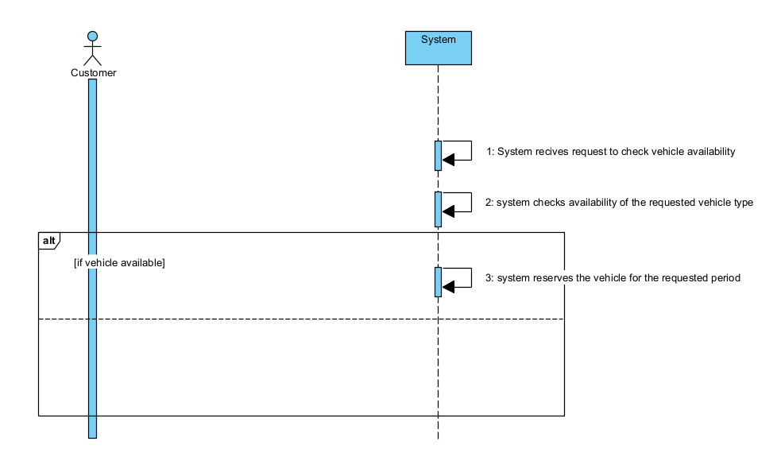

***Process Vehicle Returns  
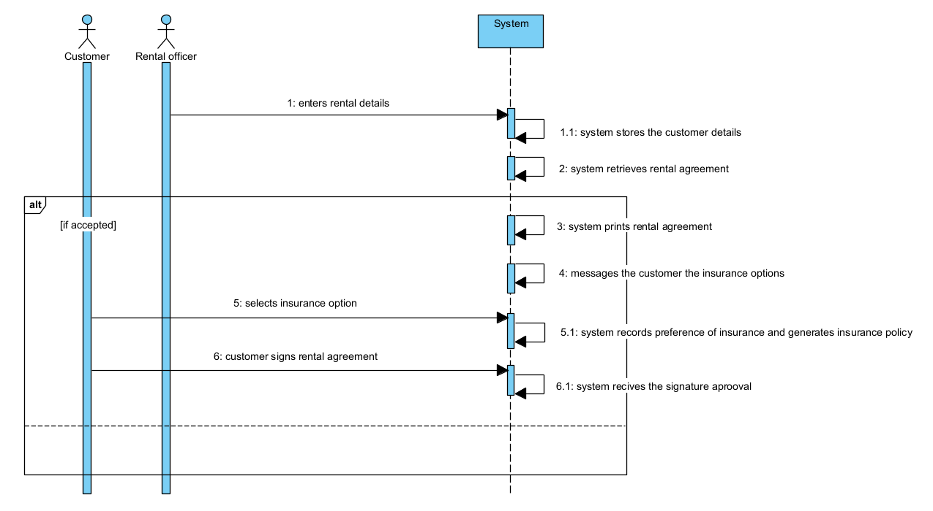***

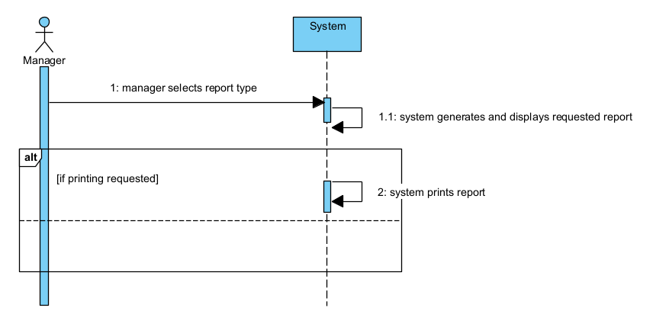***Provide Management Reports***

**1. Make Reservation:**

**Description:**

The customer accesses the company's website to make a reservation. They fill out a form indicating the start and end dates needed, the preferred vehicle, and the pickup office. After submission, the system checks vehicle availability. If available, it computes the price, registers the reservation, and generates a rental number along with a rental agreement.

**Flow of Events:**

1. Customer accesses the company's website.

2. Customer fills out the reservation form with details.

3. System checks vehicle availability.

If vehicle available:

4. System computes the price.

5. System registers the reservation and generates a rental number.

6. System creates a rental agreement.

7. Customer receives rental number and agreement.

else

8. Customer is informed that the requested vehicle is not available.

9. Customer is offered the option to indicate a new set of preferences or to cancel the reservation.

**2. Check Availability:**

**Description:**

The system checks the availability of a vehicle of a given type at the requested pickup office for a requested rental period. If available, the vehicle is reserved for the requested period.

**Flow of Events:**

1. System receives a request to check vehicle availability.

2. System checks availability of the requested vehicle type at the specified pickup office for the requested rental period.

If vehicle available:

3. System reserves the vehicle for the requested period.

3. Initiate Rental:

**Description:**

A customer arrives at a pickup office and provides a rental number to the rental officer. The system retrieves the corresponding rental agreement. If accepted by the customer, a rental agreement is printed and insurance options are presented. Upon selection, the system records the preference and generates an insurance policy to be signed along with the rental agreement.

**Flow of Events:**

1. Customer arrives at pickup office and provides rental number.

2. Rental officer enters rental number into the system.

3. System retrieves rental agreement.

4. Rental agreement is discussed with the customer.

If accepted:

5. System prints rental agreement.

6. System presents insurance options.

7. Customer selects insurance option.

8. System records preference and generates insurance policy.

9. Customer signs rental agreement and insurance policy.

**4. Process Vehicle Returns:**

**Description:**

The customer returns the rented vehicle to the rental officer, who records mileage and fuel level in the system. The system computes fuel consumption and updates the rental account. Payment is made, and the rental officer registers the payment. In case of damage, an insurance claim form is generated.

**Flow of Events:**

1. Customer returns vehicle to rental officer.

2. Rental officer records mileage and fuel level.

3. System computes fuel consumption and updates rental account.

4. Customer pays rental amount.

5. Rental officer registers payment.

If vehicle damaged:

6. Rental officer registers vehicle damage.

7. System generates insurance claim form.

**5. Provide Management Reports:**

**Description:**

The system can generate various management reports. The manager selects a report type, and the system generates and displays the requested report. Printing is optional.

**Flow of Events:**

1. Manager selects report type.

2. System generates and displays requested report.

If printing requested:

3. System prints report.