**Student :** Popa Ioan-Ciprian **Subgroup :** 5

**Homework**

**Lab 3**

***Exercise 1***-diagram1 – make reservation

-diagram2 – check availability

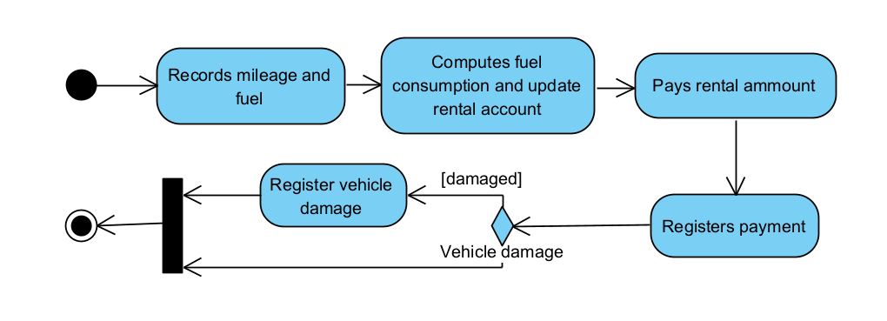

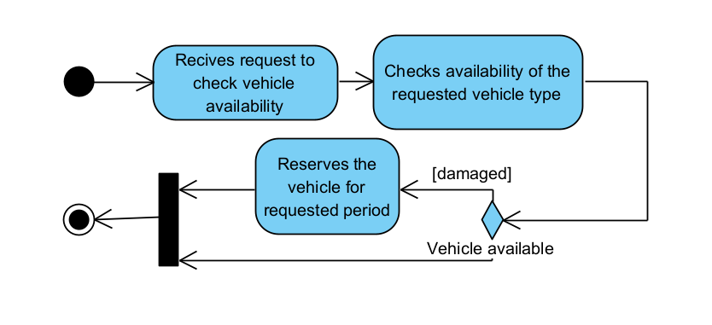-diagram3 – initiate rental

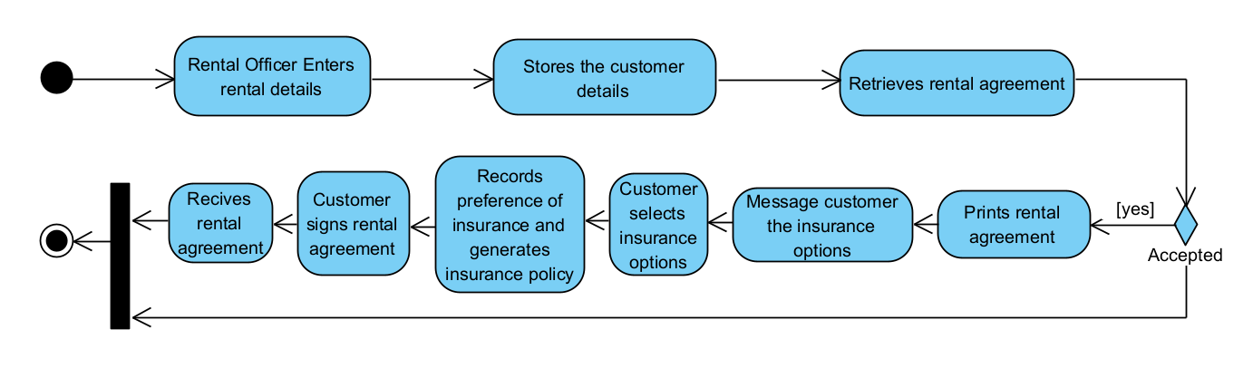-diagram4 – process vehicle returns

-diagram5 – provide management reports

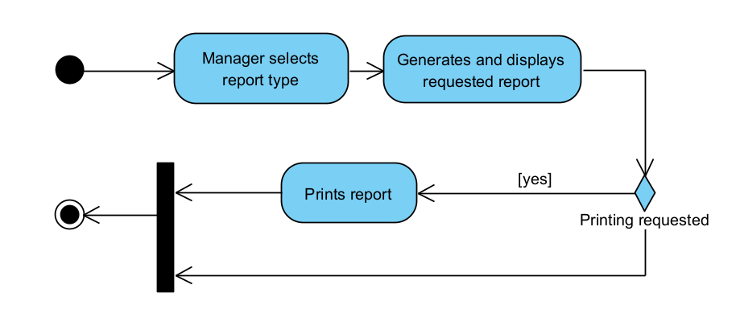

***Exercise 3***

