Agentic Systems with Google ADK

A practical guide to designing, orchestrating, and deploying multi-agent systems using Google's Agent Development Kit.

1. Introduction
This project explores how to build agentic AI systems using Google's Agent Development Kit (ADK) 1.x. Rather than building a single monolithic agent, the goal is to decompose financial analysis tasks into specialised components, agents, tools, and pipeline, that can be composed, swapped, and scaled independently.
The work covers the full spectrum of ADK capabilities: from single agents calling tools, through multi-agent orchestration patterns, to network-distributed agents communicating over the A2A protocol, with tools served over MCP and telemetry captured via OpenTelemetry.
All experiments are implemented as Jupyter notebooks backed by a shared set of 11 financial calculator tools. The models used range from local open-weight models (Gemma 4, Qwen 3.5) running on Ollama, to Gemini Flash models via the free Google AI Studio API.

2. Security and Versioning
ADK 1.31.1 (the version used in this project) includes three critical security patches that affect any production deployment:
- RCE vulnerability via nested YAML configurations. Earlier versions allowed arbitrary code execution through crafted YAML agent configurations. This was patched in 1.31.1.
- Credential leakage in Agent Registry. Fixed in 1.30.0. The Agent Registry could expose credentials in certain configurations.
- LiteLLM supply chain incident. Versions 1.82.7 and 1.82.8 of LiteLLM were compromised in a supply chain attack in March 2026. The project pins to >=1.83.0 with explicit exclusions.
The practical takeaway: always pin your ADK and LiteLLM versions explicitly, and check changelogs before upgrading. Agent frameworks are young software with a fast release cadence, and security patches arrive frequently.

3. Agent Primitives: The Building Blocks
My perspective on ADK is that any agentic system can be built from four primitives, composed together like building blocks, based on what ADK offers:
- LlmAgent: The fundamental unit. A single agent backed by an LLM, equipped with tools and instructions. It receives a query, reasons about it, decides which tools to call, and produces a response.
- SequentialAgent: Runs sub-agents one after another in a fixed order. The output of one agent feeds into the next via session state keys.
- ParallelAgent: Runs sub-agents concurrently. Each writes its result to a separate state key, fanning out.
- LoopAgent: Runs sub-agents in a repeating cycle until a condition is met or a maximum iteration count is reached.
The benefits come from composition. A SequentialAgent can contain a ParallelAgent as one of its steps. A LoopAgent's sub-agents can themselves be SequentialAgents with tools. These nest arbitrarily, producing complex execution graphs from simple, predictable components.
The small-to-big model pattern (used in the industry by companies like Anthropic) extends this by using different LLMs at different levels. Lightweight models handle triage and simple calculations. When a task requires deeper reasoning, the lightweight agent delegates to a more capable model via AgentTool, keeping cost and latency low for routine work.
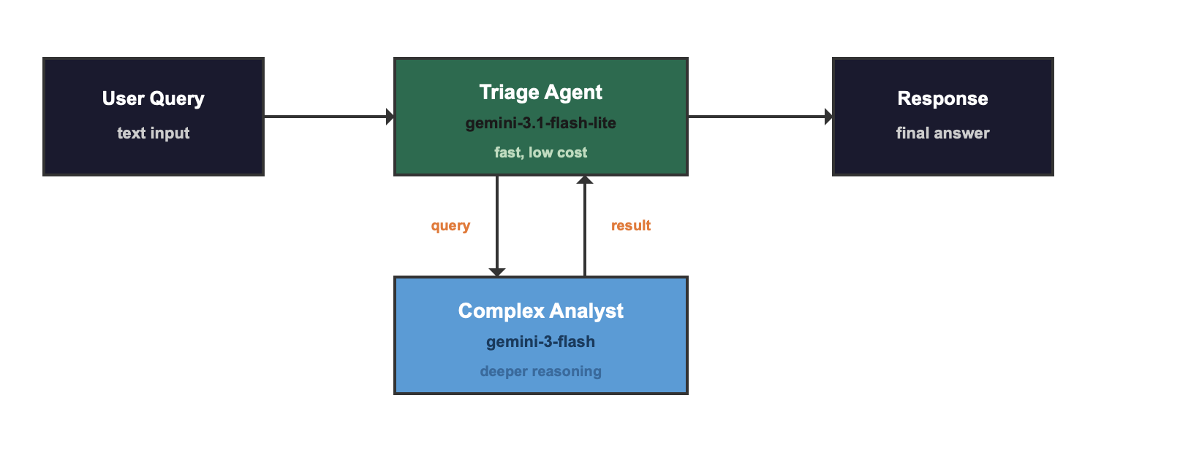

4. Agent Patterns in Detail

Single Agent (LlmAgent)
The simplest pattern formed by one agent, one set of tools, one instruction. The LLM decides which tools to call based on the query. Use this when the task is straightforward and a single agent can handle all the reasoning.

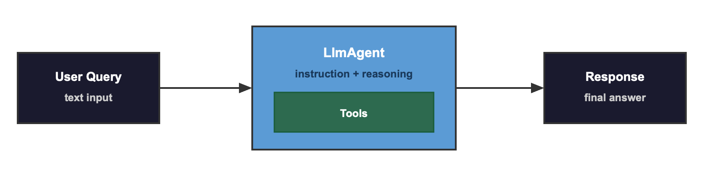

Sequential Pipeline
A fixed sequence of agents, each performing one step and writing its result to session state for the next agent to read. Data flows through output_key on each agent. The next agent's instruction contains {state_key} placeholders that ADK replaces with actual values at runtime.
When to use: multi-step pipelines where each step depends on the previous one. For example: mortgage calculation followed by risk assessment followed by summary.
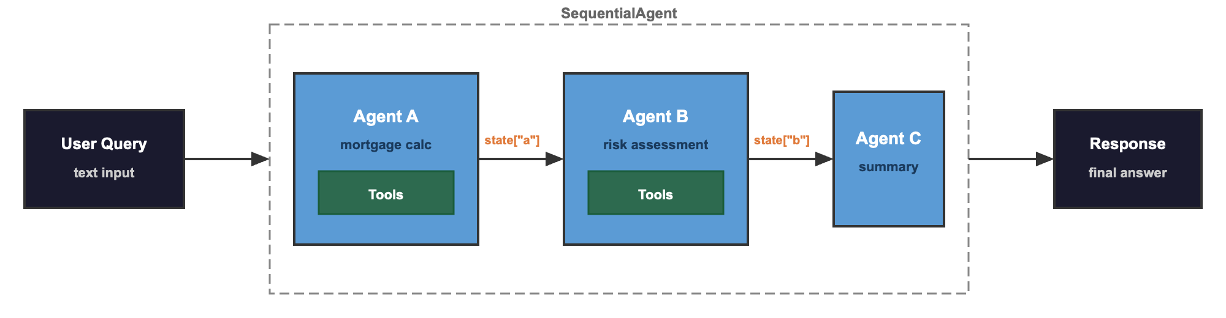

Parallel Fan-Out
Independent processes run concurrently, then a downstream agent synthesises the results. Implemented by wrapping a ParallelAgent inside a SequentialAgent.
When to use: independent processes that do not depend on each other. Loan eligibility check and investment projection can run at the same time.

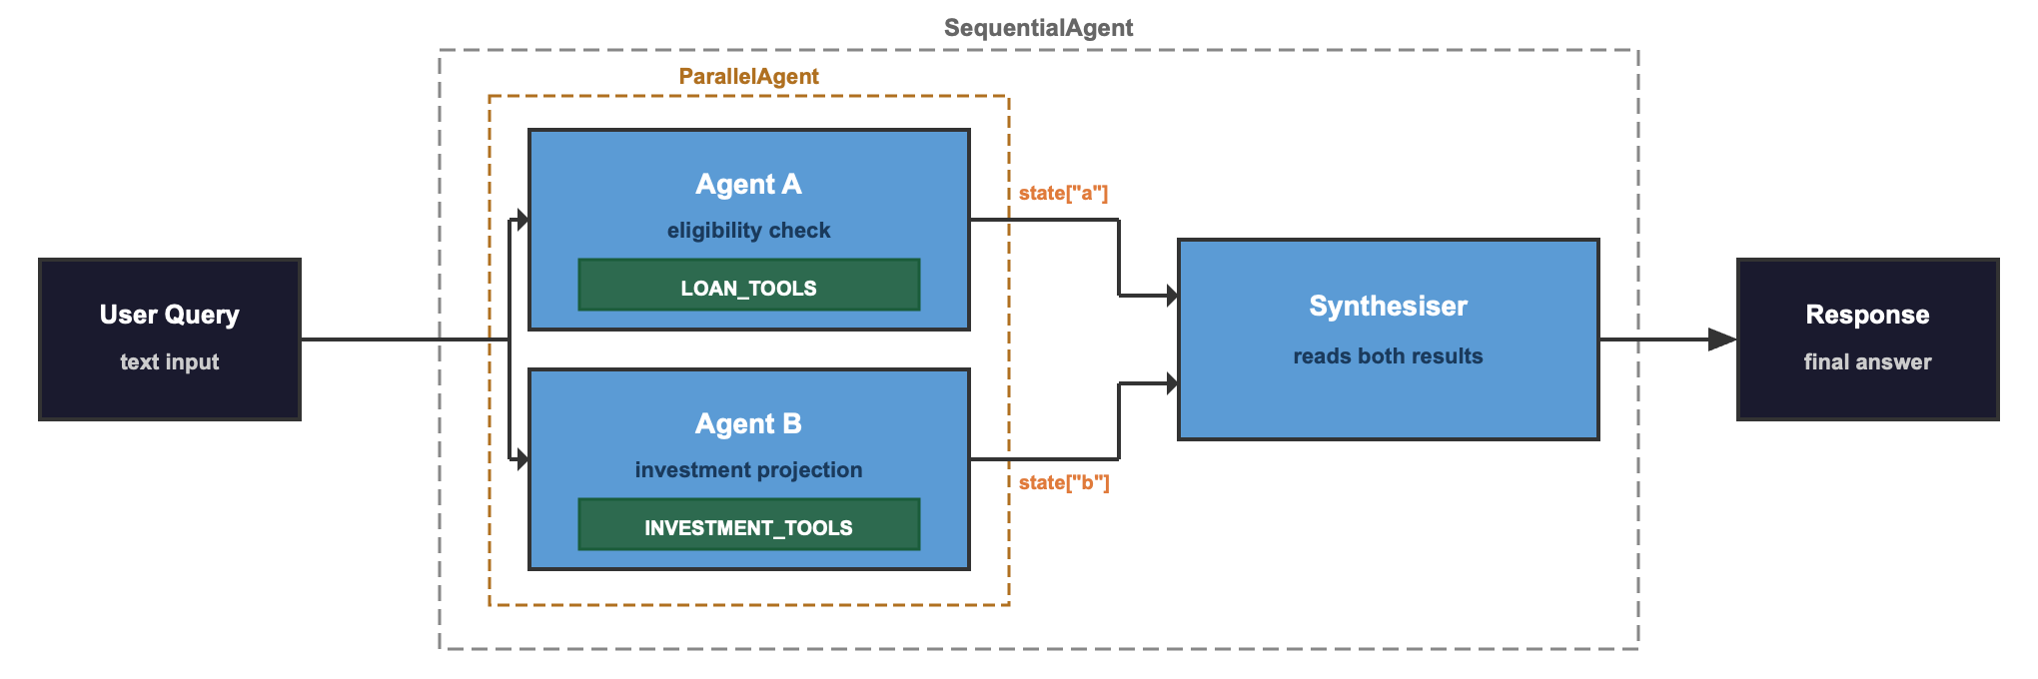

Iterative Refinement (Loop)
A generator-critic loop where one agent proposes and another evaluates, repeating until the critic approves or the maximum iteration count is reached. The proposer reads {feedback} from state (empty on first iteration) and adjusts accordingly.
When to use: tasks where quality improves with iteration. Loan structuring where the first proposal might not be appropriate.

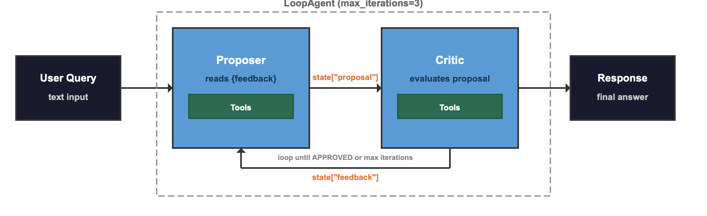

5. Agent Delegation

sub_agents + transfer_to_agent (Full Handover)
The parent agent has specialist agents as sub_agents. ADK automatically provides a built-in transfer_to_agent tool. The parent's LLM decides which specialist to delegate to, and control transfers completely. The specialist responds directly to the user.
Use this for routing and dispatch, where the parent's only job is to pick the right specialist.

AgentTool (Invoke and Return)
The parent wraps another agent as a callable tool using AgentTool(agent=...). The parent calls it, receives the result back, and can then reason over the result, call more agent-tools, or synthesise a final answer. The parent stays in control throughout.
Use this for hierarchical decomposition, where the parent needs to combine results from multiple agents.

Aspect | sub_agents + transfer_to_agent | AgentTool
Control flow | Full handover | Invoke and return
Parent sees result | No | Yes
Multi-step reasoning | Specialist handles everything | Parent can chain calls
Use case | Routing / dispatch | Hierarchical decomposition

6. Multi-Level Orchestration
The most powerful ADK pattern combines multiple primitives into a hierarchical graph. AgentTool at the top level (orchestrator keeps control), sub_agents at lower levels (department head routes internally), and leaf agents with specific tools.
This architecture supports mixed model tiers: lightweight models handle the leaf-level tool calls, while the orchestrator and risk assessment use the more capable model. The bulk of the API calls go to the cheaper model, with frontier reasoning applied only where it matters. Data flows in two ways: session state keys for horizontal passing between sibling agents, and AgentTool return values for vertical passing from child departments back to the parent orchestrator.
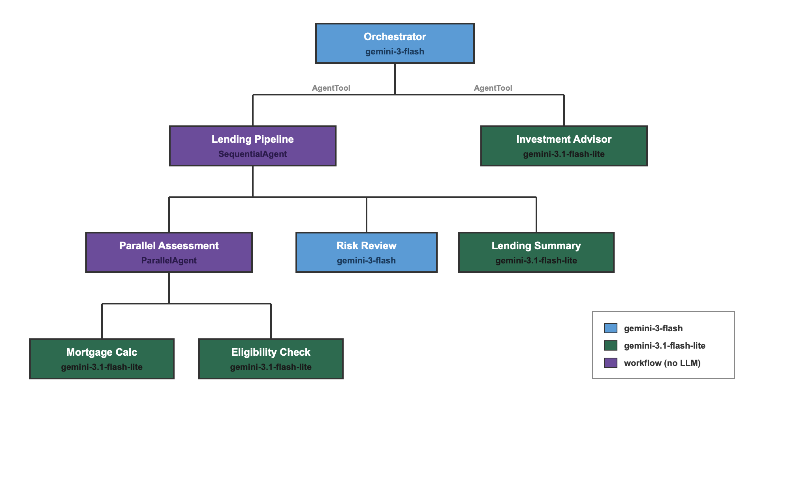

7. Cross-Framework Interoperability
ADK agents are not limited to ADK orchestrators. The project demonstrates a LangGraph orchestrator calling ADK agents over the A2A protocol. The LangGraph graph has its own state management (MemorySaver checkpointer with thread IDs), its own routing logic, and its own synthesis step. The ADK agents have no knowledge that the orchestrator is LangGraph rather than ADK.
LangGraph's approach to multi-turn conversation differs from ADK's. ADK uses persistent sessions with event history managed internally. LangGraph uses a checkpointer that persists the full state dict between invocations, keyed by thread ID. Both achieve the same result through different mechanisms.
Aspect | ADK Sessions | LangGraph Checkpointer
Persistence key | session_id | thread_id
History storage | Event list in SessionService | State dict in MemorySaver
Managed by | ADK Runner | LangGraph graph.compile()
Multi-turn | Same session_id across run_async calls | Same thread_id in config

8. A2A Protocol
A2A (Agent-to-Agent) is Google's open protocol for inter-agent communication over HTTP. It differs from ADK's in-process agent composition:
In-process: Agents share memory, session state, and the Python runtime. Communication is direct function calls. Fast and single-process.
A2A: Agents run as independent HTTP services. Communication is JSON-RPC over HTTP. Each agent has an agent card (JSON metadata) served at a well-known URL.
To expose an ADK agent via A2A, wrap it with to_a2a(agent, port=N) and serve with uvicorn. To consume, use RemoteA2aAgent(name=..., agent_card=url). A2A is the right choice when agents need to run as separate services, when you want formal API contracts, or when you need to scale agents independently.

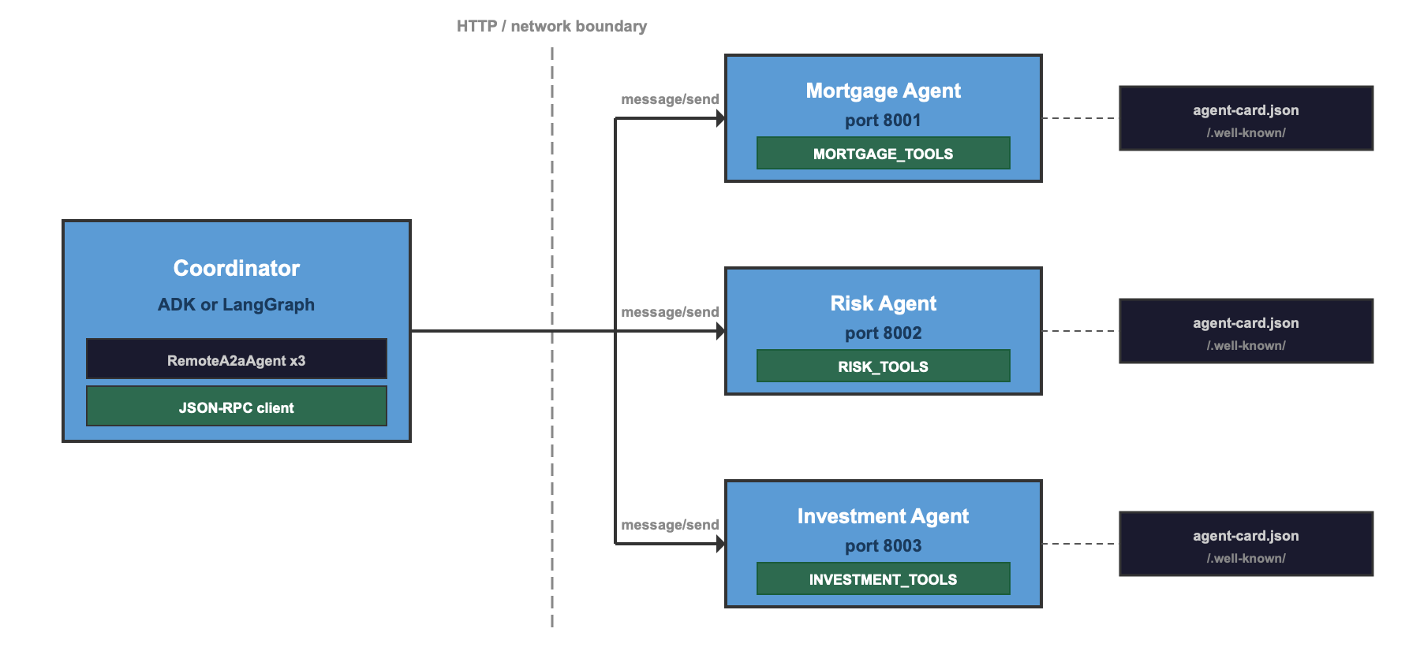

9. MCP (Model Context Protocol)
MCP does for tools what A2A does for agents: serves them over a network protocol. With MCP, tools run on a separate server, and the agent discovers them dynamically via the MCP protocol's list_tools method. The agent calls tools via JSON-RPC, and the server executes them and returns results.
ADK's McpToolset handles the integration transparently. You provide connection parameters (SSE URL for network servers), and the toolset queries the MCP server, converts tool schemas to ADK-compatible format, and proxies all tool calls. From the agent's perspective, MCP tools are indistinguishable from local tools.

Aspect | Local Tools | MCP Tools
Location | Same process | Separate server (HTTP/SSE)
Discovery | Explicit import | Automatic via list_tools
Agent code | tools = [func1, func2] | tools = [McpToolset(...)]
Performance | Direct function call | Network round-trip
Use case | Single-process agents | Shared tool servers

10. Observability: Logging and Tracing
Production agent systems need observability at two levels:
Python logging captures application-level events: which agent is running, what tool was called, what parameters were passed. This is the developer's view of what happened.
OpenTelemetry tracing captures framework-level telemetry: span durations, parent-child relationships, model request metadata. ADK emits OTel spans automatically for agent runs, LLM calls, and tool executions.
The project captures both to a local SQLite database using a custom SpanExporter for OTel spans and a custom logging Handler for Python log records. Both include OTel trace IDs, enabling correlation: log entries can be joined with trace spans to answer questions like 'what log messages were emitted during this specific tool call?'
For production deployments, the same OTel spans can be exported to Google Cloud Trace, Jaeger, MLflow, or any OTLP-compatible backend by swapping the exporter. The instrumentation code stays the same.

EXTRA:

Models Tested
Model | Size | Runtime | Tool Calling | Speed | Notes
Gemma 4 E4B | 9.6GB | Ollama | Works (openai/ provider) | ~15s/call | Best local on 16GB
Qwen 3.5 9B | 9.3GB | Ollama | Excellent | ~90s/call | Best quality, slow
Gemini 3 Flash | Cloud | Native ADK | Excellent | ~2s/call | Used for all notebooks
Gemini 3.1 Flash Lite | Cloud | Native ADK | Good | ~1s/call | Used for leaf agents

For development speed and reliability, Gemini Flash via the free API tier (1,500 requests/day) proved to be the most practical choice. Local models remain valuable for offline work and cost-free experimentation, but the integration layer (LiteLLM + Ollama + ADK) requires more maturity before it matches the native Gemini experience, together with a powerful device to match the speed of any API-based LLM instance.

Project Structure
Path | Purpose
config.py | Shared model and runner configuration
tools/ | 11 financial tools (mortgage, risk, loan, investment)
agents/ | A2A agent servers (mortgage, risk, investment)
mcp_servers/ | MCP tool server
notebooks/1_tool_testing.ipynb | Hardcoded tool calls, no agents
notebooks/2_agent_types.ipynb | All ADK agent primitives
notebooks/3_agent_delegation.ipynb | sub_agents, AgentTool, small-to-big
notebooks/4_a2a_adk_orchestrator.ipynb | A2A with ADK coordinator
notebooks/5_a2a_langgraph_orchestrator.ipynb | A2A with LangGraph coordinator
notebooks/6_agents_adk_interrupt.ipynb | Multi-turn conversation (ADK)
notebooks/7_agents_langgraph_interrupt.ipynb | Multi-turn conversation (LangGraph)
notebooks/8_mcp.ipynb | MCP network-hosted tools
notebooks/9_telemetry.ipynb | OpenTelemetry + SQLite logging

