Project Summary

Test Account: any user from <https://dummyjson.com/users>

User with role = admin or moderator will be an officer, otherwise a user.

Admin: emilys(emilyspass)

User: averyp(averyppass), evelyns(evelynspass)

1. Login page

Call api at <https://dummyjson.com/> to perform login

Redirect to user detail page if role = user, redirect to home if is officer

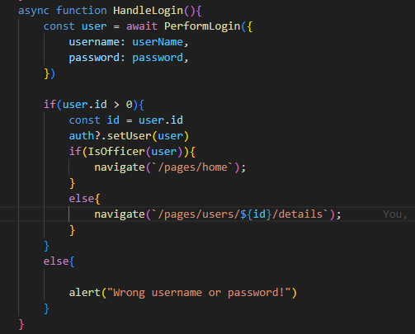

Logout function to change between user  
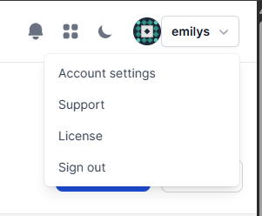

Side menu change depend on role, only officer can see preview and results page  
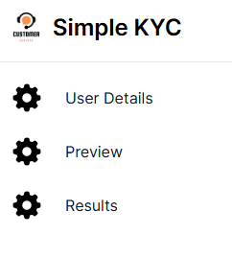

Create AuthenticatedContext to handle user session in cookie

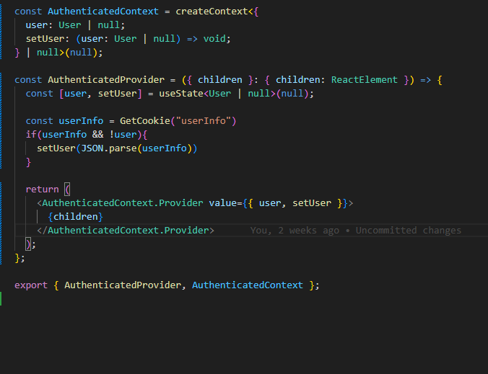

1. User Profile Page

Officer is read-only  
User can edit their info by using edit button

User can move to kyc page using kyc button

Initial value from <https://dummyjson.com/> using Map function

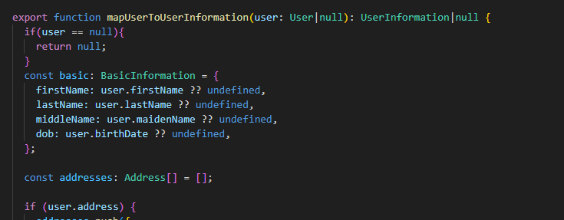

**Basic Information:**

Dob must be in valid format dd/mm/yyyy

Age is calculated from Dob

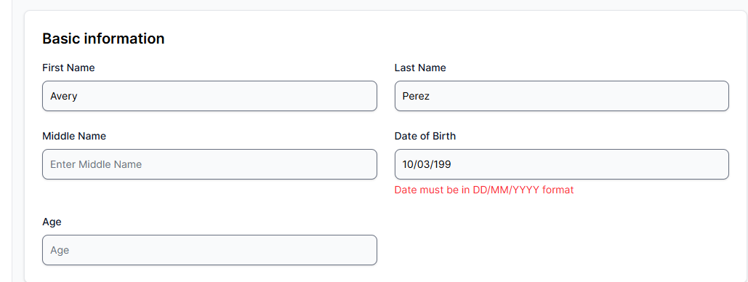

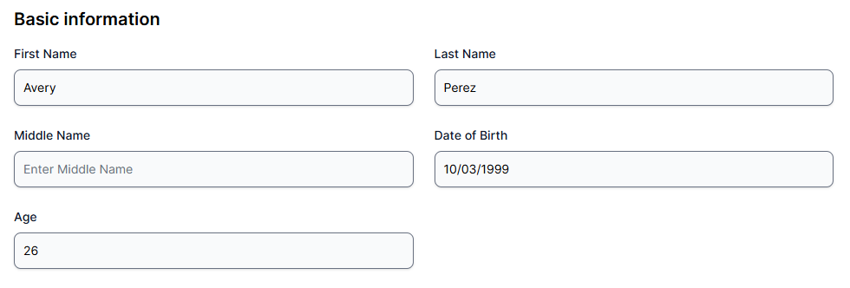

**Addresses, Emails, Identification Documents,** **Occupation and Employment Information:**

Have validation   
Press Add button to add more   
Press Remove button to remove

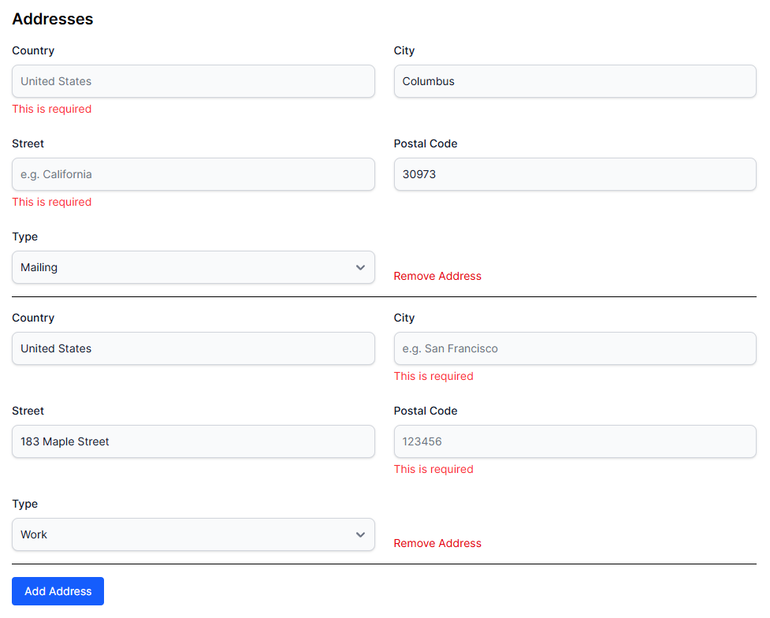

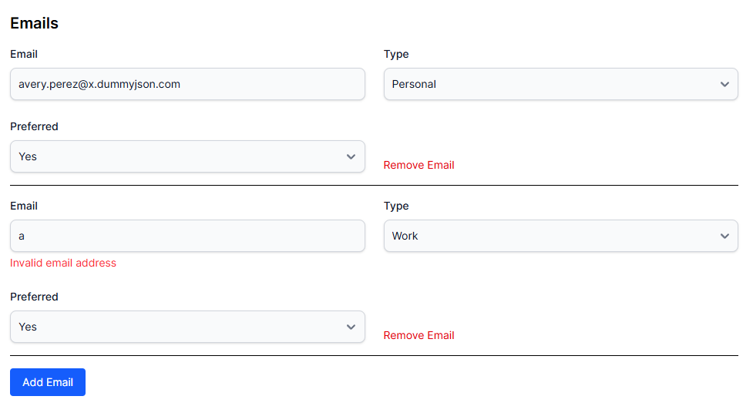

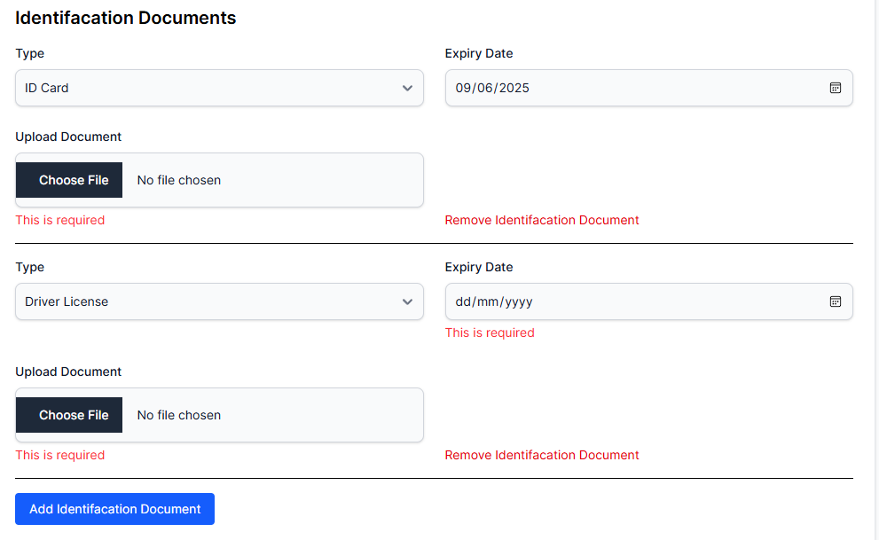

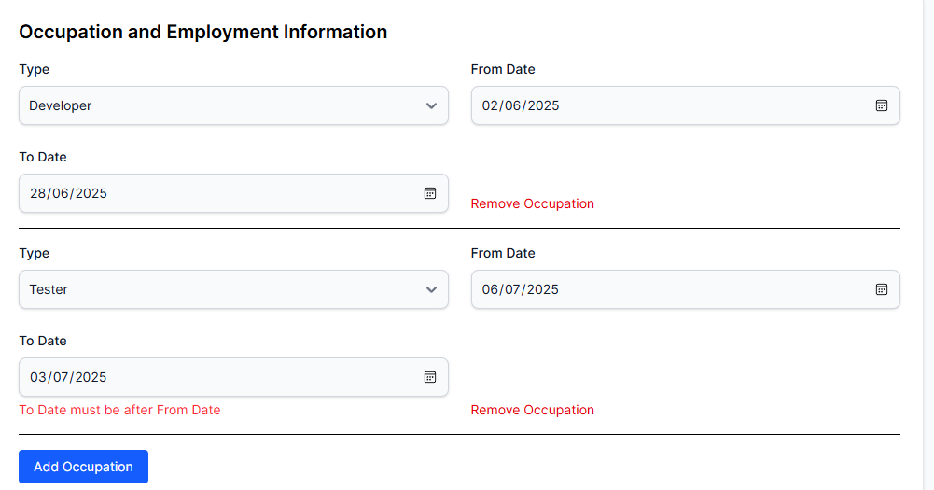

Submit button call api from https://dummyjson.com/ to mock update and save to local storage for preview and results page to use.

1. KYC

Auto calculate net worth and other total value

Have validation

Press Add button to add more

Press Remove button to remove

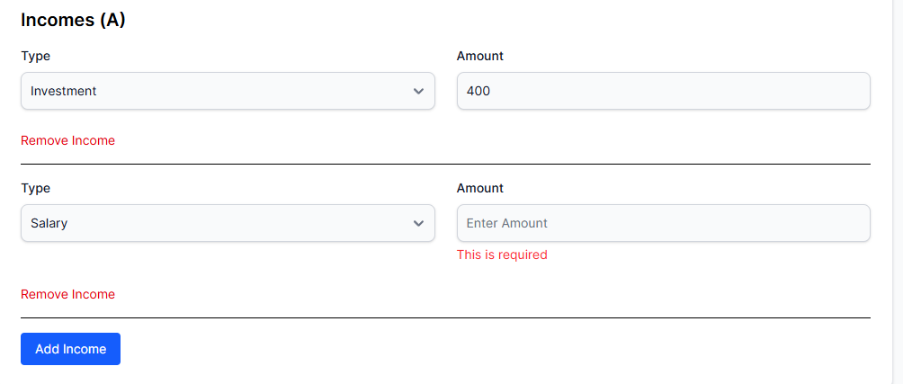

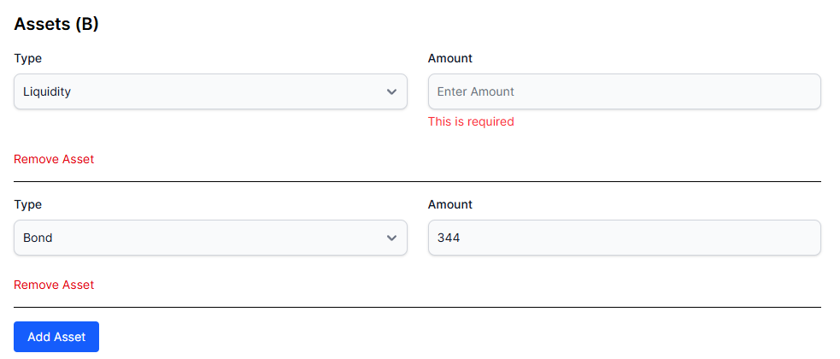

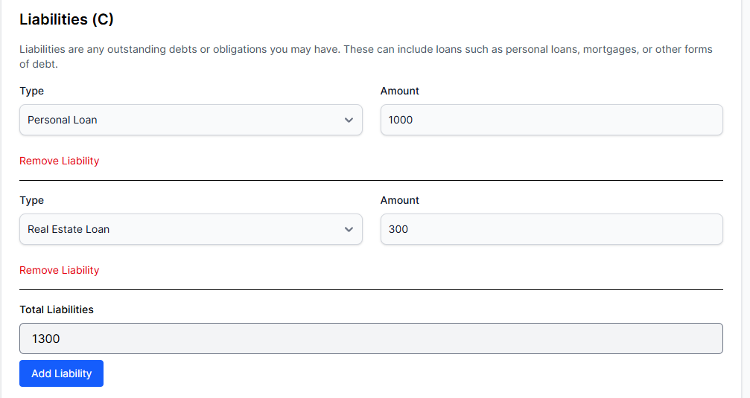

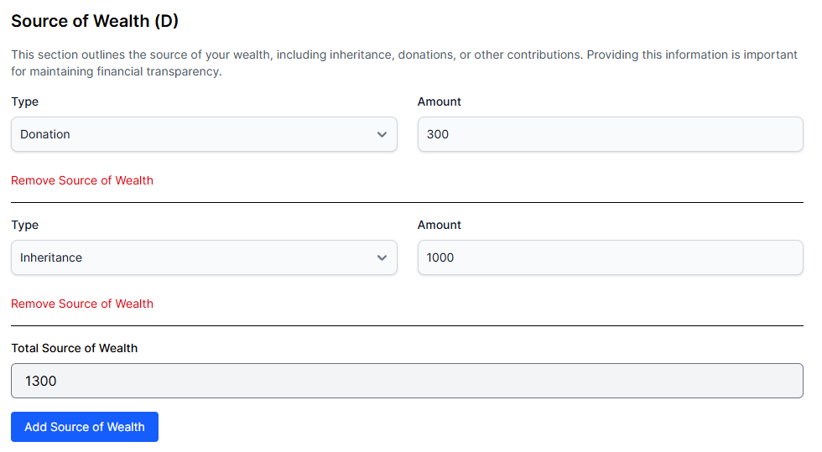 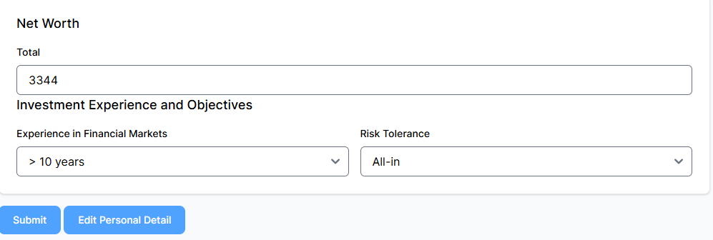

Submit button call api from https://dummyjson.com/ to mock update and save to local storage for preview and results page to use.

1. Preview page

Officer only

See a list of submissions by user with status = Active

Use approve/reject button to move submission to results page

Use preview button to see user submission in details

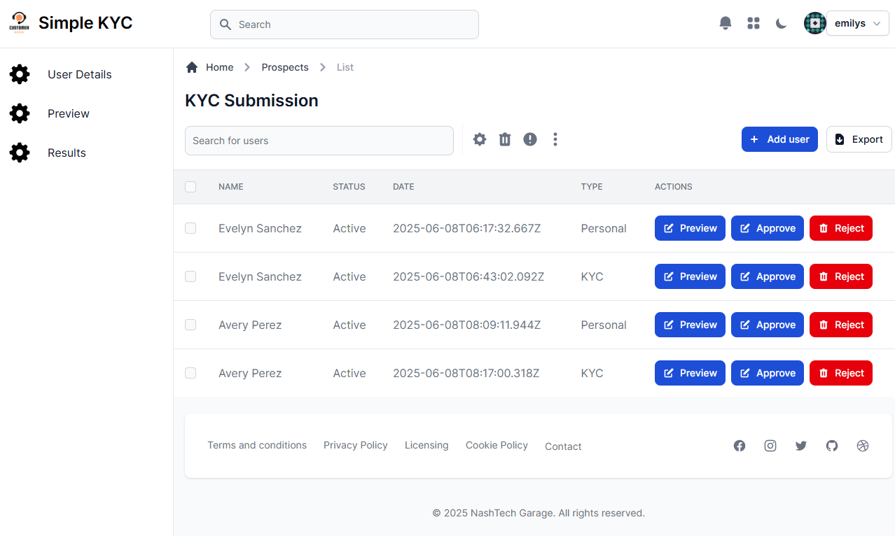

1. Preview page detail

View user submission in detail, using data from local storage

**Personal Type Submission:**

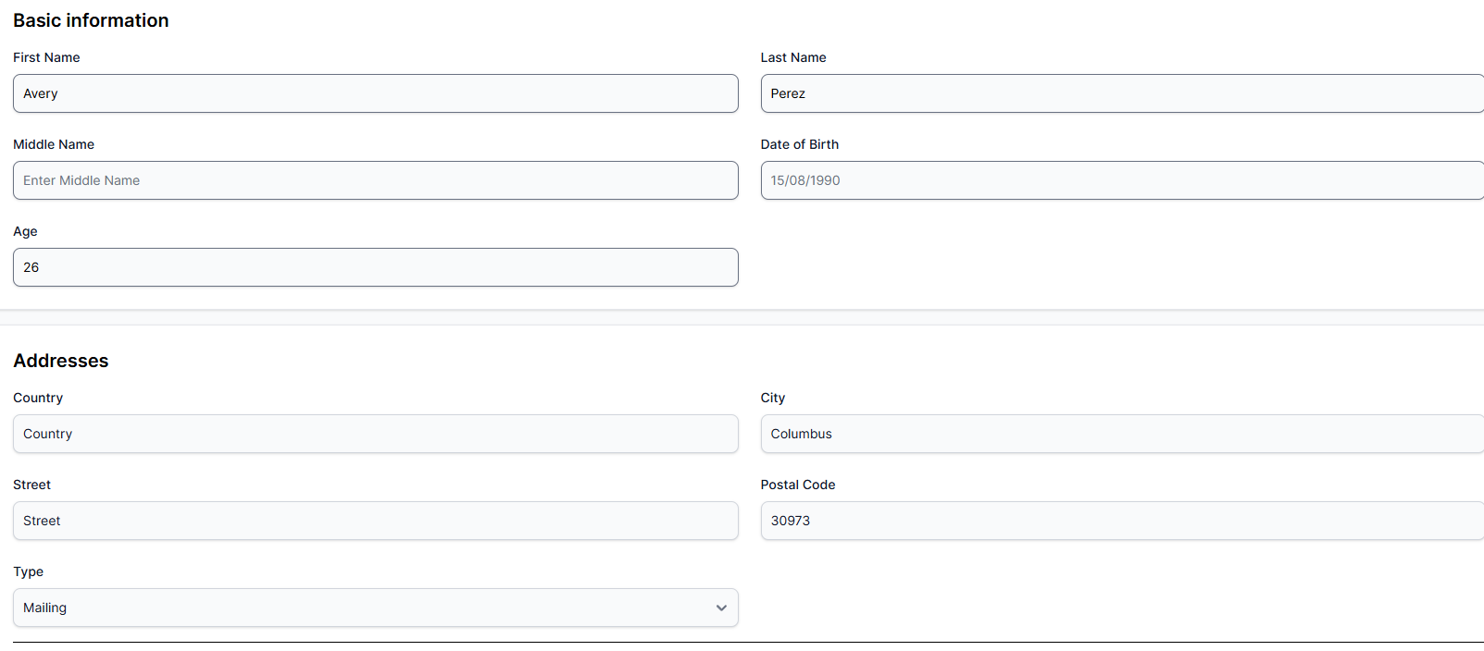

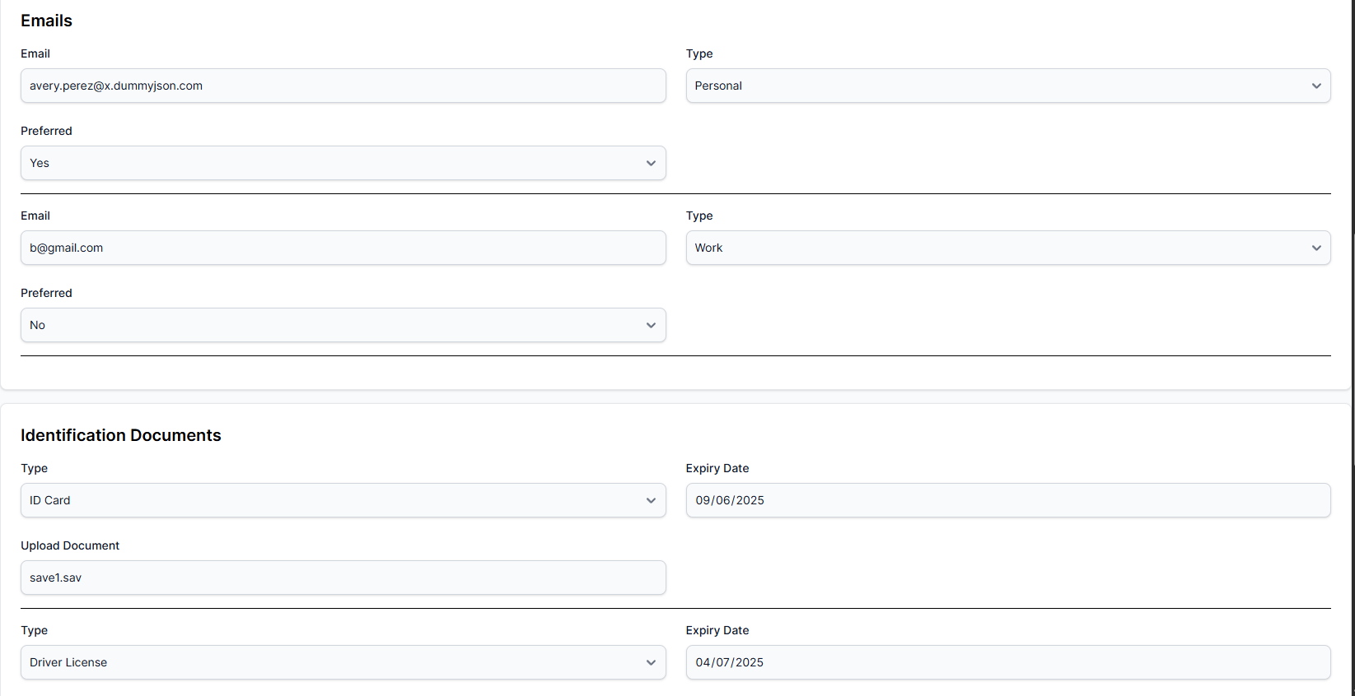

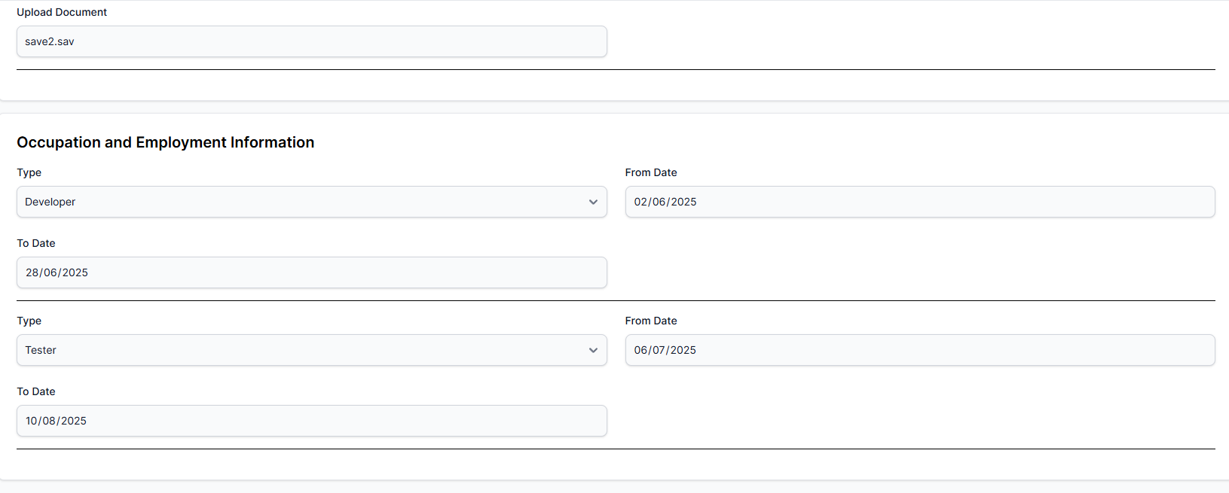

**KYC Type Submission:**

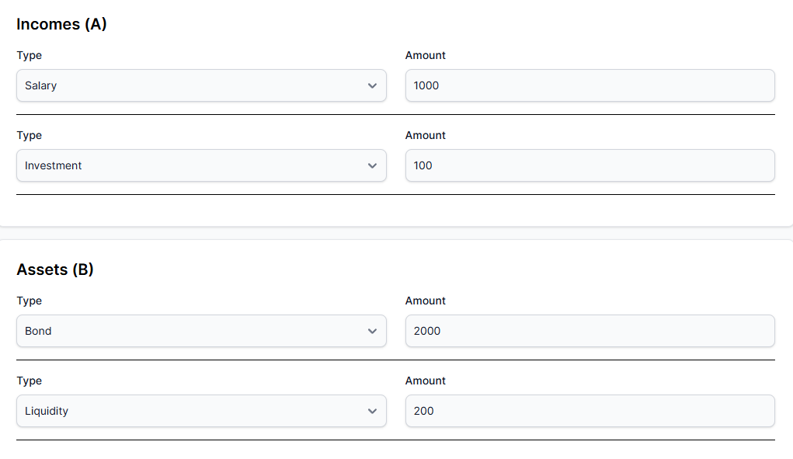

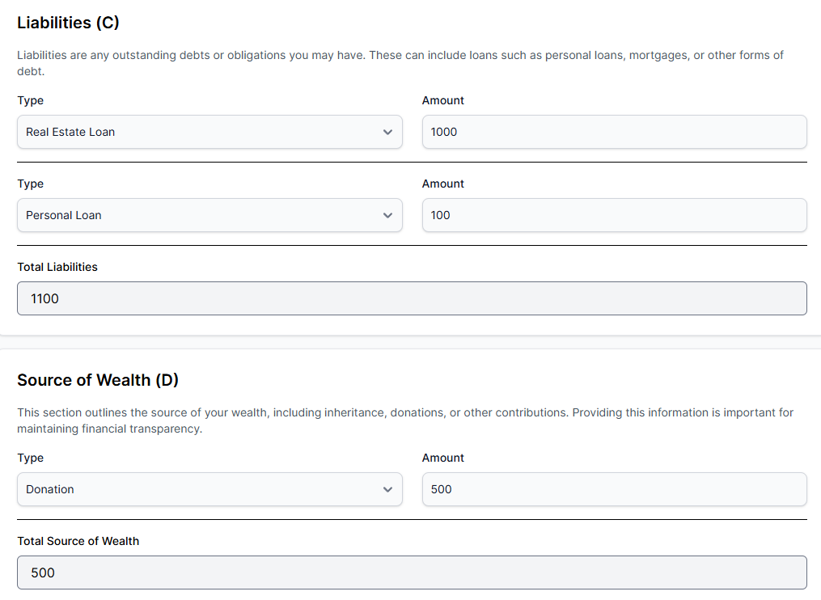

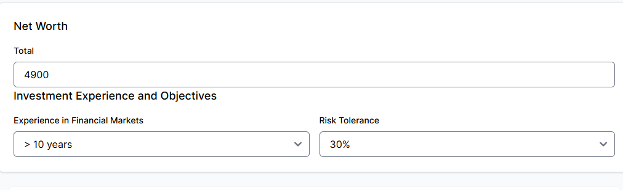

1. Results Page

Officer only

See a list of submissions by user with status = Approve/Rejected

