1. Use Terraform to create resources

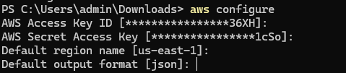

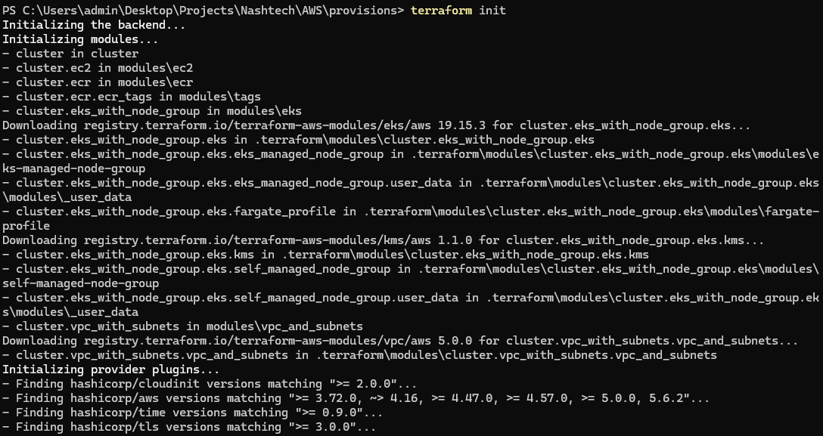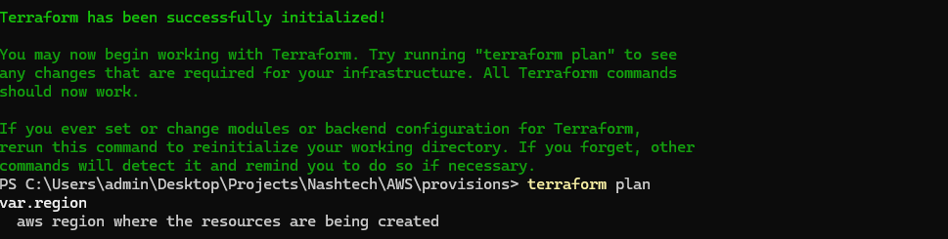

1. Create key for EC2 and put it in .tf file

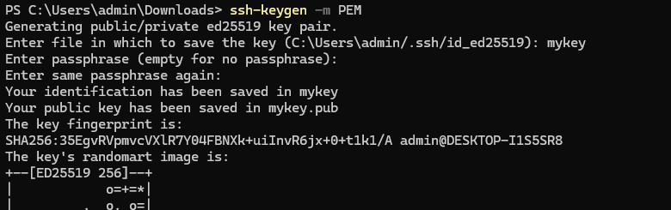

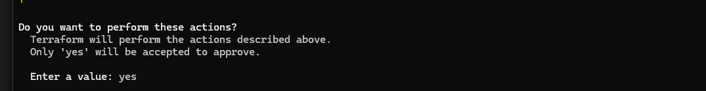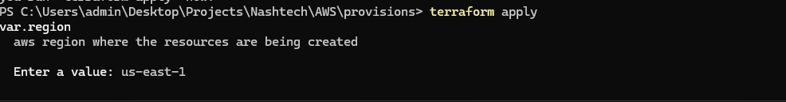

1. Verify AWS resources

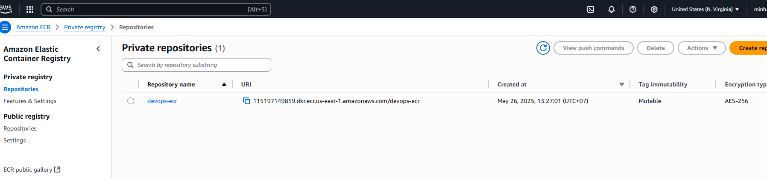

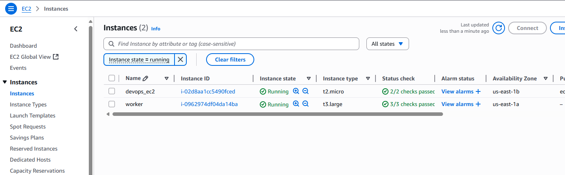

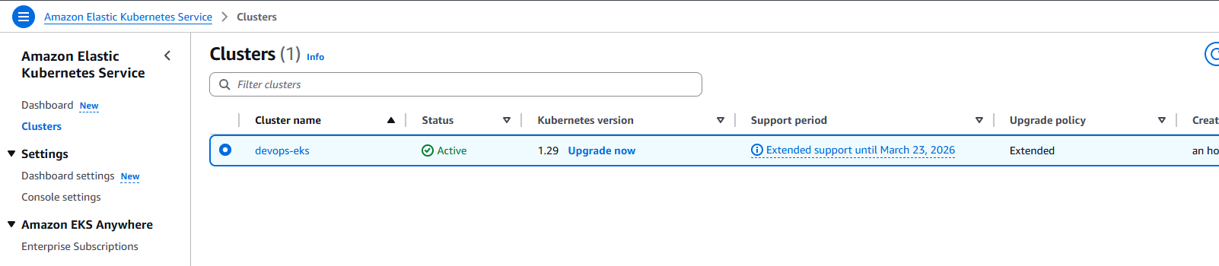

1. Install Jenkin and Docker on EC2

Follow steps in [Jenkins on AWS](https://www.jenkins.io/doc/tutorials/tutorial-for-installing-jenkins-on-AWS/)

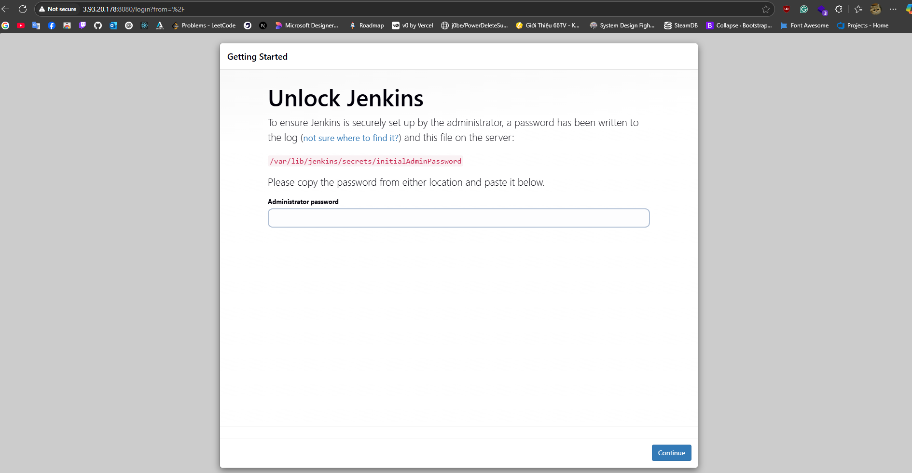



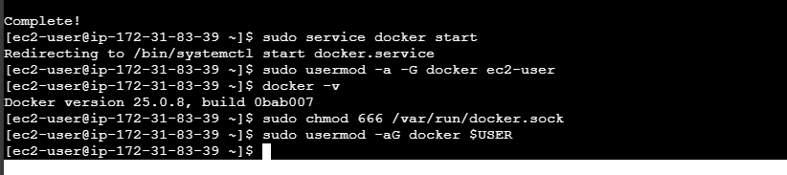

1. Install related plugin for jenkins(git,kubectl)

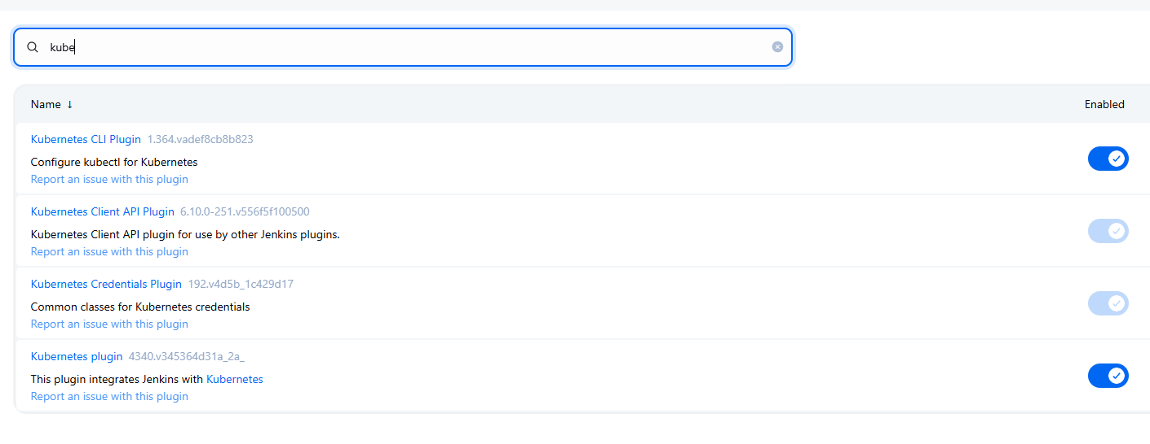

1. Add credentials for Jenkins

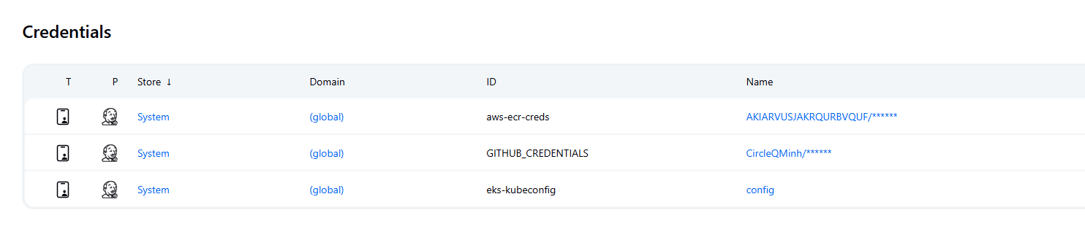

1. Create a pipeline in Jenkins

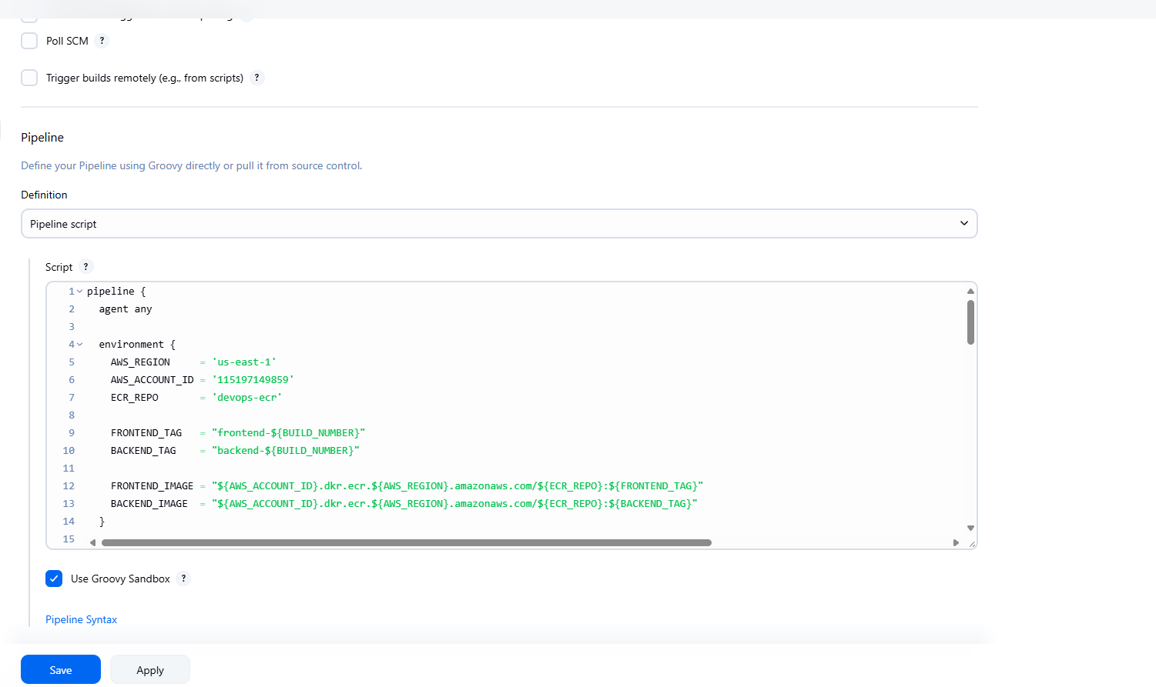

1. Run pipeline

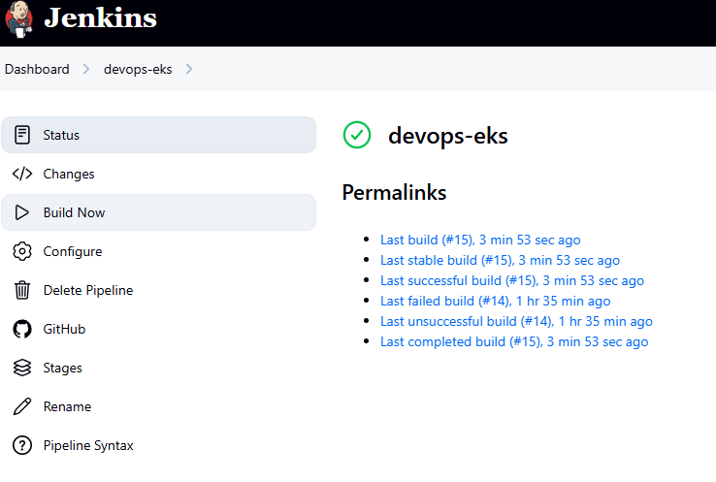

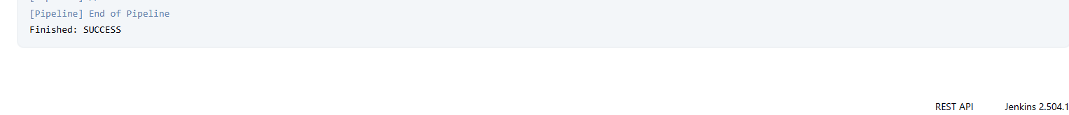

1. Verify image in ECR, resources in EKS

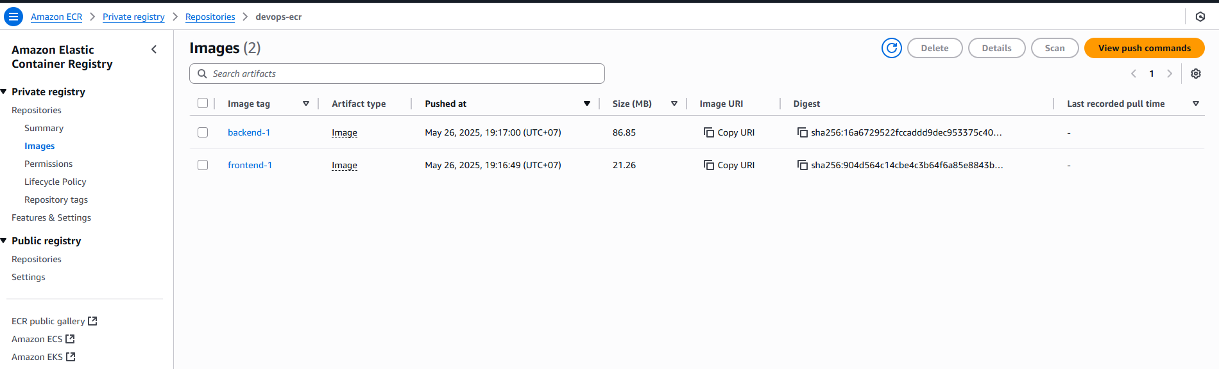

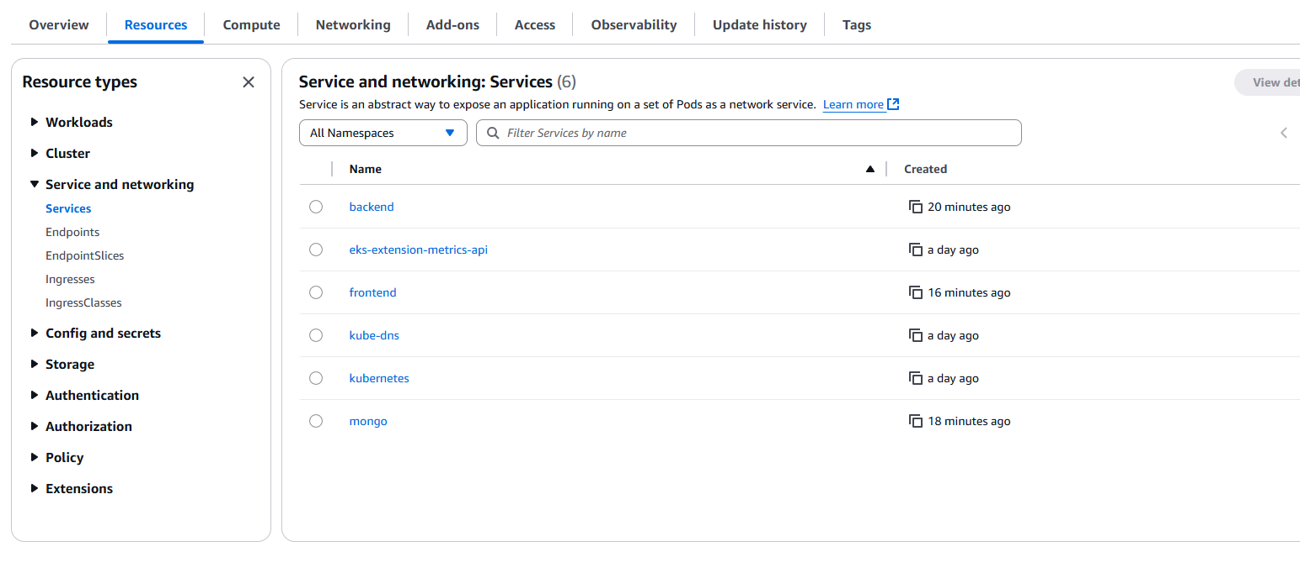

1. Use port-forward and check the app

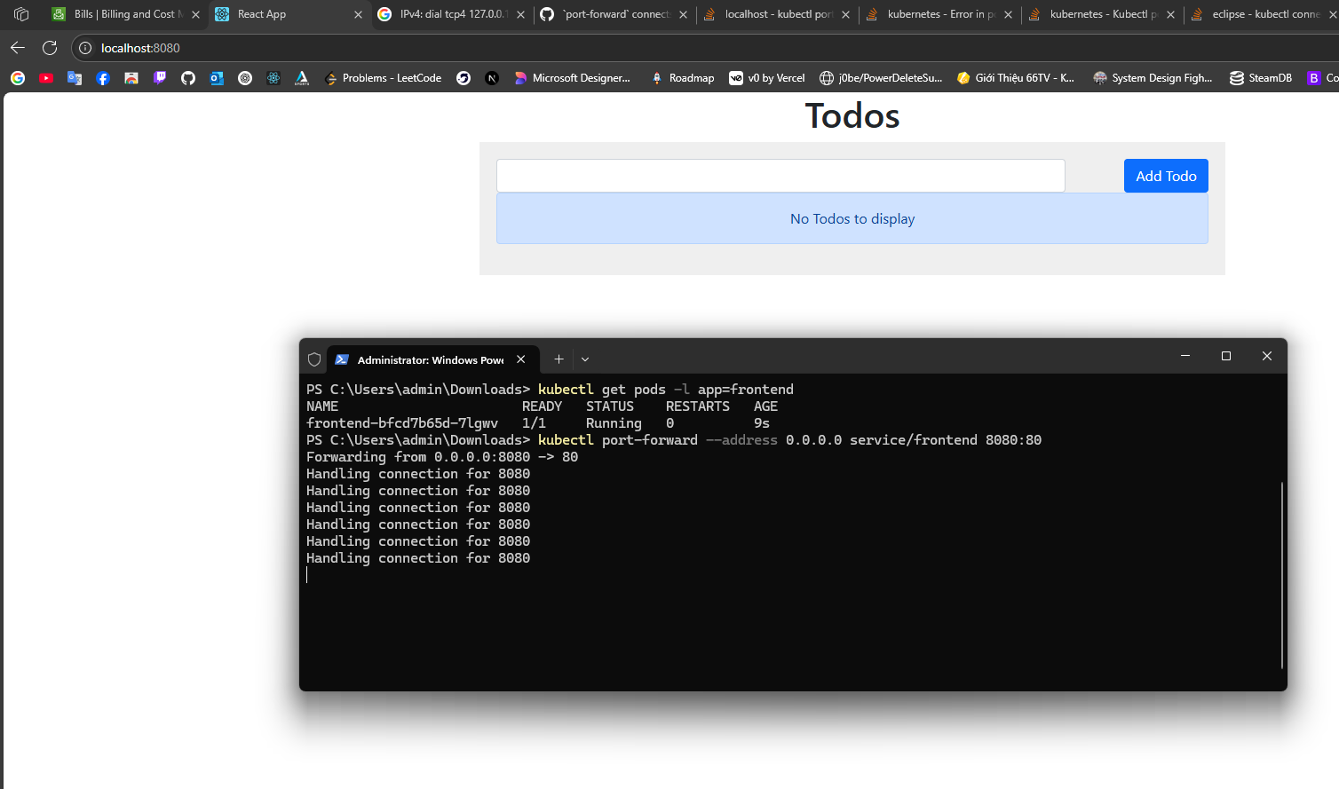

1. Install ArgoCD

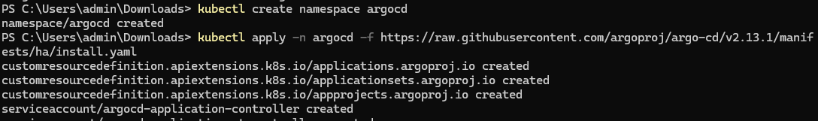

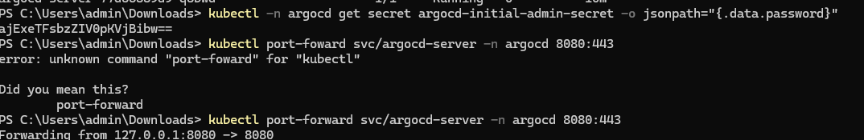

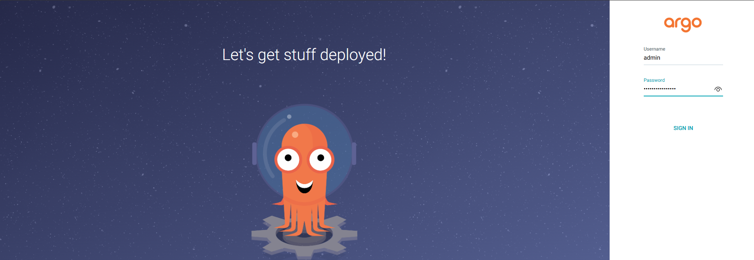

1. Create a new app in ArgoCD

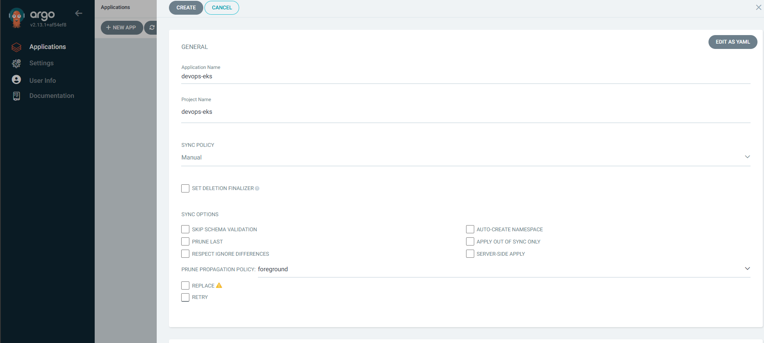

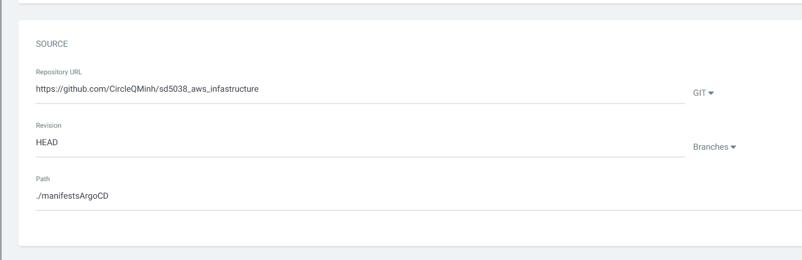

1. Sync the app from git

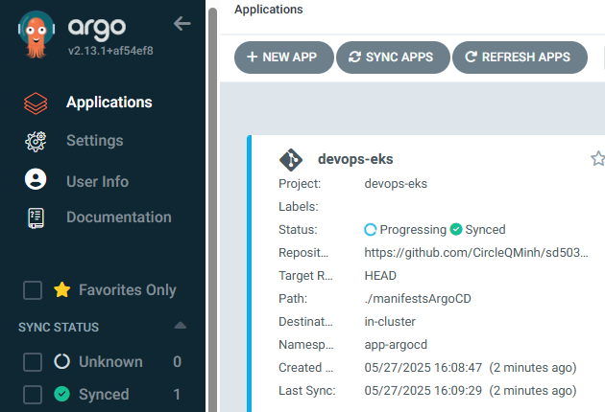

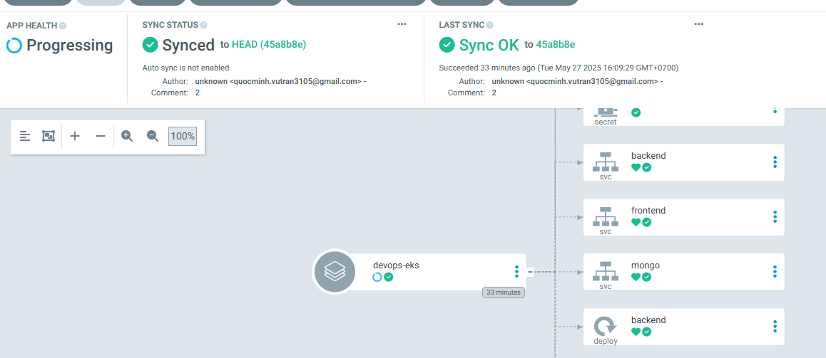

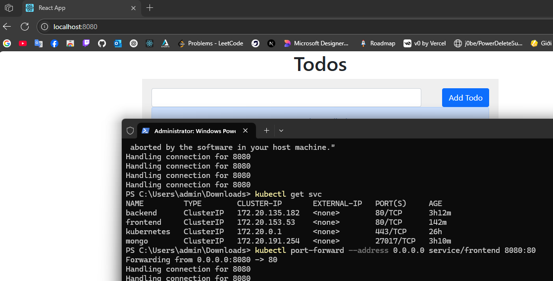

1. Install Prometheus/Grafana

