**Lime Microsystems Limited**

Surrey Tech Centre

Occam Road

The Surrey Research Park

Guildford GU2 7YG

Surrey

United Kingdom

Tel: +44 (0) 1483 685 063

Fax: +44 (0) 1428 656 662

e-mail: [enquiries@limemicro.com](mailto:enquiries@limemicro.com)

**LMS8001-Companion Driver Installation and Firmware Flashing**

***- Application Note -***

|  |  |
| --- | --- |
| Board version: | LMS8001-Companion |
| Board revision: | 01 |
| Document version: | 01 |
| Document revision: | 00 |
| Last modified: | 10/10/2017 14:35:00 |

**Contents**

1. Introduction 2

1.1 General description 2

1. Driver installation 3

2.1 Virtual COM port driver 3

2.2 DFU Driver 4

1. Firmware update procedure 5

3.1 Creating DFU file from HEX 5

3.2 Uploading firmware to LMS8001-Companion 7

**Document Revision History**

**Version v01r00**

*Released: 10 October, 2017*

Initial version.

Introduction

This document explains how to install drivers and perform device firmware update for LMS8001-Companion board.

LMS8001-Companion board contains STM32F105RBT6 microprocessor.

* 1. General description

To communicate with LMS8001-Companion board, the specific Virtual COM port driver needs to be installed on the host PC.

LMS8001-Companion has a capability to perform a firmware update using USB connection. The firmware HEX file first needs to be converted to DFU (Device Firmware Update) format and then used to flash LMS8001-Companion using the tools provided. The tools required to perform LMS8001-Companion firmware update are located in drivers\STM32_DFU\tools\ folder.

Driver installation

* 1. Virtual COM port driver

LMS8001-Companion communicates with PC via USB Virtual COM port. To install the required virtual com port driver on your system the following steps need to be performed:

1. Go to \drivers\STM32_VCP\ folder;
2. Depending on the version of windows that your system is running go to /Win7 or /Win8 directory;
3. If you are running 32-bit windows launch dpinst_x86.exe, or if you are running 64-bit windows launch dpinst_amd64.exe.
4. Click ‘Next’ when driver installation wizard appears (Figure 1) and wait.

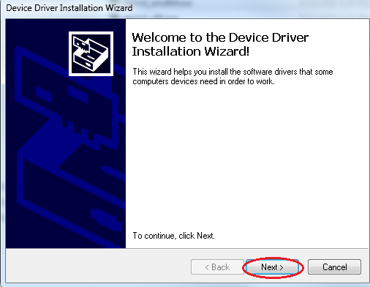

Figure 1 Driver installation

1. Click ‘Finish’ when the window shown in Figure 2 appears to complete installation.

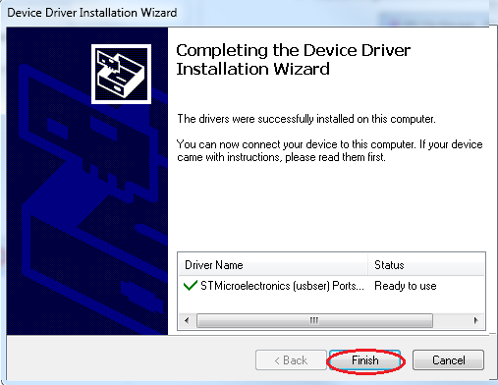

Figure 2 VCP Driver installation

* 1. DFU Driver

The DFU device driver is necessary to perform LMS8001-Companion firmware update. To install DFU device driver on your system the following steps need to be performed:

1. Go to drivers\STM32_DFU\drivers\ folder;
2. Depending on the version of windows that your system is running go to /Win7 or /Win8 directory;
3. If you are running 32-bit windows launch dpinst_x86.exe, or if you are running 64-bit windows launch dpinst_amd64.exe.
4. Click ‘Next’ when driver installation wizard appears (Figure 1) and wait.
5. Click ‘Finish’ when the window shown in Figure 3 appears to complete installation.

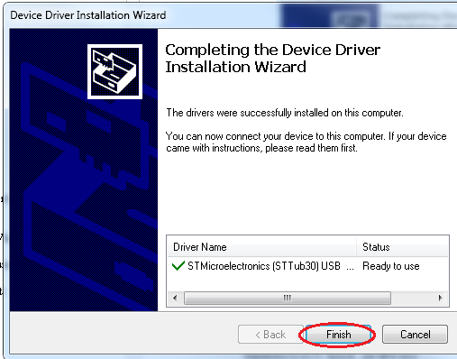

Figure 3 DFU Driver installation

Firmware update procedure

Tools used in this chapter are located in the drivers\STM32_DFU\tools folder.

* 1. Creating DFU file from HEX

This procedure is only required if you need to use a firmware file that is in HEX format. If you have downloaded firmware that is already in DFU format skip this chapter.

A file in HEX format cannot be directly uploaded to LMS8001-Companion. It must be first converted to DFU file format using the following steps:

1. Start DFU File Manager application (DfuFileMgr.exe);
2. Choose to generate DFU from HEX (Figure 4);

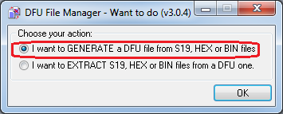

Figure 4 DFU File Manager start-up screen

1. In the main window of the DFU file manager click ‘S19 or Hex’ button (Figure 5). A file open dialog should appear. Use it to select the HEX file to convert to DFU format.

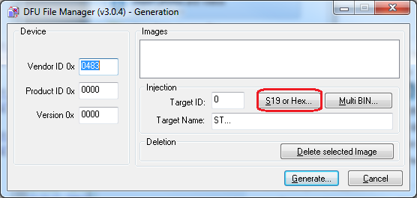

Figure 5 DFU File Manager main window

1. Click “Generate” button (Figure 6) and chose a filename for DFU file in the dialog that appears.

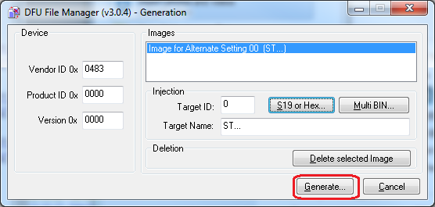

Figure 6 DFU File Manager main window

1. A message shown in Figure 7 should appear if DFU file has been generated successfully. Click OK and close DFU file manager.

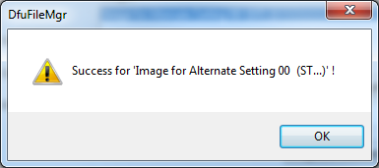

Figure 7 DFU File Manager message

* 1. Uploading firmware to LMS8001-Companion

To upload DFU firmware file to LMS8001-Companion the following steps need to be performed:

1. Connect LMS8001-Companion to your PC via USB.
2. Set MCU BOOT switch on LMS8001-Companion board to the following positions (Figure 8):
   * BOOT0 – High Level (MCU BOOT switch 1 – On)
   * BOOT1 – Low Level (MCU BOOT switch 2 – Off)

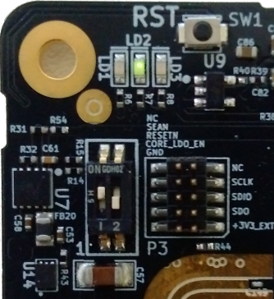

Figure 8 Boot switch positions – DFU mode

1. Press Reset button on LMS8001-Companion board. The device should be detected by your PC. It should appear in the Windows Device Manager under the name of ‘STM Device in DFU Mode’ as shown in Figure 9.

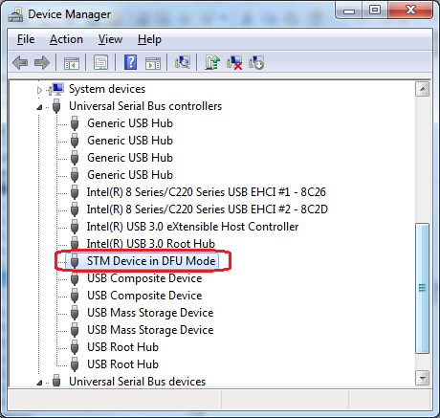

Figure 9 DFU Device in Windows Device Manager

1. Start ‘DfuSe Demo’ application (DfuSeDemo.exe).
2. Make sure that:
   * The board is detected by application (Figure 10-A);
   * The internal flash is selected for programming (Figure 10-B);
3. Click “Choose” to select the DFU file, which shall be used for firmware update (Figure 10-C). When the firmware file is successfully loaded the text “**File correctly loaded.**” is displayed at the bottom of the main application window.

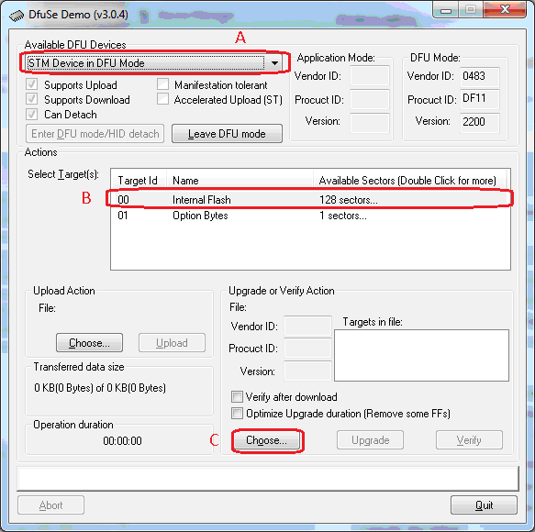

Figure 10 DfuSe Demo application main window

1. Click ‘Upgrade’ button (Figure 11).

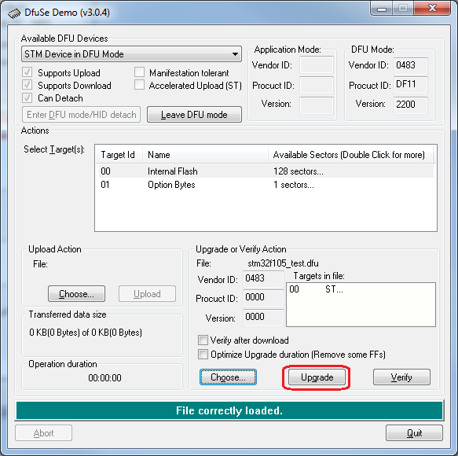

Figure 11 DfuSe Demo application main window

1. When the pop-up prompt (Figure 12) appears, click “Yes” to start flashing firmware.

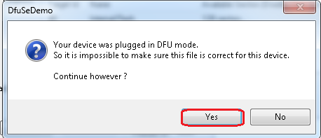

Figure 12 DfuSe Demo application pop-up prompt

1. The text “**Target 00: Upgrade successful !**” will be displayed at the bottom of the main application window when the firmware update completes successfully
2. Set MCU BOOT switch on LMS8001-Companion board to the following positions (Figure 13):
   * BOOT0 – Low Level (MCU BOOT switch 1 – Off)
   * BOOT0 – Low Level (MCU BOOT switch 2 – Off)

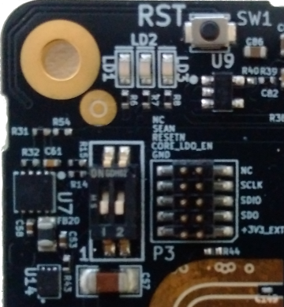

Figure 13 DfuSe Demo application pop-up prompt

1. Press ‘Reset’ button on LMS8001-Companion board. The board should now start running with the updated firmware.