***Circuit Collective Phase 1 Report***

***1st Phase - Project Overview***

**Name and Team Members:**

The ***Circuit Collective*** is a software development team, who’s members are as follows:

* **William Wedemire** - *Project Manager*
* **Bryce Gill -** *Technical Manager*
* **Tobenna Nnaobi -** *Front-End Lead*
* **Nathan Aguiar -** *Back-End Lead*
* **Jerry Yang -** *Software Quality Assurance Lead*

Each member has an additional role for this project, with each member expected to contribute code.

**Summary and Scope:**

* The purpose of this project is to create a digital inventory catalog software for a video game distribution company.
* The software will only be used by employees of the company and will not be used by the public.
* Users of the software will be able to add, edit, remove, sort and filter items in order to track the inventory.

**Goals, Objectives and Expectations:**

* We expect to deliver software focused on the functionality of managing and tracking video game inventory.
* Users will log in to the software using a company-wide password as specified by the client.
* The project will be delivered with all core functionality completed by the end of the timeframe.

***2nd Team Agreements and Elicitation Documentation***

***Summary of Team Contract:***

* Group will communicate through a Discord server
* Progress is reported through a Kanban Board
* Members are expected to reply to messages within 24 hours of receiving a message.
* Team will meet weekly at the in-person labs as well as online for weekly scrum.
* Work will be done using pair programming either in person or remotely.
* Code will be reviewed by QA and feedback given before being committed to the main branch by the Technical Manager as per the team’s policy.
* All decisions about the direction of the project will be made as a team, in consultation with the customer.
* The team agrees to keep each other accountable, and will not take reminders to complete assigned tasks personally.
* Missing deadlines is not something that the team supports - instead, if you are falling behind, ask for help, it will be given, and in return, you offer your assistance when needed.

***Elicitation Techniques Used***

Currently to date, the team has used a variety of different elicitation methods to elicit requirements from the user. These methods mostly include interviews and domain research.

**Findings in the Elicitation Process from Customer Interaction (Meeting Notes):**

1. ***Needed Functionality:***

* The software is only to be used by ***administrators***.
* There is no need for customers to use this software.
* There should be a feature for the administrators to refresh on stock when needed.

1. ***Project Constraints:***

* To be determined by environmental operational settings.

1. ***Any Additional Information:***

* It should be up to the team members to decide what are the necessary categories to properly filter and sort videogames.
* It would be nice to have a system that details the price and stock amount for each listed video game.
* It would be nice to have a feature where there is an administrator authentication system.
* It would be nice to create a system that proficiently protects core features that will change the crucial data in the database.
* The customer account creation system will not be necessary for this software product.
* Any creative liberties with the UI design are left entirely up to developers.
* The software product only requires its needed system functionality.
* It would be nice to include an administrator login system and a search relevancy system.

***3th User Stories and Prioritization***

***Justification for prioritization decisions***

Justification for prioritization of different stories was made by the customer during elicitation of requirements.

| **User Story** | **Priority** | **Estimated Effort** | **Dependencies** |
| --- | --- | --- | --- |
| Stock Catalogue  As a manager, I want an up to date stock catalogue, so software can keep track of which videogames are currently available. | Must Have | 5 Days | None |
| Search Bar  As an employee, I want a search bar, so software allows me to search games directly. | Must Have | 3 Days | Stock Catalogue |
| Inventory Tags  As a inventory controller, I want give each game a tag, so organization can be easier | Should Have | 3 Days | Stock Catalogue |
| Login Password  As a user, I want to log in securely using the universal password | Should Have | 2 Days | Authentication System |
| Shipment Trackers  As a manager, I want to be able to keep track of shipments. | Nice to Have | 3 Days | Stock Catalogue |
| Purchase Logging  As a manager, I want a customer purchase log, so that can manage them easier | Nice to Have | 3 Days | None |
| Sales and Revenue Analytics  As a manager, I want to track sales and revenue analytics. | Nice to Have | 4 Days | Purchase Logging |
| Search Recommendations  As a user, I want the search bar to automatically give a recommendation list based on what is typed in the search bar, so that makes game searching faster. | Nice to Have | 4 Days | Search Bar and Stock catalogue |

***4th Effort Estimation and Iteration Planning***

***Iteration 1***

| ***User Story*** | ***Priority*** | ***Estimated Effort*** | ***Time*** |
| --- | --- | --- | --- |
| * As a manager, I want an up to date stock catalogue, so software can keep track of which videogames are currently available.   + ***Tobenna, Nathan*** | Must Have | 5 Days | 5 Days |
| * As an employee, I want a search bar, so software allows me to search games directly.   + ***Bryce, Tobenna*** | Must Have | 3 Days | 3 days |
| * As a user, I want to log in securely using the universal password   + ***William, Bryce, Nathan*** | Should Have | 2 Days | 2 Days |
| ***TOTAL*** |  | ***10 Days*** | ***10 Days*** |

***Iteration 2***

| ***User Story*** | ***Priority*** | ***Estimated Effort*** | ***Time*** |
| --- | --- | --- | --- |
| * As an inventory controller, I want to give each game a tag, so organization can be easier.   + ***Tobenna, Jerry*** | Should Have | 3 Days | 3 Days |
| * As a manager, I want to be able to keep track of shipments.   + ***William, Bryce, Nathan*** | Nice to Have | 3 Days | 3 Days |
| * As a manager, I want to track sales and revenue analytics.   + ***William, Bryce, Nathan*** | Nice to Have | 4 Days | 4 Days |
| ***TOTAL*** |  | ***10 Days*** | ***10 Days*** |

***Iteration 3***

| ***User Story*** | ***Priority*** | ***Estimated Effort*** | ***Time*** |
| --- | --- | --- | --- |
| * As a manager, I want a customer purchase log, so that can manage them easier   + ***William, Bryce, Nathan*** | Nice to Have | 3 Days | 3 Days |
| * As a user, I want the search bar to automatically give a recommendation list based on what is typed in the search bar, so that makes game searching faster.   + ***Tobenna, Nathan*** | Nice to Have | 4 Days | 4 Days |
| ***TOTAL*** |  | ***7 Days*** | ***7 Days*** |

***Screenshot of Kaban:***

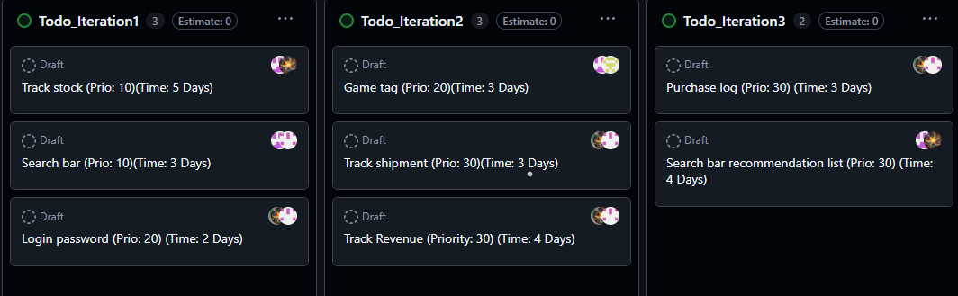

***5th Finalised Project Roadmap***

***Milestones / Deliverables:***

1. The first deliverable will contain the base functionality of the software. This will include the stock catalogue, a search bar to search within the catalogue, and a secure login to the catalogue.
2. The second deliverable will contain tagging for each entry in the catalogue, shipment tracking for managers, and sales and revenue tracking for managers.
3. The third deliverable will contain the customer purchase log for managers, and search bar recommendations.

***Key Risks And/Or Challenges:***

* **Iteration 1:**
  + Store universal password
  + Search bar requires sorting/searching in a gigantic database.
* **Iteration 2:**
  + Item tagging.
  + Log tracking.
* **Iteration 3:**
  + Search bar recommendation list requires database tag searching/sorting based on word in search bar.

***Next Step:***

* Team will begin preparing for Iteration 1 over the reading week. The next scrum meeting on February 23rd will overview any preparations made, and outline the work to be done in the following week leading up to lab 6.